GUÍA DEL USUARIO
VERSION 3.0.4

C
O N T E N T S
CAPITULO 1
INTRODUCCION
9
ACERCA DE ESTA GUÍA............................................................................. 10
Que es FlowStone ?................................................................................... 11
Como Funciona.......................................................................................... 11
CAPITULO 2
2 Interfaz de usuario
13
Caja de herramienta............................................................................. 15
Explorador de Componentes.................................................................................... 51
Panel de Filtros......................................................................................................….61
Botones de Filtro....................................................................................................….61
Cuadro de Busqueda.................................................................................................17
Búsqueda Rapida.......................................................................................................17
Restablecer todos los Filtros......................................................................................81
Favoritos....................................................................................................................18
Escala de Pantalla.............................................................................................18
Caja local de Herramientas................................................................................19
BARRA DE ETIQUETAS................................................................................. 21
EDICION DE ETIQUETAS........................................................................................21
COMPONENTES DE ETIQUETADO…………............................................................. 22
USO DE ETIQUETAS.............................................................................................23
NAVEGADOR................................................................................................. 24
SALTO...............................................................................................................24
PANORAMICA......................................................................................................25
MARCADORES.................................................................................................... 52
ESQUEMA DE VENTANA................................................................................ 26
ZOOMING............................................................................................................ 62
SCROLLING..........................................................................................................27
PANNING.............................................................................................................27
RESETTING ZOOM AND PAN.....................................................................................27
CHAPTER 3
3 Components & Links
28
COMPONENTS............................................................................................... 33
ADDING A COMPONENT...........................................................................................33
SELECTIONS AND THE ACTION PANEL......................................................................... 73
MOVING COMPONENTS........................................................................................... 73
NAMING COMPONENTS........................................................................................... 83
DELETING COMPONENTS......................................................................................... 93
RESIZING............................................................................................................ 93
MULTIPLE SELECTIONS........................................................................................... 04
CONNECTOR LABELS..............................................................................................41
CUT, COPY AND PASTE.........................................................................................41
LINKS......................................................................................................... 42
- ii -

C
O N T E N T S
CREATING A LINK..................................................................................................42
ALLOWED LINKS................................................................................................... 34
MOVING A LINK.................................................................................................... 34
DELETING A LINK.................................................................................................. 44
LINK ORDER........................................................................................................45
BENDING LINKS.................................................................................................... 64
AUTO LINKING......................................................................................................47
SMART LINKING.................................................................................................... 84
REMOVING MULTIPLE LINKS.....................................................................................49
SWAPPING LINKS.................................................................................................. 94
WIRELESS LINKS.................................................................................................. 05
FOLLOW WIRELESS............................................................................................... 15
CHAPTER 4
4 Modules
54
KEY DIFFERENCES........................................................................................ 56
APPEARANCE....................................................................................................... 65
FRONT PANEL......................................................................................................57
PROPERTIES........................................................................................................ 75
TOOLBOX............................................................................................................58
BASIC OPERATIONS....................................................................................... 59
MOVING INTO A MODULE........................................................................................59
INPUTS AND OUTPUTS............................................................................................ 06
TEMPLATE CONNECTORS.........................................................................................61
INPUT AND OUTPUT NAMES..................................................................................... 16
MAKE MODULE.................................................................................................... 26
PROPERTIES........................................................................................................ 26
WIRELESS MODULES............................................................................................. 36
FRONT PANEL.............................................................................................. 64
ENABLING THE FRONT PANEL..................................................................................64
EDITING THE FRONT PANEL..................................................................................... 56
SELECTING..........................................................................................................66
MOVING..............................................................................................................67
RESIZING............................................................................................................ 76
JUMPING.............................................................................................................68
DRAW ORDER......................................................................................................69
OUT OF VIEW ITEMS..............................................................................................69
GROUPED ITEMS...................................................................................................70
CLIENT AREA.......................................................................................................70
HIDING THE FRONT PANEL...................................................................................... 17
VISIBILITY IN PARENT MODULE PANELS...................................................................... 17
PROPERTIES................................................................................................. 73
ENABLING THE PROPERTIES PANEL...........................................................................73
ADDING PROPERTY ITEMS....................................................................................... 47
CONTROL TYPES.................................................................................................. 57
EDITING THE PROPERTIES PANEL.............................................................................. 77
RESIZING............................................................................................................ 77
CUSTOMIZING.......................................................................................................77
SYNCHRONISING............................................................................................ 79
- iii -

C
O N T E N T S
PASTE SYNCHRONISE.............................................................................................79
SYNCHRONISE ALL................................................................................................ 08
SYNCHRONISE PAINTER.......................................................................................... 08
REMOVING SYNCHRONISATION.................................................................................. 18
FINDING SYNCHRONISED MODULES...........................................................................81
FOCUS MODE.............................................................................................. 82
FOCUS
FOCUS
ON A
ON THE PREVIOUS
MODULE............................................................................................ 28
MODULE............................................................................ 28
CHAPTER 5
5 Data Types & Signal Flow
83
STREAM DATA.............................................................................................. 85
DIGITAL SIGNAL PROCESSING IN A NUTSHELL..............................................................85
MONO................................................................................................................86
POLY.................................................................................................................86
WHEN TO USE POLY OR MONO............................................................................... 68
STREAM CONNECTORS........................................................................................... 88
POLY AND MONO SECTIONS IN AUDIO APPLICATIONS.....................................................89
BOOLEAN CONNECTORS.........................................................................................90
POLY INT............................................................................................................90
SSE.................................................................................................................90
MONO 4.............................................................................................................91
PERFORMANCE..................................................................................................... 19
TRIGGERED DATA.......................................................................................... 92
HOW IT WORKS................................................................................................... 29
WHAT IT’S USED FOR............................................................................................93
TRIGGERED DATA TYPES........................................................................................ 39
EVENT DATA................................................................................................ 96
HOW IT WORKS................................................................................................... 69
EVENT DATA TYPES.............................................................................................. 79
CONVERTING BETWEEN DATA TYPES................................................................. 98
STRING <> BOOLEAN............................................................................................ 89
INT <> BOOLEAN..................................................................................................99
STRING <> FLOAT <> INT...................................................................................... 99
INT/FLOAT > POLY/MONO.....................................................................................100
MIDI <> STRING...............................................................................................101
STRING SHORTCUTS............................................................................................ 021
CHAPTER 6
6 Exporting
105
CREATING STANDALONE APPLICATIONS............................................................ 106
LIBRARY DEPENDENCIES....................................................................................... 081
CREATING PLUGINS..................................................................................... 109
INPUTS AND OUTPUTS.......................................................................................... 091
CREATE VST/VST I DIALOG................................................................................. 101
STORING VST EXPORT PREFERENCES....................................................................112
- iv -

C
O N T E N T S
PRESETS...........................................................................................................112
TIMING INFO...................................................................................................... 131
CHAPTER 7
7 Advanced GUI Editing
114
MODULE GUI............................................................................................ 115
MODULE GUI C OMPONENT................................................................................... 151
MGUI CONNECTORS...........................................................................................116
GUI CONNECTOR TYPES......................................................................................117
COORDINATE SYSTEM...........................................................................................118
DRAWING...................................................................................................119
DRAWING ON A PANEL..........................................................................................119
DRAWING ORDER................................................................................................120
CHAINING GUI C OMPONENTS................................................................................ 211
MOUSE HANDLING....................................................................................... 122
MOUSE AREA.....................................................................................................122
MOUSE CLICKS.................................................................................................. 221
MOUSE DRAGGING..............................................................................................123
MOUSE MOVES.................................................................................................. 241
DRAG ACCUMULATE.............................................................................................124
REDRAWING............................................................................................... 126
REDRAW CONTROL .............................................................................................126
PRECISION REDRAWS...........................................................................................126
CHAPTER 8
8 Ruby Component
128
INTRODUCTION............................................................................................ 129
OVERVIEW.........................................................................................................129
INPUTS AND OUTPUTS.................................................................................. 130
ADDING OR REMOVING......................................................................................... 301
CHANGING TYPE.................................................................................................130
INSERTING, DELETING AND MOVING......................................................................... 311
NAMING ...........................................................................................................131
CODE EDITOR BASICS................................................................................. 132
THE OUTPUT PANE............................................................................................. 321
THE RUBYEDIT CLASS.........................................................................................134
INPUT DATA.......................................................................................................134
OUTPUT DATA....................................................................................................135
THE EVENT METHOD.................................................................................... 138
METHOD DEFINITION............................................................................................138
CONNECTOR REFERENCING................................................................................... 391
EFFECT ON CODE EXECUTION................................................................................140
SCHEDULING EVENTS................................................................................... 141
SCHEDULING AN EVENT........................................................................................ 411
SENDING TO AN INPUT.......................................................................................... 421
-v-

C
O N T E N T S
CLEARING EVENTS.............................................................................................. 421
CLOCK ACCURACY.............................................................................................. 431
RUBY VALUES............................................................................................ 144
THE RUBY VALUE TYPE....................................................................................... 441
PASSING RUBY VALUES.......................................................................................144
PERSISTENCE............................................................................................. 147
USER STATE MANAGEMENT................................................................................... 471
DEBUGGING............................................................................................... 149
ERROR REPORTING............................................................................................. 491
THE WATCH METHOD........................................................................................... 501
DRAWING.................................................................................................. 151
THE DRAW METHOD............................................................................................ 511
DRAWING CLASSES AND METHODS.......................................................................... 521
PENS, BRUSHES & COLORS..................................................................................152
BASIC SHAPES...................................................................................................153
LINES AND CURVES............................................................................................. 541
GRAPHICS PATHS............................................................................................... 561
TEXT............................................................................................................... 581
BITMAPS...........................................................................................................161
REDRAW...........................................................................................................163
CLIPPING.......................................................................................................... 631
SMOOTHING.......................................................................................................164
VIEW PROPERTIES.............................................................................................. 651
ADVANCED BRUSHES................................................................................... 167
LINEAR GRADIENTS............................................................................................. 671
PATH GRADIENTS................................................................................................171
HATCH BRUSHES................................................................................................ 781
TEXTURE BRUSHES............................................................................................. 801
ADVANCED PENS........................................................................................ 182
PEN ALIGNMENT................................................................................................. 821
LINE JOINS........................................................................................................183
DASHES............................................................................................................185
BRUSHED LINES................................................................................................. 861
LINE CAPS........................................................................................................187
INTERACTION.............................................................................................. 192
OVERVIEW.........................................................................................................192
HANDLING MOUSE EVENTS...................................................................................193
MOUSE CLICKS.................................................................................................. 941
MOUSE CAPTURE & DRAGGING.............................................................................195
KEY MODIFIERS..................................................................................................196
MOUSE MOVE....................................................................................................197
MOUSE CURSOR.................................................................................................198
CONTROLS AND DIALOGS.............................................................................. 200
IN PLACE EDIT CONTROLS.................................................................................... 002
DROP LISTS...................................................................................................... 012
MESSAGE BOXES................................................................................................202
EXTERNAL DLLS........................................................................................204
- vi -

C
O N T E N T S
THE WIN32API EXTENSION................................................................................. 042
CREATING A FUNCTION OBJECT ............................................................................. 042
MAKING THE CALL.............................................................................................. 062
MIDI....................................................................................................... 208
READING MIDI OBJECTS .................................................................................... 082
CREATING MIDI OBJECTS.................................................................................... 102
FRAMES.................................................................................................... 212
MONO TO FRAME................................................................................................212
THE FRAME CLASS............................................................................................. 132
FRAME TO MONO...............................................................................................214
FRAME SYNC.....................................................................................................215
PROCESSING FRAMES IN A DLL............................................................................. 162
RUBY LIMITATIONS....................................................................................... 218
SINGLE INTERPRETER........................................................................................... 182
STANDARD RUBY LIBRARIES..................................................................................218
DECLARATION ORDER.......................................................................................... 192
DECLARATION PERSISTENCE..................................................................................219
GEMS.............................................................................................................. 192
RUBY DLL............................................................................................... 221
CHANGES..........................................................................................................221
BUILDING THE DLL............................................................................................. 222
CHAPTER 9
9 DSP Code Component
223
DSP CODING............................................................................................ 224
THE DSP CODE COMPONENT............................................................................... 242
INPUTS AND OUTPUTS.......................................................................................... 242
SYNTAX COLOURING............................................................................................ 252
EDITOR.............................................................................................................226
LOCAL VARIABLES............................................................................................... 262
ASSIGNMENTS.................................................................................................... 272
EXPRESSIONS.....................................................................................................229
CONDITIONAL STATEMENTS.................................................................................... 302
COMMENTS........................................................................................................230
ADVANCED FEATURES.................................................................................. 231
ARRAYS............................................................................................................231
HOP................................................................................................................232
LOOP...............................................................................................................232
STAGES............................................................................................................233
DEBUGGING.......................................................................................................235
CHAPTER 10
10 DLL Component
237
INTRODUCTION............................................................................................ 238
THE COMPONENT........................................................................................ 239
DEFINING INPUTS
AND
OUTPUTS............................................................................. 392
- vii -

C
O N T E N T S
CONNECTOR TYPES.............................................................................................240
THE DLL................................................................................................. 242
DATA TYPES......................................................................................................242
INTS................................................................................................................ 432
FLOATS............................................................................................................ 442
BOOLEANS........................................................................................................ 442
STRINGS...........................................................................................................244
FLOAT ARRAYS...................................................................................................245
INT ARRAYS.......................................................................................................246
BITMAPS...........................................................................................................248
FRAMES............................................................................................................249
HELPERS.......................................................................................................... 502
EXAMPLE 1 – FLOAT ADD.....................................................................................251
EXAMPLE 2 – STRING UPPERCASE.........................................................................252
EXAMPLE 3 – AUDIO DELAY.................................................................................. 532
CONNECTING.............................................................................................. 254
A NOTE
ABOUT
OUTPUTS...................................................................................... 552
DEBUGGING............................................................................................... 257
DEBUGGING USING VISUAL STUDIO.......................................................................... 572
CODE – TEST – DEBUG CYCLE............................................................................. 582
SHARING................................................................................................... 260
SHARE THE DLL SEPARATELY...............................................................................260
EMBED THE DLL................................................................................................. 602
PROS AND CONS OF EMBEDDING............................................................................ 612
EXPORTING........................................................................................................261
CHAPTER 11
11 Options
262
THE OPTIONS DIALOG................................................................................. 263
APPLICATION......................................................................................................264
NAVIGATOR........................................................................................................266
TOOLBOX..........................................................................................................267
SCHEMATIC........................................................................................................268
MODULES..........................................................................................................269
EXPORT............................................................................................................270
ADVANCED........................................................................................................ 712
- viii -

1 Introducción
ACERCA DE ESYA GUIA Y SINOPSIS DE SOFTWARE
T

CHAPTER 1
Acerca de esta Guía
Este manual proporciona una descripción detallada del software FlowStone y sus funciones. Su objetivo es
para mostrar cómo funciona el software y lo que sus capacidades son.
Si usted está buscando tutoriales luego ver la sección de tutoriales de la web DSP Robotics:
http://www.dsprobotics.com/tutorials.html (English)
Para obtener información acerca de los componentes individuales que se incluyen con el software, consulte la
Guía de referencia. Estos documentos se pueden encontrar en la sección de Manuales de nuestro sitio web en:
http://www.dsprobotics.com/manualsarea.php (English)
Información y artículos sobre el software adicional se puede encontrar en Ingles:
http://www.dsprobotics.com /support.html (English)
Si usted tiene algún comentario sobre esta guía, por favor envíe un correo electrónico a info@dsprobotics.com. ( En Ingles )
- 10 -

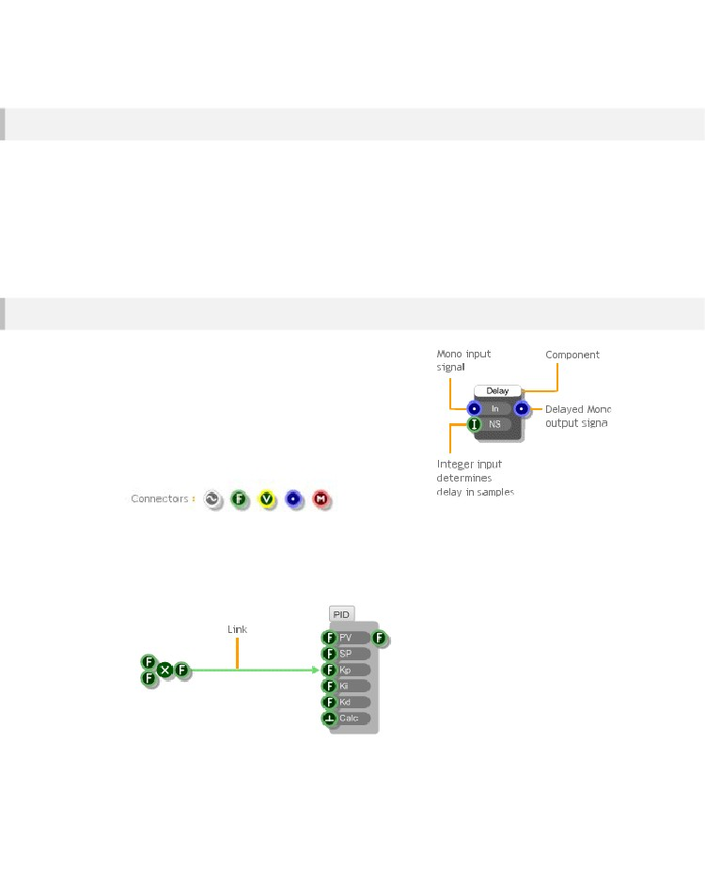
INTRODUCTION
Que es FlowStone?
FlowStone es un lenguaje de programación gráfica para el rápido desarrollo de software
aplicaciones. Usando el software que tiene una flexibilidad completa para crear exactamente el tipo de aplicación que desea.

Puede agregar controles personalizados para modificar los parámetros en tiempo real y el grupo de estos controles juntos para hacer potentes interfaces de usuario.
Sus creaciones terminadas se pueden exportar como aplicaciones ejecutables completamente independientes o plugins de audio.

Estas aplicaciones se pueden utilizar en cualquier PC con Microsoft Windows o utilizados en el centro de su propio sistema embebido.
¿Cómo funciona?
Conceptualmente, FlowStone es muy simple.
El software proporciona un conjunto de bloques de construcción llamados componentes. Cada componente realiza una función diferente.

Un componente puede tomar los datos de proceso ella, pasa hacia fuera. Por tanto, un componente puede tener entradas o salidas o ambos.
Las entradas y salidas se llaman conectores. Hay diferentes
tipos de conector para diferentes tipos de datos. Cada conector tiene
un símbolo propio para que pueda identificar fácilmente el tipo de dato..
Los datos se pasan entre los componentes conectándolos entre sí con enlaces.
Un enlace inicia en un conector de salida de componentes y termina en un conector de entrada. En general, los datos pasan a través de un enlace desde el principio hasta el final (de izquierda a derecha). Sin embargo, en algunos casos, los datos también pueden pasar de derecha a izquierda
(leer sobre esto más adelante).
- 11 -

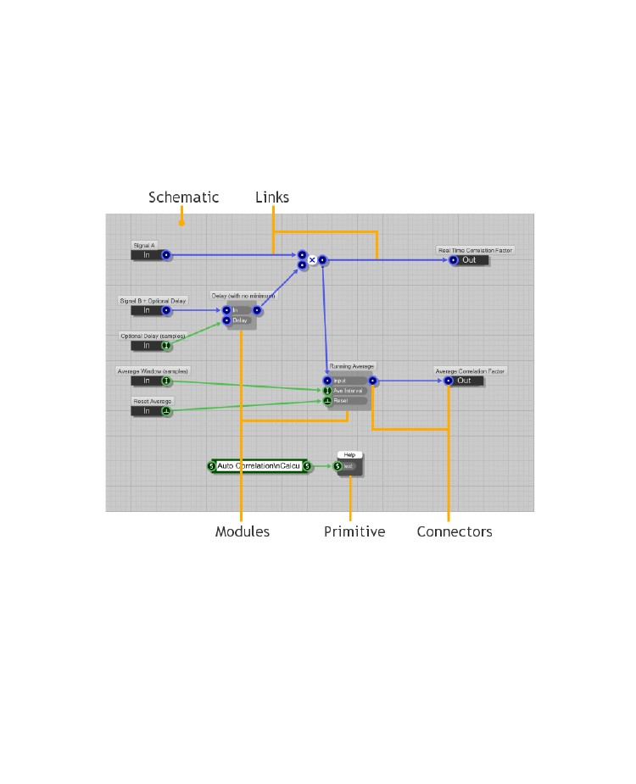
CAPITULO 1
Componentes y enlaces se colocan en un 1024x1024 cuadrícula que llamamos un esquema. Con el fin de permitir esquemas más sofisticados que tenemos un tipo especial de componente llamado módulo.

Los módulos son tipos especiales de los componentes en que se definen por su propio esquema. que contiene otros componentes y módulos.

Los módulos también pueden tener un panel frontal interactivo con sus propios controles y gráficos personalizados.
Cualquier componente que no es un módulo lo llamamos un primitivo.
Mediante la combinación de diferentes primitivas y módulos puede crear una amplia gama de diferentes comportamientos y
en última instancia, los módulos que son aplicaciones individuales en su propio derecho.
Estos luego pueden ser exportados como aplicación ejecutable independiente para su uso fuera del software.
- 12 -

INTERFAZ USUARIO
2 Interfaz de Usuario
A PRIMERA
MIRAR AL REDEDOR
- 13 -

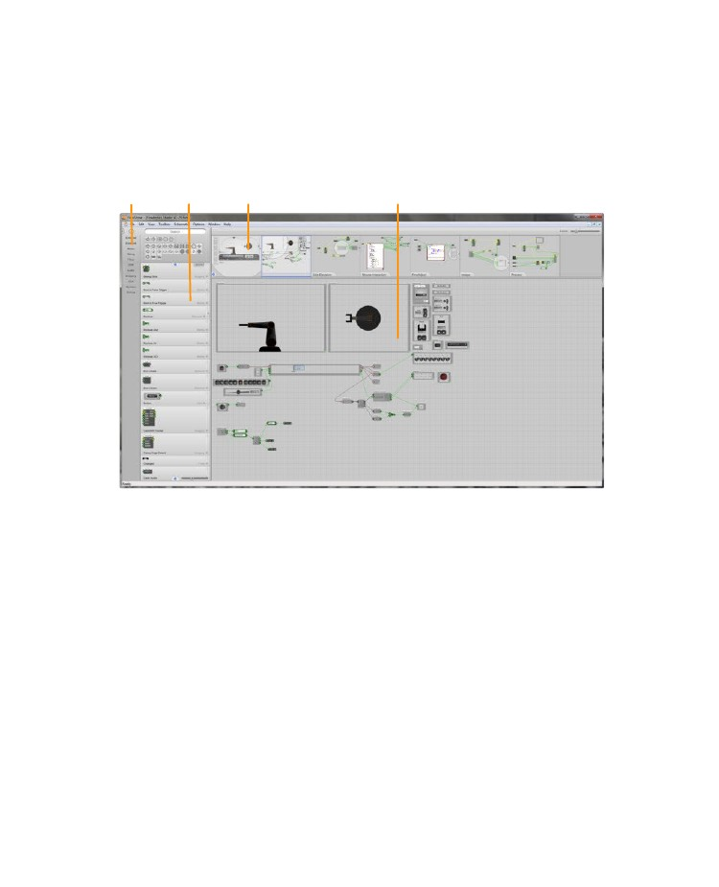
CAPITULO 2
Antes de poder comenzar a utilizar el software, necesita saber un poco acerca de la interfaz de usuario. Vamos a empezar por echar un vistazo a la ventana principal de la aplicación y cómo se presenta.
En la parte superior de la ventana se encuentra la barra de menús. Todas las funciones de las aplicaciones se puede acceder desde aquí y es el primer lugar al que debe mirar si usted es nuevo en el software y desea tener una idea de lo que usted puede hacer con él.

Como el puntero del ratón pasa por encima de los elementos de menú de texto de ayuda aparece en la barra de estado en la parte inferior de la ventana de aplicación..
Tag Bar
Toolbox
Navigator
Schematic Window
Usted no va a quedarse con la barra de menú por mucho tiempo sin embargo.

En FlowStone por lo general hay varias maneras de ejecutar la misma acción por lo que en el tiempo se encontrará con la interacción directa, menús contextuales o teclas de acceso directo en lugar.
Corriendo por el lado izquierdo de la aplicación es la caja de herramientas, que proporciona todos los componentes para la construcción de sus esquemas.

A la izquierda de esta se encuentra la barra de etiquetas. Esto le permite acceder rápidamente a componentes sobre la base de un conjunto de etiquetas configurables.
En la parte superior de la ventana es el Navegador. Como su nombre lo indica, este se usa para navegar a través de su esquema. Usted encontrará este inestimable una vez que sus esquemas comienzan a ser más complejo.
La mayor parte del espacio de trabajo de la aplicación está ocupada por la ventana Esquema. Aquí es donde su se crean esquemas.

- 14 -

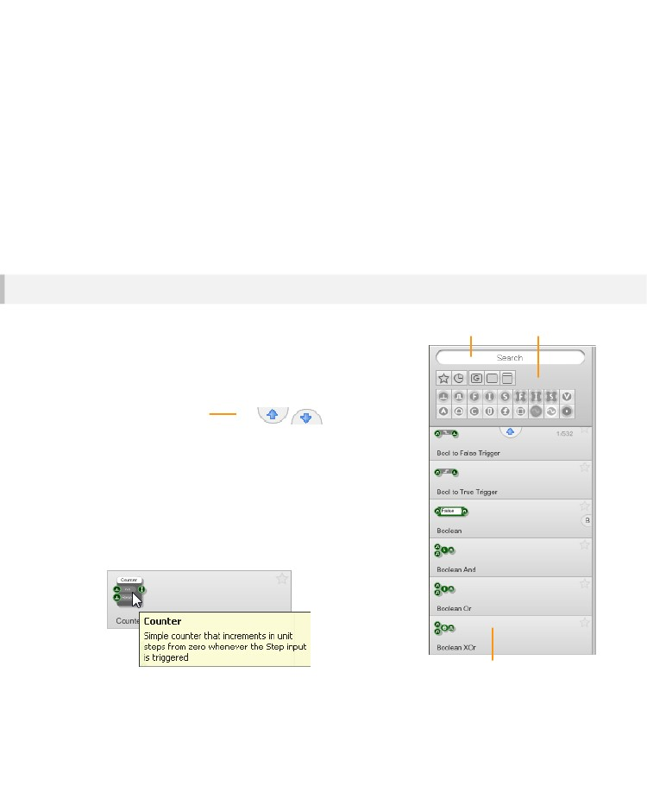
USER INTERFACE
Caja de herramientas
La caja de herramientas proporciona los elementos básicos para un esquema - los componentes. Ya hay más de 450 componentes para elegir y que están creciendo en número todo el tiempo.
Por supuesto, si hay cientos de componentes, entonces usted querrá ser capaz de poner sus manos en el componente que está buscando de forma rápida y con poco esfuerzo.

Afortunadamente existen varios mecanismos en su lugar para que este sea excepcionalmente fácil.

Explorador de componentes
Search Box
Filter Pane
Explorador
La parte principal de la caja de herramientas es el navegador componente. Esto demuestra cada componente y su nombre.
Puede desplazarse a través de los componentes haciendo clic en
la página hacia arriba y hacia abajo.
Page Up/Down Buttons
También puede desplazarse utilizando la rueda del ratón, pulsando el
RePág y AvPág llaves o con el cursor arriba y abajo para
moverse entre los elementos.
Ayuda Instantánea
Usted puede obtener ayuda para un componente, con solo
pasar el mouse sobre ella.
Una ventana pop-up aparecerá dando una breve descripción de
la finalidad del el componente.
Component Browser
- 15 -

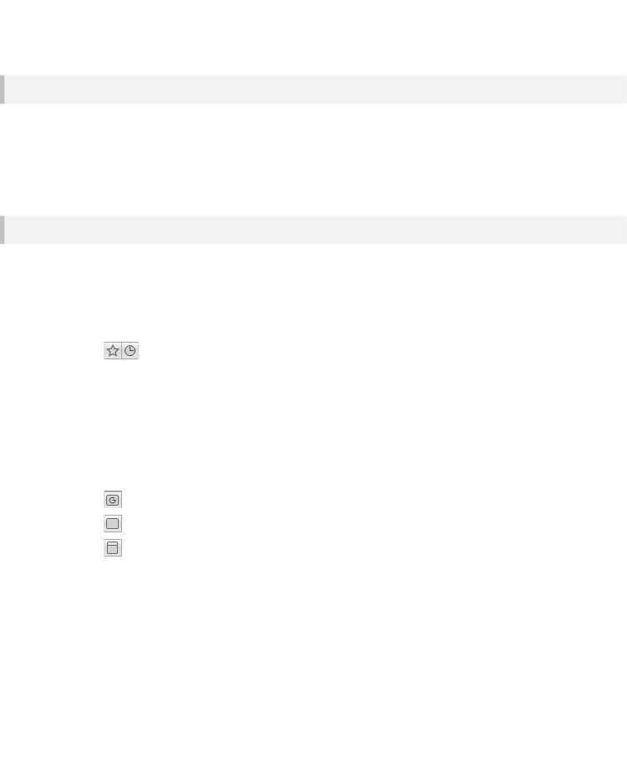
CHAPTER 2
Panel de Filtro
El panel de filtro aparece en la parte superior de la caja de herramientas. Esto le permite encontrar lo que estás buscando por mucho más rápido que navegar por que le da la capacidad de filtrar los componentes que se muestran sobre la base de ciertos criterios.
Hay dos partes en el panel de filtros, el cuadro de búsqueda y los botones de filtro. Hablaremos de esto en las dos secciones siguientes.
Botones de Filtro
Los botones de filtro le permiten localizar el componente buscando con sólo unos clics.
Los Favoritos y los Recientes.
Los dos primeros botones de la fila superior cambian la lista de componentes para que sólo los favoritos o recientes se muestran los componentes usados​​.
El filtro utilizado recientemente muestra los componentes que se utilizó por última vez.
Se ordenan de tal manera que el utilizado más recientemente es en la parte superior de la lista.
El filtro de favoritos muestra sólo los componentes que haya marcado como favorito
(Leer sobre esto más adelante),
Categoría de Filtros
Los próximos 3 botones en la fila superior, filtra la lista por categorías.
Cada componente corresponde a una de 3
Categorías:
- Un módulo con un panel frontal o GUI (más sobre paneles frontales en el capítulo Componentes)
- Un módulo sin necesidad de un panel frontal o GUI
- Un Primitivo
Al hacer clic en uno de ellos sólo verá los componentes que entran en esa categoría.

Es posible ir a la lista o aplicar más filtros de búsqueda si es necesario para el hogar en el componente que está buscando.

Puede mantener Mayús y haga clic para seleccionar dos de ellas a la vez.
Esto le permite mostrar todos los módulos con o sin GUI por ejemplo.
- 16 -

USER INTERFACE
Tipo de Filtros
El segundo grupo de botones de filtro son los tipos de filtro. Usted verá un botón para cada tipo de conector aquí.
Haga clic en uno de estos y la lista de componentes cambiará para mostrar sólo los componentes que tienen un Conector del tipo seleccionado.
Puede aplicar más de un filtro tipo al mismo tiempo. Para ello, mantenga la tecla CTRL o MAYÚS mientras
hacer clic. Esto mostrará los componentes que utilizan al menos uno de cada uno de los tipos seleccionados. Así que si usted selecciona Se le aparecen Int y flotar tipos por ejemplo, sólo los componentes que tienen Int. y flotar conectores.
No todos los tipos se muestran de forma predeterminada. Usted puede cambiar esto seleccionando Editar Tipos de filtro de la Menú Herramientas o haciendo clic en el botón '+' que aparece cuando se pasa el puntero del ratón sobre la filtrar botones de tipo.
Haga clic en los botones de tipo de añadir o eliminarlos continuación, haga clic de distancia o seleccione el menú Edición Tipos de filtros elemento para terminar la edición.
Cuadro de Busqueda
El campo de búsqueda aparece en la parte superior de la caja de herramientas y ofrece una forma rápida de ir directamente a la componente que desee.

Sólo tienes que escribir algún texto en la caja y al escribir los componentes reducirán a mostrar sólo los que coinciden.
La búsqueda se ve en el nombre del componente y el texto de ayuda. Resultados de Búsqueda son priorizados por partido nombre del componente primero y luego por el texto de ayuda.
Usted puede saltar rápidamente a la caja de búsqueda en cualquier momento pulsando CTRL + F
Búsqueda Rápida
Otra forma de localizar rápidamente un componente es utilizar la función de búsqueda rápida. Esto se basa en que usted lo sepa el nombre del componente, o al menos el principio del nombre.
Basta con mover el cursor del ratón por lo que es el componente de herramientas del navegador y luego comience a escribir la el nombre del componente que desee. El componente actualmente seleccionado cambiará a medida que escribe con el fin para que coincida con el nombre con lo que has escrito.

Después de un par de segundos el texto de búsqueda que ha escrito se
borra automáticamente y por lo que si usted comete un error simplemente hacer una pausa por un segundo y empezar a escribir de nuevo.
Esta puede ser una manera muy rápida para localizar los componentes y puede ser utilizado en conjunción con los filtros que haya utilizado.
- 17 -

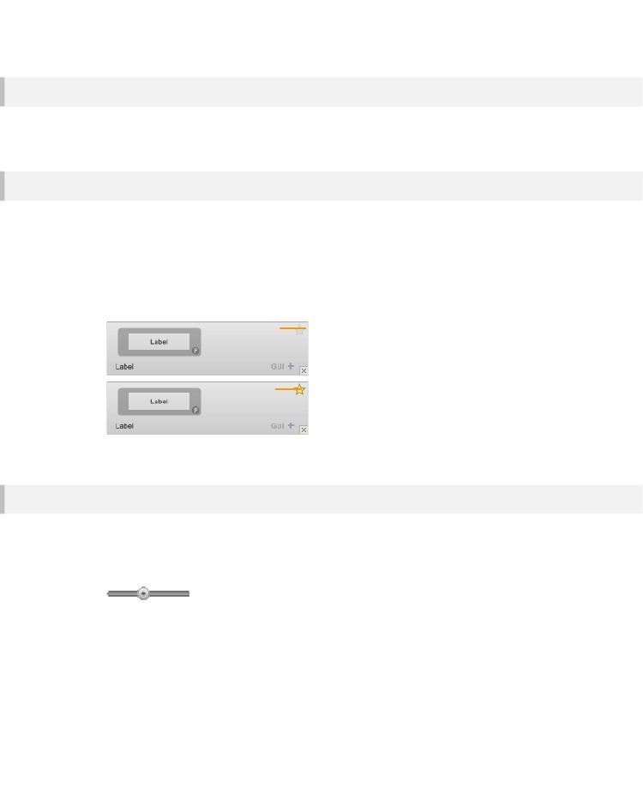
CHAPTER 2
Borrar todos los Filtros
Para borrar todos los filtros (incluida la búsqueda) usted puede hacer clic derecho sobre el panel de filtros o pulse el Tecla ESC en su teclado.
Favoritos
Puede crear una lista de componentes favoritos que utiliza con más frecuencia. Al usar el filtro de los favoritos en el panel de filtros que tiene una forma muy rápida de conseguir en los componentes que necesita con el mínimo de esfuerzo.
Para marcar un elemento como favorito, simplemente haga clic en el icono de la "estrella" en la esquina superior izquierda de la componente tal como aparece en la caja de herramientas. La estrella ahora aparece resaltada.
Para eliminar un componente de la lista de favoritos todo lo que necesita hacer es hacer clic en el icono de la 'estrella' de nuevo.
Click to Add as Favourite
Component is in Favourites
Click to remove
Escala de Visualización
Todos los artículos en la caja de herramientas se muestran a escala. Esto hace que sea mucho más fácil de identificar los componentes de su apariencia.
Puede establecer la escala con el control deslizante en la parte inferior de la caja de herramientas.
También puede cambiar la escala en pasos regulares utilizando el cursor teclas izquierda y derecha en la teclado.
Cambiar la escala a su nivel más bajo sólo mostrará los nombres de los componentes de la caja de herramientas. es útil si usted prefiere la navegación por solo texto.
- 18 -

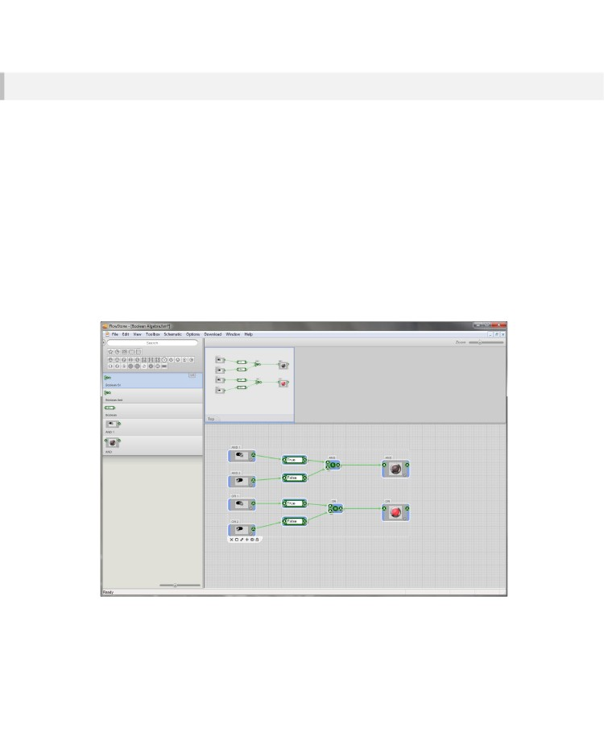
USER INTERFACE
Caja de herramientas Local
A veces, es posible que prefiera trabajar desde un conjunto más limitado de componentes.
Esto es a menudo el caso para educadores que no quieren que sus estudiantes sean abrumados
por la gran cantidad de componentes que se ofrecen.
Usted puede hacer esto mediante la creación de lo que llamamos una caja de herramientas Local.
Una caja de herramientas local es una caja de herramientas reducida que es específica para un esquema.

Se ahorrará con el esquema y que sólo aparecerá cuando ese esquema es el que usted está usando.
cambiar los esquemas de la caja de herramientas,

cambia demasiado.
Creando la Caja local de herramientas
Hay dos maneras de hacer esto. La primera forma es seleccionar los componentes en el esquema que desea tener en su caja de herramientas y luego seleccione “Create Local Toolbox” en el menú Schematic, o presione MAYÚS + CTRL + T.
La caja de herramientas cambiará por lo que sólo contiene los módulos y primitivas que se han seleccionado. El Bar Tag
se oculta automáticamente como componentes en la caja de herramientas Local no tiene etiquetas.
La segunda forma de crear una caja de herramientas locales es seleccionar un módulo y luego seleccione Crear Local Caja de herramientas en el menú Esquema, o presione MAYÚS + CTRL + T. En esta ocasión el cuadro de herramientas locales contener todos los componentes que están dentro del módulo.
- 19 -

CHAPTER 2
Tenga en cuenta que la caja de herramientas local no tiene dependencia de los componentes de los que fue creada. Esto significa que se puede crear una caja de herramientas local.
a continuación, elimine los componentes de la caja que se han hecho.
Así, por ejemplo, un profesor puede crear un esquema que quieren los estudiantes construir, hacer un local de caja de herramientas a partir de ese esquema y luego borrar todo en el esquema.

El estudiante puede tomar el esquema y se les pedirá recrear el original de los bloques de construcción de la caja de herramientas locales.
Removiendo la caja de herramienta local
Para eliminar una caja de herramientas locales, elija “Remove LocalToolbox” en el menú Esquema, o presione MAYÚS + CTRL + T de nuevo.

Restaurar la caja Local de Herramientas
Puede restaurar la última caja de herramientas local seleccionando Restaurar Herramientas local en el menú Esquema o presionando SHIFT + CTRL + T.

Una vez más, le permite cambiar fácilmente entre lo local y la plena tamaño de la caja de herramienta local.

Tamaño de la caja de herramienta
Restoring a Local Toolbox
You can restore the last local toolbox by selecting Restore Local Toolbox from the Schematic menu or
by pressing SHIFT + CTRL + T once again. This allows you to easily switch between local and full
sized toolboxes.
Saving and Loading a Local Toolbox
A local toolbox is automatically saved with its schematic. So when you open a schematic again, any
local toolbox is restored.
As we said earlier, you can delete everything in the schematic and still save it with the local toolbox.
- 20 -

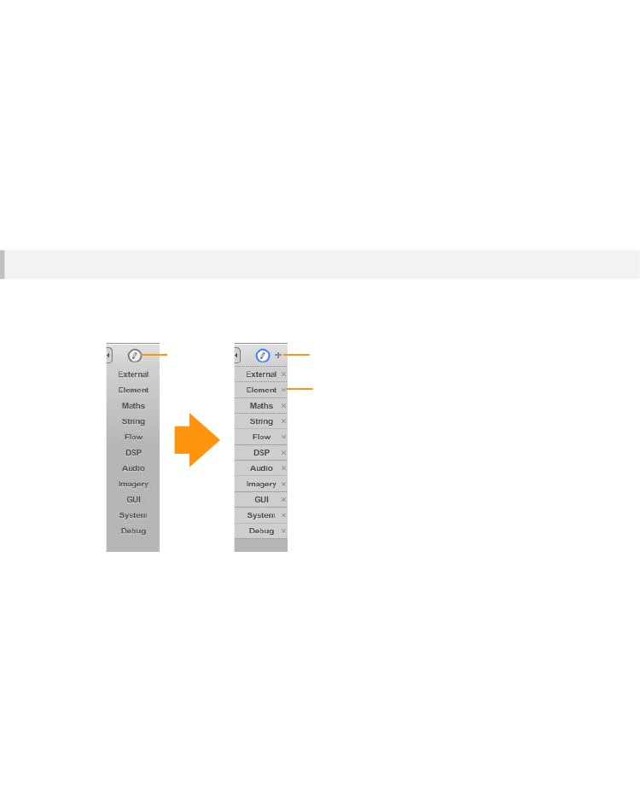
USER INTERFACE
Tag Bar
La caja de herramientas incorpora un sistema de etiquetas que permite organizar los componentes sobre la base de algunas características compartidas. Se agregan y se muestran Etiquetas en la barra de etiquetas.

A continuación, puede aplicar etiquetas a componentes individuales y el uso de la barra de la etiqueta para filtrar al instante la caja de herramientas basado en una etiqueta en particular o
conjunto de etiquetas.

Editando Etiquetas
Hay algunas etiquetas ya previstos pero se puede cambiar por completo estos si así lo desea.

Para hacer cualquier tipo de cambio que primero deberá desbloquear la barra de etiquetas para su edición. Para ello haga clic en el botón Editar, este pondrá el Bar Tag al modo de edición.
Edit tags
Adds a tag
Delete the tag
Adición de Etiquetas
Para agregar una etiqueta, haga clic en el botón + y uno nuevo se añadirá al final de la lista. Escriba el nombre y la pulse Intro en el teclado para terminar.
Moviendo Etiquetas
Puede mover las etiquetas alrededor cuando usted está en el modo de edición. Basta con hacer clic, mantenga y arrastre hacia arriba o hacia abajo para cambiar el orden.
- 21 -

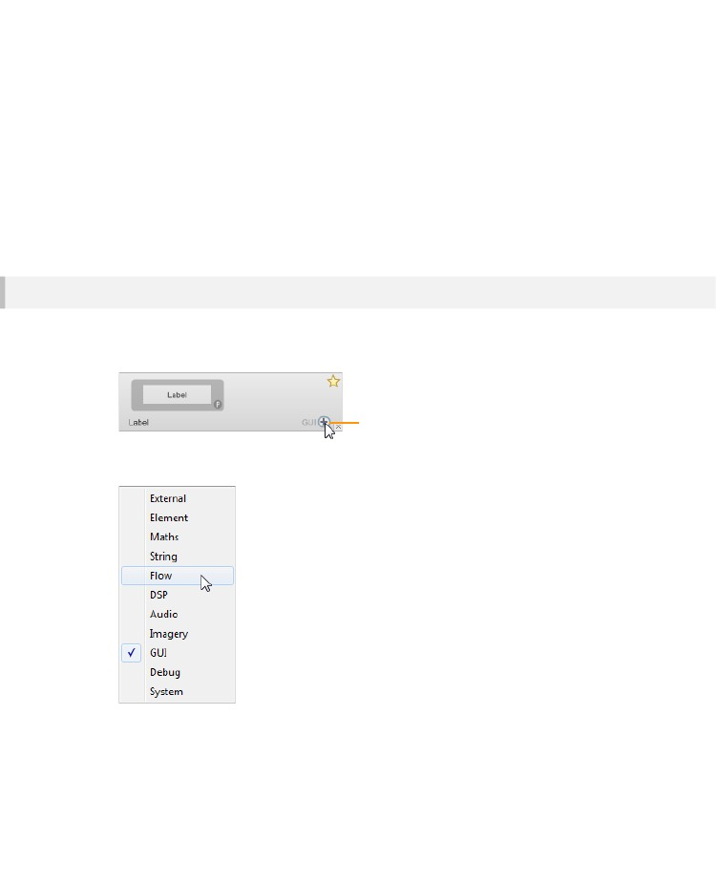
CHAPTER 2
Edición y Supresión de Etiquetas
Para editar una etiqueta, simplemente haga doble clic en él. Escriba sus cambios y luego haga clic en eliminar o presione retorno a fin.
Las etiquetas se pueden eliminar haciendo clic en el botón x en el lado derecho de la etiqueta.
Crear un Separador
Si usted tiene una gran cantidad de etiquetas que usted puede querer separarlos en los bancos. Para hacer esto usted puede crear un separador para romper cada conjunto. Agregando un separador es fácil. Sólo tiene que añadir una etiqueta de forma normal, pero para el texto utilizar tres caracteres de signo resta decir '---'. El separador abarcará toda la anchura de la barra cuando se sale del modo de Edición

Etiquetando Componentes
Una vez que tenga algunas etiquetas, a continuación, puede añadir a los componentes de la caja de herramientas. Para cambiar las etiquetas para un componente, haga clic en el botón de etiqueta para ese componente. Esta se encuentra en la esquina inferior derecha de cada componente en la caja de herramientas.
Tag Button
Un menú emergente aparecerá con todas las etiquetas en la barra de etiquetas. Haga clic en una etiqueta para añadirla sin control o un comprobado etiqueta para eliminarla.
Los componentes pueden tener más de una etiqueta. Esto significa que usted no tiene que marcar componentes sobre la base de una característica particular. Por ejemplo, el componente Abs red de flotadores podría tener un Variable de matriz y una etiqueta de Matemáticas. Las etiquetas para cada componente se muestran a la izquierda del botón de la etiqueta.
- 22 -

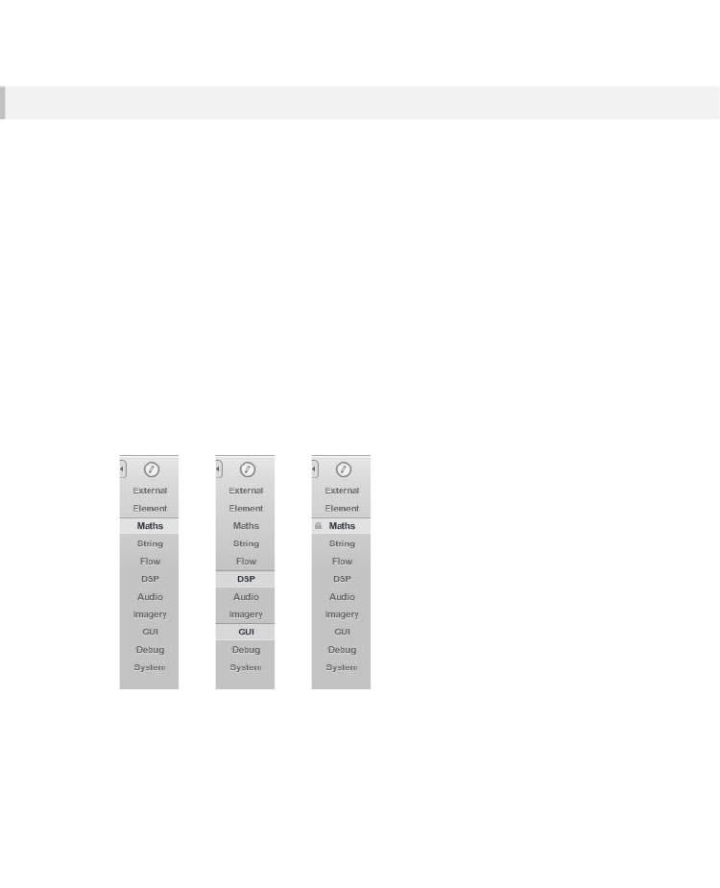
USER INTERFACE
Using Tags
Now that you have your tag bar set up and your tags applied to components you can use the tag bar to
filter the toolbox and help you locate components more quickly.
Filtering by a Tag
To filter by a single tag, just click on it. The tag will show as selected and the toolbox will filter
accordingly. Tags are applied in combination with any filters set on the Filter Pane.
If you click on a different tag the previous one will automatically be deselected. To filter by more than
one tag, hold SHIFT as you click.
Locking Tags
It may be that you only want to work with a particular set of components. In this case you can lock a
tag in place by double-clicking on it. The tag will remain selected until you click on it again.
Clearing Tags
You can clear tags by clicking on them or you can clear all tags in one go by right-clicking anywhere on
the tag bar.
Single Tag
Multiple Tags
Locked Tag
- 23 -

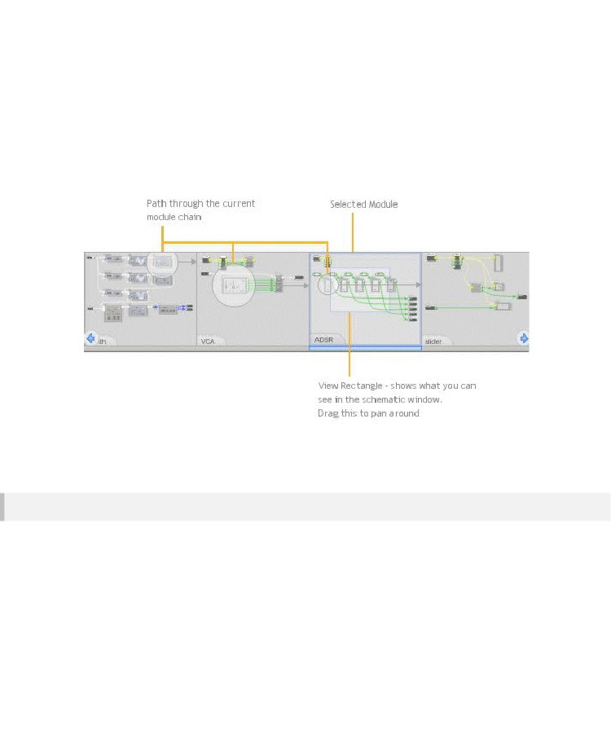
CHAPTER 2
Navigator
El Navegador le permite ver DÓNDE SE ENCUENTRA en do Esquema. Esto Es muy Useful CUANDO SE Tener Varias Capas de módulos PORQUE la ventana Esquema SÓLO Muestra el módulo de Que Usted está Edición.
Saltando
El navegador no es sólo visual, es interactivo también. Puede saltar a cualquier módulo en la cadena actual al hacer clic en él. También puede utilizar las teclas numéricas para hacer esto (siempre y cuando no esté usando el PC teclado para la entrada MIDI). Número 1 siempre te llevará al nivel superior. The PGUP and PGDN keys
se moverá arriba y abajo de la jerarquía actual.
- 24 -

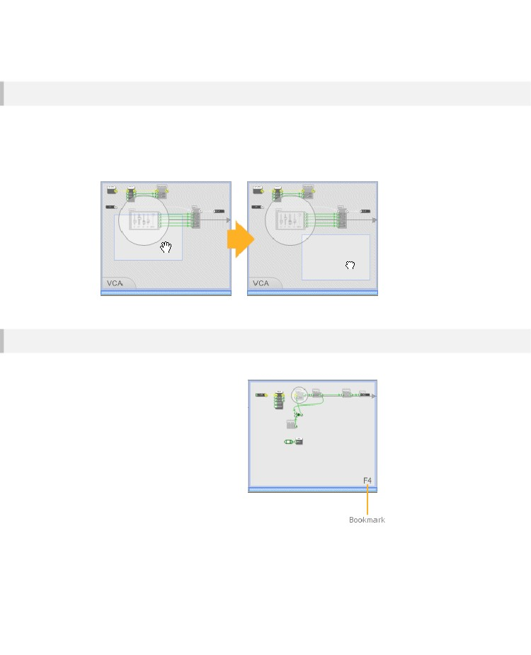
USER INTERFACE
Panning
Se resalta el módulo actual de la cadena. En el interior se ve un rectángulo que representa la parte de el módulo que se puede ver en la ventana de esquema. Este es el llamado Vista Rectángulo. Usted puede haga clic y arrastre para desplazarse por este esquema.
Marcadores
Puede marcar determinadas partes de su
esquemática para que pueda volver fácilmente a ellos. Para ello basta con ir a la parte de el esquema que desea marcar,
Mantenga pulsado SHIFT y pulse una de las funciones teclas (F1 ... F15). El navegador mostrará la tecla de función asociada.
Para volver al marcador en un momento posterior sólo tiene que pulsar la tecla de función. También puede entonces hojear de nuevo al punto de que hayas venido
desde presionando la función de una tecla todo el tiempo.
Para eliminar un marcador todo lo que tiene que hacer es saltar a ella a continuación, mantenga SHIFT y pulse la misma tecla de nuevo.
- 25 -

CHAPTER 2
Ventana Esquemática
La ventana de esquema es donde todo se junta. Los componentes pueden ser arrastrados hasta aquí desde la caja de herramientas. Puede conectar los componentes arrastrando vínculos entre ellos.
La ventana de esquema tiene todas las características que usted esperaría en un editor: deshacer, copiar y pegar, selección múltiple, el zoom, y ayuda sensible al contexto están completamente soportadas.
Acercamiento
La ventana Esquema es totalmente ampliable. Hay varias maneras en que puede acercarse el esquema ventana:
Mouse Wheel
La forma más fácil para hacer un zoom es utilizar la rueda del ratón. Mantenga presionada la tecla CTRL y luego mover el ratón, con interés acercar y hacia usted para reducir.
Cuando el zoom de la rueda del ratón, el programa se ampliará hacia o desde el punto en el que posicionar el puntero del ratón. Esto le permite hacer zoom y paneo en un solo movimiento.
Si el ratón lo admite, también puede devolver el esquema para el nivel de zoom por defecto pulsando el botón de la rueda del ratón. La posición de panorama esquemático también se devuelve a él es por defecto.
Zoom Slider
El control deslizante de zoom se encuentra en el lado derecho de la barra de herramientas. Al mover el control deslizante hacia la izquierda hará zoom y hacia la derecha agrandar
Zoom Slider
La posición del zoom por defecto se muestra como un pequeño punto por encima de la barra deslizante. El deslizador se ajustará a esta posición que usted pasa para hacer más fácil para volver a la configuración predeterminada. El nivel de zoom por defecto también puede ser
logrado haciendo doble clic en el control deslizante.
Context Menu
Right-click on an empty part of the schematic and select Zoom In or Zoom Out
- 26 -

USER INTERFACE
Keyboard
Simply press the + (zoom in) or - (zoom out) keys.
Scrolling
Puede utilizar la rueda del ratón para desplazarse por la ventana esquemática arriba o hacia abajo. Mantenga pulsado SHIFT y mueva el rueda del ratón para desplazarse horizontalmente.
Panning
Además de utilizar el Navegador, puede desplazarse rápidamente por la ventana esquemática por el acaparamiento de la fondo y moverlo con el ratón. Para hacer esto:
1.
2.
Haga clic izquierdo en una parte vacía de la esquemática y mantenga presionado el botón del ratón.
Ahora haga clic y mantenga pulsado ese botón abajo también. El cursor cambiará para mostrar una mano agarrar el esquema.
3.
Ahora mueva el ratón y el esquema se moverá con ella. Suelte ambos botones del ratón para terminar arrastrando.
También puede desplazarse por la celebración de la barra espaciadora hacia abajo.
El cursor cambiará a la mano. Mantener el espacio bar y arrastre el esquema alrededor.Resetting Zoom and Pan
Si alguna vez necesita restablecer el zoom y desplazarse de vuelta a sus posiciones por defecto que usted puede hacer esto mediante la selección Restablecer en el menú Ver o presionando el botón HOME.
- 27 -

CHAPTER 3
3 Componentes &
Links
LOS
ELEMENTOS BASICOS DE UN ESQUEMA
- 28 -

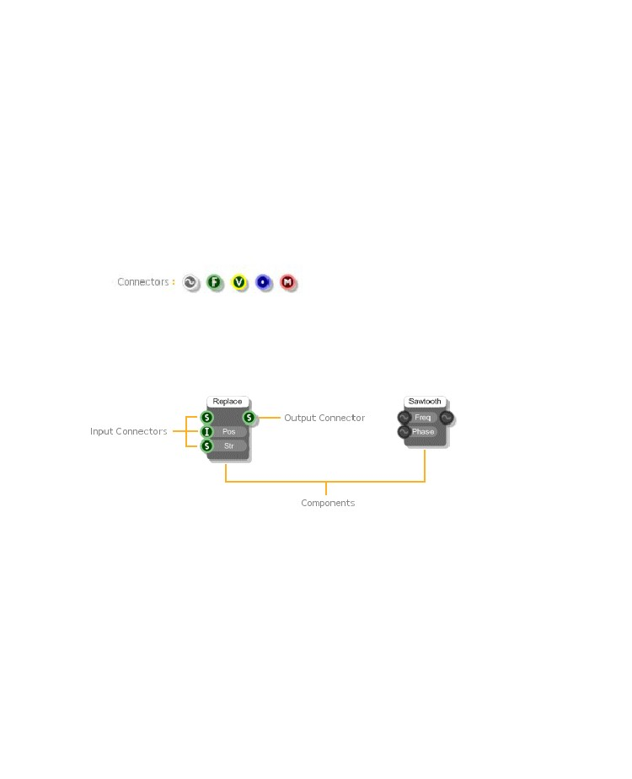
COMPONENTS & LINKS
Los componentes y enlaces son los ladrillos y el mortero de un esquema FlowStone.
Entender cómo editar y manipular estos elementos básicos es esencial para trabajar con el software ya que la mayoría de la interacción que usted tiene con FlowStone será a través del esquema.
Hemos introducido el concepto de componentes y enlaces a la derecha en el inicio de esta guía. Vamos a repasar esta de nuevo, pero ahora en un poco más de detalle este momento.
Componentes
Los componentes proporcionan la funcionalidad en un esquema. Cada uno realiza una tarea bien definida. ellos están representados por bloques rectangulares con adornos circulares llamados conectores que pueden aparecer en los lados izquierdo o del lado derecho (o ambos).
The connectors on the left-hand side are called Input Connectors. These provide the component with
information that it uses when performing it’s defined task.
The connectors on the right-hand side are called Output Connectors. These provide information about
the outcome of the of the task performed by the component.
In the example above the String Replace component takes 3 inputs: the original text string, the position
at which the replacement is to be made and the text string to be inserted. The output is the modified
string.
- 29 -

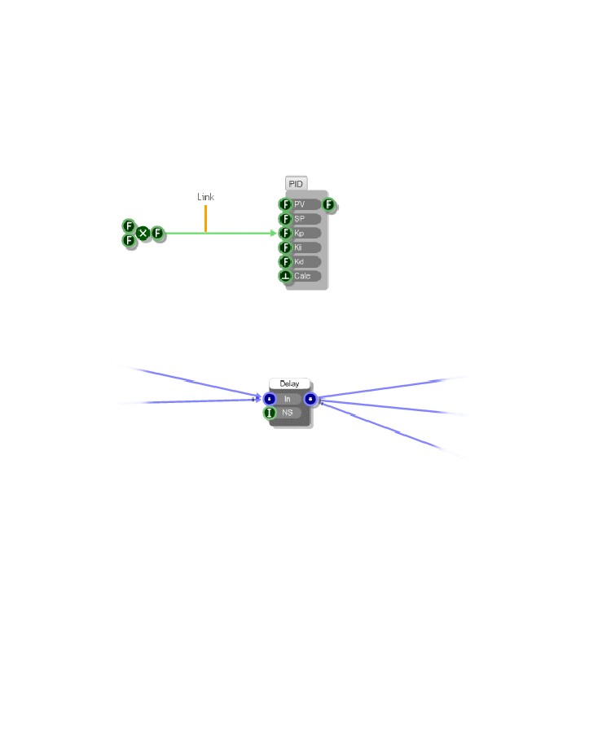
CHAPTER 3
Links
Links define how information flows between components in a schematic. A link passes from the output
connector of one component to the input connector of another component. The direction of information
flow is generally left to right or from output to input but in some cases information can pass from input
to output as well.
You can have multiple links from the same output connector. You can also have multiple links passing
to the same input connector. However, you can only have one link going from the same output
connector to the same input connector.
When multiple links arrive at the same input connector then, for some connector types, the data from
each link is added together. In other cases the data is just merged.
- 30 -

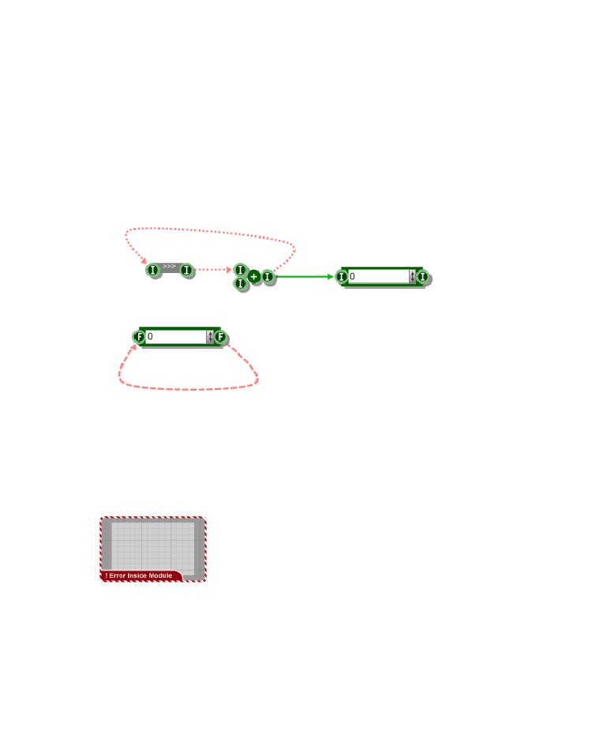
COMPONENTS & LINKS
Infinite Feedback
Los enlaces pueden ser conectados desde un componente en sí mismo para crear caminos de realimentación. Sin embargo, en algunos circunstancias esto puede crear un bucle de retroalimentación infinita.

Si esto sucede, el software 'congela' la enlace afectada (s). Un enlace congelada se muestra como una línea discontinua de color rojo o línea de puntos.
Enlaces congelados siguen funcionando pero los datos fluyen a través de ellos se reduce (pero no exclusivamente en total) para evitar que el software de bloqueo hacia arriba.
[Nota que los vínculos entre la corriente, poli o conectores mono nunca se congelan como retroalimentación es siempre permitido en estos casos.]
Una línea discontinua indica que el bucle infinito es en la dirección hacia adelante es decir, de izquierda a derecha como cambios son desencadenado.

Una línea de puntos indica que la dirección está al revés, es decir, de derecha a izquierda como los datos se están
reunidos.
Enlaces congeladas son relativamente raros. Sin embargo, cuando llegan a ocurrir, se pueden localizar fácilmente porque cada módulo que contiene un enlace congelado en algún lugar debajo de ella se resalta con un rayado rojo y blanco frontera y un adorno diciendo que hay un error en el interior.
Si usted sigue los módulos de color rojo en la jerarquía que finalmente va a llegar al enlace congelado (s).

- 31 -

CHAPTER 3
Manejo Links congelados
Así que, ¿cómo lidiar con enlaces congelada una vez que los has encontrado?
Usted puede ser capaz de obtener el comportamiento que estabas deseando lograr mediante la inserción de un bloqueador del disparador o utilizando un componente de muestreo y retención que desencadena de otro lugar.
Podría ser que la retroalimentación puede ser necesario sólo en una dirección a la vez así que podría usar select componentes para asegurarse de que los datos sólo se envía en una dirección o la otra.
Algunos componentes han construido en el manejo para evitar la retroalimentación infinita que se produzcan. The Switch componentes, por ejemplo, (interruptor del float, String Interruptor etc) tienen este tipo de comportamiento. Inserción de una en
entre enlaces congelada a menudo puede resolver el problema.
A veces un enlace congelado puede ser simplemente eliminado y se mantiene la misma funcionalidad. El enlace puede han agregado como una exageración o por error.
- 32 -

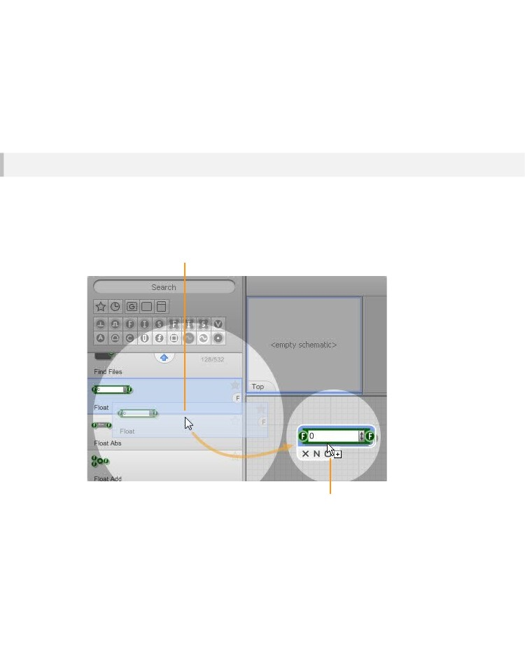
COMPONENTS & LINKS
Components
Adding a Component
Dragging From the Toolbox
Para añadir un componente a un esquema, sólo tiene que ir a la caja de herramientas, escoja el componente que desee y arrástrelo
en su esquema.
Haga clic en el componente que desee a continuación,
mantenga y arrastrar a la ventana esquemática
Suelte el botón del ratón para soltar el
componente en el esquema
- 33 -

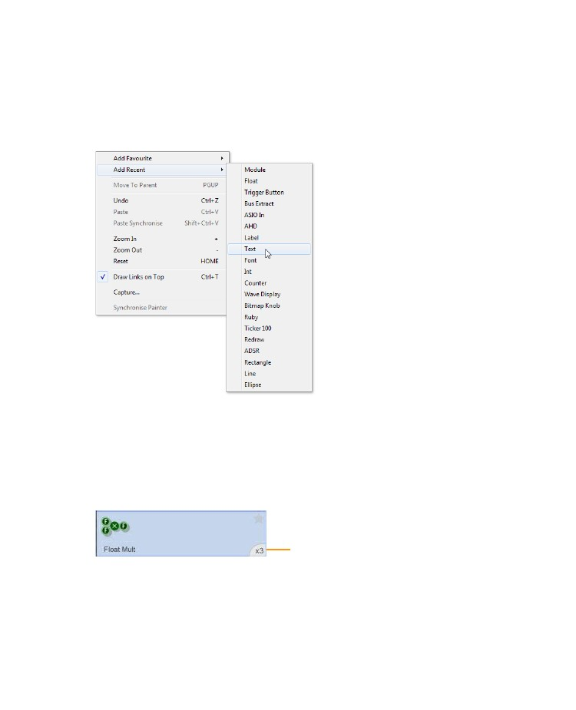
CHAPTER 3
Adding from the 'right-click' Menu
You can also add components from the Favourites or Recent lists by right-clicking on the schematic -
saving you from having to visit the toolbox altogether.
Right-click on an empty part of the schematic then choose Add Favourite or Add Recent depending on
which list you want to use, then just choose a component from the resulting popup sub menu.
Stacking Components
Sometimes you may want to add more than one component at a time. You can do this by stacking up
components before dragging them all to the schematic.
To increase the number in the stack just click on the component the same number of times as the
number you require. You’ll see a counter appear in the bottom-left corner of the component in the
toolbox.
Stack indicator
To decrease the number in the stack right-click on the component. When you have the number you
need just drag them across as before.
- 34 -

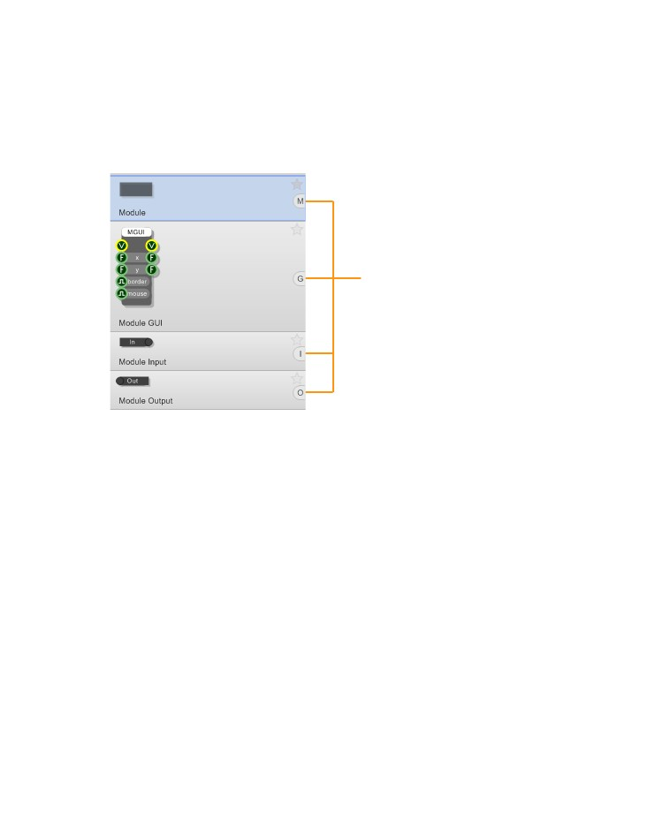
COMPONENTS & LINKS
Keyboard Shortcuts
As you become familiar with the software you’ll find that there is a certain small group of components
that are used much more frequently than others. In order to save you time constantly going back and
forth to the toolbox you can make use of keyboard shortcuts.
Where a component has a shortcut key assigned this is displayed on the component in the toolbox.
Shortcut Key Indicators
- 35 -

CHAPTER 3
Disabled Components
On some occasions it is not possible for you to add a particular component to your schematic. This is
because some components are only allowed once within a particular module or the whole schematic.
This can also occur if you're running the Free or Enterprise editions and you reach one of the limits for
components of a particular type.
If this happens the component will have a red 'no entry' symbol over the top of it.
Symbol indicates that the
component cannot be added at
the current location in the
schematic
Hitting Return
One final way to add components from the toolbox is to use the return Key on the keyboard. This is
handy if you’ve just done a search say. Hitting return when in the toolbox (or the search box) will
always add the currently selected component to the schematic.
- 36 -

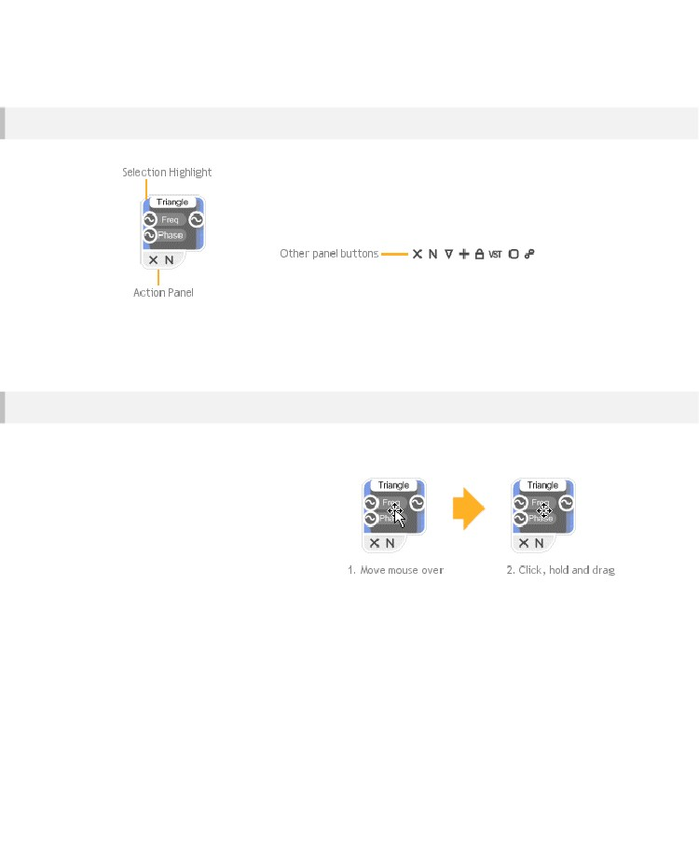
COMPONENTS & LINKS
Selections and the Action Panel
To select a component simply click on it. When you do this you'll see the
action panel. This contains a number of buttons. the 'X' button will delete
the component. The 'N' button will allow you to name the component.
Other buttons may appear depending on the type of component
selected - more on these later.
The commands in the action panel can also be invoked from the menu
bar and the context menu. To get the context menu, right-click on the
component.
Note that as well as the selected component(s), any links that start and end in a component that’s
selected will also be considered part of the selection
Moving Components
To move a component:
1.
Move your mouse over it. The cursor
will change to Move/Select.
Click and hold the mouse button. the
cursor will change to Move.
3.
Drag to the desired position and release
the mouse button.
2.
For fine movements you can use the nudge feature. With a component selected use the cursor keys to
move it up, down, left or right by one grid square.
- 37 -

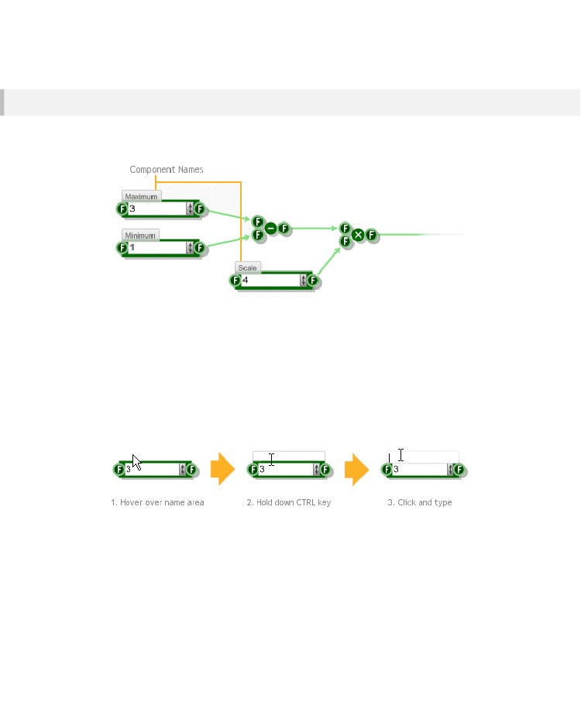
CHAPTER 3
Naming Components
You can give a component a name. This is just a label that can be used to remind you the role of a
component in your schematic.
To give a component a name, click the 'N' button on the action panel or right-click on the component
and select Rename. Alternatively you can select the component and press CTRL+R.
An edit box will appear above the component. Type the name here then press ENTER, TAB or just
click on another part of your schematic. You can press ESC at any time to cancel.
Direct Interaction
For a more interactive way to add names, hover the mouse over the area just above the component
and hold CTRL. The frame of the name box will be highlighted. Click in the box and proceed as before.
Editing Names
To edit a name you can use the action panel and right-click options as before or you can just click on it
as shown below.
- 38 -

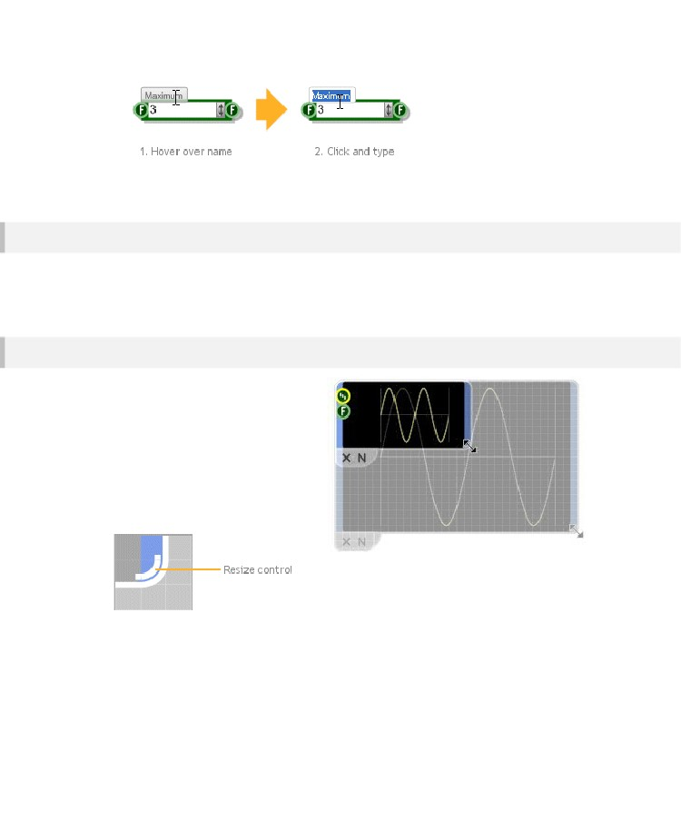
COMPONENTS & LINKS
Deleting Components
Deleting a component is extremely easy. The quickest way to do this is to select it then press the DEL
key. You can also press the 'X' button on the action panel or right-click on the component and select
Delete.
Resizing
Some components can be resized to
make them bigger or smaller. Some
components only resize horizontally,
others resize vertically as well.
If a component can be resized, the resize
control will appear in the bottom-right
corner of the selection highlight. The
control is a white arc that traces the
corner of the selection.
To
resize,
move
your mouse over the resize control. The mouse pointer will
change to the resize cursor. Click and hold then drag top
resize.
- 39 -

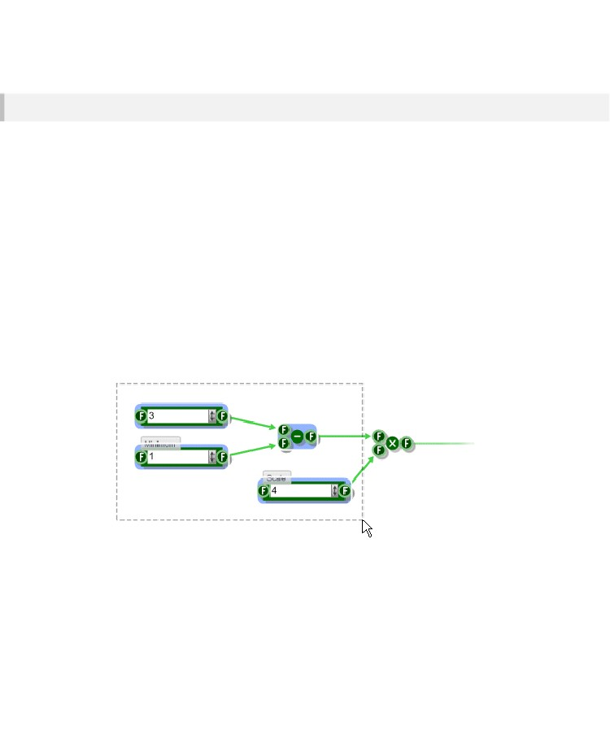
CHAPTER 3
Multiple Selections
You can select multiple components at the same time. This is useful if you want to move a group of
components but maintain their relative spacing or if you want to delete a whole load of things in one
go.
There are two ways to create a multiple selection. The first way is to hold down SHIFT and then click
on each of the components in turn. If a component is already selected, clicking on it will remove it from
the selection.
A quicker way to make a multiple selection is to drag select. This involves dragging out a rectangle to
enclose all the components that you want to select.
To drag select:
1.
2.
Click on a blank part of the schematic to the top-left of the components you want to select.
Holding the mouse down, move the mouse down and to the right. You'll see a dotted rectangle
appear as you move.
The components will show as selected as you move the mouse so when the selection is what you
want release the button.
3.
- 40 -

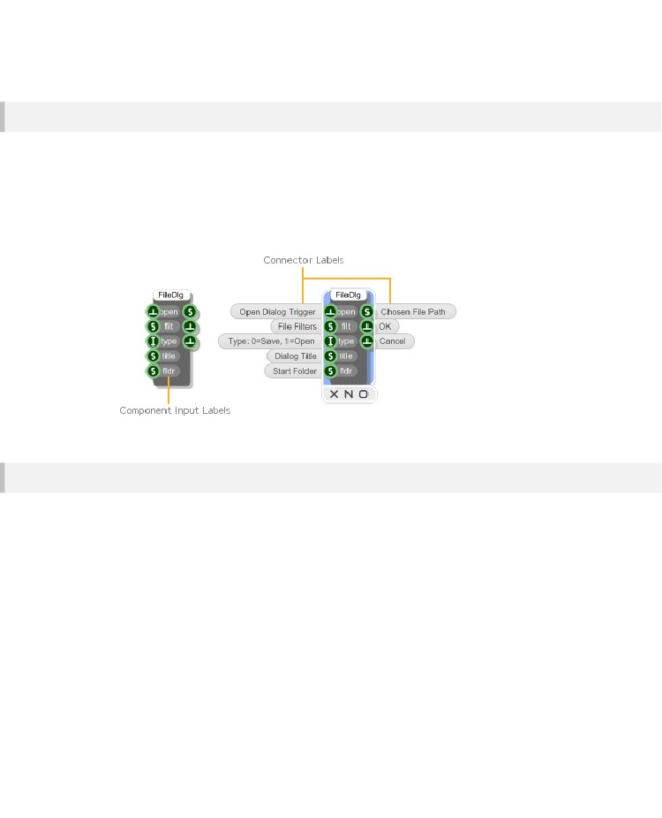
COMPONENTS & LINKS
Connector Labels
Most components have a short label for each of their input connectors. There isn’t enough room on the
component body for both inputs and output labels. The outputs are usually less ambiguous and fewer
in number and so input labels are usually preferred.
Component labels are usually very short and provide a quick reminder of what each connector is for. If
you need more information you can select the component (by clicking on it). Where available,
additional connector labels will appear to the left and right of the component.
Cut, Copy and Paste
FlowStone supports the standard Cut, Copy and Paste operations for moving or duplicating parts of a
schematic. Both single and multiple selections can be cut, copied and pasted.
You can access these operations from the Edit menu or by right-clicking on a selection in the case of
Cut or Copy or anywhere on your schematic in the case of Paste.
Copying a selection will place a duplicate of the components and links on the Clipboard. The clipboard
is an invisible buffer that retains what was last copied to it. Cutting is like a combined copy and delete
as the original selection is removed from the schematic.
Having Cut or Copied a selection you can then go to any other part of your schematic or to any other
schematic you have open and paste in a copy of the clipboard contents. Copies are pasted at the
current mouse location. You can hold ALT while pasting to have pasted elements stack up at the
location of the source elements.
- 41 -

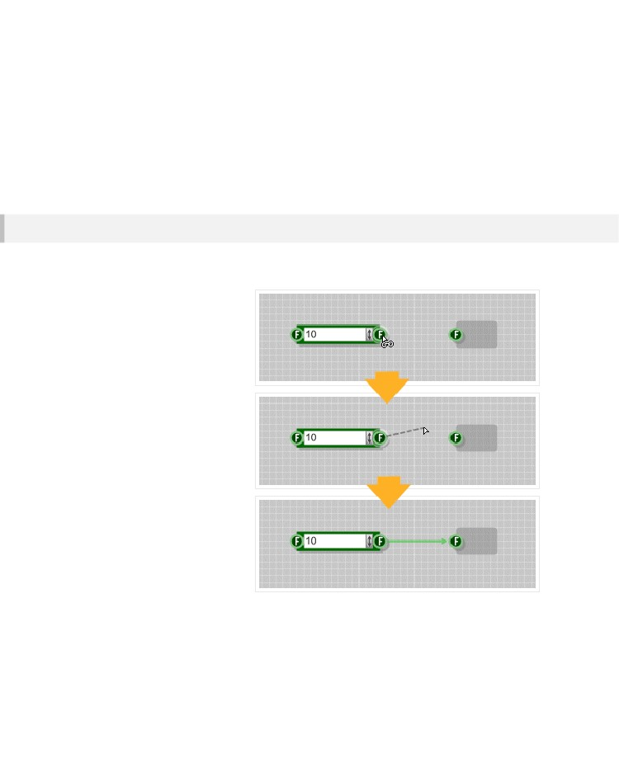
CHAPTER 3
Links
In this section you'll learn how to move a link to another connector or delete it completely. You'll also
see how to change link order and how to bend a link.
Creating a Link
Links must start at an input connector and end at an output connector. You can link another component
or to itself, to create a feedback path say.
To create a link:
1.
Move your mouse over an
output connector. The
connector highlight will
show as you pass over it.
Click and hold, then drag
towards the input
connector. You'll see a
dotted line representing the
potential link.
Keep dragging until your
mouse passes over the
input connector. The
potential link will snap to
the connector to indicate
that the link can be formed.
4.
Release the mouse button
to create the link.
2.
3.
- 42 -

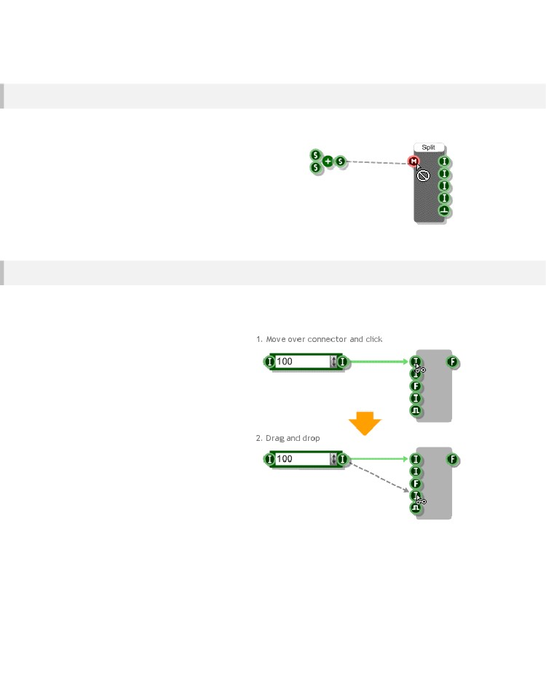
COMPONENTS & LINKS
Allowed Links
A veces no es posible establecer un vínculo entre un par de conectores.
Cuando esto sucede, la cursor del ratón cambiará para mostrar esta.
En general, los enlaces sólo pueden hacerse entre los conectores del mismo tipo. Sin embargo, hay varias excepciones a esta. Por ejemplo, los flotadores y Ints se pueden conectar lo que puede Flotadores y Stream conectores.
Una descripción completa de todas estas excepciones se puede encontrar en el capítulo 5 en la conversión entre tipos de datos en la página 98.
Moving a Link
You can move the end of a link from the input connector to another input connector on the same
component. You can also move it to an input connector on a completely different component.
To move a link:
1.
Move the mouse pointer over the input
connector where the link ends. The
cursor will change to the linking pointer.
Click and hold. You'll see a dotted outline confirming that you've picked up the
link that you wanted.
3.
Drag the link to another input connector and release the mouse
button.
2.
- 43 -

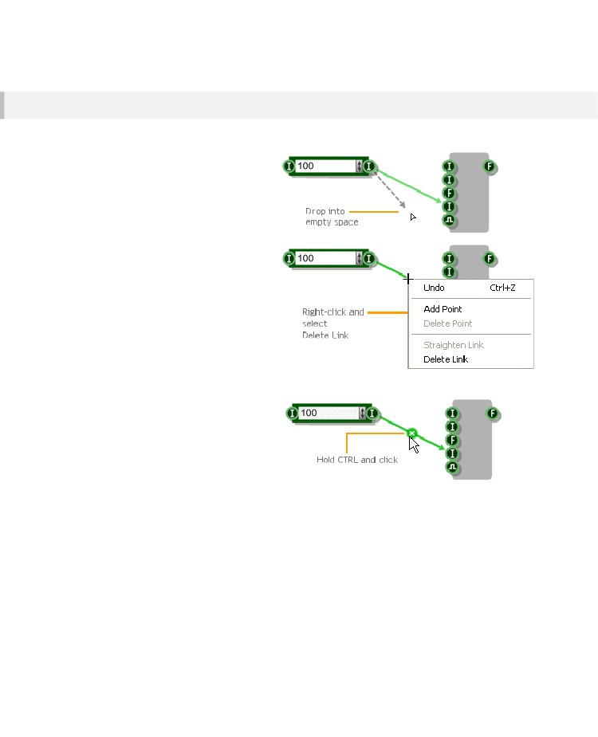
CHAPTER 3
Deleting a Link
There are several ways to delete a link. You
can pick it up and drop it into empty space.
Just move it from the input connector (as
described above) but don't link it to another connector.
You can also right-click on the link and
select Delete Link from the context menu.
For really quick deleting, hold down CTRL.
When your mouse passes over a link, the
delete button will appear. Click the button and the link is
gone.
- 44 -

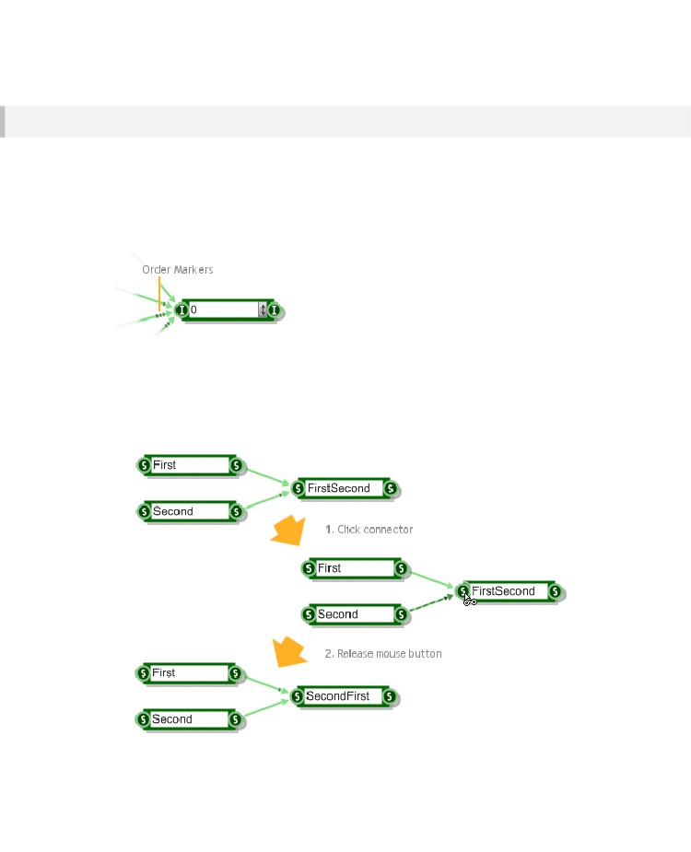
COMPONENTS & LINKS
Link Order
Cuando hay muchos enlaces que terminan en el mismo conector de entrada, el orden de los enlaces puede afectar el comportamiento de su esquema. Por ejemplo, si tiene dos enlaces que están pasando datos de cadena a una cadena conector, la primera cadena en llegar tendrá el segundo anexo al mismo.
El orden de un enlace se indica mediante un marcador de fin. Esta es una serie de muescas perpendicular al enlace en su punto final. El primer eslabón de la orden tiene ningún marcador, el segundo tiene un marcador con una muesca, la tercero tiene dos muescas, etc..
Changing the Order
Es útil ser capaz de cambiar el orden de los vínculos en un conector de entrada. Para ello, simplemente haga clic en el conector y el enlace de la parte superior actual (el último en el orden) se convertirá en el enlace de abajo
(la primera en el orden).
- 45 -

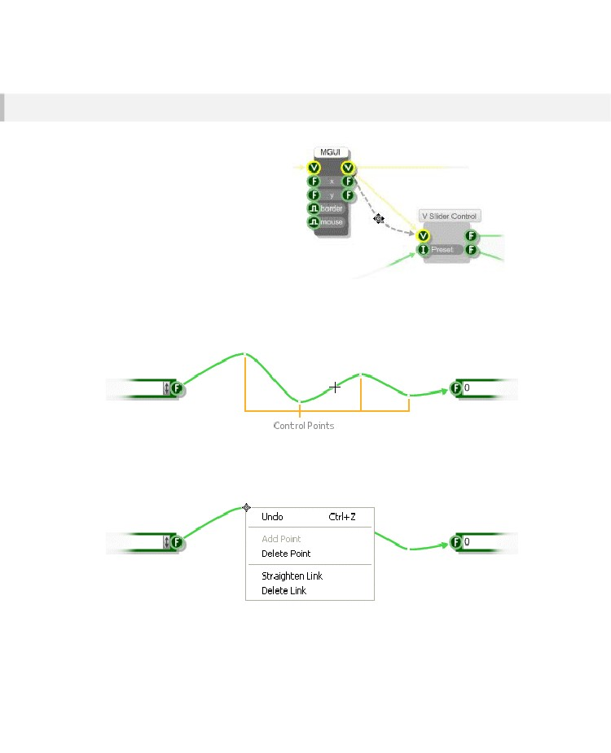
CHAPTER 3
Bending Links
In a complex schematic with many
components, sometimes a straight line just
won't do. Often you'll struggle to avoid
creating links that run over components or
each other.
To get round this problem, you can bend any
link to make your schematic clearer and
easier to read. All you have to do is click on
the link and pull it into place.
Cada curva que usted pone en un enlace crea un punto de control. Los puntos de control definen la trayectoria del enlace. Si mover el puntero del ratón sobre un enlace que quede resaltado y los puntos de control se muestran como pequeños cuadrados. Los puntos de control serán o negro o blanco, dependiendo del color del enlace.
Puede arrastrar los puntos de control en torno a la re-forma al enlace. También puede eliminar un punto de control por haga clic en un punto y seleccionando Eliminar Point en el menú contextual.
Para eliminar todos los puntos de control y hacer que el enlace de una línea recta de nuevo, seleccione Straighten Link del menú contextual.
- 46 -

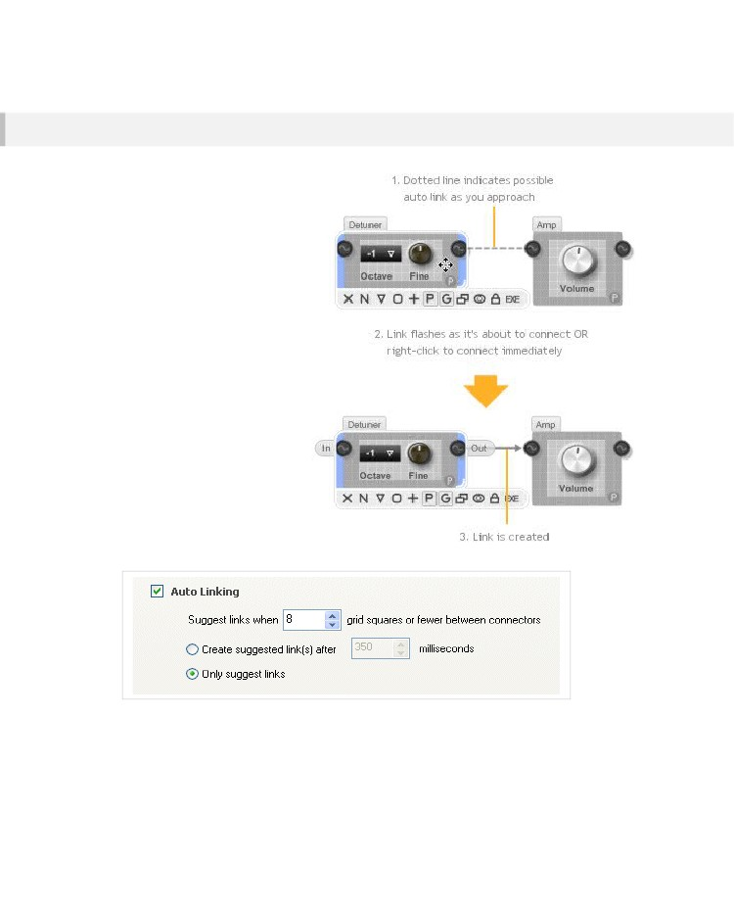
COMPONENTS & LINKS
Auto Linking
To help you build your schematic
more quickly we have the
Automatic Linking feature. When
this feature is switched on you can
create a link between two
connectors by moving a
component so that the required
output connector is on the same
horizontal and sufficiently close to
the required input connector.
When these conditions are
satisfied a dotted line will appear.
This suggests where the link would
be created. If you then pause for a
fraction of a second the link will
flash and become permanent.
If you don’t want to have to wait for
the link to be created you can
instantly accept the suggested link
by clicking the right mouse button.
Hay varias opciones para el Auto Vinculación.
Estos se pueden ajustar mediante la selección esquemática desde el menú Opciones.
You can change the time between suggestion and link creation you can also set how close connectors
have to be before a link is suggested. If you only want to use the right-click method to make a link then
you can set the auto linking to only suggest links and of course you can turn the feature off altogether.
- 47 -

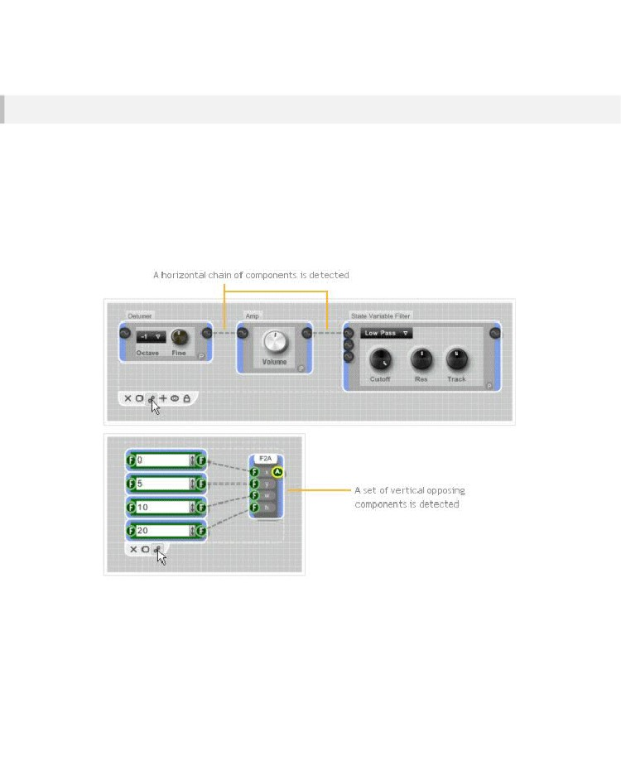
CHAPTER 3
Smart Linking
Si es necesario enlazar varios componentes entre sí de forma rápida, puede utilizar la característica de enlace inteligente.
Simplemente coloque sus componentes de una manera lógica, seleccione y luego
haga clic en cualquiera de los componentes del botón de enlace
en el panel de acción o seleccione Vincular componentes en el menú Esquema.
El software hará una mejor conjetura en cómo desea que los componentes a ser unidos entre sí. Si utiliza el botón del panel de acción para hacer esto, entonces cuando se pasa el puntero del ratón sobre el botón, el software
indicará los enlaces que se crearían
Vinculación inteligente es útil si tiene varios componentes que desea vincular a otro componente o si quieres componentes de la cadena juntos.
- 48 -

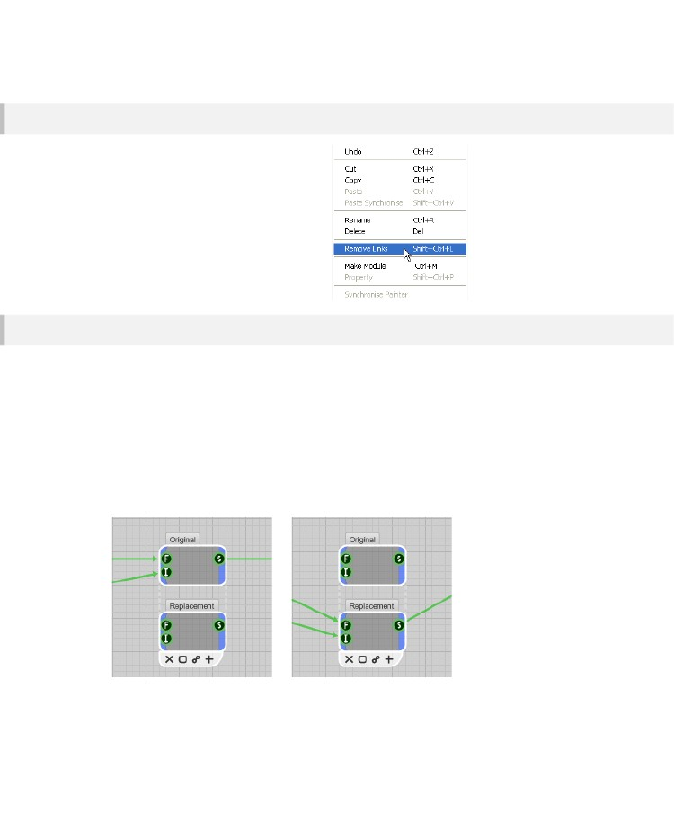
COMPONENTS & LINKS
Removing Multiple Links
You can remove all the links in a selection in
one go. Simply right-click on the selection and
choose Remove Links from the pop-up menu.
This can be very useful when you have a large
section of schematic that you need to
disconnect
Swapping Links
Sometimes you might want to replace a component in a schematic with another component. The most
common reason for doing this is when you have a newer version of a module that you want to use in
place of an existing one (see the next chapter to learn about modules).
You can do this by hand by moving all the links one by one but this is time consuming and can lead to
errors if you forget a link or where it was in the link order.
To help we have the Swap Links feature. Simply select the two components, right-click and choose
Swap Links from the popup menu. The links from one component will swap to the other and vice-
versa. If the components don't have the same number of inputs or outputs then the software will
transfer the links it can and drop any that it can't.
- 49 -

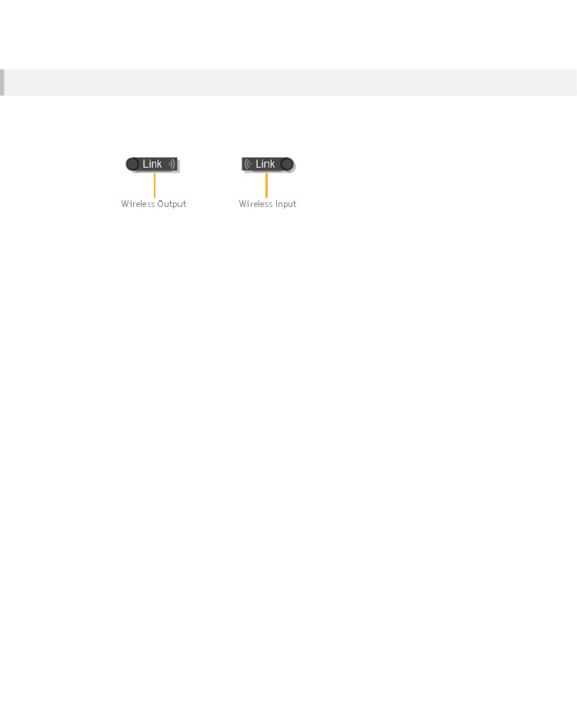
CHAPTER 3
Wireless Links
Los enlaces inalámbricos proporcionan un mecanismo para pasar datos a través de la jerarquía de módulo sin tener que crear ningún enlace físico. Ellos son como las redes inalámbricas en el mundo real. Tiene un transmisor
llamado una salida inalámbrica en un extremo y un receptor, una entrada sin hilos en el otro extremo.
Se establece una conexión entre una salida y una de entrada inalámbrico Wireless sólo si se cumplen las tres condiciones siguientes:
1.
2.
3.
La entrada sin hilos debe aparecer en un módulo por debajo de la salida Wireless en la jerarquía
La entrada sin hilos y de salida deben tener la misma etiqueta
La entrada sin hilos y de salida deben tener el mismo tipo de conector
Cuando se establece un enlace de los indicadores de conexión de la entrada inalámbrica y salida se encenderán.
- 50 -

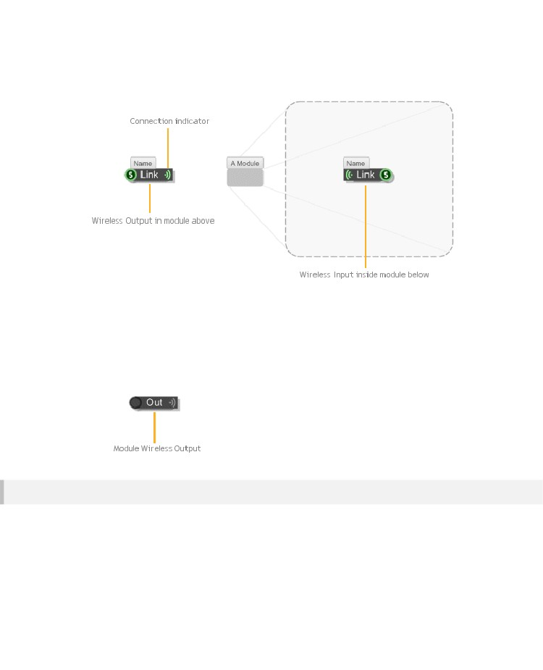
COMPONENTS & LINKS
Los enlaces inalámbricos sólo funcionan en la jerarquía del módulo, no se puede vincular de nuevo hacia arriba. Además, el rango de una salida inalámbrica sólo se extiende hasta la próxima salida inalámbrica por debajo de ella que tiene la misma etiqueta y el tipo de conector.
La misma salida inalámbrico se puede conectar a múltiples entradas inalámbricas y viceversa, siempre y cuando se ajusten a los criterios 3 descritos anteriormente.
Hay otro componente inalámbrico llamado Output Wireless Module. Esto se utiliza para hacer un módulo inalámbrico. Consulte la sección Módulos para más información sobre este.
Follow Wireless
Los enlaces inalámbricos son excelentes para mantener sus esquemas ordenado pero tienen un inconveniente: que puede ser muy difícil de seguir. Para ayudar con esto tenemos la función Seguir Wireless.
Para utilizar esta sólo tiene que seleccionar una entrada o salida inalámbrica Wireless y, o bien haga clic derecho y seleccione Seguir inalámbrica desde el menú o la tecla TAB.

El esquema saltará a la primera conexión de salida inalámbrica o de entrada. La trayectoria del vínculo también se indicará en el Navegador.
- 51 -

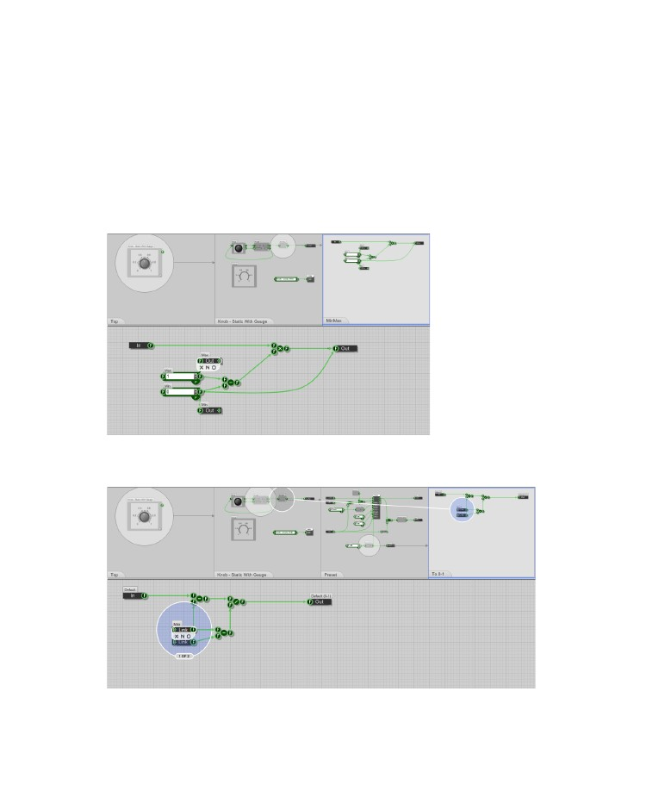
CHAPTER 3
El componente inalámbrico de conexión se resaltará y una etiqueta a continuación se mostrará el número de componentes inalámbricos a juego existen, y el índice de la que actualmente es resaltado.
A continuación, puede hacer clic derecho sobre un área vacía de la esquemática y seleccione Siguiente Wireless componentes o presione TAB. Finalmente se TAB de nuevo al componente que empezar con - el componente inalámbrico fuente.
EXAMPLE
Below we have one of the standard toolbox modules. We've moved into a sub module called MinMax.
We want to see what the Module Wireless Out component called Max is connecting to. All we do is
select the component and press the TAB key.
The schematic jumps to the first Wireless Input component that that connects to Max. We can see
from the highlight that this is component 1 of 2.
- 52 -

COMPONENTS & LINKS
El esquema muestra el camino a través del esquema de este componente y la conexión inalámbrica.
Debido a que hemos seleccionado una salida Módulo inalámbrico de la conexión se muestra desde el punto de la transmisión es decir, el módulo primario.
Podemos ver claramente que el receptor se encuentra en el interior del módulo de 'A 0-1 "dentro" prefijado ".
Si continuamos pestaña iremos a la segunda entrada inalámbrica y luego de vuelta a la fuente. Una vez más, porque estamos siguiendo una salida Módulo inalámbrico se muestra el origen como el módulo principal.
Para dejar de seguir las conexiones inalámbricas, simplemente haga clic en el esquema o realizar algún otro tipo de edición operación.
- 53 -

CHAPTER 4
4 Modules
MANAGING COMPLEXITY
- 54 -

MODULES
You may recall from the introduction that components are broken into two types: primitives and
modules. A primitive has a predefined behaviour. It’s a black box whose behaviour can't be changed.
A module on the other hand has it's behaviour defined by a schematic. You can add inputs and outputs
and the internal behaviour can be modified to do virtually anything you want.
The module component can be found in the toolbox under the Module filter group. Drag one into a
schematic and you'll see that an empty module is just a grey box.
The action panel for a module has addition buttons to reflect the additional operations that you can
perform on it. Of these the most important is the Move Into Module button (represented as an inverted
triangle). By pressing this button you can go inside a module to view it’s schematic and from there
define the module’s behaviour.
Modules are very simple in concept but they are extremely powerful. They can be used to partition off
functionality into pieces that can be reused again and again. They are essential for managing
complexity in anything but the very simplest of schematics.
- 55 -

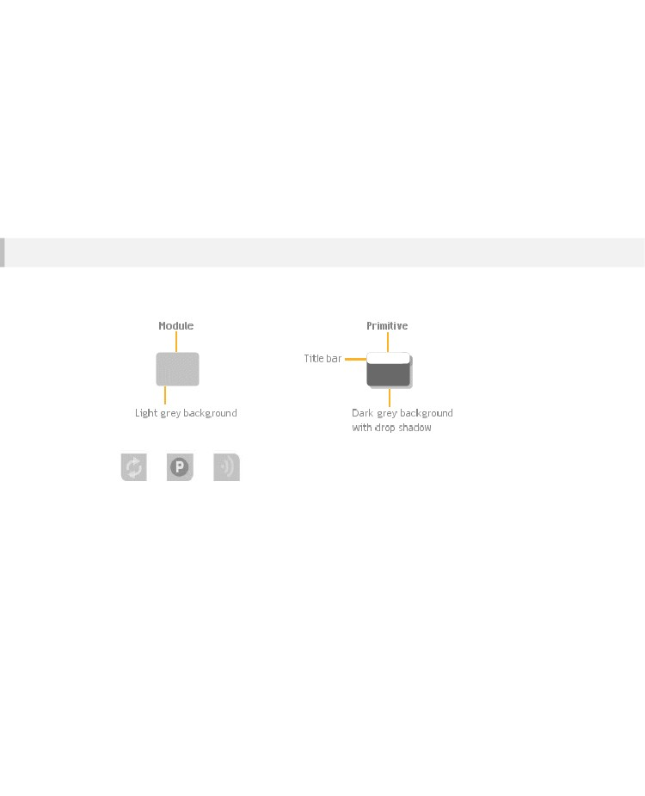
CHAPTER 4
Key Differences
Apart from the fact that a module has it’s own schematic there are a few other key differences between
Modules and Primitives. This section outlines those differences. More details are given in subsequent
sections.
Appearance
First off modules can be differentiated from Primitives by the way they look. A module has a light grey
background whereas a primitive has a dark grey border with a drop shadow and title bar.
A module can also have additional adornments
indicating syncing, properties or wireless capabilities.
More on these later.
- 56 -

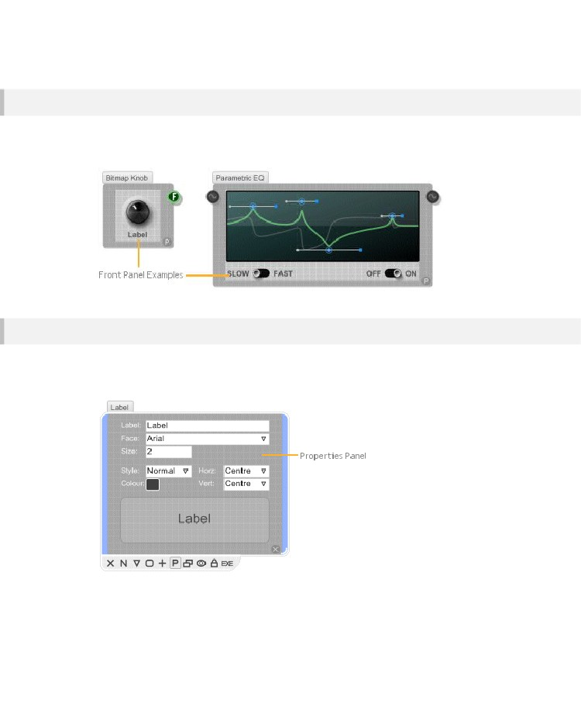
MODULES
Front Panel
Any module can have a front panel. This is shown on the module itself and provides an interactive
surface for adding controls or displaying graphics. The front panel graphics and interaction is all
defined in the module’s schematic.
Properties
If you want to control the behaviour of a module in a more interactive manner then instead of using
input connectors you can define a properties panel. Again the properties panel is defined by the
module’s schematic.
- 57 -

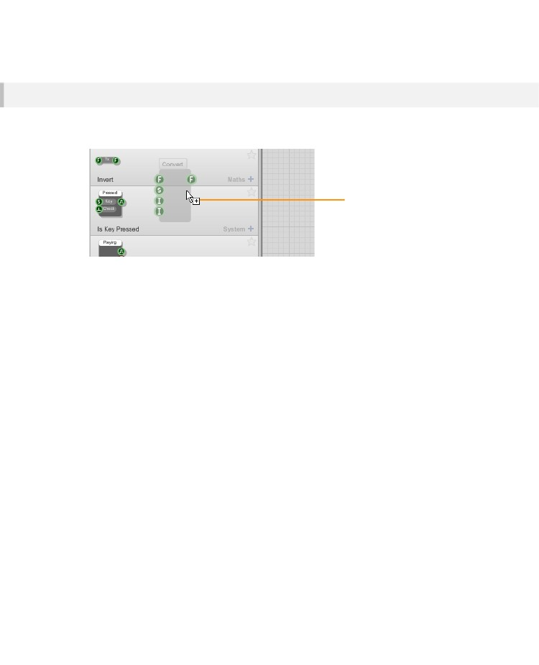
CHAPTER 4
Toolbox
The final key difference between a module and a primitive is that a module can be dragged to the toolbox for
use at a later date. You can drag a module on it’s own or you can drag all selected modules in one go.
Dragging a module to
the toolbox
When you do this the module will automatically acquire any tags you have selected at the time. If no
tag is selected then the module will have no tags added automatically.
- 58 -

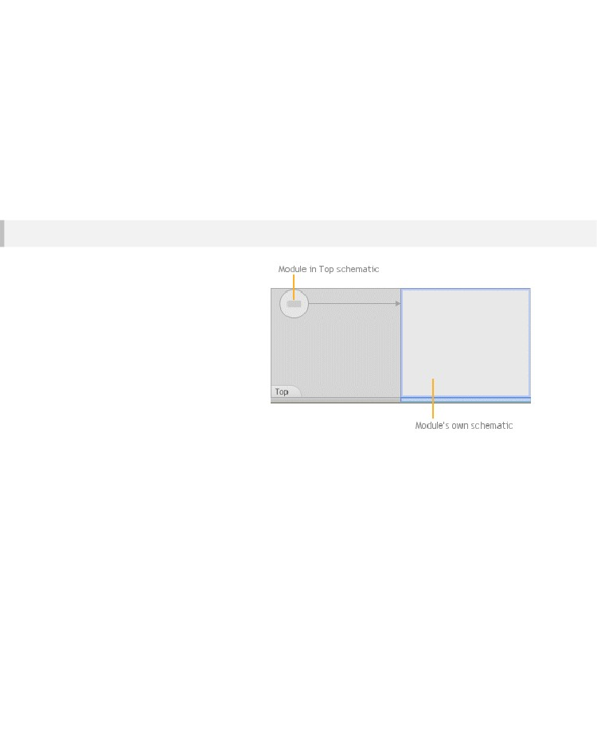
MODULES
Basic Operations
You can do everything to a module that you can do to a primitive. You can delete it, name it, move it
around etc. The key difference between a module and a component is that you can go into a module
and view or edit it's schematic.
Moving into a Module
With most operations in FlowStone
there are many ways to do the same
thing. Moving into a module is no
exception.
To move into a module, either:
1.
Click the Move into Module
button on the action panel
Double-click on the module
Right-click on the module and
select Move into Module from the
context menu
4.
With the module selected, press
the PGUP key
The Schematic Window will change to show the module's own schematic, the Navigator will also
change to reflect this.
To move back out of the module again, either right-click and select Move to Parent or press the PGDN
key. You can also double-click on an empty part of the schematic or of course use the Navigator.
2.
3.
- 59 -

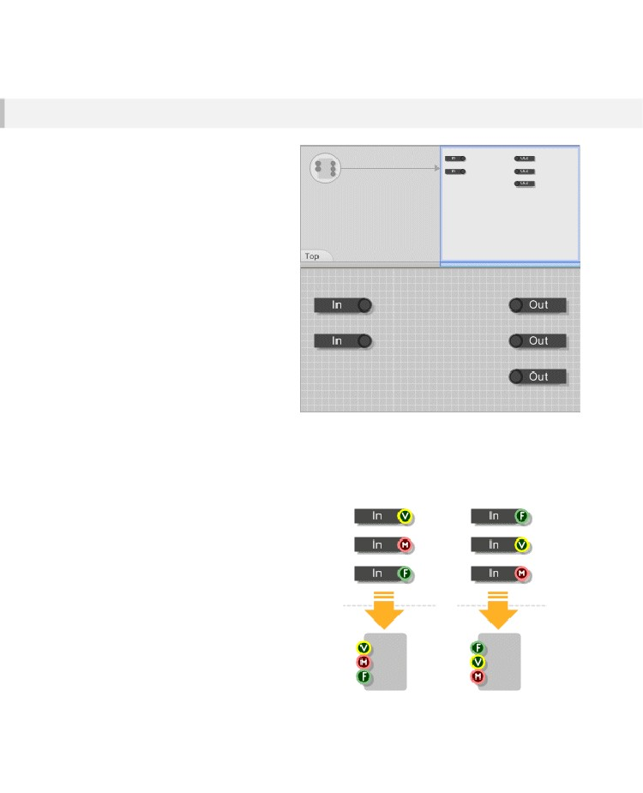
CHAPTER 4
Inputs and Outputs
To get information into and out of a
module you need to add inputs and
outputs. To do this, just drag them in
from toolbox in the usual way (you'll find
them under the Module group). The
example opposite shows a module with
two inputs and three outputs.
For a quick way to add Module Inputs
and Module Output components you can
use keyboard shortcuts. A select few
components are used much more
frequently than the others. To save you
going to the toolbox each time you can
just press a particular key and a new
component is dropped at your mouse
position.
To add an input press 'I', to add an
output press 'O'. Note that these
shortcuts will not work if you are using
your PC keyboard for MIDI input.
Input/Output Ordering
It's usual to keep the inputs on the left and the
outputs on the right but it’s up to you.
What does matter is the position of inputs relative
to one another as this determines the order of the
inputs on the module itself. By swapping the
vertical positions of the input and output
components you can easily change the order of
inputs for a module.
If components have the same vertical position the
horizontal position is taken into account, with the
left-most input being higher in the order.
The same rules apply to the outputs.
- 60 -

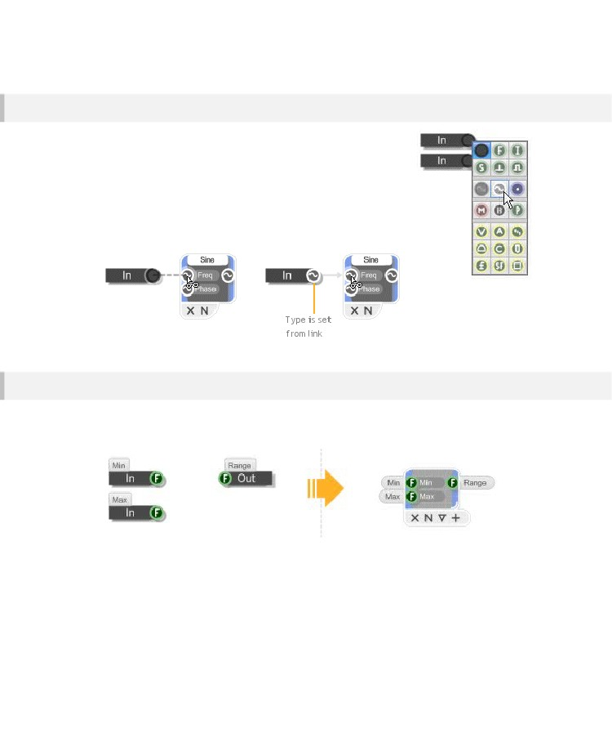
MODULES
Template Connectors
Los conectores para los componentes de entrada y salida del módulo del módulo son lo que llamamos Conectores de plantilla. Estos tienen ningún tipo definido.
Hay dos maneras que usted puede asignar un tipo a un conector de plantilla:
1.
Captará automáticamente el tipo de otro conector mediante la creación de un enlace a ese conector.
Ajuste el tipo de forma explícita al hacer clic derecho sobre el conector y la elección del tipo en el menú contextual.
2.
Input and Output Names
If you give your inputs and outputs names then these will be displayed when you select your module.
In addition, input names will be automatically displayed on the module body itself.
If you want to be even more complete you can provide both short and long descriptions. To do this you
need to name the module input or output component in the form <long name>\n<short name>. So for
example, the label “Maximum height of rectangle\nmaxh” would give an input or output a short name of
“maxh” and a long name of “Maximum height of rectangle”.
- 61 -

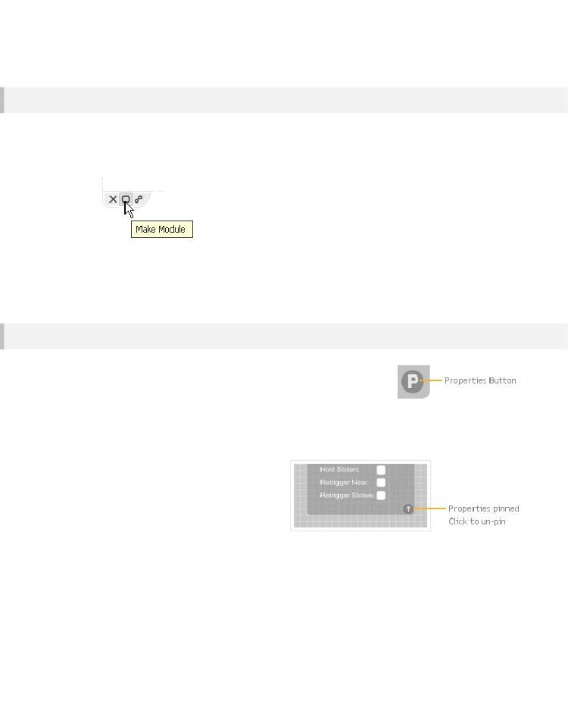
CHAPTER 4
Make Module
Usted encontrará que a medida que crea un esquema que usted quiere y necesita piezas de sección off en módulos separados con el fin de gestionar la complejidad cada vez mayor. Usted puede hacer esto fácilmente utilizando la función Módulo Marca.
Sólo tiene que seleccionar un número de componentes a continuación, haga clic en el botón Módulo de Marca en la acción de selección panel (o haga clic derecho en la selección y seleccione Crear módulo).
The software will create a new module and place the selected components and links inside (the layout
of all components is preserved). A module input or output will be created for each link that connects to
the selection. The old links are then connected to the inputs and outputs on the new module instead of
the selection.
Properties
We mentioned earlier that modules can have properties. These affect how the
module looks or behaves. When a module has properties the properties
button will be shown in the bottom-right corner of the module. This is in the
form of a small circle with a letter P in the centre.
When you click the properties button the module will expand to show the properties panel. With the
panel open you are free to make any changes you want. The panel will then remain open until you
click on some other part of your schematic.
If you want to make the properties panel display
permanently you can pin it open by holding
CTRL as you click the P button. The P will
change to a pin icon to show that the properties
will stay open.
- 62 -

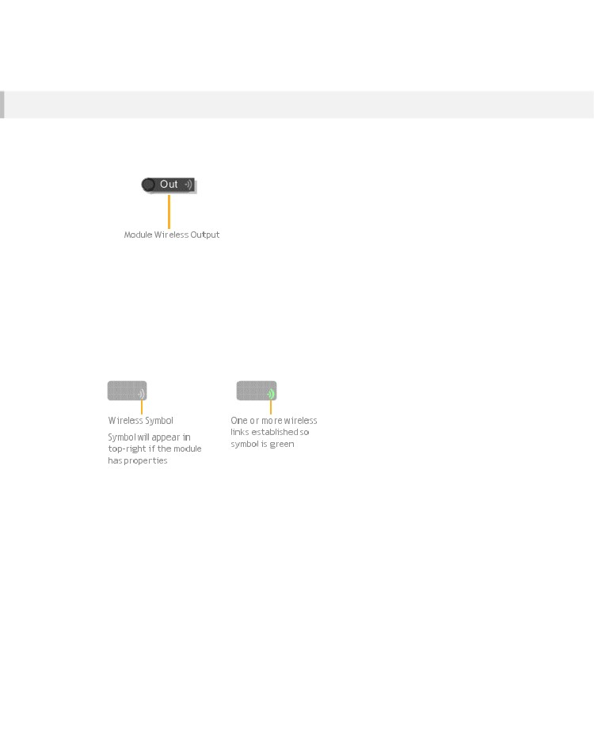
MODULES
Wireless Modules
Most modules will have fixed output connectors that you physically link up to other connectors.
However, it is sometimes useful to make a module output wireless. Instead of using a Module Output
component you use a Module Wireless Output component.
By adding wireless outputs to your module the module becomes a wireless module. The module will
behave In the same way as a Wireless Output component establishing wireless links with matching
Wireless Input components lower down in the module hierarchy.
As with Wireless Outputs a match is determined by the type of connector and the component label.
Wireless modules can be identified by the wireless symbol which appears on the module body. This
will appear grey when no links have been established. However, if one or more Module Wireless
Outputs within the module have established connections with matching Wireless Inputs the wireless
symbol will light up.
- 63 -

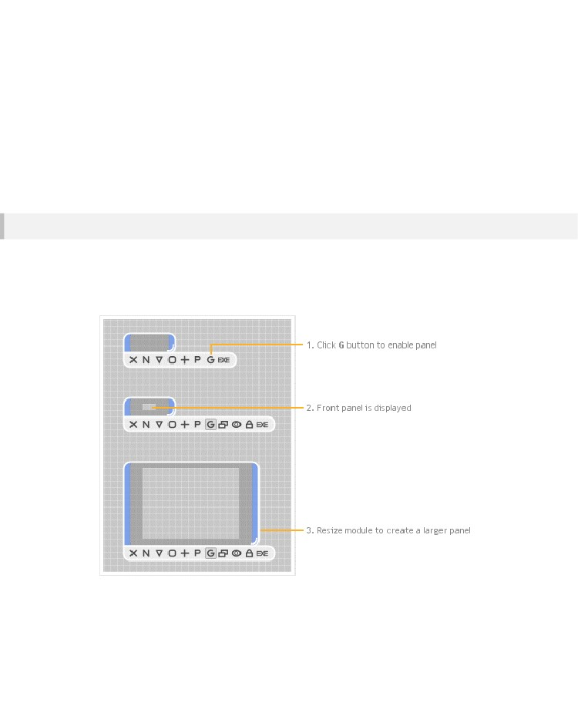
CHAPTER 4
Front Panel
Every module has the option of having a front panel. Front panels allow you to add interactive
elements to your schematic and they are the mechanism by which you provide a graphical user
interface (GUI) for your creations.
Enabling the Front Panel
The front panel is shown on the module itself. By default the front panel is disabled. To enable it, select
the module then click the G (GUI) button (you can also right-click on the module and select Enable
Front Panel).
If you resize the module the front panel will resize accordingly.
- 64 -

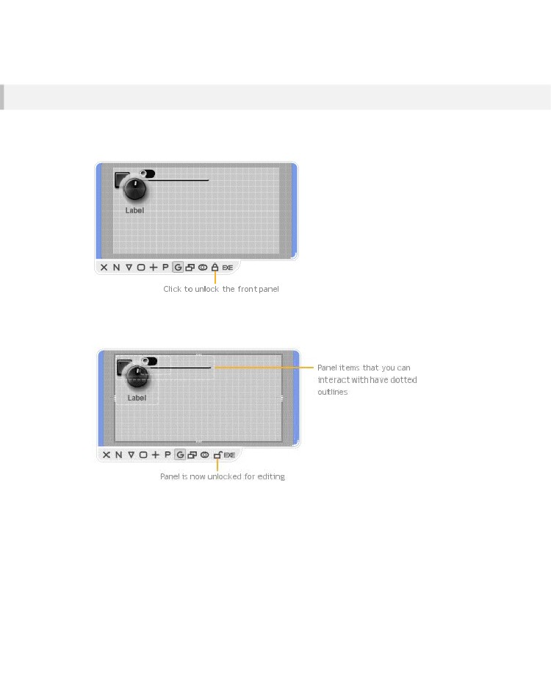
MODULES
Editing the Front Panel
Al colocar las perillas, deslizadores y otros controles dentro de un módulo que tiene un panel frontal entonces estos elementos aparecerán inmediatamente en el panel frontal. Sin embargo, todo va a ser apilados en la parte superior izquierda esquina.
In order to arrange the items you need to unlock the front panel. First select the module then click the
padlock button on the action panel (you can also right-click on the module and select Edit Front Panel
or hold CTRL and press E).
The front panel will stay unlocked until you lock it again. However, you’ll only be able to edit the panel
while the module is selected. When the module becomes deselected it will operate as if the panel was
locked.
- 65 -

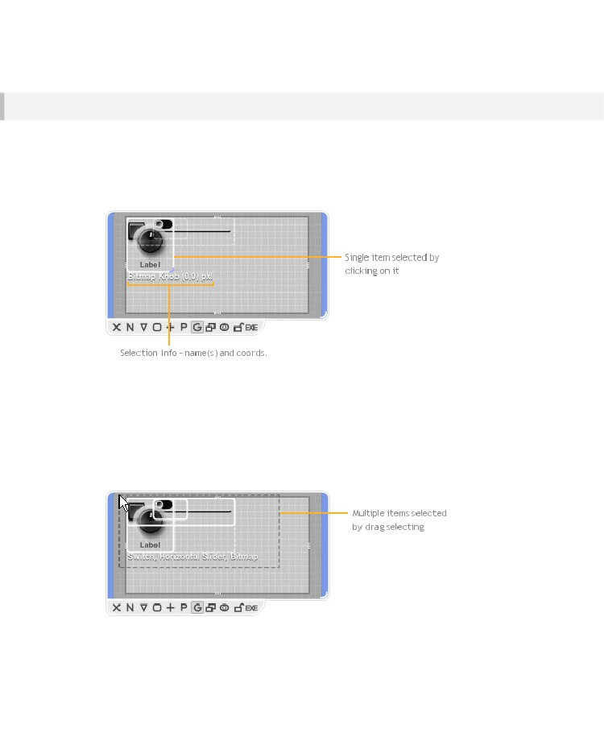
CHAPTER 4
Selecting
You can select items in the front panel in the usual way by clicking on them. If you hold SHIFT you can
click to add or remove items from the selection. You can also click on an empty part of the front panel
and drag to select all items in a rectangular area. To select all the items you can use CTRL+A.
If one item is underneath another you can hold ALT and click to alternate between selecting the top
item and the one below.
Selection Info
Either above or below the selected items you’ll see some text showing information about the selection.
The first part this is the module names for the items in the selection. The second part is shows you the
coordinates of the top-left corner of the selection. The coordinates are in the form “(x,y)” followed by
“sqr” or “px”. If sqr is showing then the coordinates are in grid squares. If px is showing then the
coordinates are in pixels at the default zoom level. You can switch between grid squares and pixels by
clicking on the selection info text.
- 66 -

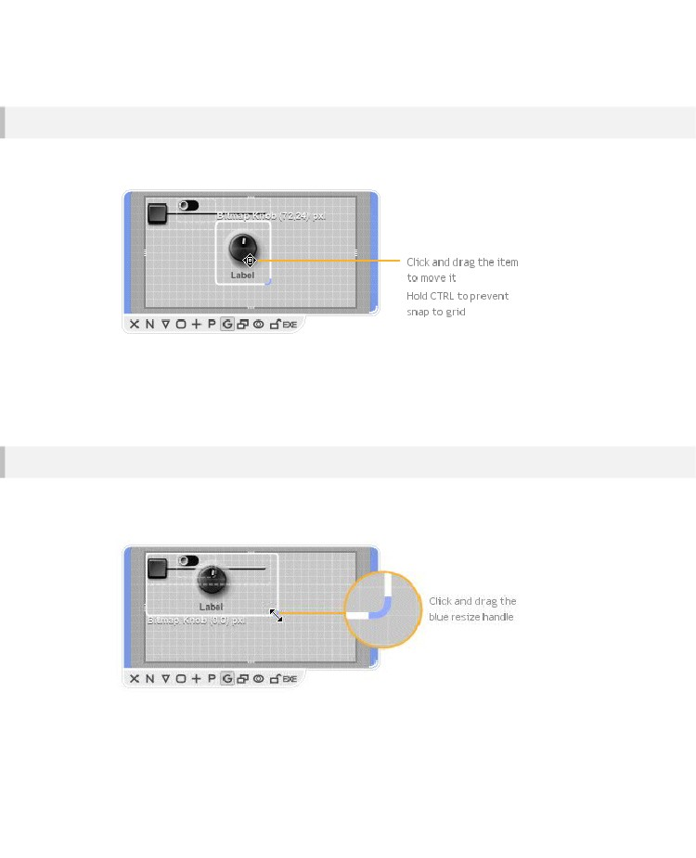
MODULES
Moving
Having selected items you can then move them by dragging them around. By default the position
snaps to the grid but you can prevent this by holding CTRL as you drag.
You can also use the cursor keys to nudge a selection by one grid square at a time in any direction. If
you hold CTRL while nudging you will move a distance equivalent to 1 pixel at the default zoom level.
If you’re zoomed in or out then you’ll move by a distance that is equivalent to 1 pixel at the current
zoom level. This allows you to have ultra fine control over the placement of items on a front panel.
Resizing
You can resize front panel items. This works in the same way as for components in a schematic. First
select the item you want to resize. The bottom-right corner of the selection will show a blue resize
control. Click and drag this to resize.
Note that because each item in the front panel is actually the front panel of a module somewhere lower
down in the hierarchy, resizing an item will resize the corresponding module in the schematic.
- 67 -

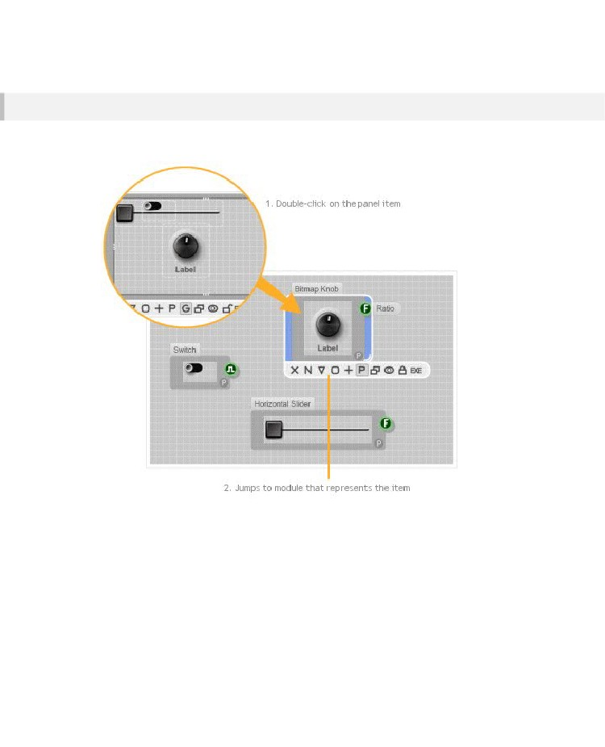
CHAPTER 4
Jumping
If you want to jump straight to the module that is represented by a front panel item then all you need to
do is double-click on it.
- 68 -

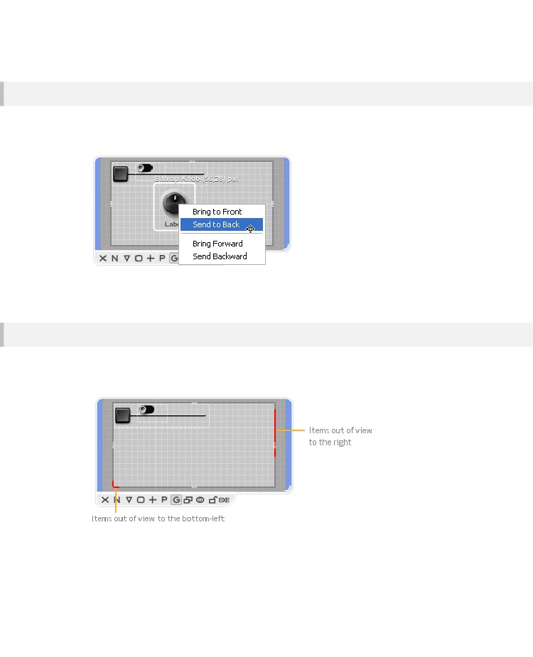
MODULES
Draw Order
If you have several items that overlap with each other then you can determine which ones appear on
top of the others by using the order menu. Right-click on a selected item (or items) and a pop-up menu
will appear.
You can then choose whether to bring a selection forward in the draw order or send it backwards. You
can send the item straight to the back or bring it to the front.
Out of View Items
It is possible for panel items to move out of view. This can happen when resizing the panel or when
copying and pasting modules. When this occurs you’ll see red markers on the edge of the panel’s
exterior. These also indicate the location of the items.
To get the items back into view simply right-click on the module and select Bring Panel Items Into View.
This option is also on the Schematic menu on the menu bar.
- 69 -

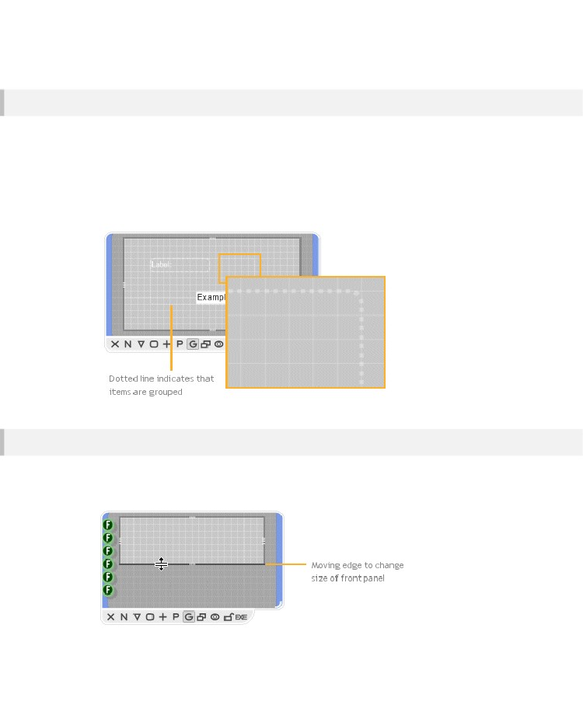
CHAPTER 4
Grouped Items
Sometimes front panel items are grouped together. This is determined by the way that the modules are
constructed. We’ll talk about how this comes about later on so for now we’ll just talk about what
happens when it occurs.
Grouped items are indicated by a thin dotted line around the items. The only way that grouped items
behave differently from those that are not grouped is that they are constrained to appear in the same
draw order relative to each other. For example, if you send one item in the group backwards, all the
other items in the group will move backwards too.
Client Area
On occasions you may need to change the size of a front panel without changing the size of the
module. This can happen when the number of module inputs or outputs imposes a minimum size on
the module but you want the height of front panel to be smaller.
- 70 -

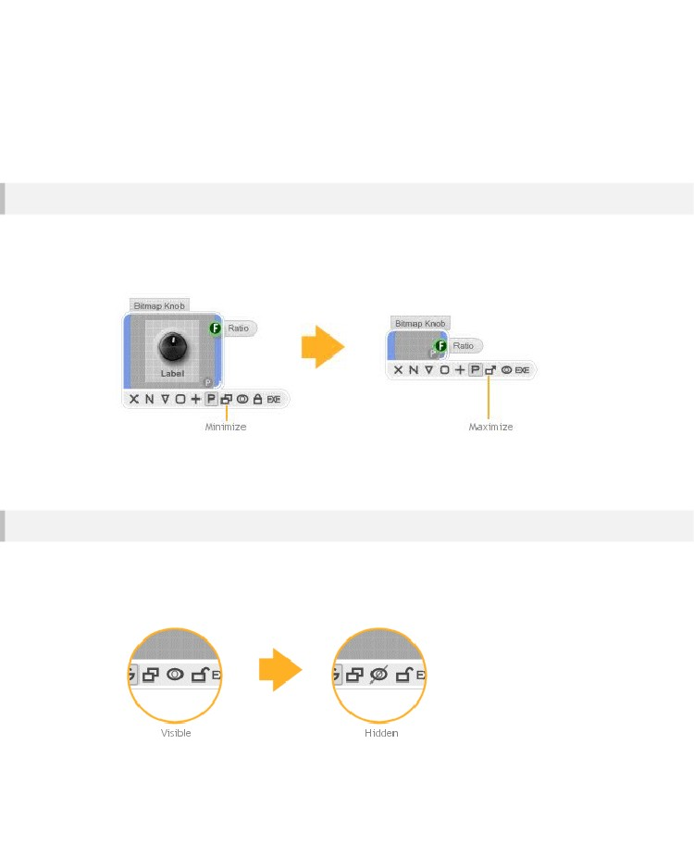
MODULES
When the front panel is unlocked you’ll see a thick dark grey border around the panel edge. This defines
the client area. You can drag the borders around to change the size of the client area. When an edge is
moved from it’s standard position it changes to a darker grey colour. Note that when this happens the edge
becomes detached from the module boundary and will not resize when the module resizes unless it is
forced to do so. You can reattach an edge to the module by dragging it back to it’s original position
Hiding the Front Panel
Sometimes you want a module to have a front panel but you don’t want to display it. This may be
because it is too big and you want your schematic to be compact. You can hide the front panel by
minimizing the module. First select the module then click on the Toggle Minimize button on the front
panel (or right-click on the module and select Minimize Front Panel).
The module will appear as it would be if no front panel were present. You can maximize the module
again to show the front panel if you wish by performing the same action.
Visibility in Parent Module Panels
There are some circumstances under which you don’t want a module’s front panel to appear in parent
module front panels. For example, you may be using a knob to control a variable for experimentation
purposes or you may want to hide a background image to stop it from getting in the way while you
arrange other panel items.
- 71 -

CHAPTER 4
Puede ocultar un módulo seleccionando el módulo y hacer clic en el botón de ojo en el panel de acción (o usted puede hacer clic derecho en el módulo y seleccione Mostrar Panel de Padres). El botón ocular mostrará con un tachado para indicar que el módulo no se muestra en los paneles frontal del módulo padre.
El Show En funcionamiento Panel de Padres funciona en selecciones múltiples también.
- 72 -

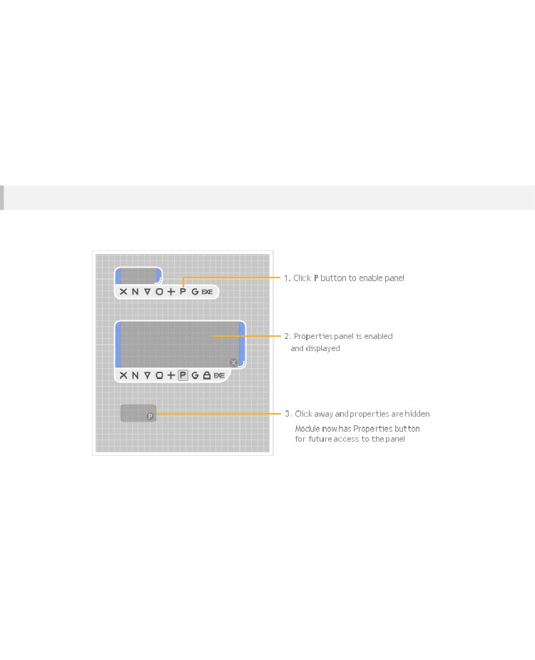
MODULES
Propiedades
Ya hemos visto cómo acceder y cambiar las propiedades de un módulo, pero ¿cómo llegan allí en el primer lugar? En esta sección usted aprenderá cómo agregar propiedades a tus propios módulos..
Habilitación del panel de propiedades
Para activar el panel de propiedades de todo lo que necesita hacer es seleccionar el módulo y haga clic en el botón P
En el panel de acción. También puede hacer clic en el módulo y seleccione Habilitar Propiedades..
- 73 -

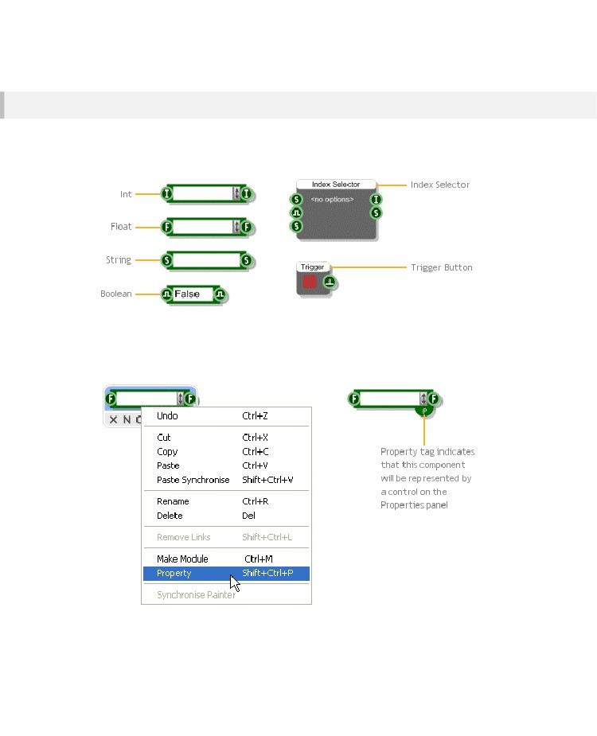
CHAPTER 4
Adding Property Items
The items on the property panel each map onto a particular component somewhere within the module
or it’s sub-modules. There are six different types of components that can be enabled for display on the
properties panel. They are: Int, Float, String, Boolean, Index Selector and Trigger Button.
To enable one of these components for display on the properties, right-click on the component and
select Property. You’ll see a small tag with a letter P in the middle appear in the bottom-right corner of
the component. This indicates that this component is a Property and will be represented by a control
on the Properties panel.
- 74 -

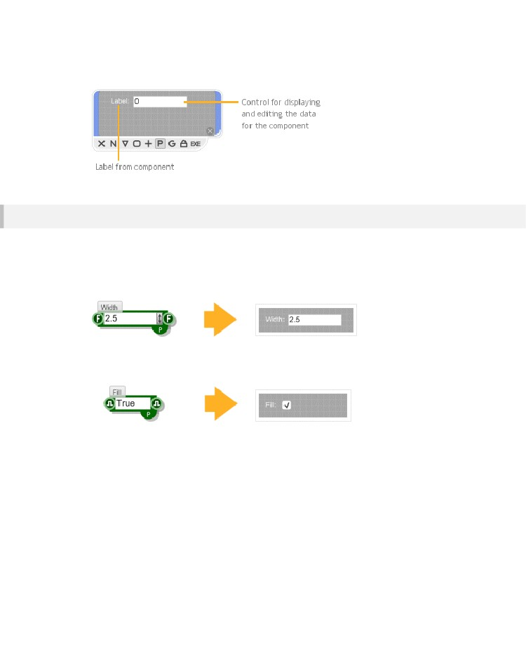
MODULES
If you add a label to the component this will be used on the front panel to identify the component. If you
now go back to the properties panel you’ll see the property control for the component.
Control Types
Each of the five property enabled component types has a control that represents it on the Properties
panel. There are just three different types of control.
Float, Int and String components are represented by Edit controls. These have a label which takes it’s
text from the label of the component.
Boolean components are shown as a check box. Again the label for the check box uses the text from
the label of the Boolean component
- 75 -

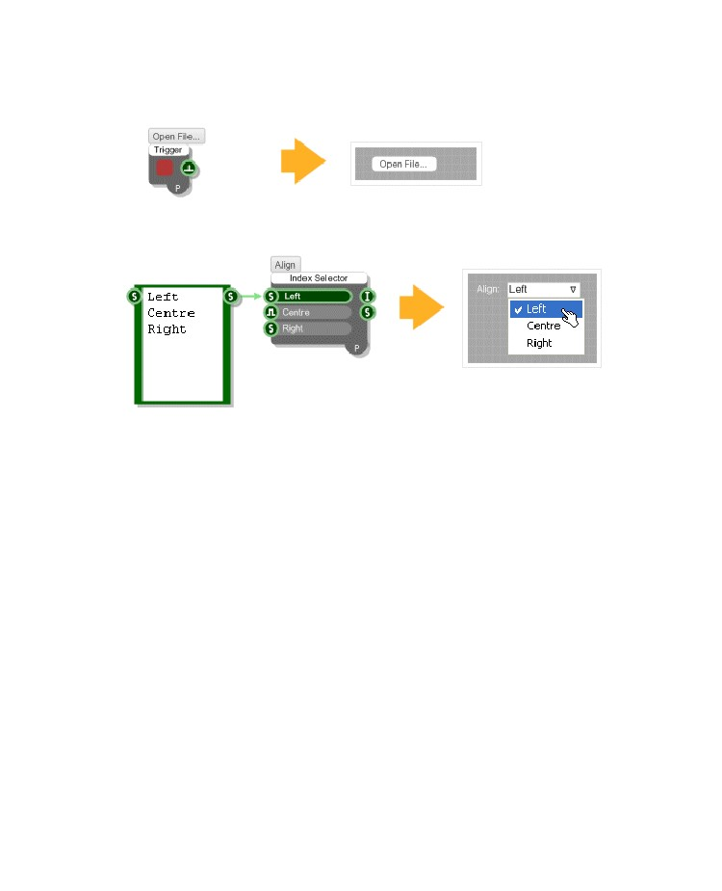
CHAPTER 4
The Trigger Button component is represented by a button. The button text is taken from the label
assigned to the Trigger Button component.
The Index Selector component is used for selecting from a list of options so this is represented as a
drop-down list. The component label once again supplies the text for the control label.
- 76 -

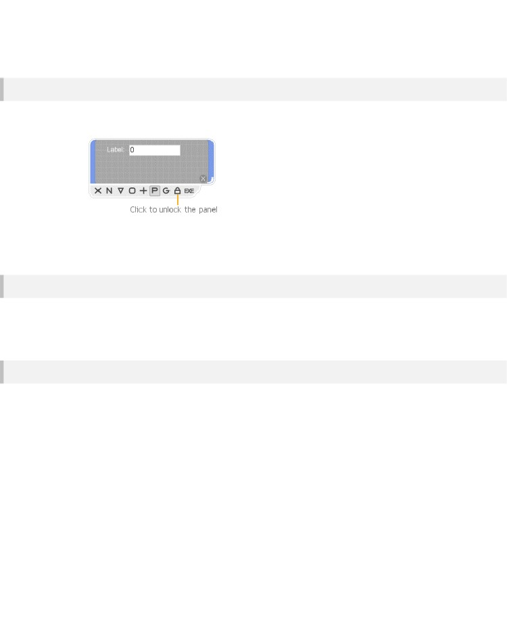
MODULES
Editing the Properties Panel
To edit the positions of items on the panel just unlock the panel, exactly the same as you would for
editing a front panel.
Editing is then exactly the same as for the front panel. You can select items, drag and nudge items
around or resize them. See the section on the module front panel for more details.
Resizing
The size of the properties panel can be adjusted independently of the size of the module. When the
panel is open any resizing of the module will only apply to the properties panel. When you click away
or close the properties panel the module will return to it’s original size.
Customizing
You are not just restricted to the three control types described earlier. Because the panel works just
like an extra front panel you can in fact add any kind of controls or graphics you like. All you need to do
is connect your custom GUI to a Wireless Input with the label ‘Properties’.
- 77 -

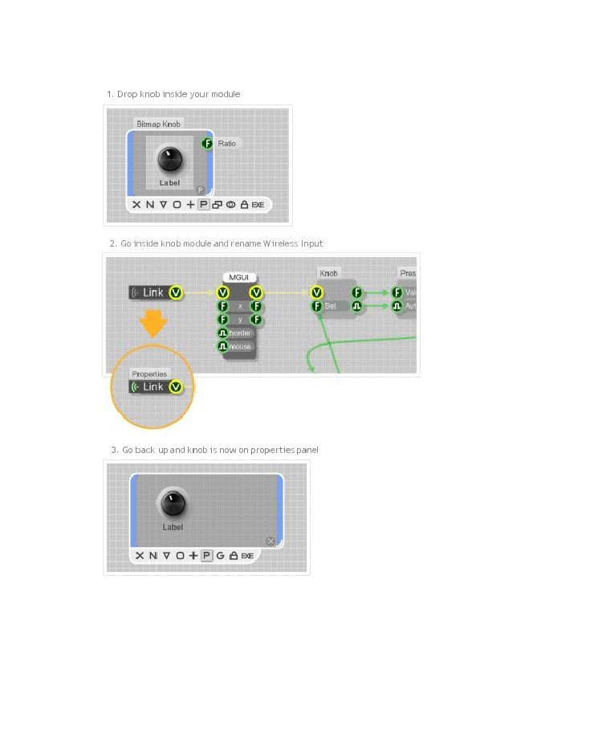
CHAPTER 4
The example below shows how to show a knob on the properties panel.
- 78 -

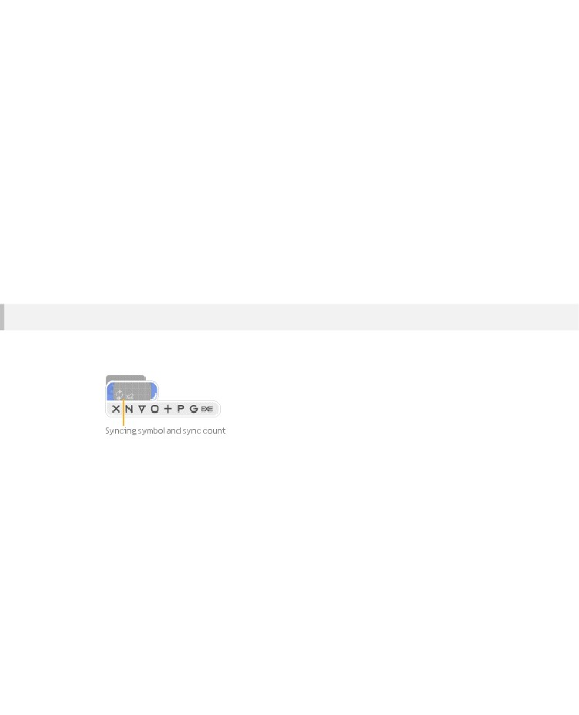
MODULES
Synchronising
You’ll often find that you have many copies of the same module scattered around your schematic. This
is one of the great benefits of modules – you create one and then you can use it in many other places.
However, what happens when you want to change the behaviour of the module?
Well, you certainly don’t want to have to change all your copies one by one. You could change just one
of them and then copy and paste it again but that’s not great either. It would be much better if you
could just transmit the changes to all your modules as you make them. That’s exactly what Module
Synchronising or Module Syncing is designed to do.
When one or more modules are synchronised any changes you make to one module are instantly
made to all the others, it’s that simple.
Paste Synchronise
You can put copies of modules in sync as you make them. Instead of pasting a copy of the modules,
choose Paste Synchronise from the Edit menu or use SHIFT+CTRL+V.
When you Paste Synchronise for the first time you’ll notice that both the original module and the copy
now have the module syncing symbol. The pasted copy will be selected. When a synced module is
selected you will also see the sync count. This indicates how many other modules are synced with this
one. The count is of the form xN where the x symbol represents multiplication and N is a number.
- 79 -

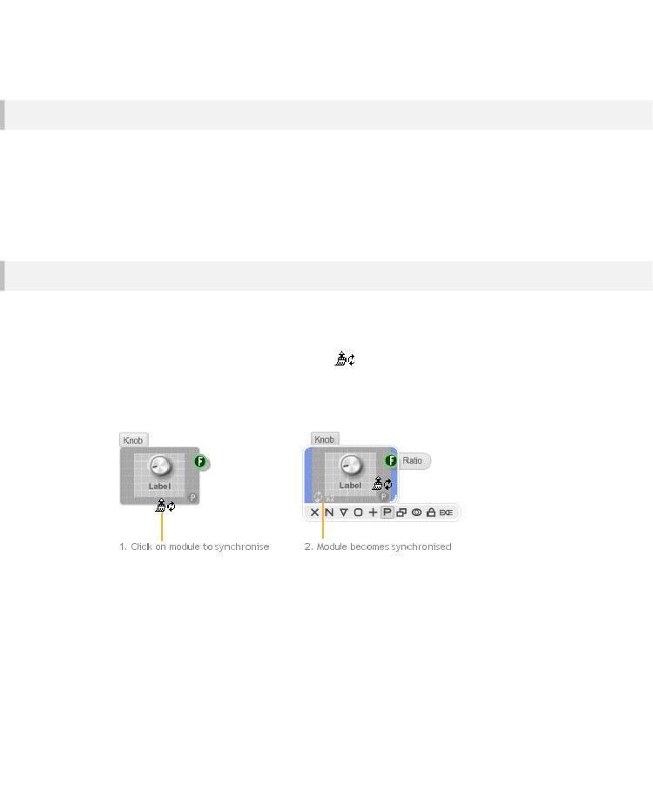
CHAPTER 4
Synchronise All
If you didn’t think in advance that you wanted copies of a module to be in sync then don’t worry.
There’s an easy way to put them all in sync after they have been created. Just right-click on one of the
modules and select Synchronise All. All the modules that match the module you clicked will be put into
sync, regardless of where they reside in your schematic.
Note that if any of the original copies have been altered in any way then they cannot be brought into
sync.
Synchronise Painter
For more selective syncing we have the Synchronise Painter feature. This is a mode that you put the
software into which allows you to click on the modules that you want to put in sync.
Right-click on the module that you want to synchronise with and select Synchronise Painter. The
cursor will change to the synchronise paintercursor . To make another module sync with
this one all you need to do is click on it.
If the module is identical and so can be synced the module border will flash blue to indicate that the
operation succeeded.
You can navigate through your schematic while the Synchronise Painter is switched on. You can use
the Navigator or the module action panels. You can also hold CTRL to temporarily disable painting
while you double-click on a module to go inside it.
To exit Synchronise Painter mode you can right-click on your schematic and uncheck the Synchronise
Painter option. Alternatively, you can hit the ESC key. If you try and perform any other editing operation
whilst the Synchronise Painter is on it will immediately switch off and you’ll return to standard editing
mode.
- 80 -

MODULES
Removing Synchronisation
You will on occasions need to be able to stop a set of modules from syncing with each other. It’s
actually a good idea to remove syncing when you know that you don’t need to make any more
changes.
There are three ways to do this. You can use the Synchronise Painter as described above. For a really
quick way to remove syncing you can right-click on a synced module and select Un-synchronise All.
This will remove syncing from all of the modules that are synced with the one you clicked.
You can also just remove syncing for a particular module on it’s own by right-clicking on it and
selecting Un-synchronise.
Finding Synchronised Modules
If you want to locate modules that are synced with a particular module then simply select the module
and press the TAB key.
The software will jump to the next module that is in sync. Continue pressing tab to cycle through all the
modules that are synchronised. Eventually you will return back to the module that you started with.
You can also hold SHIFT and press TAB to ycle through the synced modules in the opposite order.
- 81 -

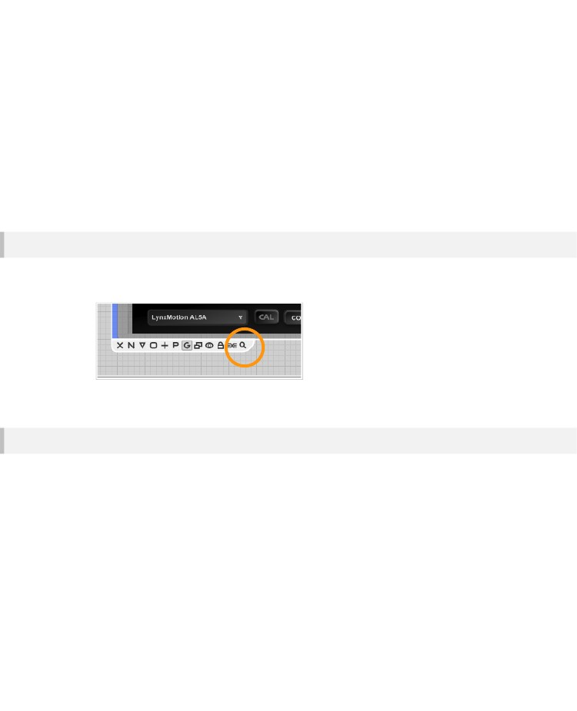
CHAPTER 4
Focus Mode
If you're building an application to export sometimes you may want to preview it or even just use it
without all the editing interface getting in the way. You can do this using a feature called Focus Mode.
Focus Mode applies to a particular module. It collapses the application window around a module and
allows you to have it as the main focus – as if it was the application.
Focus on a Module
To put a module into Focus Mode, select the module then click the focus mode button on the action
panel (looks like a magnifying glass). Alternately right-click on the module and select Focus Mode.
To exit Focus Mode click the close button, press the ESCAPE key.
Focus on the previous Module
You may want to preview your application or module when you're in some other part of the schematic
without having to navigate back to find it each time. You can do this by selecting Focus Mode from the
View menu or by right-clicking on an empty part of schematic and selecting Focus Mode.
The last focused module will be selected in this case regardless of any other module that may be
selected in the schematic at the time.
For quick switching Focus Mode in this way you can use the keyboard shortcut SHIFT + ESCAPE.
- 82 -

DATA TYPES & SIGNAL FLOW
5 Data Types &
Signal Flow
CONNECTOR
TYPES EXPLAINED
- 83 -

CHAPTER 5
FlowStone supports over 30 different types of data. Each type has it’s own connector with a unique
symbol for easy recognition. Although there are many different types of data they all fall into one of
three different categories: Stream, Triggered or Event.
Stream data covers all digital audio and control signals. These signals are fluctuating at sampling rate
and so any components which process them will also perform calculations at sampling rate.
Triggered data works in a completely different way. Where stream data is continuously flowing,
triggered data only flows in response to some event. Usually the event is a user interaction or data
arriving from some external source like an interface card or a timer.
Event data is similar to triggered data in that it flows in response to some event. However, the way in
which it flows is quite different.
Note that in the vast majority of cases data flows from left to right, by this we mean from output
connector to input connector. This is true for all Stream and all Event data but there are a few
exceptions with some of the triggered data types.
- 84 -

DATA TYPES & SIGNAL FLOW
Stream Data
Si usted está interesado en aplicaciones de audio o procesamiento de datos a altas velocidades de datos, entonces usted tendrá que trabajar con los datos de la secuencia. Streams entregan señales digitales de alta velocidad de datos que usted puede entonces el proceso en el software. Esto se conoce como procesamiento de señal digital (o DSP). Si usted no está familiarizado con DSP entonces la siguiente sección le dará una visión general rápida.
Procesamiento digital de señales en una cáscara de nuez
¿Qué es DSP?

Bueno, vamos a empezar con una señal que vamos a definir como el valor continuo de un cierto parámetro en el tiempo. Esto podría ser cualquier cosa, desde la temperatura de una habitación de audio tomado de algún dispositivo de escucha.
Si no se pasa la señal en su ordenador desde una fuente externa, como un micrófono, entonces tiene que ser convertida de una señal analógica a una digital . Esto se hace mediante la medición de la magnitud de la señal en repetidas ocasiones durante intervalos de tiempo discretos.
Cada medición se denomina una muestra y el resultado es una serie de números que es la señal digital.
El proceso se denomina muestreo y la velocidad a la que se mide se llama la tasa de muestreo.
El índice más utilizado para las señales de audio, por ejemplo, es 44 100 muestras por segundo, a menudo representados como una frecuencia de 44.1 Khz pero las tasas más altas también se utilizan para obtener las señales de mayor calidad.
La parte de procesamiento de DSP consiste en tomar la corriente de números que representan la señal digital y su conversión en otra corriente de números mediante la aplicación de una combinación de transformaciones matemáticas.

Esto es lo que FlowStone no usa en secciones de componentes de secuencia de datos que se conectan entre sí.

La señal de salida puede ser convertido nuevamente en analógico y transmite o escuchó como el sonido a través de auriculares o altavoces.

Una característica clave del software es que puede procesar estas muestras individualmente a la tasa de muestreo.

Muchas aplicaciones no son capaces de esto y tienen que procesar una colección de muestras en un solo marco con el fin de mantener el uso de la CPU en niveles aceptables. Esta restricción limita las posibilidades de procesamiento, ya que es a menudo un requisito para procesar una muestra determinada en base a la muestra que la precedió. Esta situación se denomina retroalimentación y única captación de la muestra es una capacidad de FlowStone que lo diferencia de otro software.
- 85 -

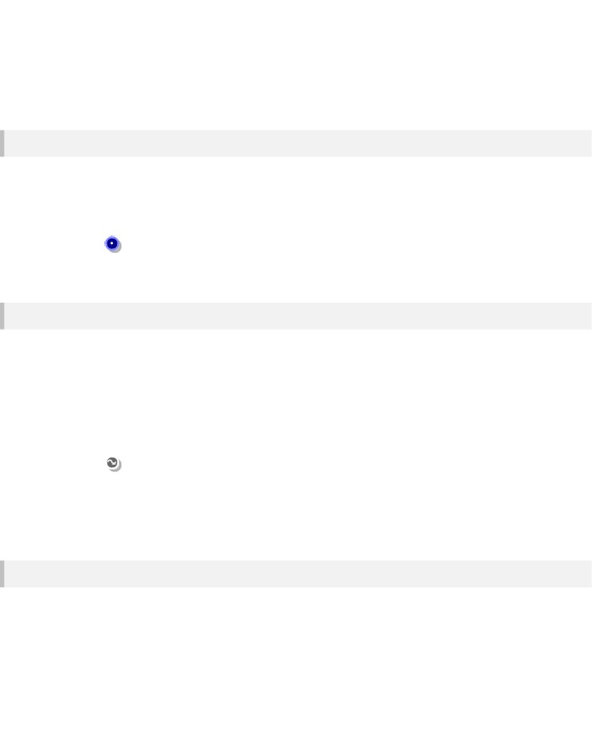
CHAPTER 5
Hay dos principales tipos de datos de flujo: Poly y Mono. Poly sólo se utiliza para aplicaciones de audio donde las señales de sonido se generan a partir de las notas MIDI. Si usted no está generando el audio de esta manera entonces puede ignorar completamente Poli.
Mono
Mono lleva una sola señal en la frecuencia de muestreo. Un conjunto de componentes mono conectados entre sí (para formar lo que se llama una sección Mono) siempre tiene datos que fluye a través de él. Una vez conectado a la derecha a un componente Direct Sound Out o salida ASIO una sección Mono se ejecuta constantemente, incluso si hay una señal de nivel cero que pasa por.
Conector Mono - un solo canal de flujo de movimiento rápido de los datos de coma flotante que oscila a una velocidad de muestreo. Siempre y cuando esté conectado a un componente de salida de sonido, como Direct Sound Out siempre está activa.
Poly
Conectores Poly pueden llevar a muchas señales digitales a la vez. Una sección Poli sólo utiliza su tratamiento cuando existan señales que pasan a través de él. Poli sólo se utiliza para aplicaciones de audio y se genera en respuesta a las notas MIDI.
El número de señales se determina por el número de notas que se tocan. Si no hay señales entonces no hay éxito CPU. Sin embargo, cuando hay una o más notas jugando obtendrás el uso proporcional de la CPU para cada señal generada (aunque debido a la forma FlowStone utiliza SSE, que sólo te dan una aumentar en cada 4 ª nota).
Conector Poli - representa las señales de audio multicanal. Cada canal es un movimiento rápido arroyo independiente de datos de punto flotante que oscila a una velocidad de muestreo. Los datos son de varios canales porque hay un canal para cada nota que usted juega.
Cuándo utilizar Poli o Mono
Usted podría utilizar una combinación de componentes de poli (una sección de Poli) para modelar la parte polifónica de un sintetizador. Con una sección Poli puede generar señales de audio separadas para cada voz o una nota que usted juega. A continuación, puede combinar las señales de Poly Mono y tienen una sección Mono donde usted aplicar efectos a la señal combinada en su conjunto.
- 86 -

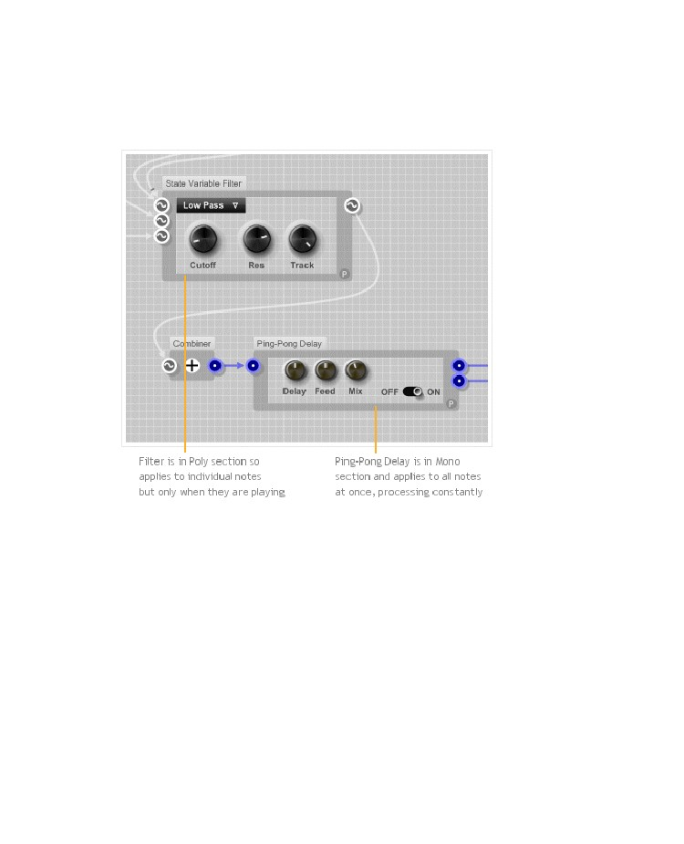
DATA TYPES & SIGNAL FLOW
Conectores Poly y Mono le permiten ver fácilmente qué tipo de datos está fluyendo a través de diferentes partes de su esquema. Esto es importante porque cuando se agrega a su esquema que necesita saber si el tratamiento que usted introduce se aplicará de forma acumulativa para cada voz (Poli) o constantemente
por una señal (Mono).
- 87 -

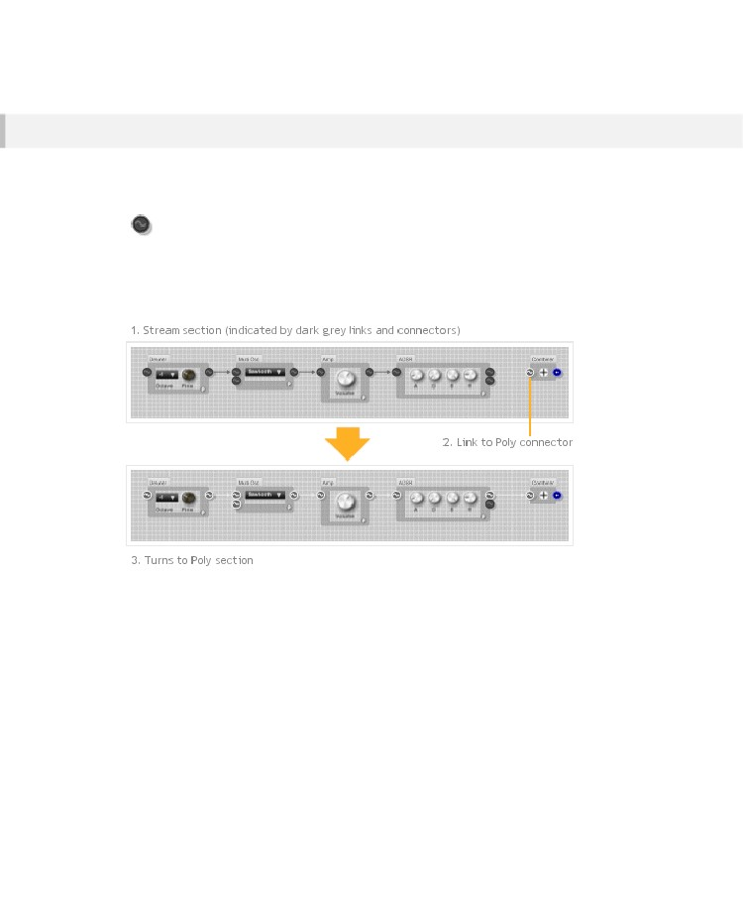
CHAPTER 5
Conectores Stream
Puede crear módulos que se pueden utilizar en una sección de un mono o poli mediante el uso de conectores Stream.
Se ven como versiones de color gris oscuro del conector poli.
Stream connector
Cuando un conector de salida de corriente está vinculado a un conector de Poly o Mono al instante recoge ese tipo.
El cambio de tipo fluye entonces desde la izquierda a la derecha de nuevo por cualquier otro procedimiento conectores corriente cambiándolos al nuevo tipo de acuerdo.
- 88 -

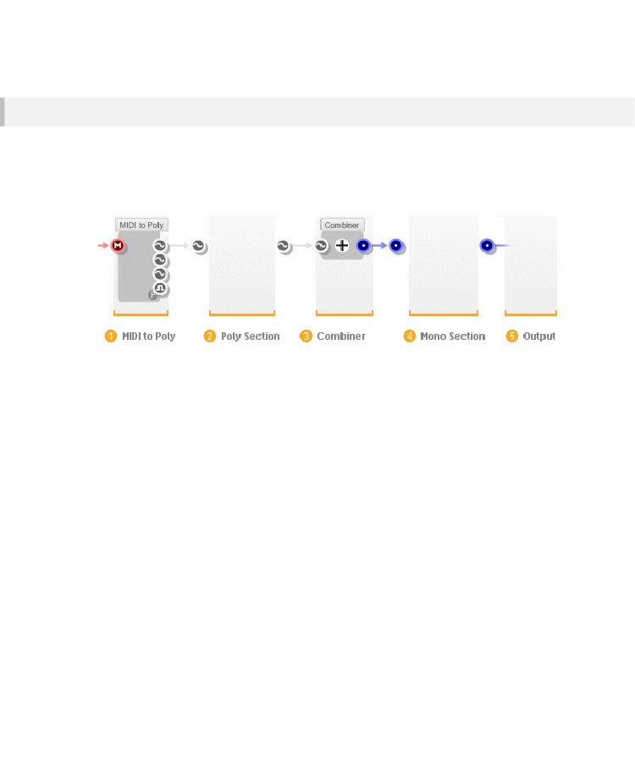
DATA TYPES & SIGNAL FLOW
Poly y Mono Secciones en aplicaciones de audio
Para obtener los datos a fluir a través de un poli o sección mono que tienes que conectarlo correctamente. En la mayoría de los casos usted desea utilizar la entrada MIDI de un teclado o de otra fuente para generar notas. A continuación, desea que cada nota para hacer un sonido que se puede escuchar
La configuración más común sería el que figura a continuación:
1.
2.
3.
4.
5.
El MIDI al módulo de Poli convierte los datos de notas MIDI entrantes en señales Poly
La sección Poli procesa las señales
El módulo combinator luego combina las señales independientes Poly en una señal mono
La sección Mono aplica un procesamiento para el resultado
La señal final es enviado a su tarjeta de sonido a través de un componente Direct Sound Out o salida ASIO dentro
FlowStone oa través de la configuración de audio de acogida si se utiliza dentro de un plugin
NOTA: Si usted no tiene Direct Sound Out o componente de salida ASIO
el procesamiento de audio no se realizará
A, sección poli utilizable completa siempre comienza con un módulo MIDI a Poly y termina con un módulo combinator. La única excepción es si usted está usando un analizador de señal para mirar la salida de un tramo de poli.
Usted puede tener una sección Mono sin sección Poly. Esto es lo que tendría si estuviera creando un efecto que realiza alguna DSP en una señal entrante. Sin embargo, si quieres escuchar todo lo que tiene que conectar una sección Mono a un dispositivo de salida a través de un componente Direct Sound Out o salida ASIO.
- 89 -

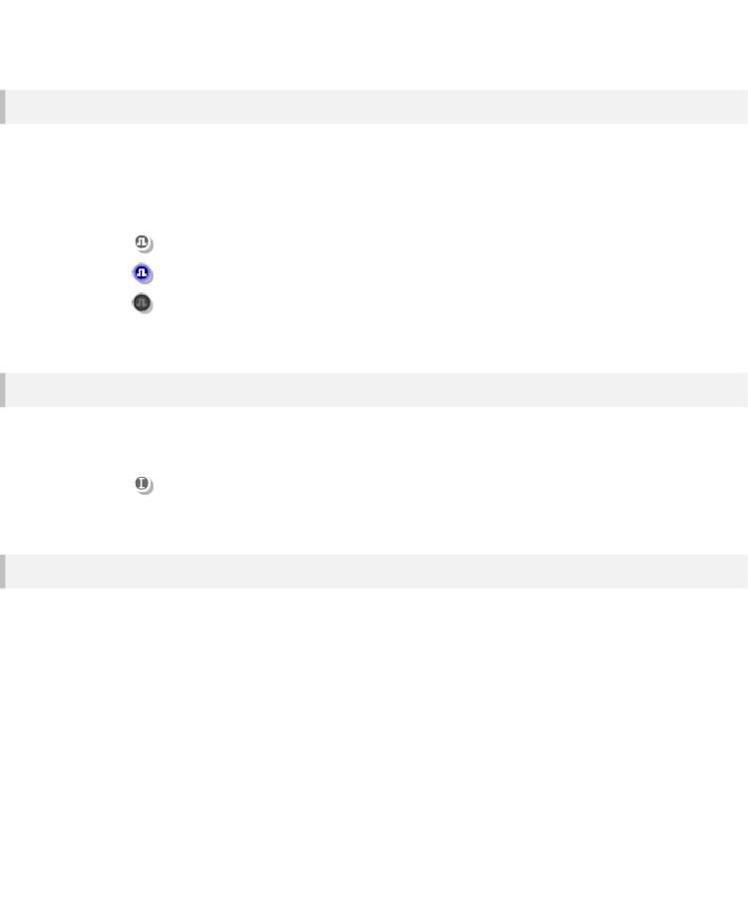
CHAPTER 5
Boolean Connectors
There are Boolean equivalents of the Poly, Mono and Stream data types. They are only seen on a few
components, most notably the Poly and Mono comparison components.
The MIDI to Poly module has a Poly Boolean output which shifts from false to true when a note is
played and can therefore be used as a gate signal.
Poly Boolean – multi-channel mask, one mask for each note playing
Mono Boolean – single channel mask, constantly running
Stream Boolean
Poly Int
El tipo de datos de poli Int. es el entero equivalente del tipo Poly. Sólo se utiliza en el gráfico a Poli para permitir la indexación de frecuencia de muestreo de Arrays de flotador.
PolyInt - multicolor número entero de canales, un canal para cada nota de juego
SSE
Si una CPU soporta SSE entonces tiene un conjunto de instrucciones incorporadas en la que permiten las operaciones matemáticas que se realizarán en varios conjuntos de datos al mismo tiempo. FlowStone hace pleno uso de esto cuando el procesamiento de datos de la secuencia.

El resultado es que se puede procesar con eficacia hasta 4 canales al mismo tiempo por el mismo costo de la CPU como una sola.
- 90 -

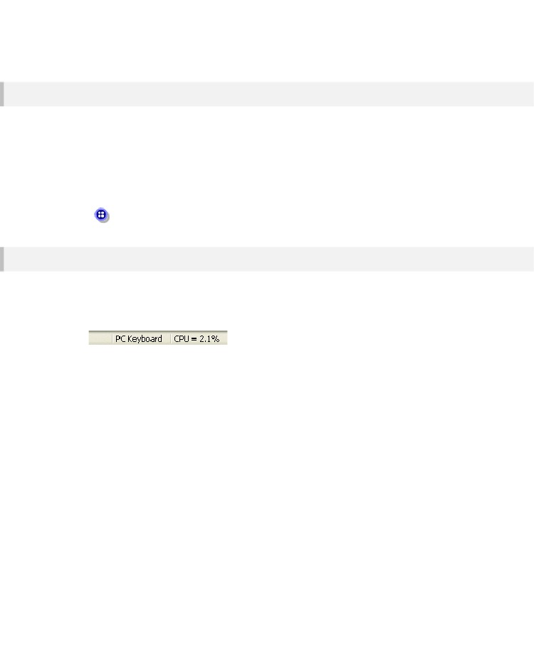
DATA TYPES & SIGNAL FLOW
Mono 4
If you really want to get the best performance out of a Mono section then you need to consider using
the Mono4 data type. It’s not always possible to use this but when you can it makes a huge difference
to performance.
Mono sections only have one sound process. Because FlowStone uses SSE this process could be
doing four times the work for the same cpu cost. To take advantage of this we have the Pack and
Unpack components. These allow you to literally pack four mono channels into one Mono4 stream.
Mono4 – four Mono signals processed as one
Performance
Para ayudar a medir el efecto de los cambios en las partes de su esquema de flujo que tenemos un medidor de cpu.
Esto se puede encontrar en el lado derecho de la barra de estado en la parte inferior de la ventana de aplicación. El medidor de CPU es muy básico. Sólo se mide el rendimiento de la CPU de las secciones de la corriente, no se mide el rendimiento GUI.
- 91 -

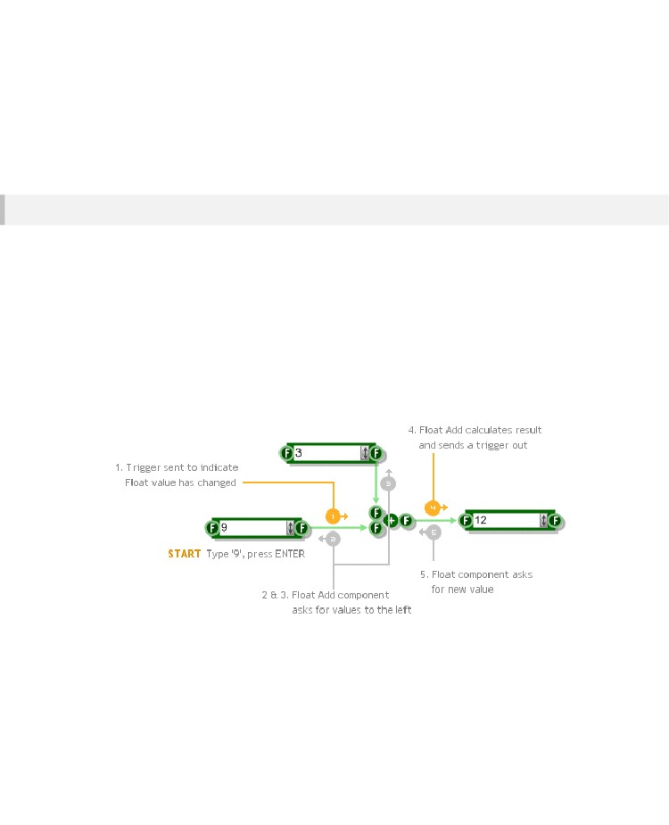
CHAPTER 5
Triggered Data
How it Works
Datos activa sólo fluye a través de un esquema cuando se produce un evento que 'disparadores' un cambio. Hasta que esto suceda secciones de datos activados permanecen en un estado de equilibrio.
Cuando un evento ocurre un mensaje de llamada de activación se envía a través de los conectores de salida de uno o más componentes.

El gatillo fluye a través de los enlaces hasta que llega a otro componente. Ese componente luego evalúa si el estado se vería afectado.

Cualquier recálculos necesarios se realizaron a continuación y un disparador se envía a través de los conectores de salida de dicho componente. El proceso continúa creando un efecto de cascada a través de la esquemática.
El siguiente ejemplo muestra algo muy simple de dos números, se suman.

Cuando se escribe en un componente Float esto da lugar a uno de los eventos que hemos estado hablando y comienza una ráfaga de disparo.
Tenga en cuenta que durante la parte de recálculo de un componente puede pedir a los demás componentes que proporcionen valores a sus entradas para sus últimos valores.

Esto en sí mismo puede provocar un aluvión de mensajes a la izquierda.
- 92 -

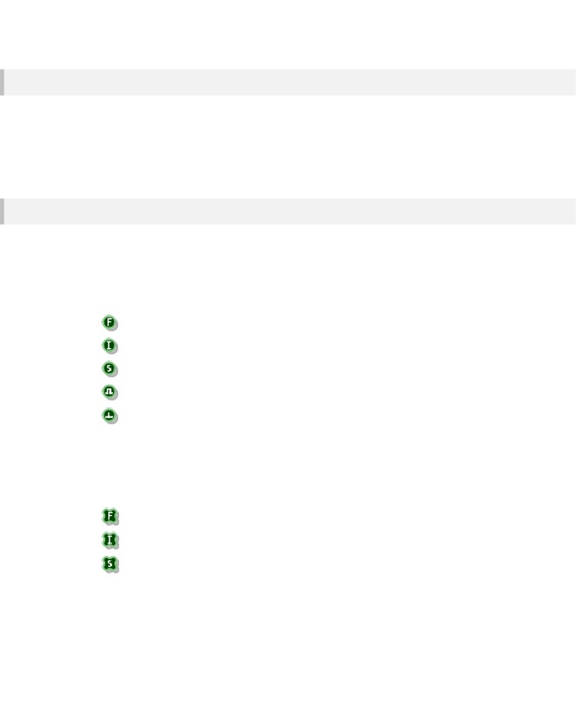
DATA TYPES & SIGNAL FLOW
Para que se Utiliza
los datos desencadenado tiene dos funciones principales.
En primer lugar se proporciona una forma de realización de cálculos que no necesitan ser hechas a la tasa de muestreo. En segundo lugar que le permite construir elementos muy detallados y complejos de interfaz de usuario, que sólo tienen que responder al interactuar con ellos.
Como regla general el DSP rápido es manejado por el flujo de datos y la interfaz de usuario más lenta DSP y es manejada por los datos disparada.
Tipos de datos disparables
Los diversos tipos de datos activadas se pueden agrupar en varias categorías basadas en su propósito.
Primary Types
Estos son los tipos más comunes. Representan datos simples, como números y texto.
Float - un número de punto flotante de 32 bits
Int - un entero de 32 bits con signo en el rango desde -2147483648 hasta 2147.483648 millones
String – una cadena alfanumérica de caracteres de longitud ilimitada
Boolean – uno de dos valores: true o false
Trigger - no es realmente un tipo de datos (no hay datos) sino que se utiliza para pasar mensajes de activación
Tipos de matriz
Estos tipos representan matrices de tamaño variable de algunos de los tipos primarios. Una matriz es simplemente una lista ordenada de elementos del mismo tipo. Los tipos de matriz tienen un patrón de esquema 'de cuatro hojas "en lugar de un círculo.
Float Array – matriz de números de punto flotante de 32 bits
Int Array – gama de 32 bits entero con signo en el rango desde -2147483648 hasta 2147483.648 mil
String Array – conjunto de cadenas de caracteres
- 93 -

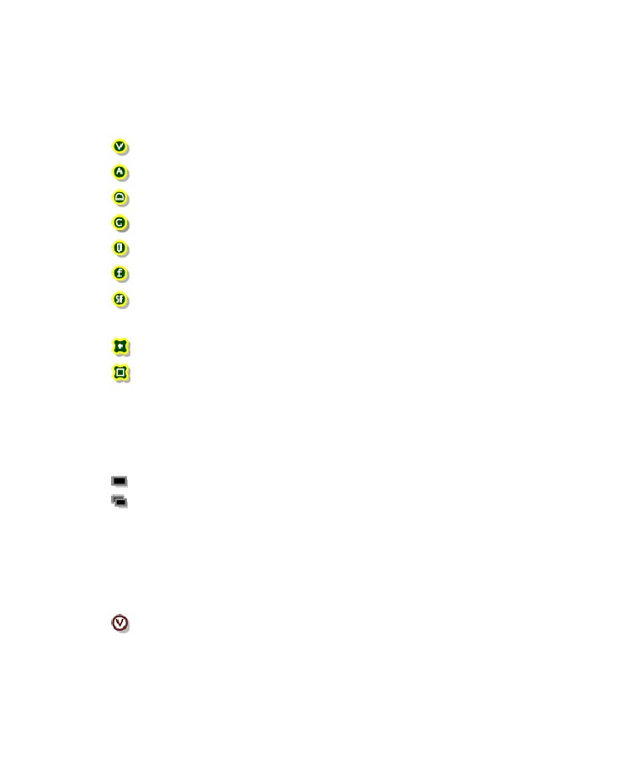
CHAPTER 5
Tipos de interfaz gráfica
Estos se utilizan solo para la edición de interfaz gráfica de bajo nivel por lo que no se necesita saber acerca de ellos hasta llegar a utilizar los componentes GUI.
View – transporta toda la información de dibujo y el ratón
Área – se define mediante las coordenadas de la esquina superior izquierda, una anchura y una altura
Mouse – eventos de ratón (botón izquierdo arriba / abajo, mover el ratón, etc)
Color – en formato argb ('a' es el nivel de transparencia)
Pen – para dibujar líneas - definido por el color, grosor y estilo
Font – Información que comprende la fuente de letra, tamaño y estilo
String Format – información de alineación para dibujar texto
Bitmap – 32bit image
Point Array – una matriz de puntos (pares de punto flotante)
Bitmap Array – una matriz para los mapas de bits
Memory Types
There are two types that represent buffers of data stored in memory. They are most frequently used for
storing wave file data for samples.
Mem – a contiguous section of data in memory
Mem Array – an array of memory sections of unlimited length
Ruby Types
En un Ruby todos los datos se considera como un objeto. Los números son objetos, las cadenas son objetos, las matrices son objetos. Fuera del código Ruby objetos tienen el mismo tipo: VALOR así que cuando se pasa objetos de Ruby entre los componentes de Ruby se les pase a través del conector Valor Ruby.
Valué – puede referirse a cualquier objeto de Ruby
- 94 -

DATA TYPES & SIGNAL FLOW
Special Types
There are a handful of data types that stand on their own.
MIDI – todos los mensajes MIDI estándar
Voice – Actualmente sólo se utiliza dentro del MIDI al módulo de Poli, pero podrá ser extendido en el futuro
Bus – el conjunto definido por el usuario de los tipos de datos que viajan juntos a través del mismo conector
Preset – lleva información sobre el parámetro preestablecido y cambios de programación de plugins
Template – no es un tipo de datos, en lugar de esto, toma lo que sea que lo conecte a él
- 95 -

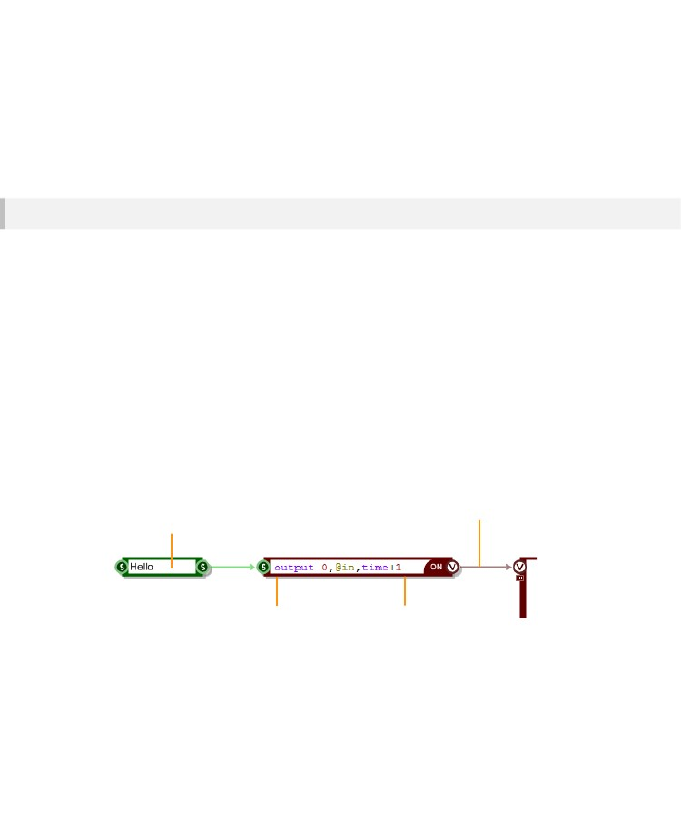
CHAPTER 5
Eventos de Datos
Como Trabaja
Como dato desencadenados , los datos de eventos sólo fluye a través de un esquema cuando ocurre algo que causa un cambiar . Hasta que esto suceda secciones de datos de eventos permanecen en un estado estable .
Cuando ocurre un evento un mensaje denominado evento se envía a través de los conectores de salida en uno o más componentes . El Evento fluye a través de los enlaces hasta que llega a otro componente .
Todo esto suena muy similar al sistema de disparo . Sin embargo , existen dos diferencias importantes . primero el evento lleva datos con él.

El sistema de disparo sólo señala que se ha producido un cambio, componentes y luego vuelven a llamar ( a la izquierda ) para calcular sus valores. Eventos transportan datos con ellos . una vez que un caso llega a un componente que no hay de volver a llamar .
La segunda diferencia es que los eventos están programados . Cuando se crea un evento primero se le da un tiempo erradicar y sólo se ejecutará cuando se llega a ese momento. Esto significa que usted puede especificar exactamente cuando se desea un evento ocurra. Este tiempo se integra completamente con los datos de la secuencia , para que pueda programar eventos que se producen en una muestra precisa.
Actualmente los datos de eventos sólo se aplica al componente de Ruby. Vea la sección de Rubí de componentes para más información .
1 String changes sending trigger to
right via trigger system
4 Time+1 arrives and event is sent out
2 Ruby component calls back to
get the new string value and
stores it.
Use of the trigger system
ends here. After this point the
Ruby component will never
call back for a value, it can
only use what it has been
sent.
3 Ruby component
schedules an event to be
sent out 1 second into the
future using the Event
system
- 96 -

DATA TYPES & SIGNAL FLOW
Tipos de Datos Eventuales
Fuera de los componentes de Ruby sólo un tipo de datos utiliza el sistema de eventos, Ruby Valor.
En Ruby todos los datos se considera como un objeto. Los números son objetos, las cadenas son objetos, las matrices son objetos.

Fuera del código Ruby, los objetos tienen el mismo tipo: VALOR así que cuando se pasa objetos de Ruby
entre los componentes de Ruby se les pase a través del conector Valor Ruby.
Vamos a discutir esto con más detalle en la sección Rubí componentes de esta guía.
Value – can refer to any Ruby object
- 97 -

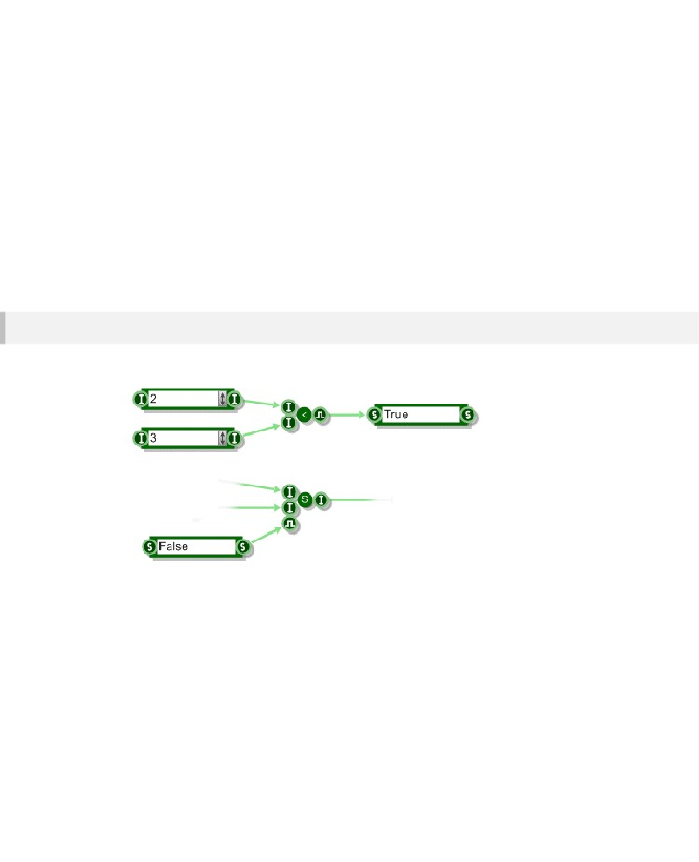
CHAPTER 5
La conversión entre tipos de datos
En la mayoría de los casos va a crear vínculos entre los conectores del mismo tipo. Sin embargo, FlowStone soporta varias conversiones automáticas e intuitivas entre tipos de datos que encontrará extremadamente práctico.
En la mayoría de los casos va a crear vínculos entre los conectores del mismo tipo. Sin embargo, FlowStone soporta varias conversiones automáticas e intuitivas entre tipos de datos que encontrará extremadamente práctico.
String <> Boolean
You can get a boolean value from a string and also convert from a boolean to a string:
- 98 -

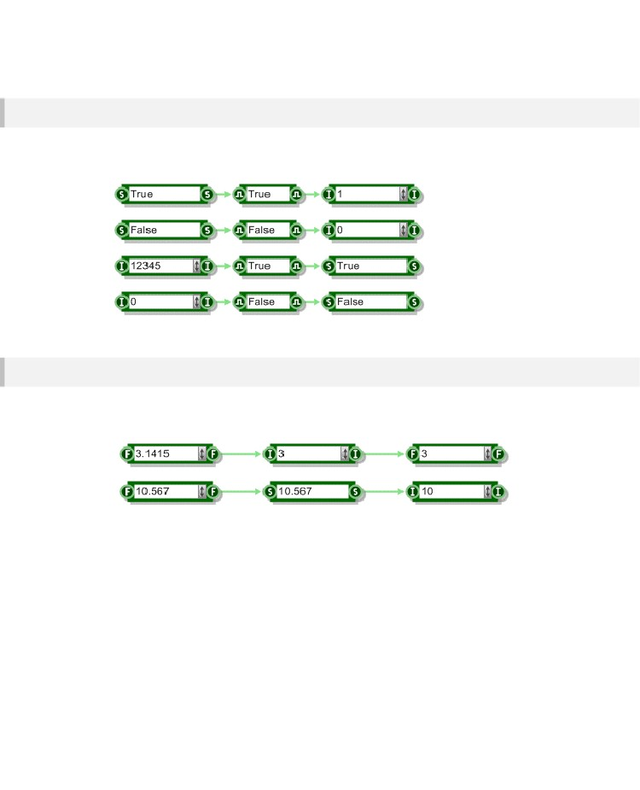
DATA TYPES & SIGNAL FLOW
Int <> Boolean
Boolean and Int are also interchangeable. Zero represents a false value, any other value is considered
to be true.
String <> Float <> Int
Puede convertir de nuevo y adelante entre las cuerdas, flotadores y ints. Redondeo obviamente ocurrir al convertir de Flotante a Int (la parte decimal es ignorado).
- 99 -

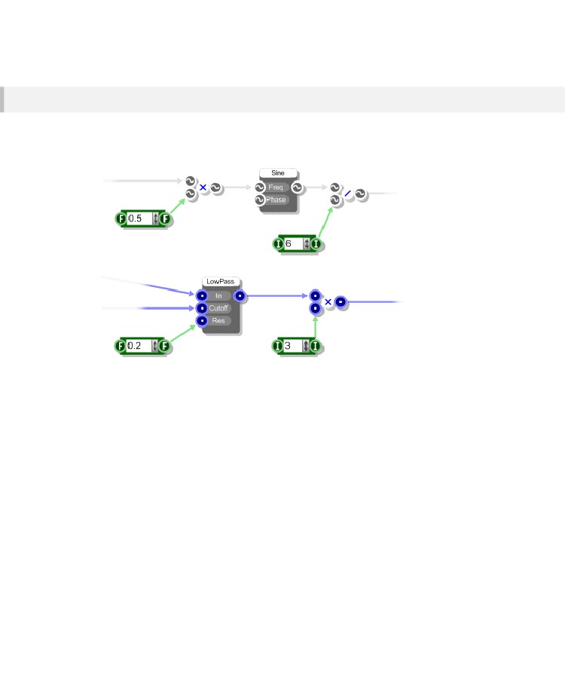
CHAPTER 5
Int/Float > Poly/Mono
Un flotador o Int se pueden conectar a las entradas de Poly o Mono. Estos actúan como señales que mantienen un nivel constante. No puede sin embargo conectar un poli o Mono a un flotador o Int. De hecho conectores Poly y Mono
sólo se pueden conectar a sí mismos..
- 100 -

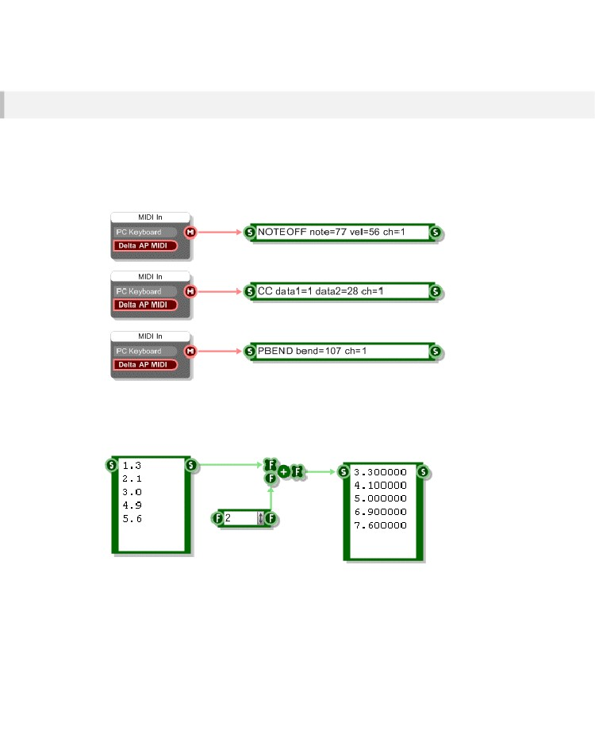
DATA TYPES & SIGNAL FLOW
MIDI <> String
Esto no es tanto una conversión como una manera práctica de revisar qué datos MIDI es procedente de un MIDI de salida. Conecte un componente de datos String y nota on / off, cambio de control y mensajes de pitch bend, etc se muestran junto con los diversos parámetros que las definen.
Como no se trata de una conversión, como tal, usted necesita MIDI "fuerza" a los enlaces de Cuerda manteniendo SHIFT + CTRL al vincular.
Float Array <> String
Usted puede convertir fácilmente entre una cadena y una red de flotadores.
- 101 -

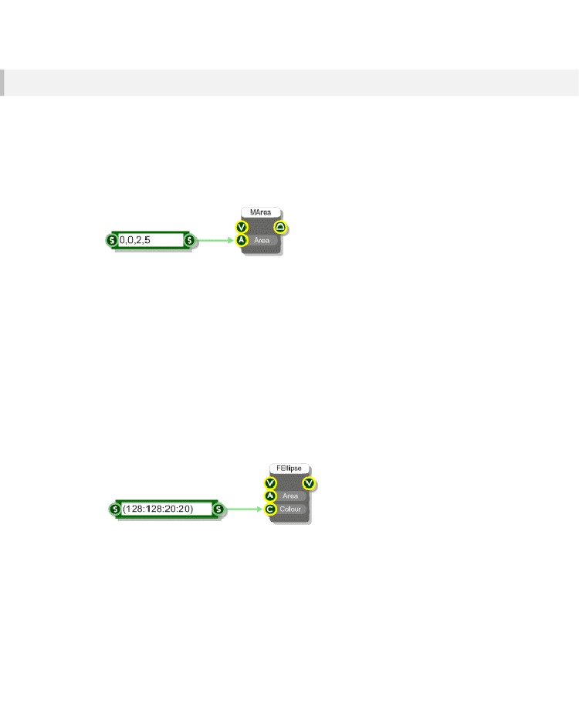
CHAPTER 5
Accesos directos de cuerda
El componente de datos String se puede utilizar como un atajo para la definición de los distintos tipos de datos de la GUI. Los colores, las Áreas, Bolígrafos y más pueden ser definidos en una única cadena de texto.
Area
Para crear un área de utilizar el formato "x, y, w, h", donde "x" e "y" dar a la esquina superior izquierda de la zona y "w" y "h" dar el ancho y alto de la zona. Todas las dimensiones están en cuadrículas, por supuesto.
Colour
There are two ways to specify a colour using a data String. You can use one of the 14 predefined
colours which are as follows:
Black, White, Red, Green, Blue, Yellow, Grey
tBlack, tWhite, tRed, tGreen, tBlue, tYellow, tGrey
(the 't' colours are partially transparent)
Use the colour by name in the String component. Note that the colour names are not sensitive to case.
The second way to specify a colour is by ARGB. Use the format "(a:r:g:b)" where a is the transparency,
r is the red component, g is the green component and b is the blue component. All values are integers
in the range zero to 255.
Pen (pluma)
Una pluma tiene tres atributos: color, grosor y estilo. El uso de un componente de la cadena se puede especificar una pluma por la prestación de estos atributos en el "color, grosor, estilo" formato.
- 102 -

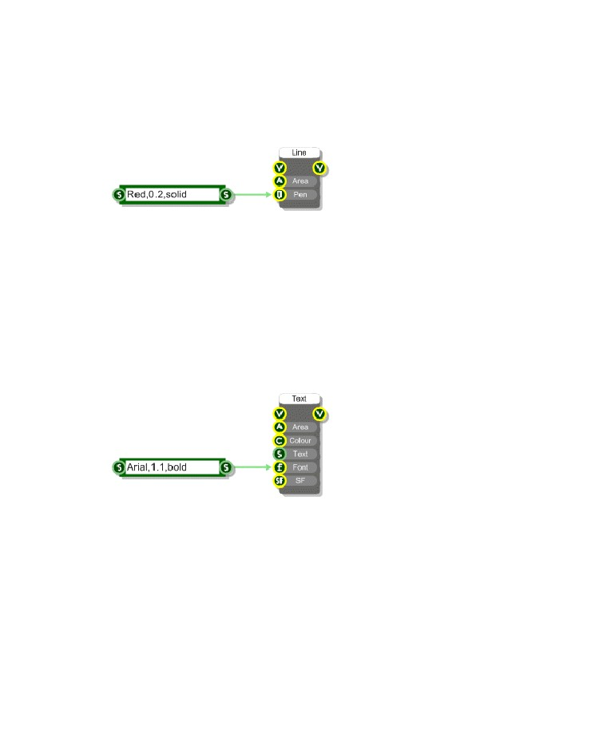
DATA TYPES & SIGNAL FLOW
The colour part is exactly the same as for specifying a colour with a string (see above). The thickness
is a floating point number in grid squares. The style can be any one of the following strings:
solid, dash, dot, dashdot, dashdotdot
You can leave the style parameter out and a solid style will be assumed.
Font
Fonts can be generated by Strings using the format "typeface,size,style". Typeface is the name of the
font face e.g. Arial or Tahoma. Size is the height of the text in grid squares (it is not a point size).
Style can be any combination of the following strings (in any order):
normal, bold, italic, underline, strike
Some examples: bolditalic, underlineboldstrike, italicunderline. You can leave the style parameter out
and a regular style will be assumed.
- 103 -

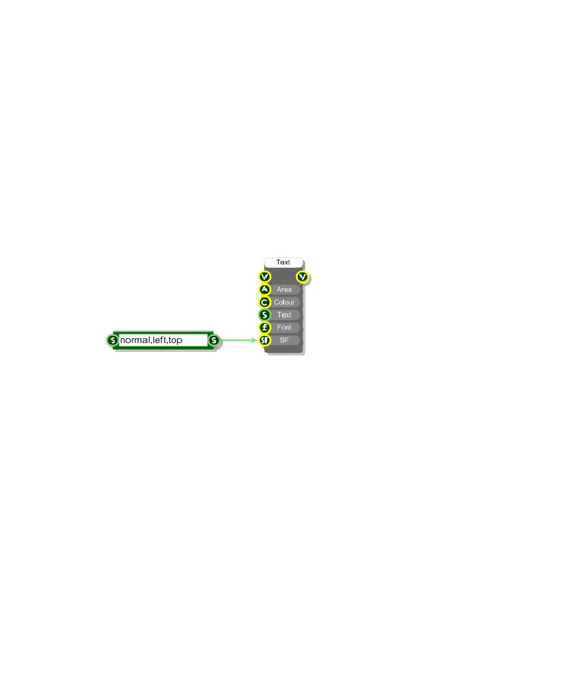
CHAPTER 5
StringFormat
StringFormats are specified using the format "style,horizalign,vertalign". The style can be any
combination of the following strings (in any order):
normal, righttoleft, nowrap, vertical
Some examples: nowrapvertical, nowraprighttoleft. You can also use 0 to indicate no style options
apply.
For horizontal alignment you can use:
left, center or right
For vertical alignment you can use
top, center or bottom
- 104 -

EXPORTING
6 Exporting
CREATING
STANDALONE APPLICATIONS AND PLUGINS
- 105 -

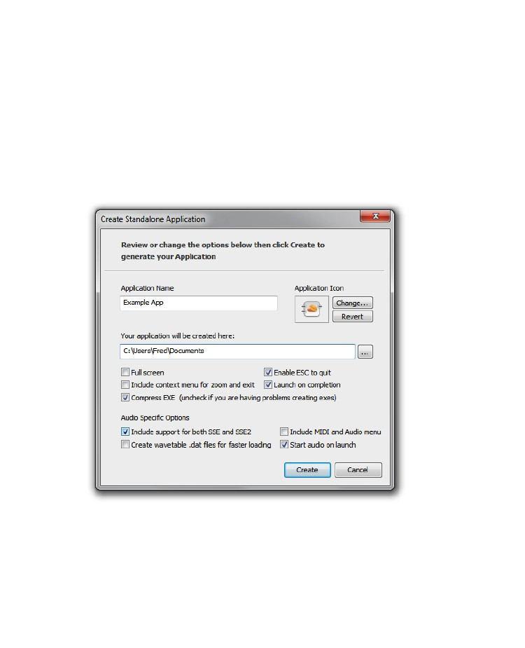
CHAPTER 6
Creating Standalone Applications
FlowStone can be used to create complete applications that will run on their own. First click the EXE
button on the action panel of the module you want to export (or right-click on the module and select
Create Standalone from the pop-up menu).
The Create Standalone Application dialog will appear.
Application Name
The application name is the name of the .exe file that will be generated. By default the software will
use the module label. If there is no label the dialog will show the last name that you used.
- 106 -

EXPORTING
Application Icon
You can choose your own icon for your application. Click Change and locate the icon you want using
the resulting dialog box. Icons need to be stored in .ico files before they can be used by FlowStone. If
you decide you just want to use the default icon click the Use Default button. A preview of the icon that
the software will use is shown on the dialog box.
Your application will be created here
Applications are created in a particular folder and you have the option to change this.
Full Screen
Check this box if you want your application to launch and fill the whole screen. This is the ideal option
for applications intended for embedded systems.
Include context menu for zoom and exit
This option determines whether the default right click menu is present in your exported exe. This menu
allows users of the exe to change zoom level, move to full screen and exit the application..
Enable ESC to Quit
This option enables the Escape key as a means of exiting your generated exe. It's useful for
applications that run in full screen where you don't want to have a Quit button or menu on the GUI.
Launch on Completion
You can choose whether to launch the newly generated application on completion by checking this
box.
Compress EXE
Exported exes are automatically compressed to decrease file size. On a very small number of systems
this has been found to interfere with the export process causing it not to work. If you are experiencing
problems of this nature then you can disable compression.
Include Support for SSE and SSE2
The PC on which you generate your exe may support SSE2 or it may just support SSE. When you
export an exe the software saves code that is optimised for the SSE capabilities of your own PC. If you
then give the exe to someone whose PC has different SSE capabilities from you the software needs to
make adjustments on loading so that the plugin will work.
- 107 -

CHAPTER 6
These adjustments can slow down the loading process. To avoid this you can choose to include
support for all SSE setups at export time. This way there is no reduction in loading speed when exes
are used on PCs with different SSE capabilities.
Create wavetable .dat files for faster loading
The Sawtooth and Sine components use wavetables. These are generated on startup but you can
choose to save them to a local .dat file in order to speed up the exe loading time.
Include MIDI and Audio Menu
For audio applications FlowStone can create exes with a default menu that allows users to select MIDI
input and Audio output. You can choose not to have this menu and either provide access to these
options through your own GUI or not provide them at all.
Launch on Completion
You can choose whether to launch the newly generated application on completion by checking this
box.
Start Audio on Launch
If this option is selected the software will attempt to open the default audio driver when the exe
launches.
Click Create and within a few seconds your application .exe will be created in the target location that
you specified. If you checked the Launch On Completion box the application window will appear.
Library Dependencies
On most occasions your exported exe can be distributed on its own. However, some components in
FlowStone are reliant on external libraries. If your project uses these components and you then export
to a standalone you will need to distribute the supporting libraries together with your executable.
You will be informed of any dependency when you export.
We provide pre-packaged installers for the libraries on our web site. You are free to distribute these in
the form they are provided. For more information see our web site page:
http://www.dsprobotics.com /libraries.html
- 108 -

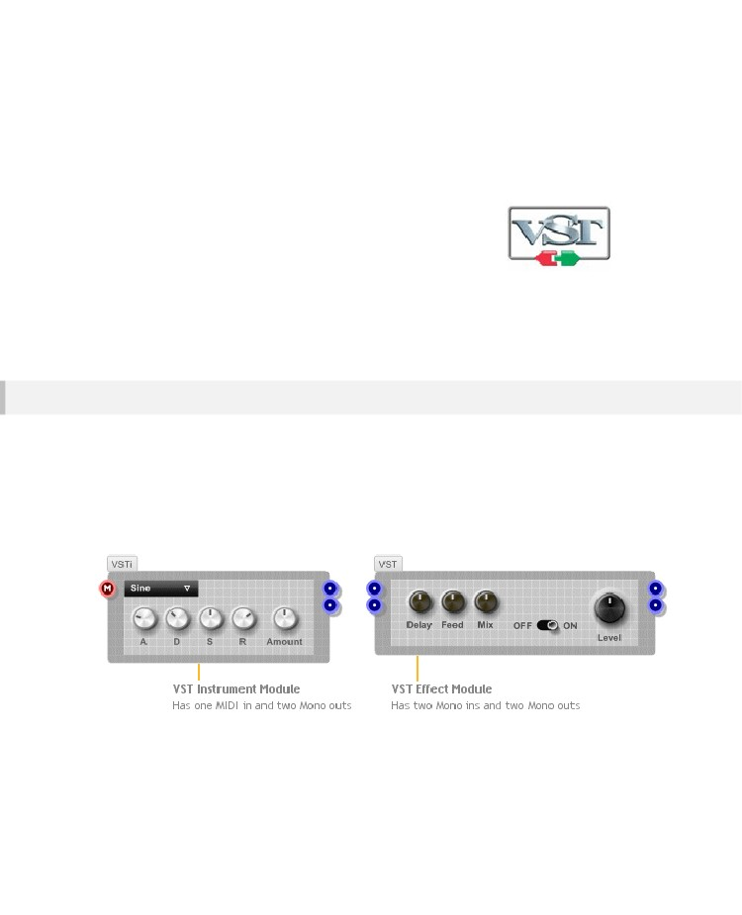
EXPORTING
Creating Plugins
FlowStone puede exportar plugins VST totalmente independientes.
VST es un formato estándar creado por Steinberg. Un plugin VST es un
procesador de efecto digital virtual o instrumento que se puede utilizar en
aplicaciones compatibles VST para crear música.
El mecanismo para la creación de un plugin en FlowStone es muy simple.
Todo lo que necesitas es un módulo con una combinación aceptable de
entradas y salidas MIDI y / o Mono.
El panel frontal del módulo (si se proporciona uno) proporcionará la interfaz de usuario de su plugin. Dentro de su módulo es necesario proporcionar las entradas y salidas necesarias entonces todo lo que ocurre en el medio es de usted.
Inputs y Outputs
Para un instrumento VST necesitará una entrada MIDI y dos salidas mono módulo. Esto permite que el instrumento para enviar datos de audio estéreo basado en señales MIDI enviados desde un host.
Efectos VST pueden variar. Usted puede crear un efecto MIDI que toma una entrada MIDI y una salida MIDI.
Para un efecto de audio estándar se necesitan dos entradas mono y dos salidas mono.
Por supuesto, usted puede tener cualquier número de entradas y salidas, pero usted necesitará un host que puede manejar el datos que está solicitando desde o enviar a la misma.
Tenga en cuenta el botón VST, y por lo tanto la opción de crear un plugin desde un módulo, no aparecerán a menos que la combinación de entradas y salidas es aceptable.

Usted puede utilizar el VST VSTi o módulos en la caja de herramientas si desea un módulo de plantilla a utilizar como punto de partida para su complemento.
- 109 -

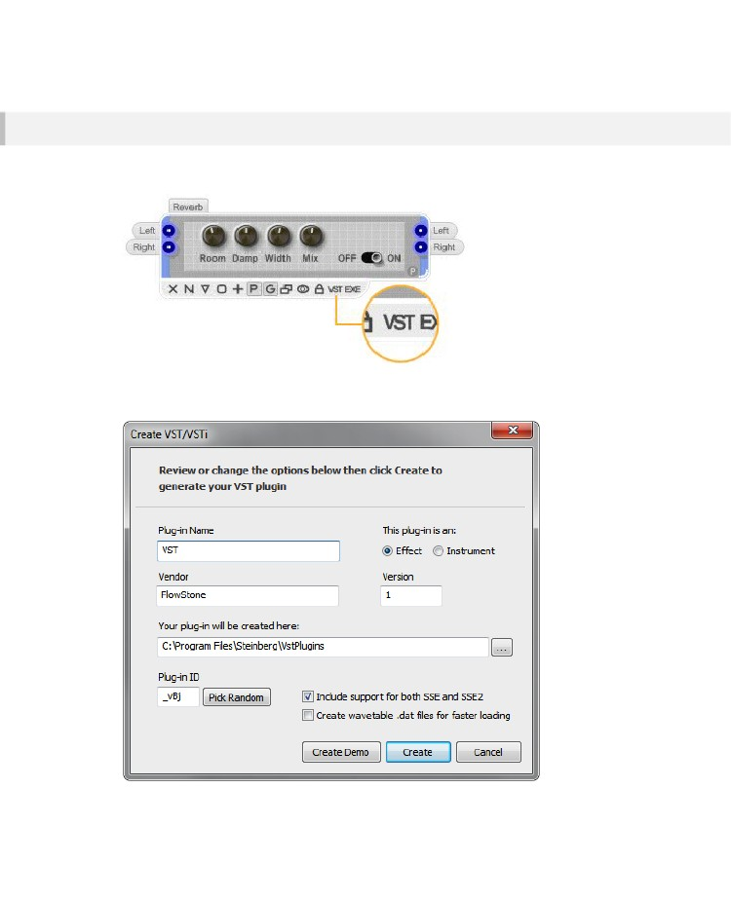
CHAPTER 6
Create VST/VSTi Dialog
To create a VST plugin, simply click the VST button on the action panel of your plugin module or select
the module and choose Create VST/VSTi from the Schematic menu.
When you click the VST button you’ll be presented with the Create VST/VSTi dialog. This allows you to
specify the various characteristics of your plugin.
- 110 -

EXPORTING
Plug-in Name
The plug-in name is the name of the dll that will be generated and the name that will be used when the
plug-in is listed in your host. By default the software will use the module label. If there is no label the
dialog will show the last name that you used.
This plug-in is an
The plugin type will be set automatically based on the combination of inputs and outputs on your
module. Basically if you have one MIDI input and two mono outputs then Instrument will be selected
otherwise Effect will be selected.
Vendor & Version
The vendor name is your name or your company name if you want to specify one. You can also set a
version number, this must be an integer value.
Your plug-in will be created here
Plugins are created in a particular folder and you have the option to change this.
Plug-in ID
You can set the four character unique ID for your plugin. This is part of the VST standard. You should
try to use an id that is not used by any other. However it is widely recognised that with the number of
VST plugins in circulation it’s almost impossible for the unique id system to work. In the majority of
hosts it is not necessary to have a unique id.
Include Support for SSE and SSE2
The PC on which you generate your plugin may support SSE2 or it may just support SSE. When you
export a plugin the software saves code that is optimised for the SSE capabilities of your own PC. If
you then give the plugin to someone whose PC has different SSE capabilities from you the software
needs to make adjustments on loading so that the plugin will work.
These adjustments can slow down the loading process. To avoid this you can choose to include
support for all SSE setups at export time. This way there is no reduction in loading speed when plugins
are used on PCs with different SSE capabilities.
Create wavetable .dat files for faster loading
The Sawtooth and Sine components use wavetables. These are generated on startup but you can
choose to save them to a local .dat file in order to speed up the plugin loading time/
Click Create and within a few seconds your plugin dll will be created in the target location that you
specified.
- 111 -

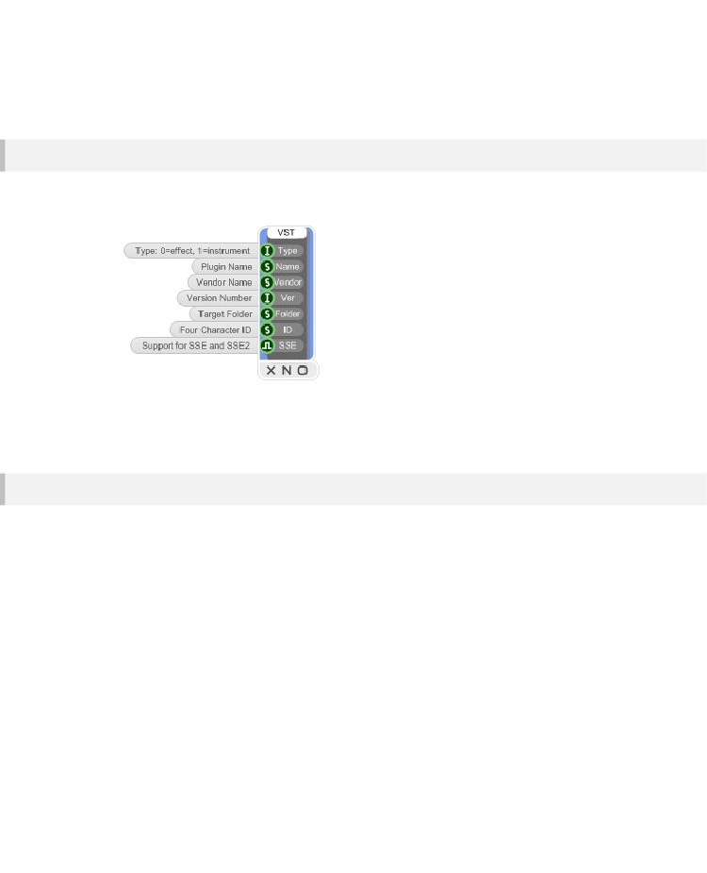
CHAPTER 6
To create the plugin click the Create button. You can also create a demo version. This will insert
intermittent noise bursts into your plugins.
Storing VST Export Preferences
In order to preserve the settings you want to use in the Create VST/VSTi dialog you can add a VST
Plugin Info component to your module. This has inputs for all the parameters in the dialog.
With nothing connected to an input the default value will be used. However, if you provide a value for
any of the inputs the corresponding field in the dialog will be filled out with this value when you press
the VST button.
Presets
Most VST plugins include a set of preset data that you can use to instantly call up collections of
parameter settings. FlowStone includes support for presets. All the standard controls (knobs, sliders
etc.) already contain components for storing and preset data. To make use of this all you need to do is
add a Preset Manager component inside your plugin module.
- 112 -

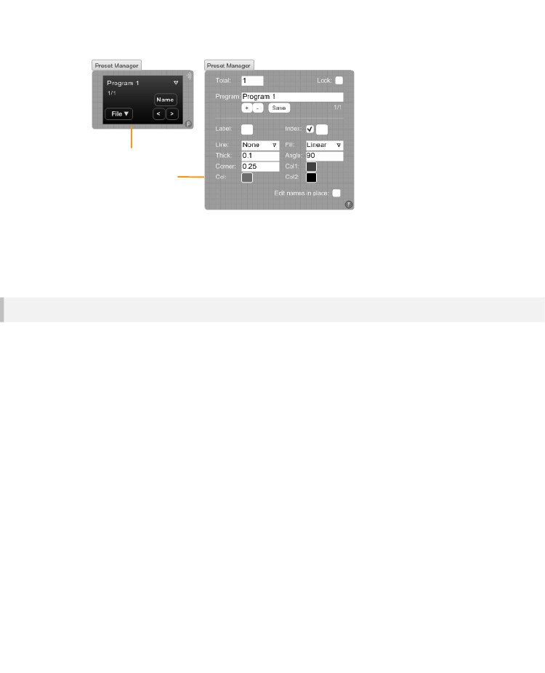
EXPORTING
Preset Manager module
...with properties open
Use the Preset Manager properties to set the total number of programs, their names and whether the
preset data is to be locked or not. When presets are locked any changes you make to them are lost
when you change program – this applies to exported plugins as well as inside SynthMaker.
Timing Info
Some VST plugins depend on information that is sent from the host application where it is being used.
Typical examples are the sampling rate, tempo and whether the host sequencer is playing. You can get
access to such information using special components. These components are:
Sample Rate, Tempo, Time Signature, Delay Compensation, Is Playing, Bar Start Position, Sample
Position, PPQ Position, VST Editor Open.
For information on how these work please refer to the components reference guide..
- 113 -

CHAPTER 7
7 Advanced GUI
Editing
THE
GUI COMPONENTS AND HOW TO USE THEM
- 114 -

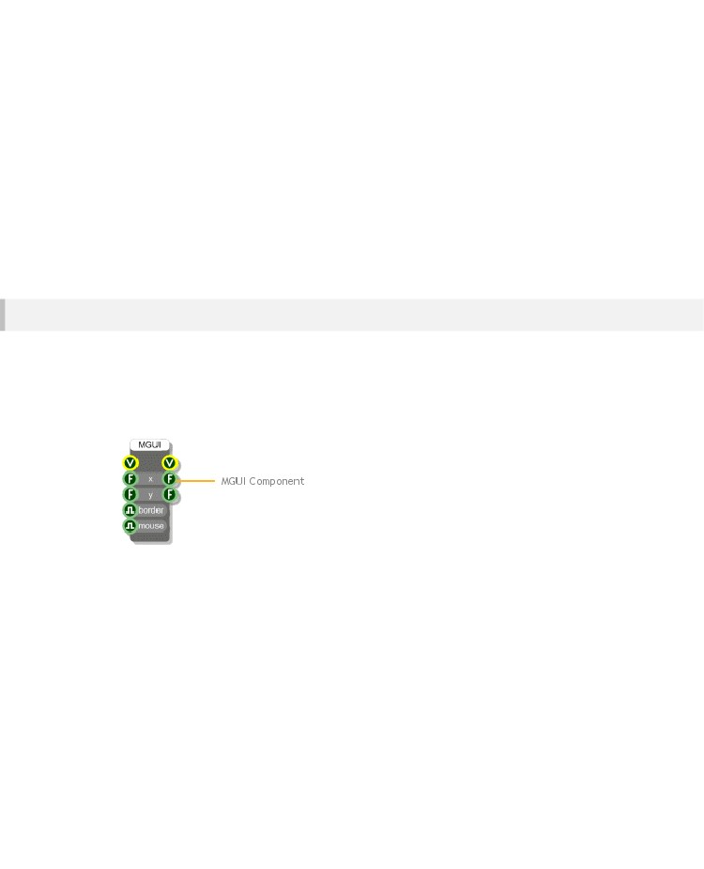
ADVANCED GUI EDITING
Module GUI
En el capítulo Módulos aprendimos cómo habilitar el panel frontal de un módulo, agregar elementos a ella y moverse a su alrededor. Utilizamos deslizadores, perillas e interruptores de la caja de herramientas.
Son ellos mismos los módulos pero sus paneles frontales se construyen utilizando componentes GUI.
En este capítulo se verá cómo crear sus propios paneles frontales con los componentes GUI. Trabajar a este nivel tienes un control completo sobre todos los detalles de cómo su panel frontal se ve y se comporta.
Module GUI Component
Ya hemos visto que el punto de partida para cualquier GUI en FlowStone es un módulo. Los módulos proporcionan la base sobre la que una interfaz gráfica de usuario se puede construir a través de su panel frontal. Puede activar el panel frontal pulsando el botón G en el panel de acción.
Sin embargo, si desea utilizar los componentes GUI es necesario tener acceso al panel dentro de su esquema y esto se hace a través del componente de interfaz gráfica de usuario del módulo (o MGUI para abreviar)
- 115 -

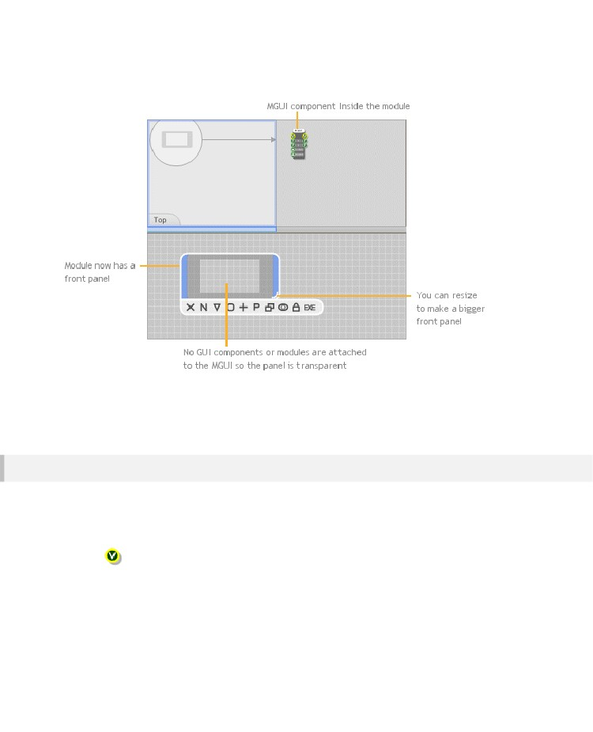
CHAPTER 7
Cree un nuevo módulo a continuación, colocar un componente MGUI interior. Usted puede encontrar el componente MGUI bajo
el grupo del filtro del módulo en la caja de herramientas.
Si se muda de nuevo a un nivel superior usted verá que el módulo ahora se ve un poco diferente. Ahora cuenta con un panel frontal, aunque con nada en él. Puede cambiar el tamaño del módulo para que el panel más grande o más pequeño. También puede observar que el botón G se ha eliminado desde el panel de acciones.
MGUI Connectors
All GUI information is sent through View connectors. These are yellow circles with a V in the middle.
The MGUI has one View output. Anything connected to this will either draw onto the front panel or
handle mouse messages from it.
View – handles all drawing and mouse messages
The two Float outputs can be used to get the size of the front panel if this is needed.
For the moment you only need to know about the output connectors. The input connectors come into
play when things start getting more advanced. We'll cover this in a later section.
- 116 -

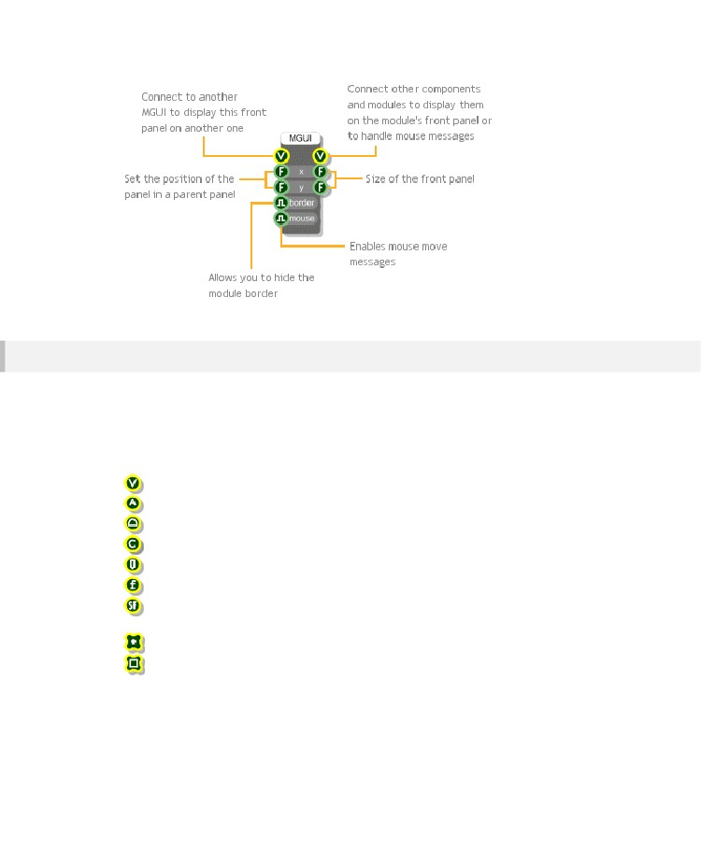
ADVANCED GUI EDITING
GUI Connector Types
The GUI components introduce a new set of data types. Each type has it's own connector and each
connector has it's own symbol. However, the symbols all have the yellow circle in common to show
that they are GUI related.
We saw these first in the chapter on Data Types:
View – transports all drawing and mouse information
Area – an are defined by coordinates of top-left corner, a width and a height
Mouse – mouse events (left button up/down, mouse move etc.)
Colour – in argb format (‘a’ is the transparency level)
Pen – for drawing lines – defined by colour, thickness and style
Font – font information comprising typeface, size and style
String Format – alignment information for drawing text
Bitmap – 32bit image
Point Array – an array of points (floating point pairs)
Bitmap Array – an array of bitmaps
- 117 -

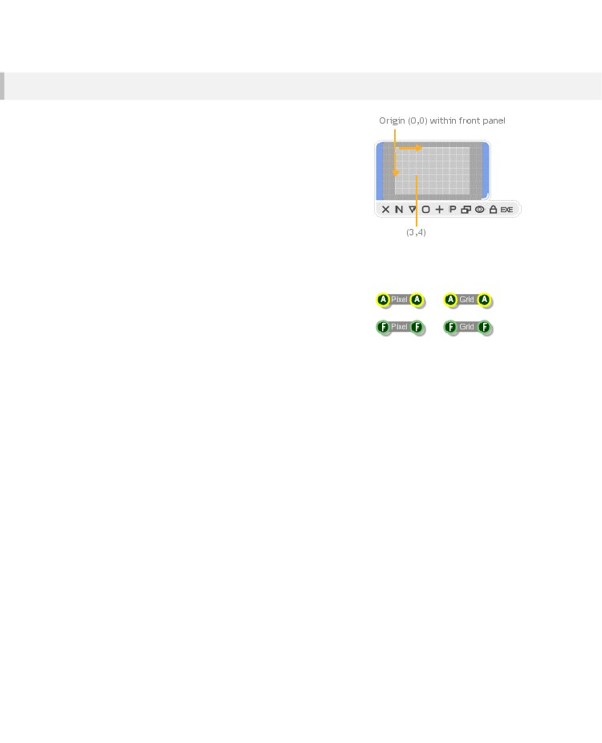
CHAPTER 7
Coordinate System
FlowStone uses a grid system to position components. Exactly
the same grid system is used by the vast majority of GUI
components for drawing and for mouse events.
The grid system is floating point based so you can have
fractions of a grid square. This allows for more precise
positioning of drawing elements.
Of course there's no getting away from the fact that the screen
uses pixels and that these form a discrete grid of points. But by
using special rendering techniques, FlowStone can still display
graphics as if they were on a continuous surface.
Working in Pixels
Sometimes you need to work in pixels instead of grid squares.
To do this you can make use of the Grid Square to Pixel and
Pixel to Grid Square components to move between the two
systems.
- 118 -

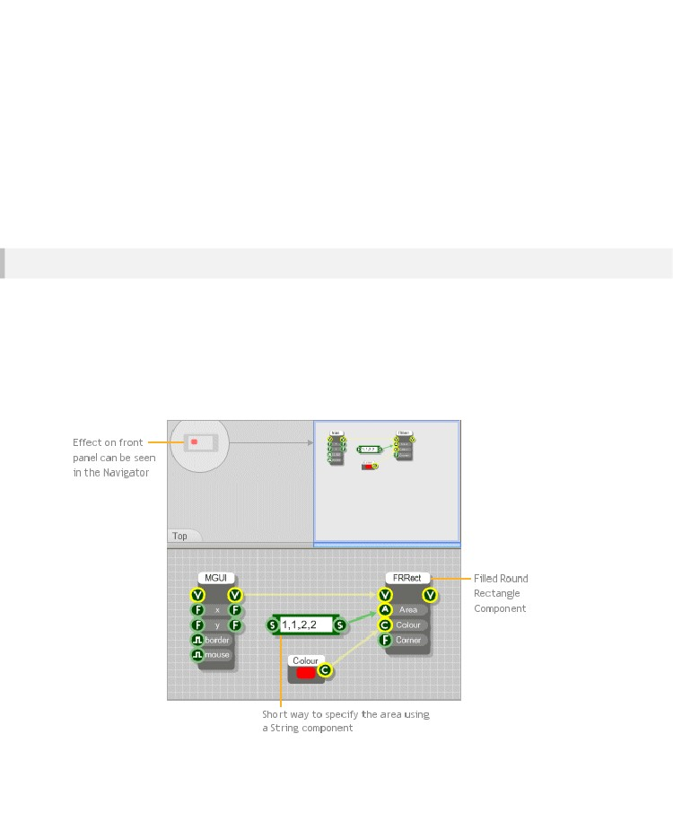
ADVANCED GUI EDITING
Drawing
This section describes how to draw using the GUI components. With the introduction of the Ruby
component you can now also draw using Ruby code. This is now the recommended way of drawing in
FlowStone. For more details see the Drawing section in the Ruby Component chapter.
Drawing on a Panel
Drawing on a front panel is a simple matter of picking a drawing primitive and connecting the View
output of the MGUI to the View input of the primitive.
All the drawing primitives can be found by selecting the GUI filter group. There are primitives for
drawing lines, rectangles, text, bitmaps and more.
The example below shows how to draw a simple filled rectangle. We've used a little shortcut to specify
the Area for the rectangle. This makes use of a string component to specify the x,y,width and height
that define the Area. The colour is defined using the colour component.
- 119 -

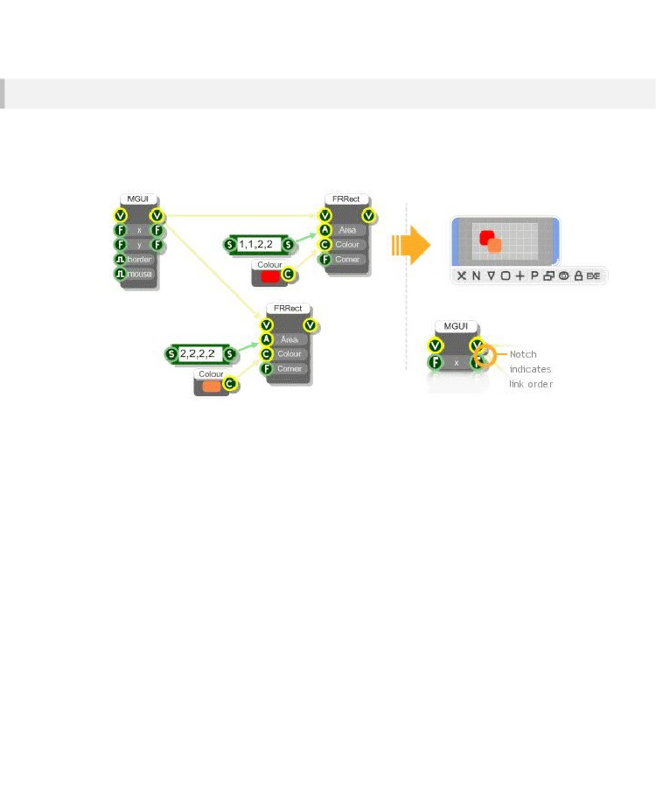
CHAPTER 7
Drawing Order
Often you'll be drawing more than one element on a front panel. If two elements overlap then the one
that is last in the link order will be displayed last and therefore over the top of the other element.
The example below shows this. The orange rectangle is on the second link from the MGUI (see Links
for more on link order). The orange rectangle will therefore be drawn on top of the red one.
- 120 -

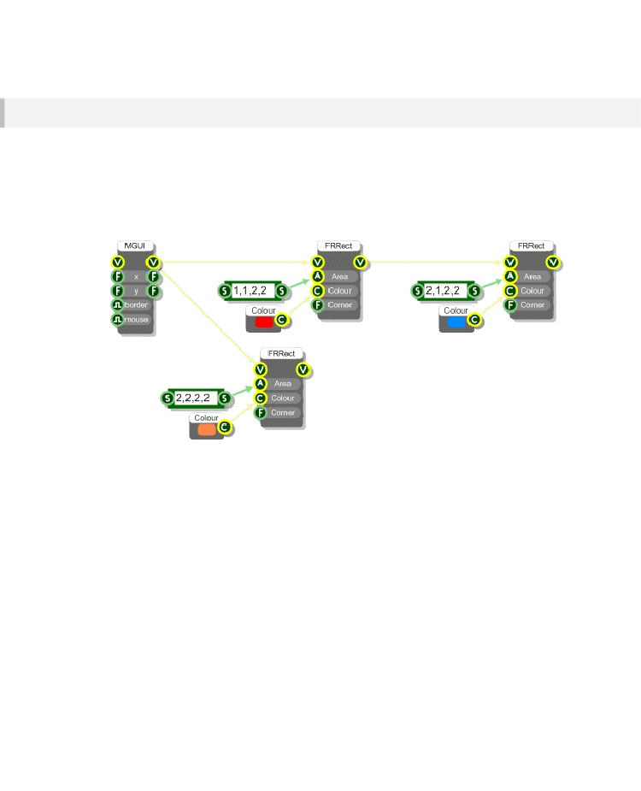
ADVANCED GUI EDITING
Chaining GUI Components
Most GUI components have a view output connector. This allows other GUI components to be linked
to them so chains of graphical elements can be created.
The example below shows how this is done. The effect on the link order is as follows: the link to the
red rectangle is taken first followed by any links from it's output connector. Then it's back to the next
link from the MGUI etc. In this example the red rectangle would be drawn under the blue one which
would then be under the orange one.
- 121 -

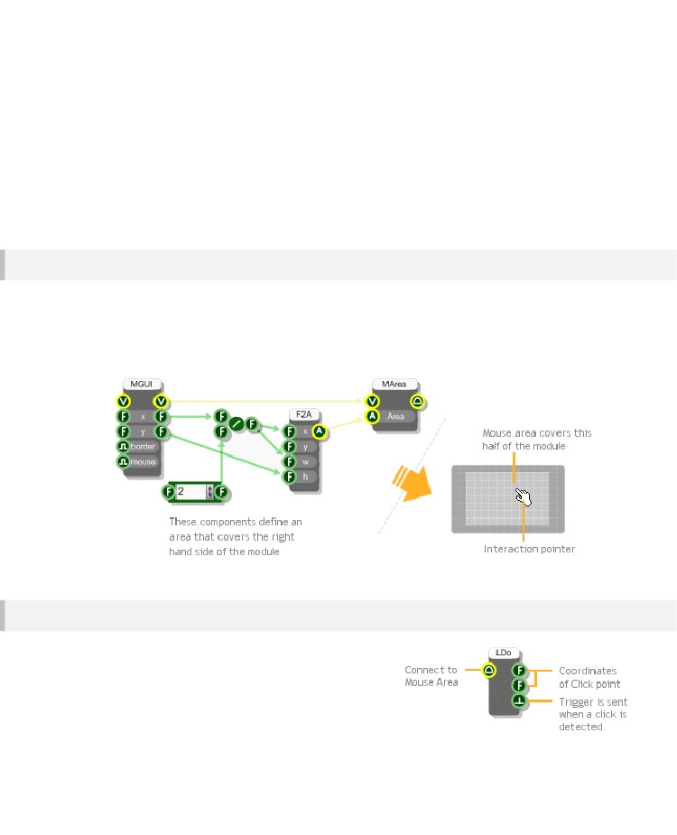
CHAPTER 7
Mouse Handling
This section describes how to handle mouse interaction using the Mouse components. With the
introduction of the Ruby component you can now also do this using Ruby code. For more details see
the Interaction section in the Ruby Component chapter.
Mouse Area
In order to receive mouse messages in a part of your front panel you must first define a mouse area.
This is done using the Mouse Area component.
The example below shows how the right half of a module can be made to receive mouse messages.
This is indicated by a change in cursor as the mouse pointer passes over the mouse area.
Mouse Clicks
To trap mouse clicks on a mouse area you'll need a Mouse L-
Button Down component. Link the Mouse output connector on
the Mouse Area component to the input on the Mouse L-
Button Down component.
- 122 -

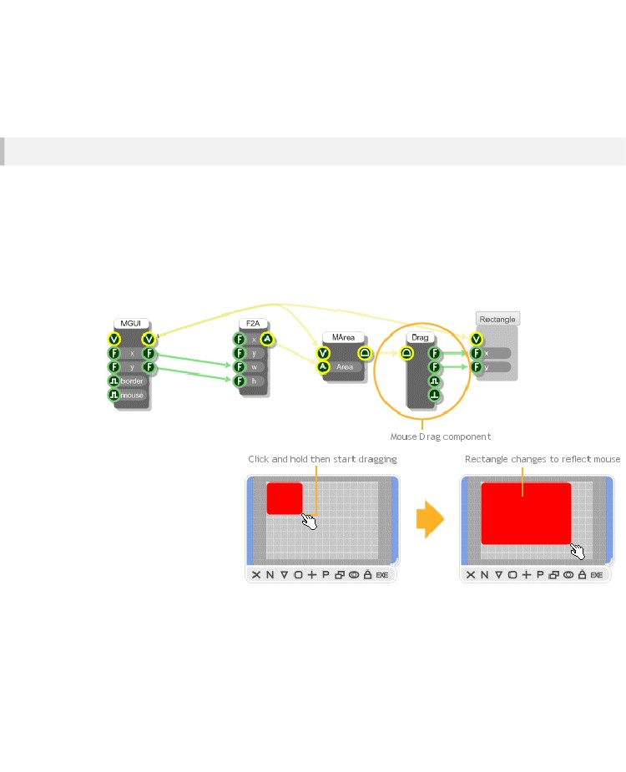
ADVANCED GUI EDITING
Whenever you click in the mouse area a trigger will be sent to the Trigger output on the Mouse L-
Button Down. The coordinates of the click point (in grid squares) will be available from the two Float
outputs.
Mouse Dragging
You can track the mouse position while the left mouse button is held down. This allows you to
implement drag operations.
The component you need to do this is the Mouse Drag component. This takes Mouse messages at it's
input and sends the coordinates to it's two Float outputs as you drag.
The example below shows how the Mouse Drag component can be used to change the size of a
rectangle. We've created our own rectangle module to handle the drawing in this example. This makes
the schematic a bit neater.
- 123 -

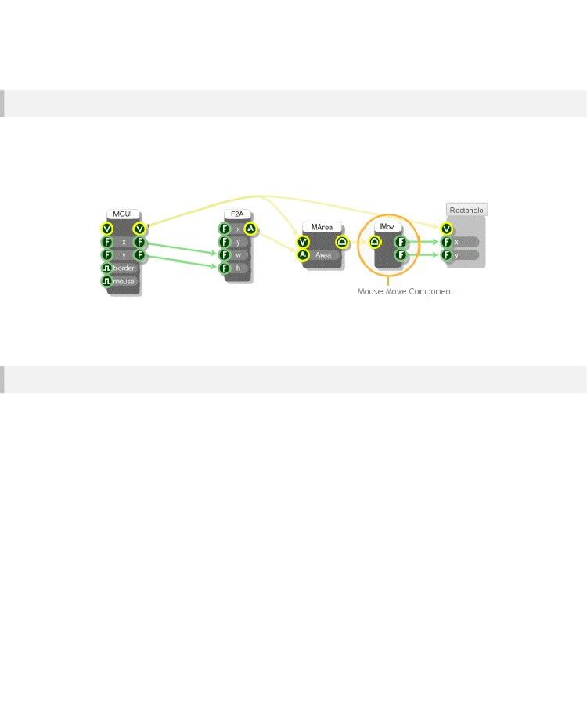
CHAPTER 7
Mouse Moves
You can also track the mouse as it moves over a mouse area. This is done using the Mouse Move
component. Before you can use this you need to enable mouse move messages on the appropriate
MGUI component. Mouse move messages are disabled by default to reduce unnecessary
performance overheads.
Try replacing the Mouse Drag component in the previous example with a Mouse Move component and
you’ll see how this works.
Drag Accumulate
The Mouse Drag component is a bit too low-level for some tasks. If you want to create a slider or
anything with moving parts that can be dragged around then it's much easier to use a Drag
Accumulate component.
Drag Accumulate components manage much of the legwork of drag operations for you. There are
three varieties: X, Y and XY.
The Y Drag Accumulate manages a parameter that varies over a particular range. When you drag the
mouse, the offset from the point where you clicked is maintained by the component. As you continue
dragging the parameter is updated according to the Y position of the mouse and a scale value that you
can specify.
- 124 -

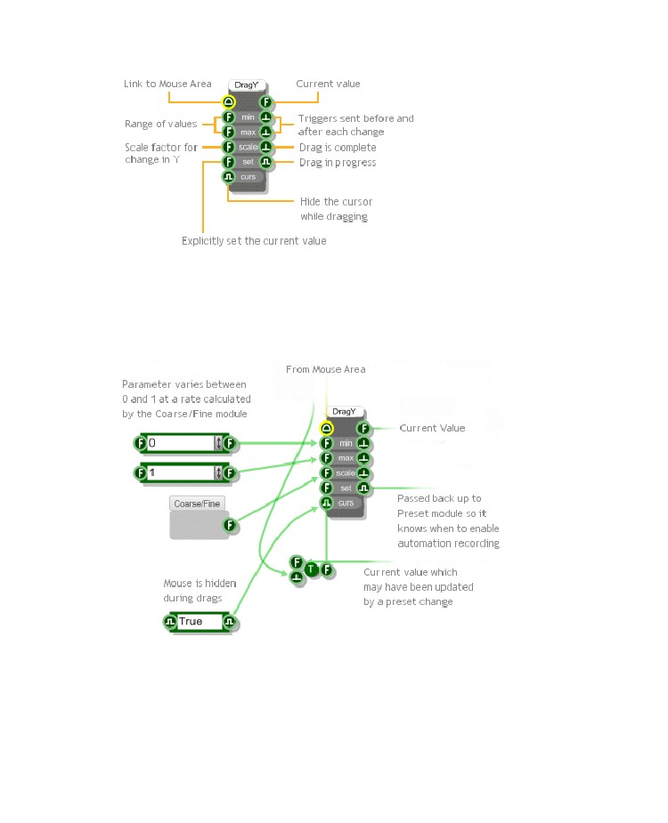
ADVANCED GUI EDITING
If you have a look deep inside the Bitmap Knob module in the toolbox you'll see how the Y Drag
Accumulate component is used. Move through the following modules:
Bitmap Knob\Knob\Interaction\Knob\Control\Moving Part\Knob Control
Inside the Knob Control module and you'll see the Y Drag Accumulate in the middle. The picture below
explains what's going on.
- 125 -

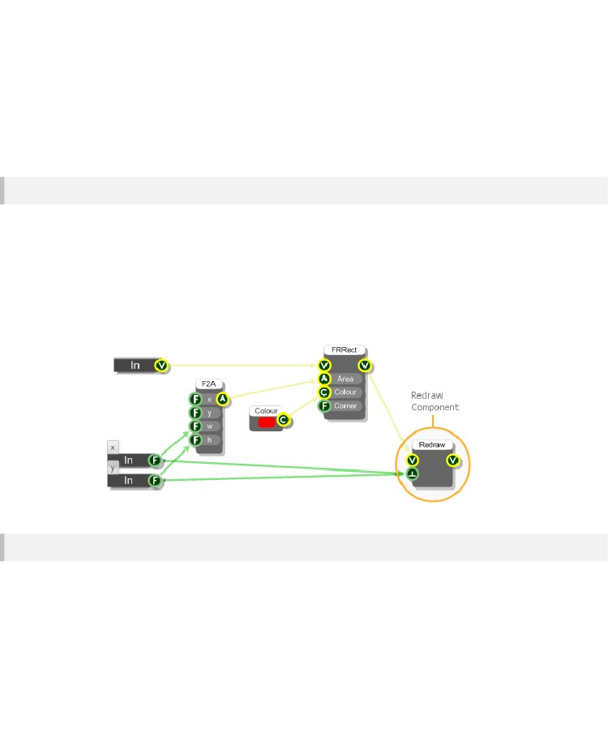
CHAPTER 7
Redrawing
Redraw Control
If you change a property of a drawing element during a mouse operation like dragging, you'll often
want the changes to be reflected immediately in the module front panel.
To allow for maximum flexibility FlowStone allows you to control when parts of the front panel are
redrawn. In the rectangle dragging example we used the simplest kind of redraw - we just forced the
whole panel to refresh. This was done using the Redraw component.
If you look inside the Rectangle module you'll see the Redraw component. When the component
receives a trigger it sends a message back up through the View links to the first MGUI it finds. When
the MGUI receives the message it redraws everything on it's front panel.
Precision Redraws
Redrawing the whole panel each time can be slow when the area is large (try resizing the module in
the example above so that it's very big - you'll notice that dragging becomes sluggish).
Often only a small area of the panel is changing at any one time so it's much more efficient to redraw
only the bit that has changed. For this purpose we have the Redraw Area component. This works in
exactly the same way as the Redraw component except that it only redraws the area that you supply to
it's Area input.
- 126 -

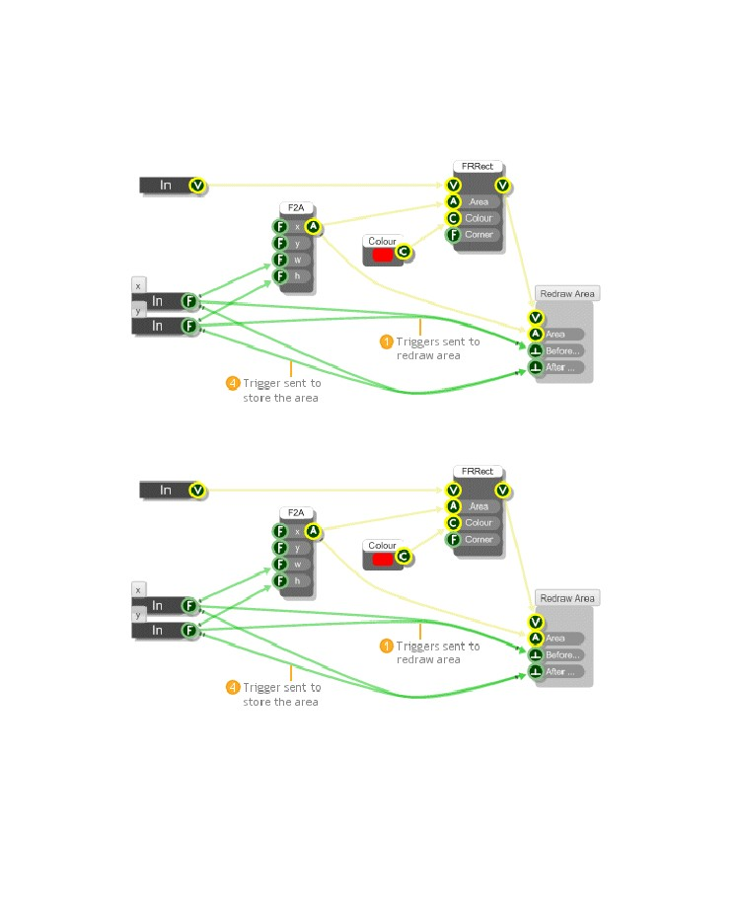
ADVANCED GUI EDITING
We've modified the drag rectangle example so it uses the Redraw Area component. Unfortunately it's
not just a simple case of linking the rectangle area to the Redraw Area component. This is because the
area before the last mouse move may need to be redrawn too. What we need is the combined area of
the old and the new rectangles.
For this example we've created a module that handles the storage of the old area and it's combination
with the new area. This uses an Area Sample and Hold to keep the old Area for when it's needed.
- 127 -

CHAPTER 8
8 Ruby
Component
A WORLD OF POSSIBILITIES
- 128 -

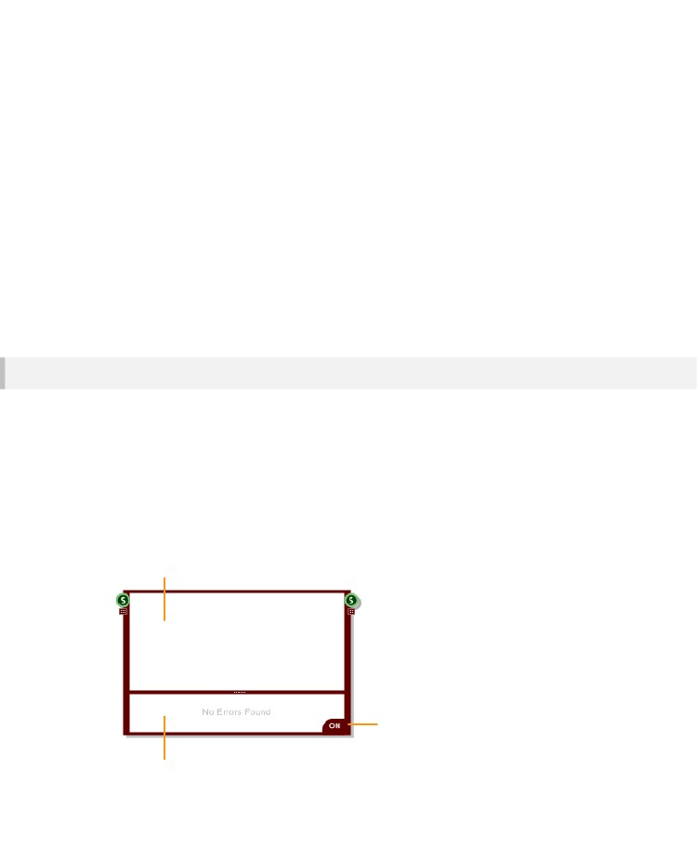
RUBY COMPONENT
Introduction
El componente de Ruby es, con mucho, el componente más flexible en la caja de herramientas FlowStone. Encapsula el lenguaje completo Ruby, que permite pasar de los datos a través de un sistema de eventos precisa eficiente del tiempo y se integra plenamente con FlowStone desencadenó tipos de datos, eventos de ratón y gráficos.
El componente de Ruby puede ser utilizado para cualquier cosa, desde simples ecuaciones a las bibliotecas de clases complejos, la interacción del usuario y procesamiento de gráficos. Realmente se abrirá un mundo de posibilidades.

Para el resto de este capítulo se asume un conocimiento básico del lenguaje Ruby que no está cubierto en esta guía. Si desea una gran referencia que recomendamos el siguiente sitio:
http://www.ruby-doc.org/docs/ProgrammingRuby
Overview
El componente de Ruby se divide en dos mitades. En la parte superior es el Editor de código. Haga clic aquí y escriba su código Ruby.
A continuación el editor es el Panel de salida. Esta área muestra los mensajes de error, la salida de código evaluado y valores de datos vistos. Puede cambiar el tamaño relativo de las áreas del Editor y salida arrastrando la barra separadora.
El botón On / Off se puede utilizar para evitar que el código Ruby de ser evaluado. Esto puede ser útil si se desea escribir código que podría generar inestabilidad mientras se escribe en (bucles while son un ejemplo de ello).
Code Editor
On/Off Button
Output Pane
- 129 -

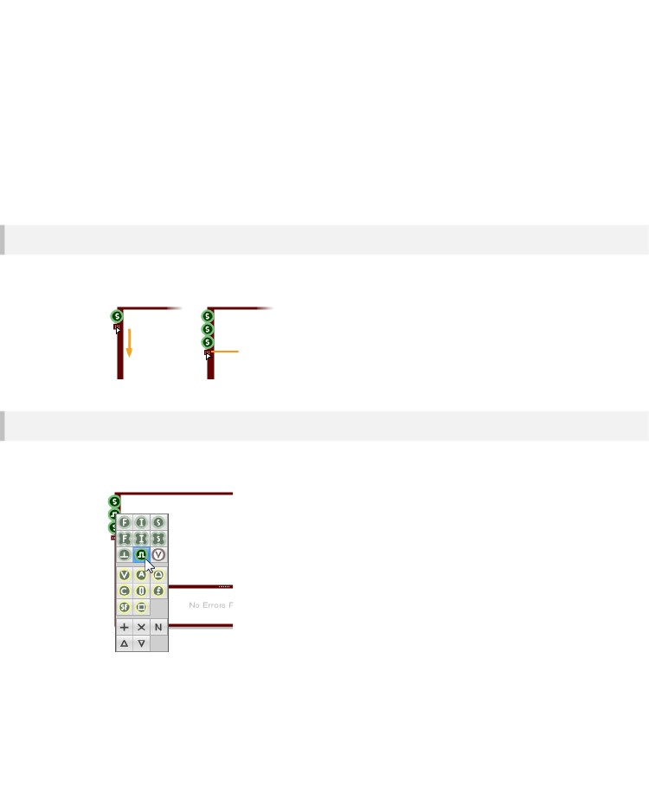
CHAPTER 8
Inputs and Outputs
The Ruby component can interface with most other triggered data types in FlowStone. By default the
component has one String input and one String output.
Adding or Removing
To change the number of inputs and outputs just click and drag the handles under the bottom most
connectors.
Drag handle down to add more
connectors or up to remove them
Changing Type
To change the type of a particular connector simply right-click on the connector and choose the type
from the resulting menu. This is similar to the way you can set the type for a Module Input or Output.
- 130 -

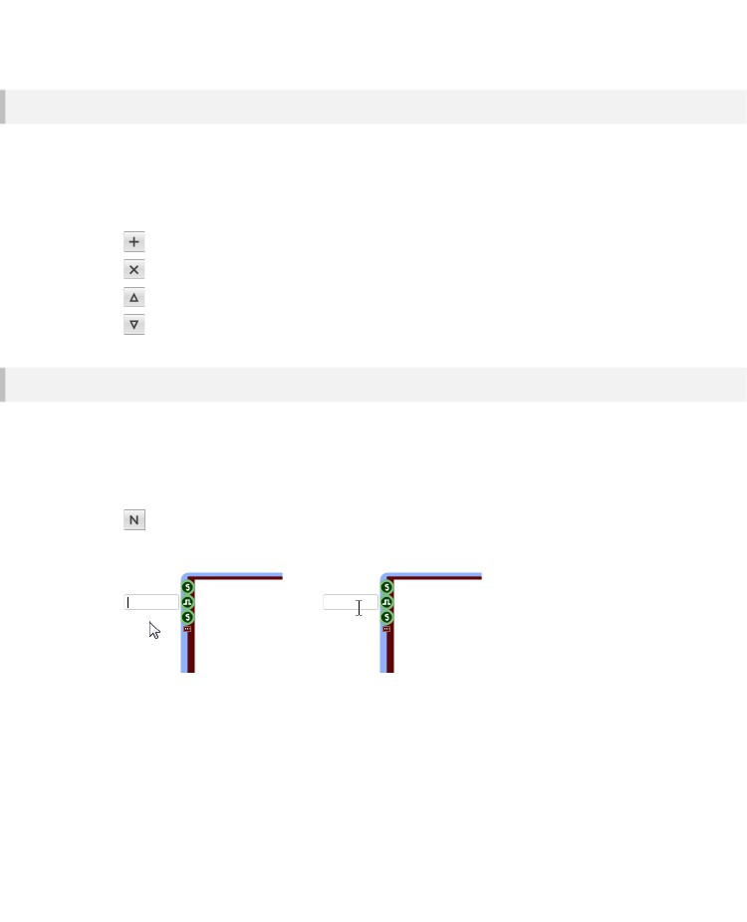
RUBY COMPONENT
Inserting, Deleting and Moving
If you don't want to upset the configuration of connectors you already have then you can add or
remove at a specific point.
These operations are performed by right-clicking on a connector. The right-click menu has a number of
buttons at the bottom for deleting or moving the connector you've click on or for adding a connector
below it.
- adds a new connector below the one you clicked on
- deletes the connector you clicked on
- moves the connector up one place in order
- moves the connector down one place in order
Naming
It's useful to be able to name connectors, not only for readability (so it's clear what the data represents)
but also because in the case of input connectors the label can be used within your Ruby code as a
variable or as a reference to an input.
There are two ways to add connector labels. First you can right-click on the connector and then click
the N button.
- opens up an in-place edit box where you can name or rename the connector
Type the name in the resulting edit box and hit the Return key.
Another way to name connectors is to first select the Ruby component then hold CTRL and hover the
mouse near the connector whose label you wish to edit. An I-Beam cursor will appear together with a
text box boundary. Click in the text box, type the name and hit return.
If you want to set multiple labels at once simply tab between the labels instead of hitting the Return
key. If a connector already has a label you can use the same methods as above to edit it.
- 131 -

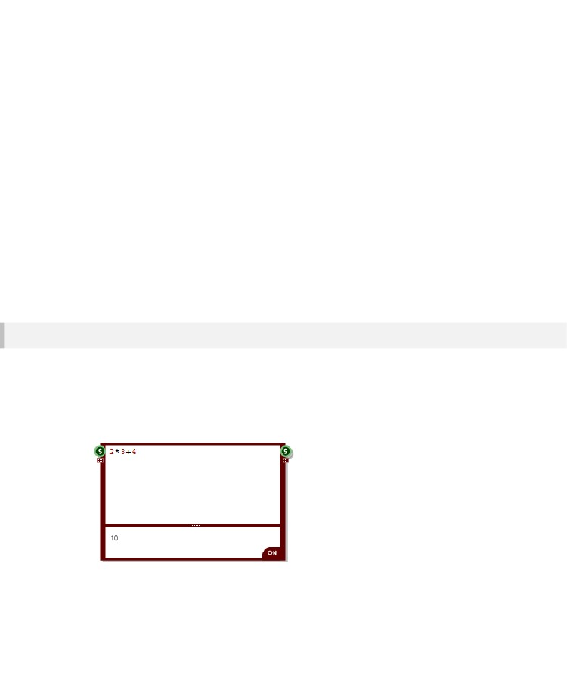
CHAPTER 8
Code Editor Basics
El editor de código es donde toda la acción sucede. Esto es donde se escribe el código Ruby, que lo procesa los datos de entrada y enviar ningún resultado a la salida (s).
El editor tiene coloreado de sintaxis para hacer el código más legible. Es compatible con todas las operaciones que usted esperaría incluyendo cortar, copiar y pegar, barras de desplazamiento automático y rueda de desplazamiento del ratón.
Hemos utilizado el hecho de que Ruby es un lenguaje extensible para implementar una serie de clases y palabras clave específicas Flowstone. También hemos definido un conjunto de métodos que se pueden implementar en su código para que con más fuerza se puede integrar con FlowStone.
El resto de esta sección se supone que sabe lo que Ruby es y tener un conocimiento básico de lo que es una clase de Ruby, el método y la variable es.
The Output Pane
Antes de entrar en el quid de la cuestión, una charla del Panel de salida.
El editor de código y panel de salida trabajan juntos.

Cualquier error o salida desde el código que escribe en el editor se muestran en el panel de salida. Por ejemplo, puede escribir cualquier expresión matemática válida en el componente de Rubí y el resultado evaluado se muestra en el panel de salida..
The example above shows 10 as the result of 2*3+4.
- 132 -

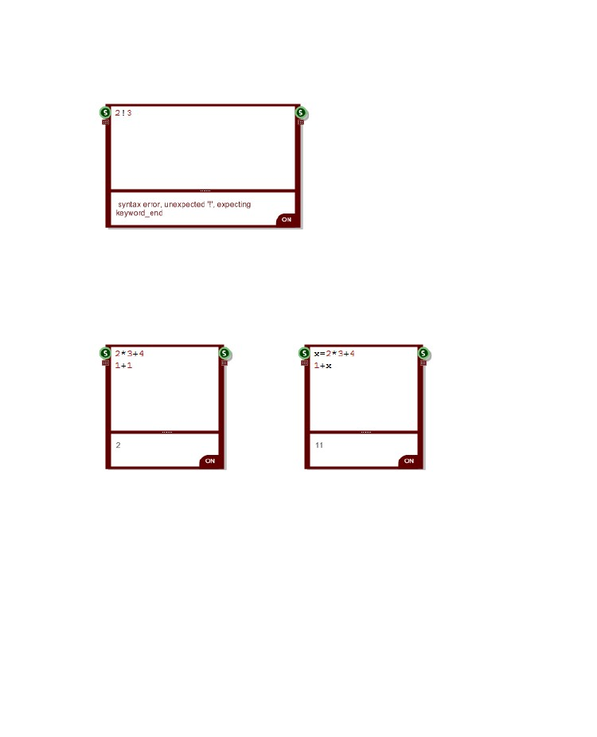
RUBY COMPONENT
Escriba una expresión válida o cualquier sintaxis que provoca un error y te sale un mensaje de error en lugar.
Tenga en cuenta sólo se muestra el primer error encontrado.
Como se puede ver, se muestra el mensaje de error en rojo para diferenciarlo de salida evaluada.
Tenga en cuenta los mensajes de error vienen directamente de la intérprete de Ruby.

A veces pueden parecer ajenas al error. Sin embargo, el componente de Rubí evalúa su código mientras está escribiendo lo que si un error hace estallar para arriba usted sabrá exactamente lo que lo causó

Una última cosa a destacar es el panel de salida sólo muestra el valor de la expresión última evaluada. Tome los siguientes ejemplos:
En el componente de la izquierda se evalúa la primera expresión, seguida por la segunda expresión. El segundo es el último y por lo que este se envía al panel de salida.
En el componente de la derecha pasa lo mismo. Sin embargo, con el fin de mostrar que la primera expresión de hecho se vuelve a evaluar hemos asignado su resultado a una variable (x) y luego se usa esta expresión en el segundo.
Ahora sabemos lo suficiente sobre el Panel de salida para proceder a las cosas más emocionantes.
- 133 -

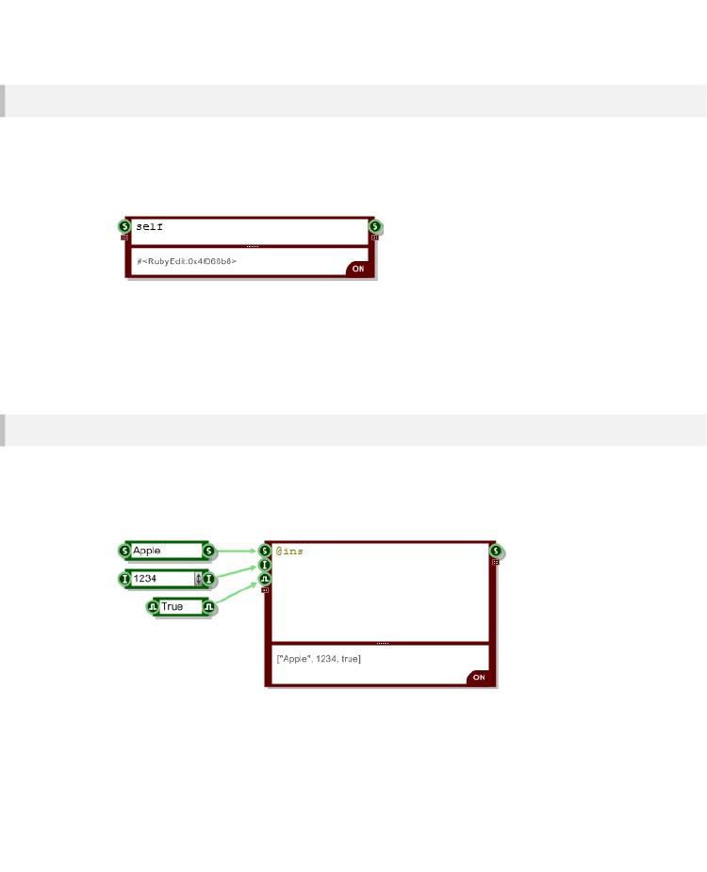
CHAPTER 8
The RubyEdit Class
Cada componente de Ruby está representado por una instancia de la clase RubyEdit.
Esta es una clase que hemos definido en FlowStone para representar el componente de Ruby.
Hemos definido los métodos y variables de instancia que le permiten comunicarse con el componente. Estos proporcionan la interfaz entre el código Ruby y FlowStone
Typing self into the Ruby component will return the instance of the RubyEdit class that represents that
component. In the above example you can see the instance representation in the output pane.You can
also use the instance variable @this instead of self.
All code you type in a Ruby component is executed within the context of the RubyEdit object that
represents it.
Input Data
Data that arrives at a Ruby component is stored in an instance variable called @ins. This is a Ruby
array and it stores the last value to arrive at each input.
You can look at this by simply typing it into the component. Note that instance variables are coloured
gold in the code editor.
To access the value at any input use the Ruby Array element reference []. Values are zero indexed so
to get the value at the second input use @ins[1].
It's quite common to have only one input so we've added another instance variable called @in that
references this first input value directly.
- 134 -

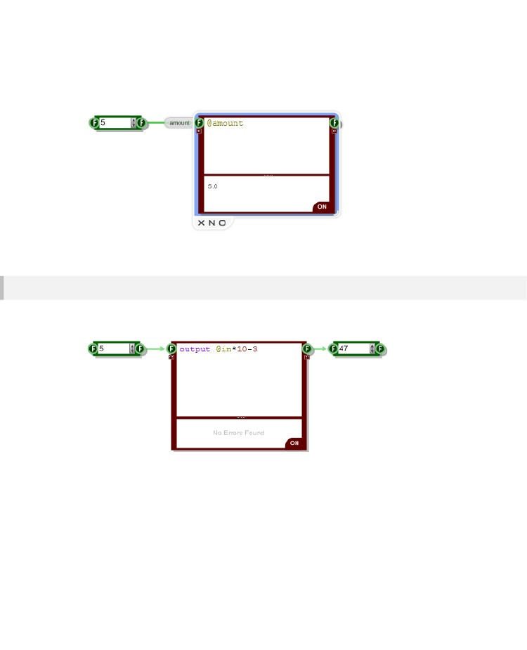
RUBY COMPONENT
Input Labels
If you set a label for your input then this is automatically translated into an instance variable that you
can use within your Ruby code.
Note that as the variable is an instance variable it must be preceded with the @ symbol.
Output Data
As well as receiving data from FlowStone you can of course send data out. To do this use the output
method.
Note that output is not a keyword, it's a method of the RubyEdit class. Usually you would invoke a
method on an object. However, in the case of the Ruby component all code is evaluated in the context
of the RubyEdit instance that represents it.
You could just as easily write self.output and you'd get the same result.
For this reason methods of the RubyEdit class are shown in purple so that you can distinguish them
from Ruby keywords (which themselves show in blue) and inherited methods (which show in black).
- 135 -

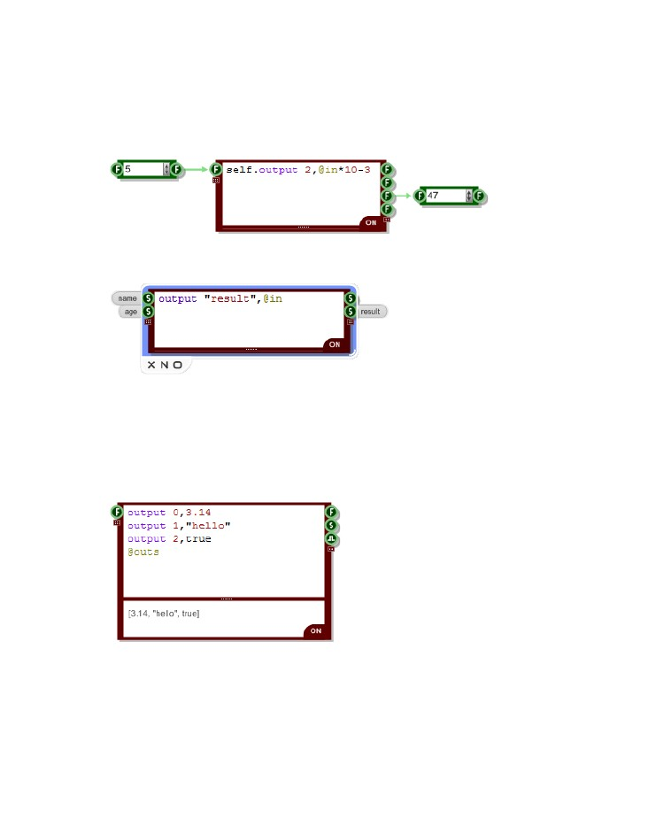
CHAPTER 8
Specifying an Output
In the previous example no output was specified and so the result is sent to the first output. If you want
to specify a particular output then you add this as the first input to the output method.
The value can be the index of an output connector (starting from zero) as shown below:
Or it can be the label of an output connector if you've specified one:
Storage of Outputs
Just as the input data was stored in a Ruby Array we do the same for the output data. The very last
value sent to an output is stored in an Array called @outs.
You can inspect the contents of this array in the same way as for the inputs array. This can be useful
when debugging.
You can change the contents of the @outs array. This can be useful if you want to change a value at
an output without sending an event or trigger. The value can then be read by other components that
connect to the output.
- 136 -

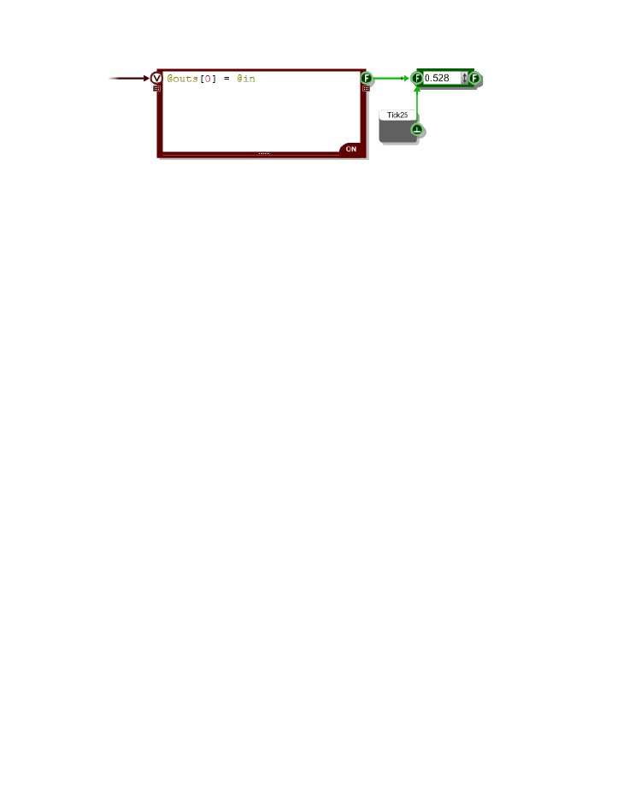
RUBY COMPONENT
This can be very useful if you have events data running at a high rate and you want to read it via
triggered data at a lower rate. The example above shows a Tick25 being used to read the output at
25Hz regardless of the rate of change of the value inside the Ruby component.
- 137 -

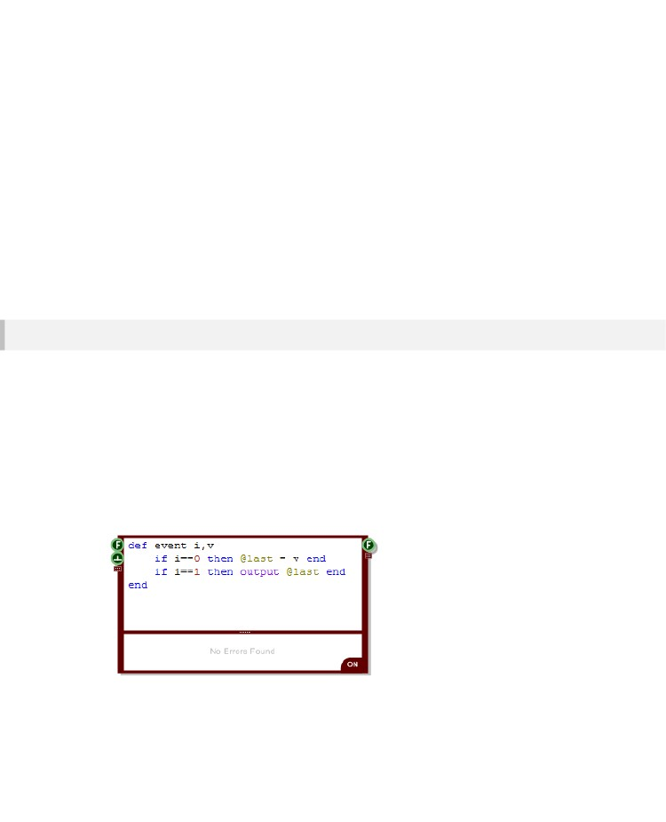
CHAPTER 8
The event Method
As we mentioned earlier, the Ruby Component evaluates your code as you type. If your code contains
expressions (as opposed to declarations or definitions) then these are executed and the last result is
displayed in the Output pane.
Outside of the editor your code will also execute whenever data arrives at an input. This allows you to
use the Ruby component for data processing.
This is all extremely useful but what happens if you want to respond to data received at one input
differently from data received at another?
Method Definition
For more advanced data handling you can define an event method. This is a special method which
FlowStone looks for whenever it receives data at an input.
The event method can have up to 3 input parameters:
▪
▪
▪
i
v
t
-
-
-
references the input at which the data arrived
value that arrived at the input
time at which the data arrived (schematic time in seconds)
You can have 0,1,2 or all 3 input parameters but you must add them in the order. So for example, you
can have no parameters or you can have i on its own or i and v or i and v and t but you can't have v
on its own or i and t without v. More on t in the next section, we'll focus on i and v for now.
The example above shows how you would define an event method that would act as a 'sample and
hold'. Data arriving at the first input is stored. Any trigger at the second input results in the last value
being sent out.
- 138 -

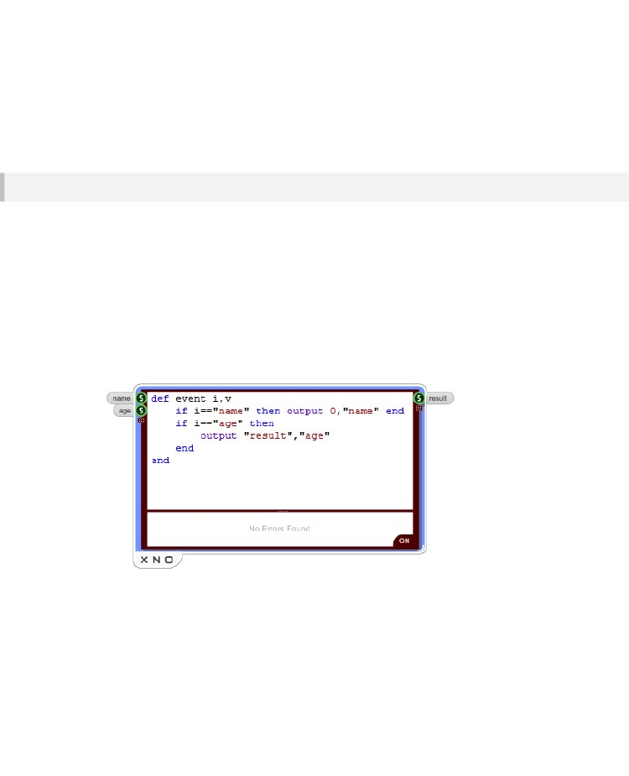
RUBY COMPONENT
If you don't supply a v input and just have a connector reference then you won't be passed any data.
The event method will still be called when data arrives at any of the inputs. You'll know which input got
triggered you just won't know what data arrived.
Note that you can name the input parameters whatever you like, you don't have to use i,v and t.
However, the method name must always be event as that's what FlowStone will be looking for.
Connector Referencing
You might think that the connector reference parameter passed to the event method is an integer value
but it is in fact an instance of the RubyEditConnector class.
Objects of this class can be treated as integer indexes when used in a comparison situation. However,
under the hood the class not only encapsulates the connector index but also any connector label that
you may have assigned.
We have added overrides of the standard comparison operators to the RubyEditConnector class
which means that as well as comparing with integer values in the event method you can also compare
directly with a string.
The previous example showed how it can be used to compare with an integer. Comparing with a string
(if you have a label for the connector) is just the same:
Comparison will work in case statements too. You can also use any of the inequality operators.
Mathematical operations can also be performed on the RubyEditConnector object and return an
integer result.
If you need to you can access the individual index or name of a RubyEditConnector object using the
index and name methods.
- 139 -

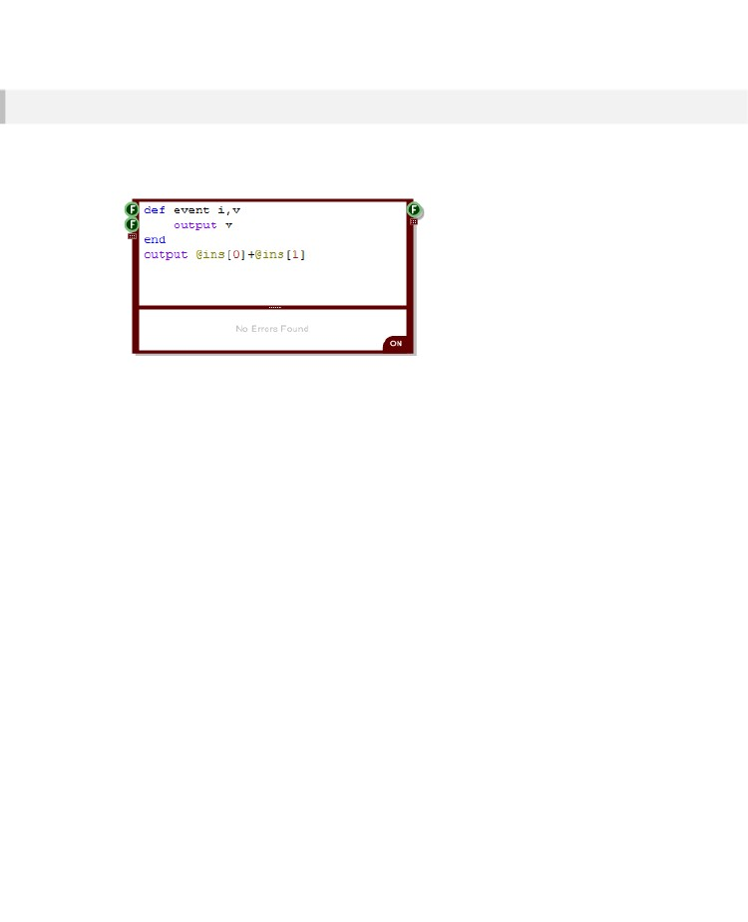
CHAPTER 8
Effect on Code Execution
If you supply an event method then any code you define outside of the method will no longer execute
when an input changes. The example below shows an event method which simply outputs the most
recent value received.
Prior to adding this method the remaining code would have executed whenever any of the inputs
changed thus resulting in the sum of the inputs being sent to the output. However, with the event
method in place FlowStone executes this method instead and ignores any other code.
- 140 -

RUBY COMPONENT
Scheduling Events
You may recall from the Data Types and Signal Flow section that, unlike triggered data which is sent
immediately, event data can be scheduled to be sent at some time in the future.
To do this a schematic has a clock. The clock is an elapsed time, in real world seconds, which begins
when the schematic is loaded or created. The clock does not represent a time of day, it is simply a
counter which continually increases.
Scheduling an Event
To schedule an event you need to provide a time stamp when you send data to an output. This needs
to be supplied as a third input parameter when you use the output method.
The time stamp will almost always be an offset from the current time. You can get the time in two
different ways depending on where you make the call from.
From any location you can use the time method. If you're in the event method then if you define it with
input reference, value and time inputs then you will have the time passed to you via the time input
parameter.
The event will be sent to the events queue and will only be sent out through the designated output
when the clock time for the event time stamp is reached.
The example below shows how to schedule an event from inside an event method using the time input
parameter.
- 141 -

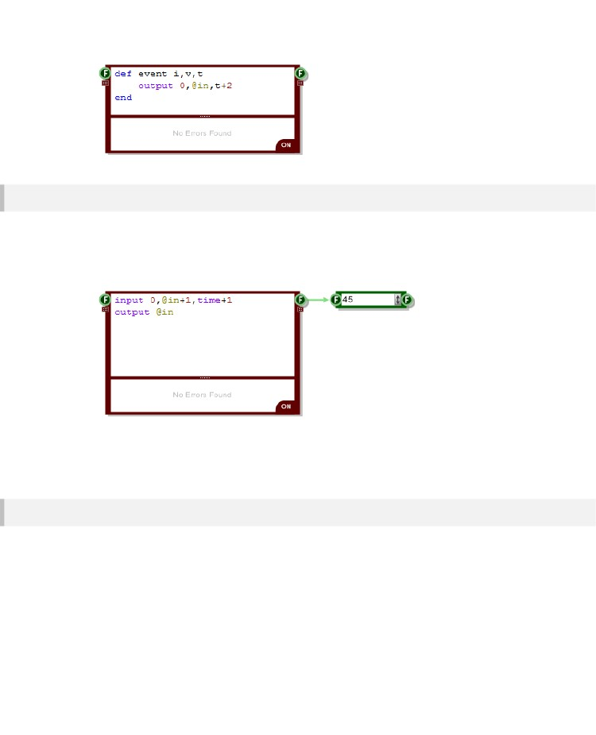
CHAPTER 8
Sending to an Input
You can send events back to the same Ruby component by sending them to an input. This is useful if
you want to create a repeating event or perform a recursive operation.
To do this use the input method. This works in exactly the same way as the output method but of
course the connector reference refers to the input you want to send the event to instead.
The above example creates a counter that moves in one second steps and continues without end.
Note that, just like for the output method, you can use a connector label instead of an index to identify
where you want to send a value to.
Clearing Events
Once you send an event it goes onto the events queue and waits until its time comes to be executed.
If you're scheduling events that happen some time in the future sometimes you might want to stop
them from happening. You can do this using the clearEvents method. This will remove all pending
events for that particular Ruby component from the events queue.
- 142 -

RUBY COMPONENT
Clock Accuracy
The schematic clock runs at 100 Hz. Unlike the Tick components which are not time precise due to
their use of Windows timers, the Events system uses a different timer which is much more accurate so
each 10 millisecond tick should occur precisely on time.
If you have any of the DirectSound or ASIO primitives in your schematic and these are switched on
then the clock will automatically switch to run in sync with the audio processing. You can then schedule
events to occur with sample precise timing within any audio frame.
- 143 -

CHAPTER 8
Ruby Values
Earlier in this guide we talked about the Ruby Value connector type. This is used to pass data from one
Ruby component to another.
It's a very simple concept but as you'll see, it's also incredibly powerful as it gives you the flexibility to
define and use your own data types.
We'll start with a quick reminder of what a Ruby Value is.
The Ruby Value Type
In Ruby all data is considered to be an object. Numbers are objects, strings are objects, arrays are
objects – everything is an object. Each object is an instance of some class. For example, an integer
object is an instance of the FixNum class and an array is an instance of the Array class.
Some classes are subclasses of a parent class. FixNum for example is a subclass of the Integer class.
Those superclasses can themselves be subclasses of another class. A key aspect of Ruby is that no
matter how many superclasses there are they all end up at one common base class called Object. So
all data is in fact an instance of the Object class and as such we can consider everything as having the
same common base type.
When referring to ruby data in this common way we call it a VALUE. As such, when you pass Ruby
objects between Ruby components you pass them through the Ruby Value connector.
Value – can refer to any Ruby object
Passing Ruby Values
Ruby values can be passed from one Ruby component to another. Data is transferred using the Event
system we talked about earlier.
Because everything in Ruby is an object you can pass anything you like between components. This
opens up many possibilities.
- 144 -

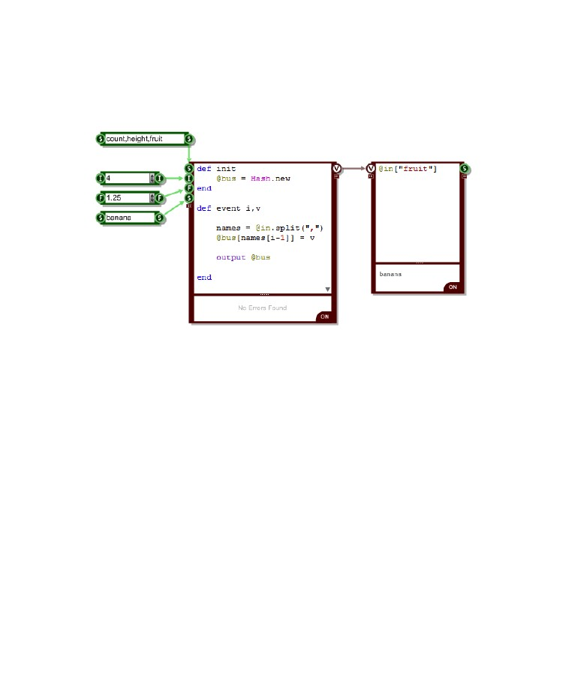
RUBY COMPONENT
For example, FlowStone has Bus components which are used to pass collections of data around via
one single connector. The Ruby Value connector can act like a bus by passing a Ruby hash (a
collection of data and string pairs).
The example below shows how a Bus can be created using the Ruby component.
Of course you can be even more clever than that. In the previous example we were passing a Ruby
Hash. However, we can pass anything we like. So we could create our own class with its own data and
pass that.
- 145 -

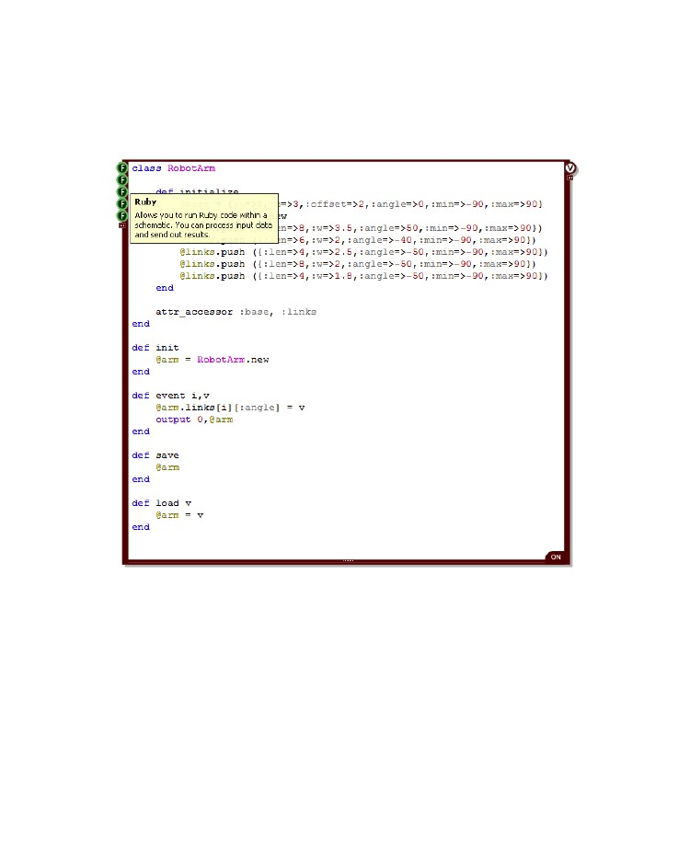
CHAPTER 8
This next example shows a RobotArm class designed to model a multiple link robot arm. This is getting
quite advanced now but you can see that the options for extending the types of data passed around
are almost limitless.
- 146 -

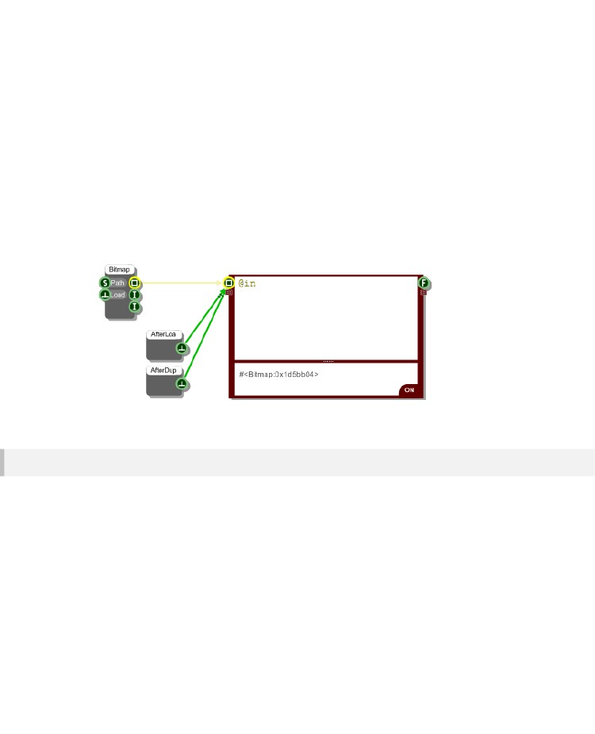
RUBY COMPONENT
Persistence
The Ruby component saves its state. If you save a schematic with a Ruby component in it then when
you load it back the @ins and @outs arrays are restored to exactly how they were before. This
ensures that the component maintains its state at all times.
The only exception to this is bitmaps. Because bitmaps can be very large these are not automatically
saved as part of the input and output arrays. If you want to restore a bitmap after loading use the After
Load component to trigger a refresh of any input bitmap. In addition you may want to add an After
Duplicate component too so that the bitmap refreshes when you copy and paste.
User State Management
If you have your own data that you want to save with a Ruby component then you can implement the
saveState and loadState methods:
def loadState v
end
def saveState
end
The way this works is really simple. In the saveState method you return a Ruby object that
encapsulates all the data that you want to save. It could be a string or an array say if you have lots of
data or it could just be a simple value.
- 147 -

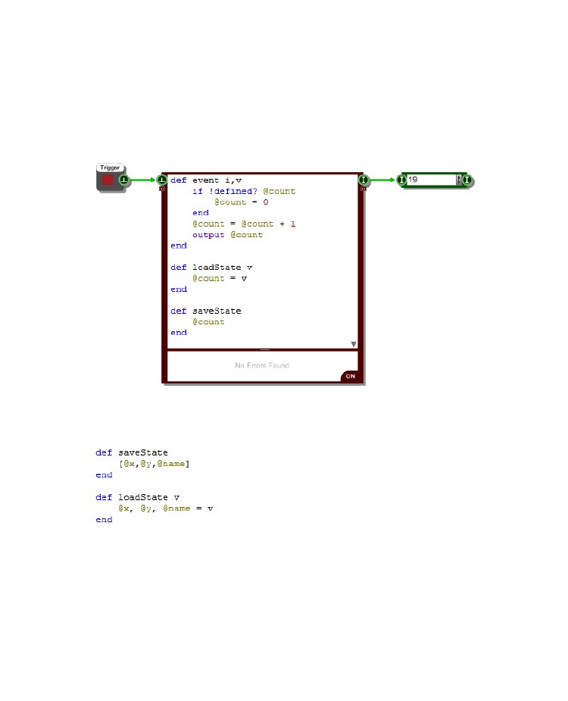
CHAPTER 8
When you save your schematic the saveState method is called by FlowStone and the state of your
Rub component is saved as well.
When you open your schematic again FlowStone calls the loadState method and passes it the data
you returned in the saveState method. All you need to do is use this data to restore your component
state back to how it was.
Here's a little example of how this works. It shows a counter that retains its current value when saved:
If you have multiple values you want to save and restore then the easiest way to deal with these is to
put them in an Array and return that in saveState. Let's say you have variables @x, @y, @name.
Here's some example code that would save and restore these:
In loadState we use Rubys syntax for assigning variables to consecutive elements in an array.
@x, @y, @name = v
is equivalent to:
@x = v[0]; @y = v[1]; @name = v[2];
When using this method always make sure you maintain the same order for the variables in your
loadState and saveState methods or you might get some strange results.
- 148 -

RUBY COMPONENT
Debugging
FlowStone is designed to make programming easier. However, it can never be foolproof and so at
some point you are bound to find yourself facing bugs which have you scratching your head.
This aim of this section is to provide you with information, hints and tips that will hopefully make the
debugging process much less of a headache.
Error Reporting
The first thing you need to know when you have an error is where it is. As we discussed way back near
the start of this whole chapter, the Ruby component evaluates your code while you are typing. If an
error occurs it is displayed immediately in the output pane.
Hopefully this will help you eliminate most problems immediately when they occur.
There are some situations where errors are not reported straight away. Errors inside any methods you
define will only show up when the method is called. There are some exceptions to this but most of the
time the error will only show itself on executing the method.
When this happens you will still get an error message. However, unlike when you're typing you may
have moved to another part of your schematic and not be able to see the component when the error
appears.
To help with this, FlowStone highlights any module that contains a Ruby component that has an error.
- 149 -

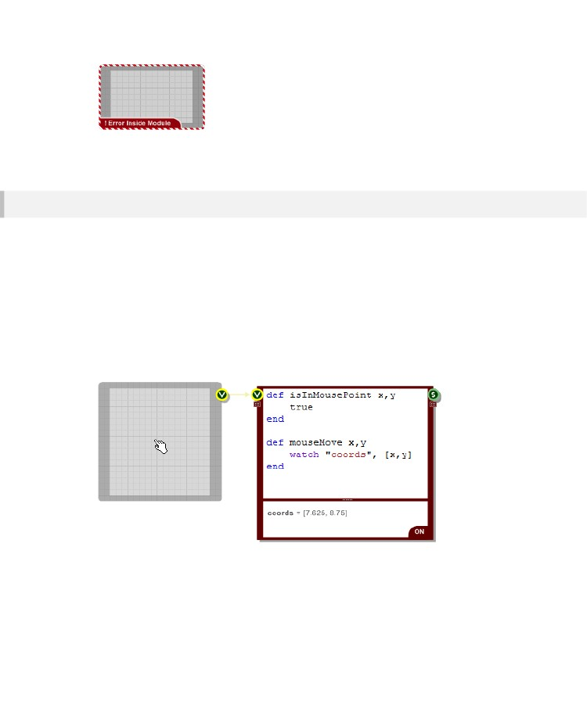
CHAPTER 8
This highlighting propagates right up to the top level so no matter where you are in your schematic,
you should see errors show up on the navigator and you can drill down through them to find the cause.
The watch Method
If you're debugging your code it's often very useful to be able to look at the values of variables as your
code runs. You'll recall from earlier in the chapter that the value of the last evaluated expression is
shown in the output pane. This is great but what if you want to see a value that is calculated earlier or
inside a method?
To help with this we have the watch method. This method takes two inputs. The first is a label to
identify the watched data in the output pane. The second input parameter is the value you want to
watch. The label can be a string or an integer value.
The example below shows how the mouse coordinates can be watched as the cursor moves across
the View (not that this requires mouse move messages to be enabled on the MGUI inside the module
– see the Interaction section for more on this).
If you just want to quickly see one value in a Ruby Edit then you can omit the string label input. This
will show with the label 'Quick Watch' in the output pane. Note that quick watch will only show the last
value sent to it so if you want to watch more than one either put all your watches in an array ( eg.
watch [x,y,name,pos] ) or use a label for each watch separately.
- 150 -

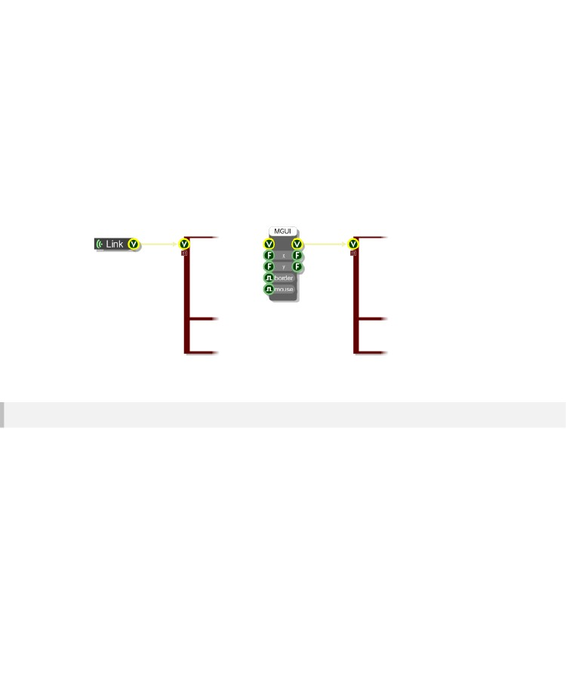
RUBY COMPONENT
Drawing
As well as handling data the Ruby component can also be used to handle mouse events and draw to a
front panel. This section covers drawing and the next handles mouse interaction.
To enable your Ruby component to draw to a front panel you need to add a View input connector and
then link this to a View output connector from an MGUI (either directly or by a series of links) or from a
Wireless Input that connects to a front panel in a module above.
Once you have this set up you can start responding to draw requests from FlowStone.
The draw Method
To respond to redraw requests from FlowStone you'll need to define a draw method. FlowStone looks
for this whenever drawing messages arrive at a View connector on a Ruby component.
The method can have an optional input connector reference parameter (if you're handling multiple
View connectors on the same Ruby component) followed by a mandatory View parameter.
{ examples }
The View parameter is an instance of the View class. This is a Ruby class that references the front
panel and allows you to draw to it. Think of it as the drawing surface.
- 151 -

CHAPTER 8
Drawing Classes and Methods
Drawing is performed by calling methods of the View object. There are also a number of Classes which
represent drawing objects.
All the methods and classes you'll use are wrappers onto Microsoft's Gdi+ graphics library. There are
some minor variations but in general they map directly onto the methods and classes of Gdi+. There
are many resources online dedicated to this so if you need any further help or examples you should be
able to look these up and translate them directly into the FlowStone equivalents.
Drawing Units
Before we begin we should quickly talk about the units of measurement we use for drawing. Because
all drawing in FlowStone is scalable we work in grid step units and not in pixels (see the Coordinates
section in the chapter on Advanced GUI Editing). All coordinates, measurements and sizes are in grid
steps.
If you ever need to know the size of a grid square you can call the gridStep method on the View object
at any time.
Pens, Brushes & Colors
Before you can draw anything you'll need either a Pen, a Brush or a Color. These are all represented
by Ruby classes. Pens are used for drawing lines and Brushes are used for filling areas. The Color
class is used to define Pens and Brushes and as an input in other drawing methods.
Color
You can't get anywhere without a Color so let's start here. Color objects are defined by three primary
colour components (red, green and blue) plus an optional transparency which is called Alpha. Each
component is an integer value in thsete range 0-255.
To create a Color object:
myColor = Color.new a,r,g,b
Where a is the alpha, r is the red component, g is the green component and b is the blue component.
Here are some examples of creating Color objects.
c
c
c
c
=
=
=
=
Color.new
Color.new
Color.new
Color.new
255,255,0,0
128,0,0,255
0,255,0
64
#
#
#
#
an opaque red
a half transparent blue
an opaque green (no transparency)
a dark grey (a single value is a grayscale)
- 152 -

RUBY COMPONENT
Pens
At their core, Pens are defined by a color and thickness (or width). They can also have a dash style,
end caps like arrows or other shapes and they can render their joints in a number of different ways.
These are more advanced features that we'll look at later.
To create a Pen object:
myPen = Pen.new color, thickness
The color parameter is a Color object that you need to create and pass in. Thickness is the line width
(again in grid steps, so this is usually a number less than 1 for thinner lines).
If you need it, you can get the thickness or width of a pen object by calling the getWidth method. You
can also set the width using the setWidth method.
The colour can be set by calling the setColor method and passing a Color object.
Brushes
Brushes can be solid colours, textures, or gradients. The simplest brush is the solid brush. This is
represented by the Brush class.
To create a Brush object:
myBrush = Brush.new color
Once again, the color parameter is a Color object that you need to create and pass in. As with pens,
the colour can be set by calling the setColor method and passing a Color object.
Basic Shapes
You can draw a number of different basic shapes using methods of the View class. They all take a
drawing instrument (either a Pen for outlines or a Brush for fills) and then a number of other
parameters to define position and size.
The parameters are usually points, collections of points or rectangles. These are represented by Ruby
arrays. A point is represented by a two element array with the first element being the x coordinate and
the second being the y coordinate.
A rectangle is represented by a four element array. The first two elements are the x and y coordinates
of the top-left corner followed by the width and the height.
A collection of points is represented by an array of two element point arrays.
- 153 -

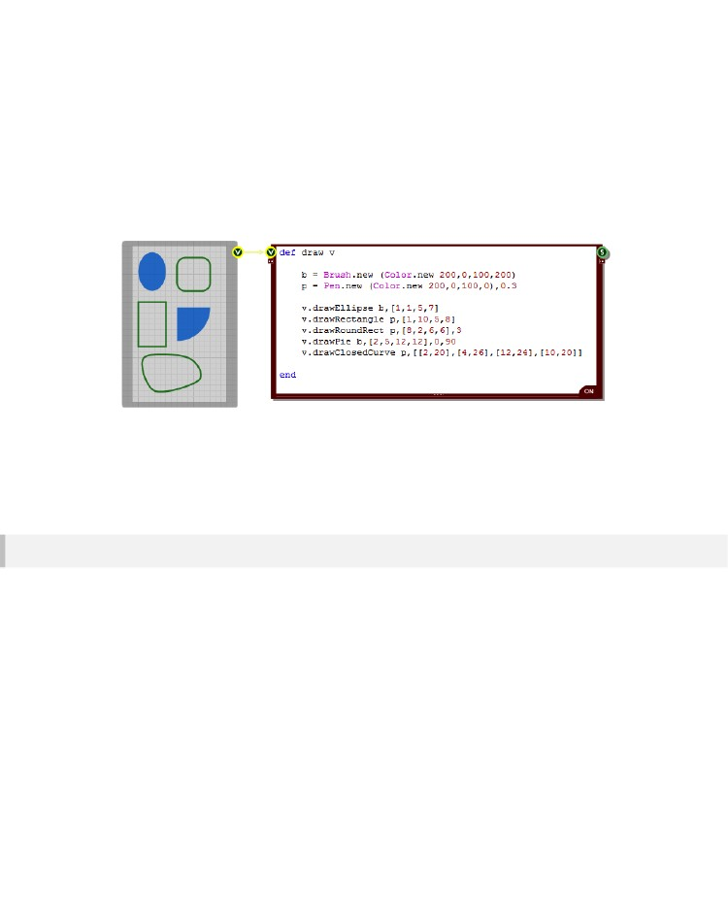
CHAPTER 8
There are 6 shape methods:
drawRectangle instrument, rect
drawRoundRect instrument, rect, corner
drawEllipse instrument, rect
drawPie instrument, rect, startAngle, sweepAngle
drawPolygon instrument, points
drawClosedCurve instrument, points
Here are some examples of drawing shapes:
The drawClosedCurve method can take an additional input:
drawClosedCurve instrument, points, tension
The tension input determines the curvature. A value of zero will produce straight lines, a value of 0.5
will produce curves at the standard curvature and increasing tensions will produce more curvy lines.
Lines and Curves
The View class has a number of different line drawing methods. They all take a pen as their first input.
The remaining parameters depend on the type of line. As with the shapes, Ruby arrays are used to
specify points, collections of points and rectangles.
There are 5 line drawing methods:
drawLine instrument, point1, point2
drawArc instrument, rect, startAngle, sweepAngle
drawCurve instrument, points
drawBeziers instrument, points
drawLines instrument, points
- 154 -

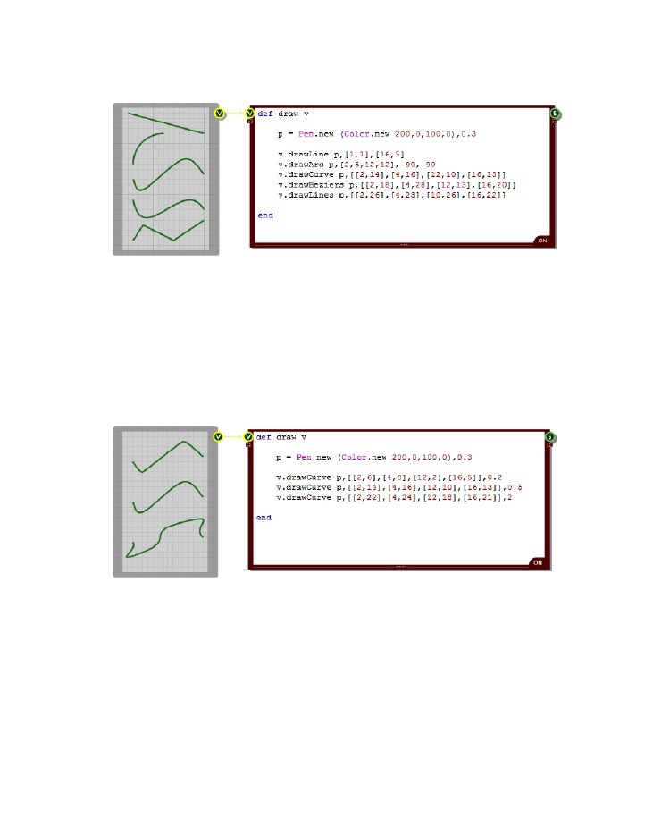
RUBY COMPONENT
Here are some examples of line drawing in action:
The drawCurve method can take two additional forms:
drawCurve instrument, points, tension
drawCurve instrument, points, offset, segments, tension
The tension input determines the curvature. A value of zero will produce straight lines, a value of 0.5
will produce curves at the standard curvature and increasing tensions will produce more curvy lines.
The offset value determines the point at which drawing will begin and the segments input determines
how many segments of the curve are drawn.
The image below shows how the curvature changes for tensions above and below 0.5:
- 155 -

CHAPTER 8
Graphics Paths
A graphics path is a combination of shapes and lines which are grouped together, in sequence to form
one single object. Paths are represented by the GraphicsPath class.
To create an instance of a GraphicsPath is easy:
path = GraphicsPath.new
After that you call methods on the GraphicsPath object to add elements to the path. There is one
method for each of the line and shape methods in the View class. They take the same parameters
except for the drawing instrument input.
There are 5 shape methods and 5 line methods as follows:
addRectangle rect
addEllipse rect
addPie rect, startAngle, sweepAngle
addPolygon points
addClosedCurve points
addLine point1, point2
addArc rect, startAngle, sweepAngle
addCurve points
addBeziers points
addLines points
Note that when you add line elements, consecutive lines will automatically get joined at their end and
start points. You can then call the closeFigure method to make the end of the last line join with the start
of the first to form a closed shape.
The addCurve and addClosedCurve methods can also take the same optional input parameters that
the drawCurve and drawClosedCurve methods take. See the previous two sections for more
information.
There is one additional add method of the GraphicsPath class called addPath. This allows you to
append another path to the path. The method has two inputs: the path to be added and a true/false
value to indicate whether the path is to connect into the existing figure (true) or be a new figure in the
path (false).
addPath path, connect
Once you have created a GraphicsPath object you can draw it using the View class drawPath method.
This takes a path and a drawing instrument (pen or brush) as inputs:
drawPath instrument, path
- 156 -

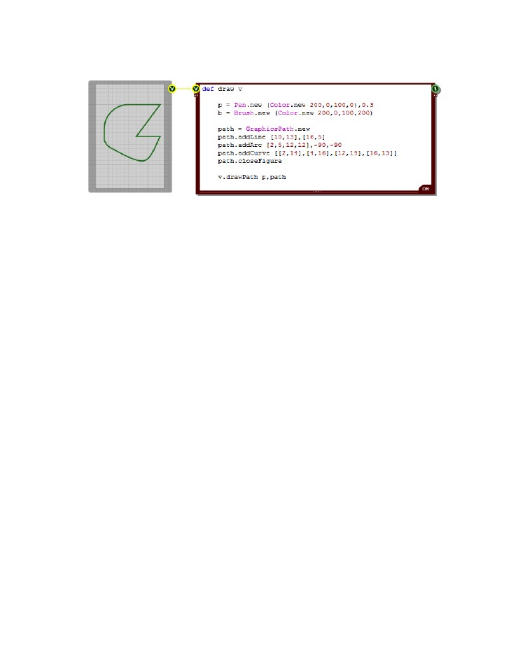
RUBY COMPONENT
The example below shows how you might use a graphics path in practice:
Other GraphicsPath Methods
You can get the bounding rectangle of a GraphicsPath object by calling the getBounds method. This
will return a Ruby array of the form [x,y,w,h] giving you the smallest rectangle that contains the
complete path.
To widen the path call the widen method:
widen pen, {optional View object}
The view object input is optional and serves only to provide scaling information. The pen input provides
a pen to widen the path by. Widening is done by adding an additional outline to the path as if the path
had been drawn in the pen.
You can check if a point is inside the GraphicsPath using the isVisible method:
isVisible point, {optional View object}
The view object input is the same as for the widen method. The point input is a two dimensional Ruby
array [x,y] for the point you want to test. The return value is either true or false.
You can also check if a point is on the outline of a GraphicsPath using the isOutlineVisible method
isOutlineVisible point, pen, {optional View object}
The first two inputs are the same as for the isVisible method. The pen input defines the pen that the
path would be drawn with. The point is then tested to see if it would lie on the drawn path. Obviously
the wider the pen, the more likely this is. The return value is either true or false.
- 157 -

CHAPTER 8
Text
You can draw text to a View using the drawString method. However, before we talk about this you're
going to need to know about two other drawing classes.
The Font Class
The Font class defines the typeface you'll use for drawing your text. You need to supply the name of
the typeface (this must be a font that is installed on your system), the size of font (in grid squares) and
the style.
The style can be any combination of “normal”, “bold”, “italic”, “underline” and “strikeout”. For example,
“bolditalic” or “strikeout-underline”. You can have spaces in the strings or use hyphens or other
symbols – as long as the key words are present then FlowStone will pick them up. You can also use an
integer in the range 0-15 to specify style combinations as a bitmask. The bits are 1 = bold, 2= italic, 4 =
underline and 8 = strikeout. So by adding these together 1+4+8 = 13 is the same as
“bold-underline-strikeout”.
Here's an example of how to create a font:
font = Font.new “Arial”,1.2,”normal”
The StringFormat Class
The StringFormat class defines how text is placed relative to its location or bounding rectangle. There
are 3 attributes to consider. Alignment determines how the text aligns horizontally. There are 3 options:
near (left), center (middle) or far (right).
Line Alignment determines how the text aligns vertically. There are 3 options here too: near (top),
center (middle) or far (bottom).
Finally Flags allows you to specify combinations of more detailed options. The flags input is an integer
that should be a bitwise combination of the options you want. There are quite a number of options so
to avoid cluttering things here we've listed them in full at the end of the next section.
Here's an example on how you might create a StringFormat object:
sf = StringFormat.new
sf.setAlignment “center”
sf.setLineAlignment “far”
sf.setFlags 4128
Drawing the Text
Now let's return to the drawString method. This is defined as follows:
drawString text, font, stringFormat, location, brush
- 158 -

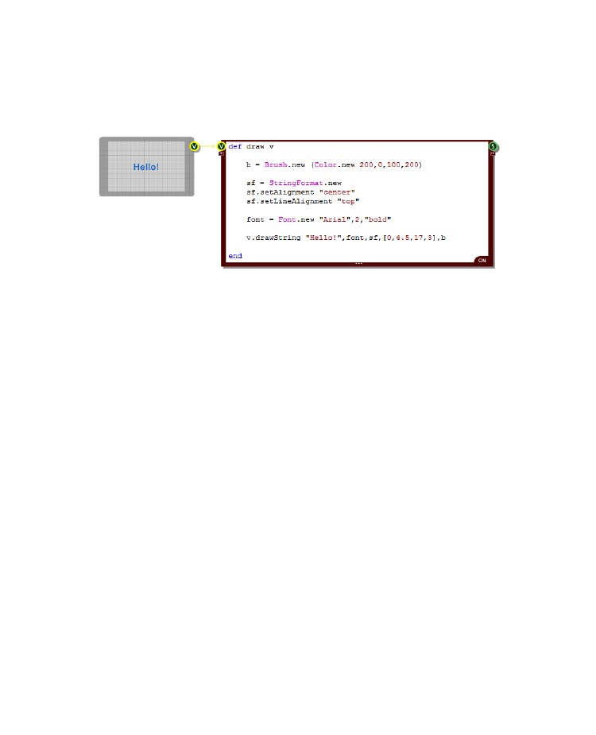
RUBY COMPONENT
The location can be a point (an array of two values) or a rectangle ( [x,y,width,height]).If the location is
a point then all drawing will be referenced to that point. If the location is a rectangle then the text will be
drawn inside that rectangle.
Here's an example:
The StringFormat object can be replaced by nil in the drawString method call should you wish to go
with the default alignment of top-left.
Measuring Text
Sometimes you need to be able to measure how much screen space a block of rendered text will
occupy. For this purpose there is the measureString method:
measureString text, font, stringFormat, location
The input parameters are the same as for the drawString method. However, if the location defines a
rectangle then this acts as a maximum bounding box for the text the idea being that once measured
the actual bounding box will be smaller than this one.
The drawString method returns a Ruby Hash containing the following items:
“bounds”
“width”
“height”
“chars”
“lines”
- the bounding rectangle that would be occupied by text [x,y,w,h]
- the width of the bounds rectangle
- the height of the bounds rectangle
- the number of characters that would be drawn
- the number of rows of text that would be drawn
A Ruby Hash is just like an array, except that you access elements by a reference object instead of an
integer index (although you can use an index too if you wish). The Hash returned by measureString
uses strings so for example, if the hash variable was called 'measure' then to get the width you would
use the following expression:
measure[“width”]
- 159 -

CHAPTER 8
String Format Flags
In the previous section on Text we talked about StringFormat flags. This section describes these in full.
This information is taken directly from the Microsoft Developer notes on GDI+.
Flag = 1
Specifies that reading order is right to left. For horizontal text, characters are read from right to left. For
vertical text, columns are read from right to left. By default, horizontal or vertical text is read from left to
right.
Flag = 2
Specifies that individual lines of text are drawn vertically on the display device. By default, lines of text
are horizontal, each new line below the previous line.
Flag = 4
Specifies that parts of characters are allowed to overhang the string's layout rectangle. By default,
characters are first aligned inside the rectangle's boundaries, then any characters which still overhang
the boundaries are repositioned to avoid any overhang and thereby avoid affecting pixels outside the
layout rectangle. An italic, lowercase letter F ( f) is an example of a character that may have
overhanging parts. Setting this flag ensures that the character aligns visually with the lines above and
below but may cause parts of characters, which lie outside the layout rectangle, to be clipped or
painted.
Flag = 32
Specifies that Unicode layout control characters are displayed with a representative character.
Flag = 1024
Specifies that an alternate font is used for characters that are not supported in the requested font. By
default, any missing characters are displayed with the "fonts missing" character, usually an open
square.
Flag = 2048
Specifies that the space at the end of each line is included in a string measurement. By default, the
boundary rectangle returned by the Graphics::MeasureString method excludes the space at the end of
each line. Set this flag to include that space in the measurement.
Flag = 4096
Specifies that the wrapping of text to the next line is disabled. NoWrap is implied when a point of origin
is used instead of a layout rectangle. When drawing text within a rectangle, by default, text is broken at
the last word boundary that is inside the rectangle's boundary and wrapped to the next line.
Flag = 8192
Specifies that only entire lines are laid out in the layout rectangle. By default, layout continues until the
end of the text or until no more lines are visible as a result of clipping, whichever comes first. The
default settings allow the last line to be partially obscured by a layout rectangle that is not a whole
- 160 -

RUBY COMPONENT
multiple of the line height. To ensure that only whole lines are seen, set this flag and be careful to
provide a layout rectangle at least as tall as the height of one line.
Flag = 16384
Specifies that characters overhanging the layout rectangle and text extending outside the layout
rectangle are allowed to show. By default, all overhanging characters and text that extends outside the
layout rectangle are clipped. Any trailing spaces (spaces that are at the end of a line) that extend
outside the layout rectangle are clipped. Therefore, the setting of this flag will have an effect on a string
measurement if trailing spaces are being included in the measurement. If clipping is enabled, trailing
spaces that extend outside the layout rectangle are not included in the measurement. If clipping is
disabled, all trailing spaces are included in the measurement, regardless of whether they are outside
the layout rectangle.
Multiple flags set can produce combined effects:
When both 2 and 1 are set, individual lines of text are drawn vertically. The first line starts at the right
edge of the layout rectangle; the second line of text is to the left of the first line, and so on.
When 2 is set and 1 is not set, individual lines of text are drawn vertically. The first line starts at the left
edge of the layout rectangle; the second line of text is to the right of the first line.
When 1 is set and 2 is not set, the individual lines of text are horizontal and the reading order is from
right to left. This setting does not change the order in which characters are displayed, it simply
specifies the order in which characters can be read.
The 2 and 1 flags can affect string alignment.
Bitmaps
If you pass a bitmap to a Ruby component via a Bitmap connector then you can use this in the View
class drawBitmap and drawBitmapSection methods to display it (or a section of it) on the View.
These methods are defined as follows:
drawBitmap bitmap, position [, alpha, rotation, origin]
drawBitmapSection bitmap, source, position [, alpha, rotation, origin]
The 'bitmap' parameter is the bitmap you want to display. In the case of drawBitmapSection the
'source' parameter is a 4 element array representing the rectangular section of the bitmap that you
want to display. The rectangle array is defined by [x,y,w,h] where x,y define the top-left and w,h define
the size of the section in pixels.
The 'position' parameter can either be a two element array representing the top-left corner of where
you want the bitmap to be displayed or it can be a 4 element array representing the rectangle that you
want to draw the bitmap into. The rectangle array is defined by [x,y,w,h] where x,y define the top-left
and w,h define the size in grid squares.
- 161 -

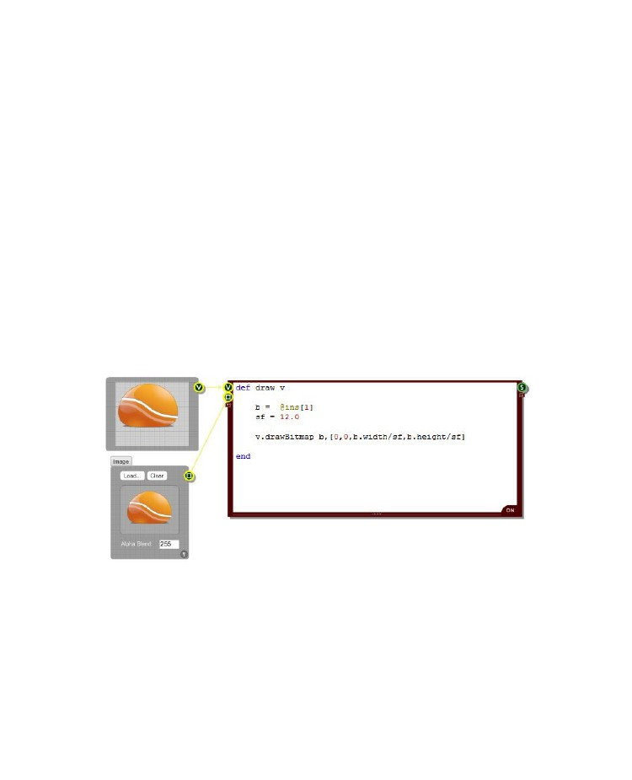
CHAPTER 8
If you supply a point for the position then the bitmap draws at full size. If you supply a rectangle the
bitmap (or section of bitmap) will be stretched or reduced in size so as to fit exactly in the rectangle.
The 'alpha' parameter is optional. This is defines the transparency level for the drawn bitmap. It is an
integer value in the range 0-255 with 255 being fully opaque and 0 being fully transparent. If you omit
this parameter a value of 255 is assumed.
The 'rotation' parameter is also optional and allows you to rotate the bitmap through an angle,
clockwise in degree. The origin of the rotation is assumed to be the centre point of the bitmap unless
you supply an 'origin' parameter, in which case this point is used instead. The origin parameter is a two
element array [x,y] where x and y are the coordinates of the rotation origin in grid squares.
The 'bitmap' parameter is an instance of the Bitmap class. There are four methods of this class for
determining the bitmap size:
width
height
widthPixels
heightPixels
The width and height methods give you the size of the bitmap in grid squares at the current default
zoom level. The widthPixels and heightPixels methods give you the exact size of the bitmap in pixels.
Here's an example of a bitmap being drawn into a rectangle scaled down 12 times:
- 162 -

RUBY COMPONENT
Bitmap Rendering Options
If you are drawing a bitmap into a rectangle that is a different size then you can choose how to render
that bitmap by setting the interpolation mode. This is done using the following View method:
setInterpolationMode mode
This takes either an integer (0-7) or one of the following strings:
"low","high","bilinear","bicubic","nearest","hqbilinear","hqbicubic"
You can also find out the current interpolation mode by using the following method. This will return one
of the 8 strings shown above:
getInterpolationMode mode
Redraw
If values changes in another method which affects what should be displayed by the draw method then
you need to be able to request a redraw. This is very easy to do. All you do is call the redraw method.
If you have more than one View connected to your Ruby component then you should also provide the
input connector reference of the View you want to redraw as an input parameter to the redraw method.
If only part of the display needs to be redrawn you can pass a rectangle after the connector reference
So that's:
redraw connectorReference, redrawArea { both optional }
Where redrawArea is a Ruby array of the form [x,y,w,h].
Clipping
Sometimes you need to be able to draw only within a portion of a View. This is where clipping comes
into play. The View class has two methods for setting the clipping:
setClip region
combineClip region, combineMode
Both methods take a region as input. This can be a four element array defining a rectangle, the same
format as the rectangles we used for drawing shapes. It can also be a collection of points defining a
polygon. This is represented by an array of two element arrays, each of which defines an (x,y) position.
You can also use a graphics path object to define the region.
The setClip method sets the clipping region to the input region. This means that drawing will only
occur within that region – anything outside is 'clipped' out.
- 163 -

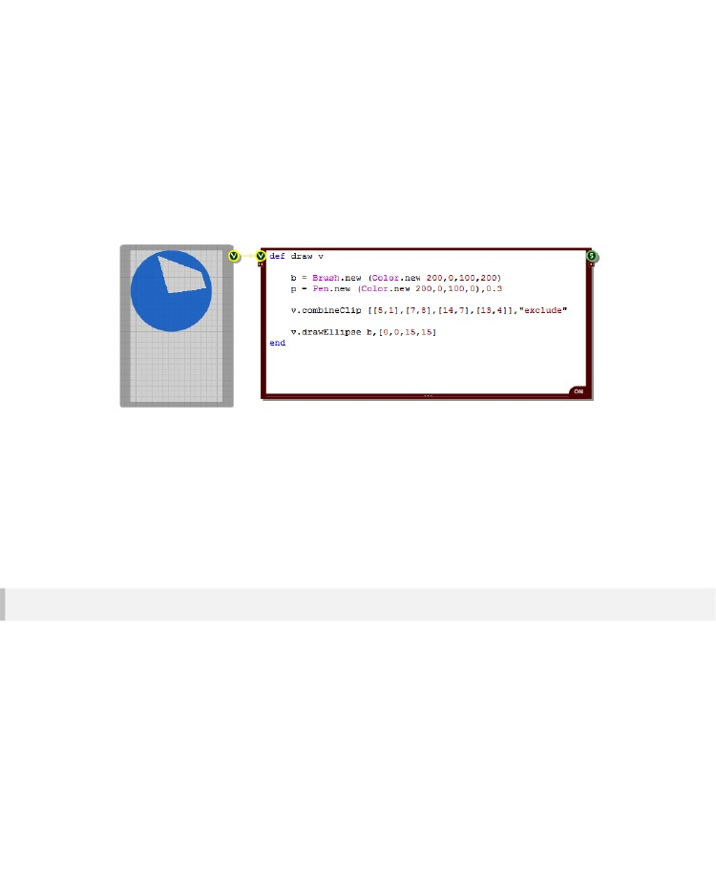
CHAPTER 8
The combineClip method combines the region with the current clipping region. The combineMode
input is a string that specifies how the regions are to be combined. The options are:
“replace”
“intersect”
“union”
- use the new region
- use the intersection of both regions
- use both regions combined
“xor”- use the union minus the intersection
“exclude”- use the old region minus the new one
“complement” - use the new region one minus the old one
Here's an example of how to use clipping:
There are another two methods relating to clipping:
resetClip
getClip
To reset the clipping region just call resetClip or you can also pass nil as the region for the setClip
method.
The getClip method will return an array representing the bounding rectangle of the current clip region
in the format [x,y,width,height].
Smoothing
By default all graphics are smoothed. The otherwise sharp jagged edges around graphics objects are
antialiased to make them appear smooth.
If you're drawing straight lines you may want to turn this off as a side effect is that it does introduce a
little blurring. The setSmoothingMode method of the View class allows you to control when smoothing
is applied. You can pass 0 & 1 or “on” & “off”.
- 164 -

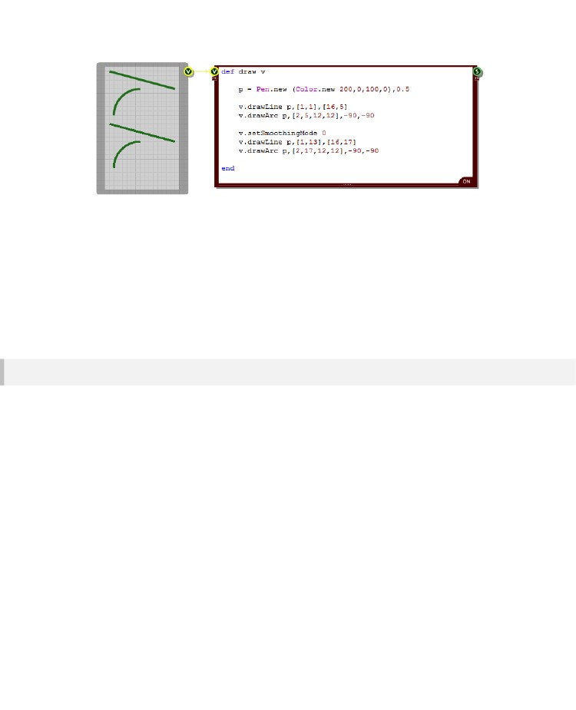
RUBY COMPONENT
There is a similar method for text smoothing called setTextRenderingHint. This method has more
input options:
“off”
“singleBitPerPixelGridFit”
“singleBitPerPixel”
“antiAliasGridFit”
“antiAlias”
“clearTypeGridFit”
- no smoothing
- use glyph bitmaps for each character with hinting
- use glyph bitmaps for each character with no hinting
- use antialiased glyph bitmaps for each character with hinting
- use antialiased glyph bitmaps for each character with no hinting
- use ClearType glyph bitmaps for each character with hinting
View Properties
There are a few more methods of the View class that we haven't mentioned yet. As well as the drawing
methods we've already talked about there are four methods that give you some important properties of
the View. These are as follows:
gridStep
defaultGridStep
width
height
The gridStep method gives you the number of pixels per grid square for a view object. The
defaultGridStep method gives you the default grid step ie. the number of pixels per grid square when
the zoom level is set to normal. If you don't change the default grid step (under Zoom Level on the
Schematic options dialog) then this will be 8 pixels per grid square.
These two methods are not often used but they can be useful in special circumstance eg. for scaling
bitmaps as you may want a bitmap to appear at normal size when at the default zoom level but scale
accordingly when zoomed.
- 165 -

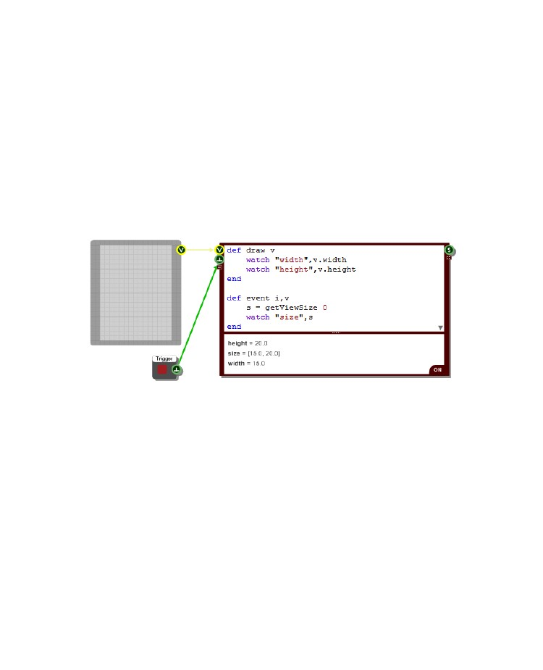
CHAPTER 8
The width and height methods are much more commonly used. If you want your graphics to change
based on the size of the front panel you're drawing to then you'll need to know the width and height.
These are of course supplied in grid square units.
Sometimes you need to be able to get the view size when you're not in the Draw method. What do you
do if you don't have access to a View object? Well we have a special method of the RubyEdit class
that you can use:
getViewSize connectorReference
You need to pass the index of the View connector that you want to query (or you can leave it blank and
zero will be assumed). The method returns a two element array containing the width and height. In the
example below we've pressed the trigger button and the event method has been called triggering the
call to getViewSize and the result is then displayed in the watch list.
If you don't have a View connected then the call to getViewSize will return nil. This can happen when
you have no link connected or during loading or init so if you intend to use getViewSize in loading or
init methods it's best to check whether the result is nil before acting on it.
- 166 -

RUBY COMPONENT
Advanced Brushes
The Drawing section covered how to create a solid brush and use it to fill basic shapes or draw text. In
this section we'll look at more advanced brush options.
Linear Gradients
You can create filled areas that flow smoothly between colours using the LinearGradientBrush class.
This is a variation on the standard Brush class and can be used as an instrument for drawing in all the
shape drawing methods just like the standard Brush.
In its simplest form a LinearGradientBrush allows you to define a gradient between two colours. You
create an instance of the class as follows:
b = LinearGradientBrush.new boundRect, color1, color2, angle, scaleTrans
boundRect
This is a rectangle ( once again defined as a ruby array [x,y,width,height] ) that defines the boundary of
the gradient fill. The gradient will fill this area so you need to make sure that you create a bounding
rectangle that fits with whatever shapes you intend to fill.
color1, color2
These are the end colours for the gradient and should be instances of the Color class. If you don't
supply an angle parameter then color1 will be at the left-hand edge of the rectangle and color2 will be
at the right-hand edge.
angle
This is angle of rotation for the gradient in degrees in the clockwise direction. If the angle is 90 degrees
for example, color1 will be at the top of the rectangle and the gradient will run downwards to color2.
scaleTrans
This defines whether the angle is affected by the transform associated with the brush. The parameter
is a boolean flag so it should be set to true or false.
Here's a simple example of a LinearGradientBrush:
- 167 -

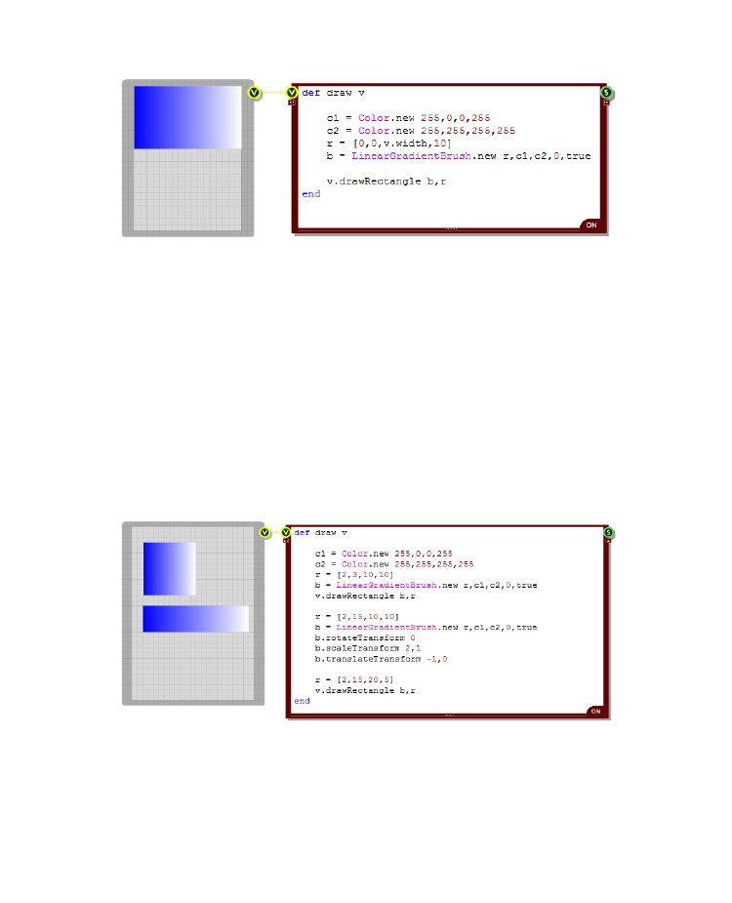
CHAPTER 8
Transformations
You can rotate, translate or scale the brush after it has been created. To do this you use the following
methods:
rotateTransform angle
translateTransform x, y
scaleTransform sf-x, sf-y
resetTransform
The rotation method takes an angle in Degrees. The translate method takes x and y offsets. The scale
method takes x and y scale factors – these are floats with 1.0 meaning no change. The resetTransform
method does exactly what it says, it resets any applied transforms.
The example below shows a gradient that has been stretched and translated.
- 168 -

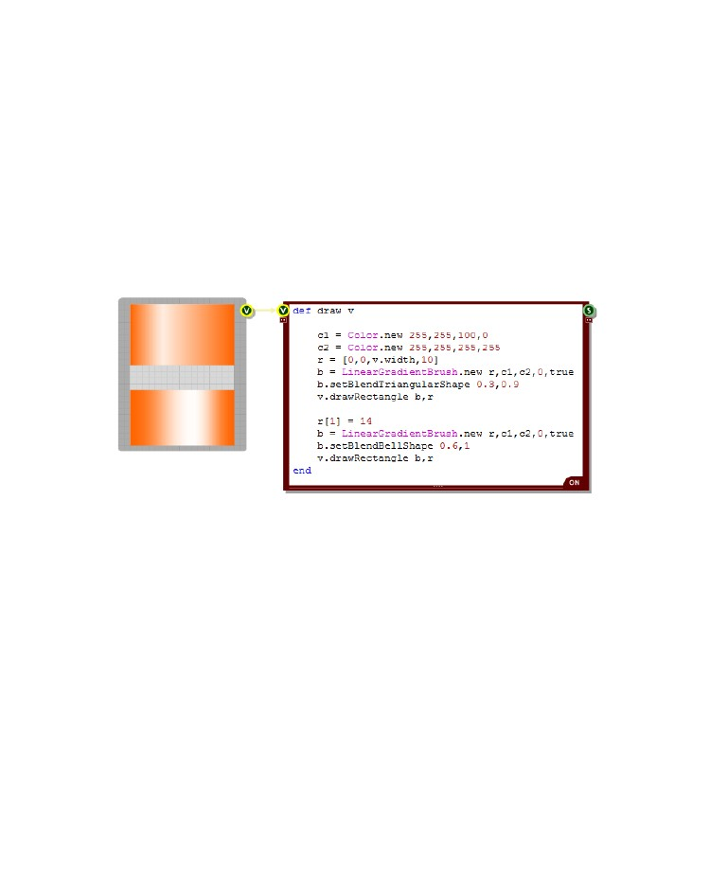
RUBY COMPONENT
Blending
You don't just have to have a straight gradient. Using the setBlendTriangularShape and the
setBlendBellShape methods you can move the end colour to some in between point and blend out on
either side. The bell option uses a non-linear blending curve.
setBlendTriangularShape focus, scale
setBlendBellShape focus, scale
Both methods take two inputs. The first is the focus. This is a float between 0 and 1 which defines the
relative distance of the end point colour from the start point. A value of 0.5 would put it bang in the
middle for example. The second parameter is the scale. This is also a float between 0 and 1 and it
defines the intensity of the colour at the focus point.
Here's an example of these in action:
You take this a step further and set your own blend points. This is done using the setBlend method.
setBlend blendArray
The method takes an array of two element arrays. Each two element array defines first a blend factor
then a position along the gradient. Both values are floats in the range 0 to 1.
- 169 -

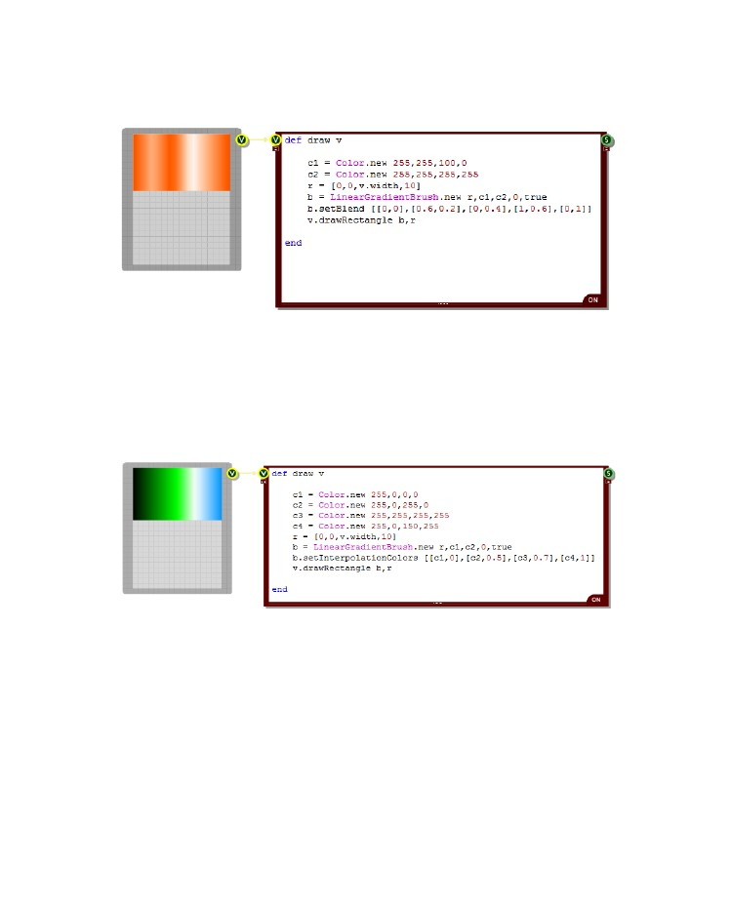
CHAPTER 8
This is all best illustrated with an example. The picture below shows a gradient with three blend points
in between the end points which themselves are set to zero (ie. color1):
You can also introduce a whole range of colours into the gradient using the setInterpolationColors
method. This is very similar to the setBlend method except that instead of a blend factor you have a
Color object paired with the position along the gradient.
setInterpolationColors colourArray
The example below shows 4 colours merging together at various points:
Wrapping
The LinearGradientBrush has a defined bounding rectangle. This makes the brush into a tile. The tile is
then used repeatedly to pave any area that is painted with the brush.
Depending on how you define your gradient you may want to flip the tiles as they are placed so that
you don't get hard edges between them. You can do this by setting the wrap mode to 'flip' using the
setWrapMode method.
setWrapMode mode
- 170 -

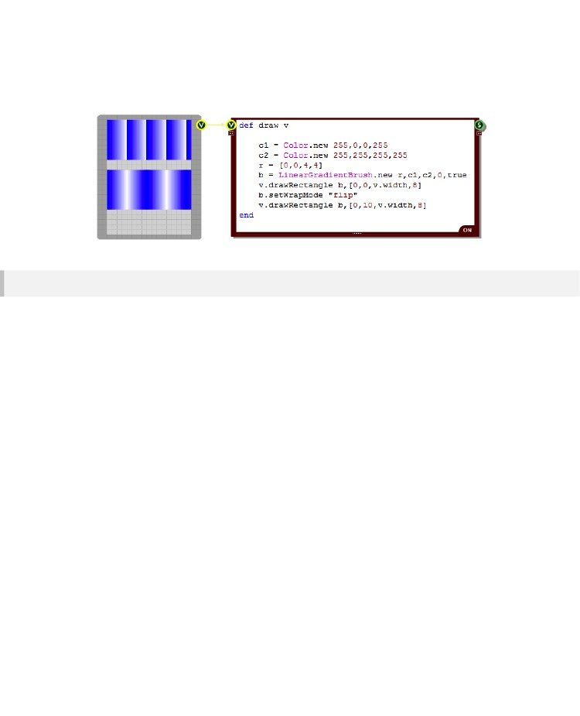
RUBY COMPONENT
The default mode is to tile without flipping but by passing the string “Flip” or the number 1 you can set
this to flipped. Here's an example of how the wrap mode affects the overall result.You can see that in
the bottom rectangle each tile is flipped so that the gradient runs smoothly from one tile into another.
Path Gradients
Path gradients provide another way of producing smooth transitional fills between different colours.
Unlike the LinearGradientBrush they create a radial gradient from a central colour out towards a set of
surrounding colours.
The surrounding area is defined by a path and colours can be distributed along the path. A single
central colour is also defined and the colour gradient is calculated by blending outwards from the
central point.
In its simplest form a PathGradientBrush allows you to define a gradient between two colours. You
create an instance of the class as follows:
b = PathGradientBrush.new path
There is a single input parameter, the path. The path can either be an array of points (represented as
an array of two element arrays containing the x and y coordinates of each point) or it can be a
GraphicsPath object.
The default colours are Black at the centre and White on the path.
- 171 -

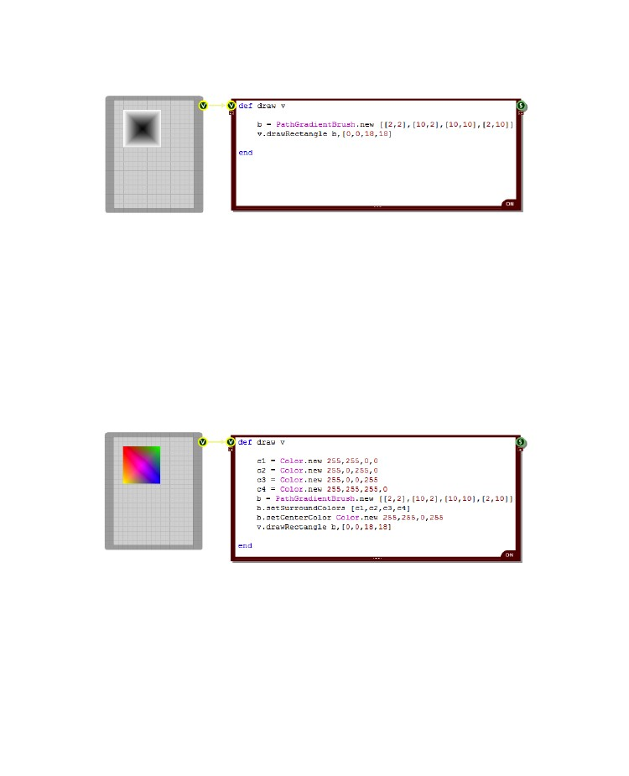
CHAPTER 8
Here's an example using a square path and the default colours:
Changing Colours
There are two methods of the PathGradientBrush class that allow you to change the colours.
setCenterColor colour
setSurroundColours colourArray
The setCenterColor method takes a single colour object. The setSurroundColours method takes an
array of colours. By default these colours are allocated in turn to each point in the path. If there are
fewer colours than path points and so we run out of colours when allocating them to points on the path,
the last colour in the array is used on all subsequent points.
The example below shows what we get when changing the centre colour to pink and the outer colours
to red, green, blue and yellow.
- 172 -

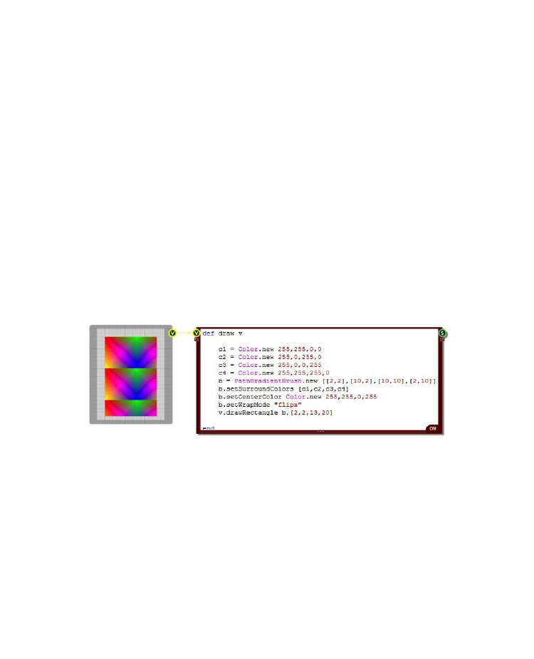
RUBY COMPONENT
Wrapping
In a similar way to the LinearGradientBrush a PathGradientBrush has a bounding rectangle which
contains the whole path. This makes the brush into a tile. The tile can then be used repeatedly to pave
any area that is painted with the brush.
Unlike the LinearGradientBrush, the default for the PathGradientBrush is to not tile or clamp. You can
change this by setting the wrap mode using the setWrapMode method.
setWrapMode mode
The various mode options allow you to flip the tiles as they are placed so that the tiles blend into one
another. Here are the options for the mode input value:
0 or “tile”
1 or “flipx”
2 or “flipy”
3 or “flipxy”
4 or “clamp” or “notile”
Normal tiling is performed
Tiling is performed with alternate tiles flipped in the x direction
Tiling is performed with alternate tiles flipped in the y direction
Tiling is performed with alternate tiles flipped in the x and y directions
No tiling is performed – this is the default option
The example below shows the “flipx” wrap mode in action. You can see how the tiles in the x direction
are alternately flipped but the tiles in the vertical direction are not.
Blending
The PathGradientBrush supports blending just like the LinearGradientBrush. Using the
setBlendTriangularShape and the setBlendBellShape methods you can move the centre colour to
some in between point and blend out on either side. The bell option uses a non-linear blending curve.
setBlendTriangularShape focus, scale
setBlendBellShape focus, scale
Both methods take two inputs. The first is the focus. This is a float between 0 and 1 which defines the
relative distance of the end point colour from the start point. A value of 0.5 would put it bang in the
- 173 -

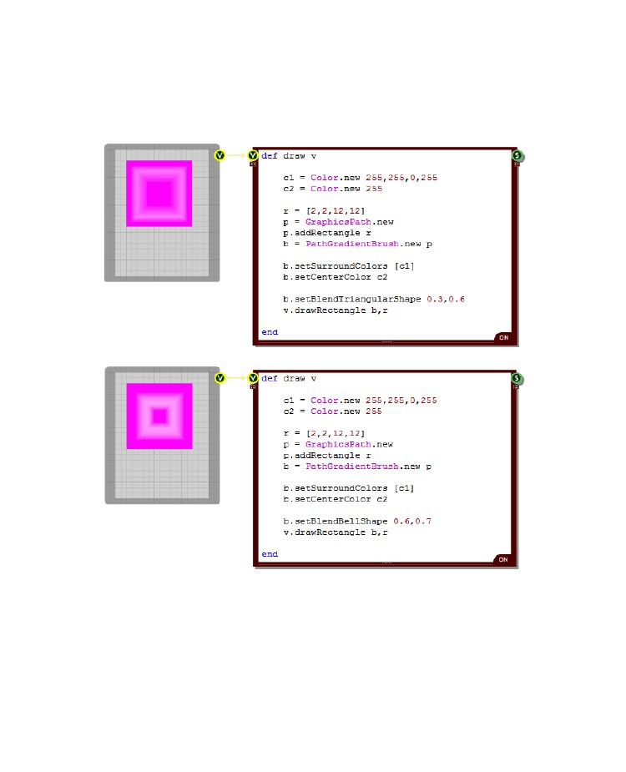
CHAPTER 8
middle for example. The second parameter is the scale. This is also a float between 0 and 1 and it
defines the intensity of the colour at the focus point.
Here's an example of these in action. We've used a GraphicsPath instead of an array of points this
time too just to show how that works when defining the brush.
You take this a step further and set your own blend points. This is done using the setBlend method.
setBlend blendArray
The method takes an array of two element arrays. Each two element array defines first a blend factor
then a position along the gradient. Both values are floats in the range 0 to 1.
- 174 -

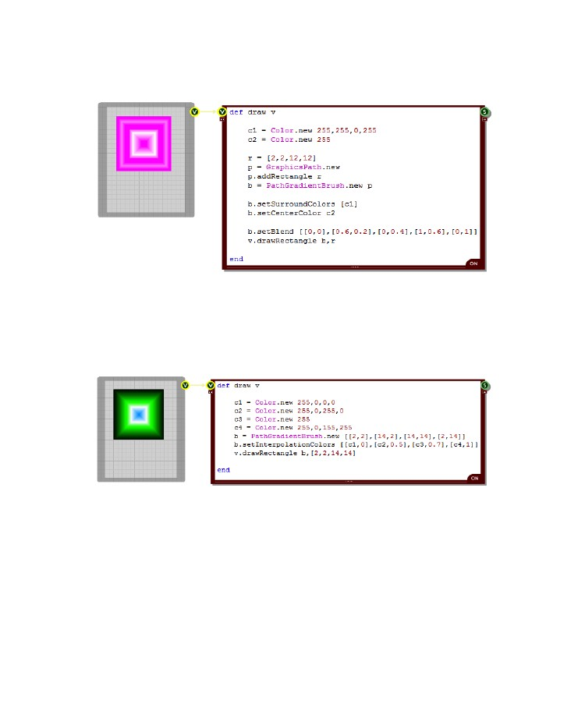
RUBY COMPONENT
This is all best illustrated with an example. The picture below shows a gradient with three blend points
in between the end points which themselves are set to zero (ie. color1):
You can also introduce a whole range of colours into the gradient using the setInterpolationColors
method. This is very similar to the setBlend method except that instead of a blend factor you have a
Color object paired with the position along the gradient.
setInterpolationColors colourArray
The example below shows 4 colours merging together at various points:
- 175 -

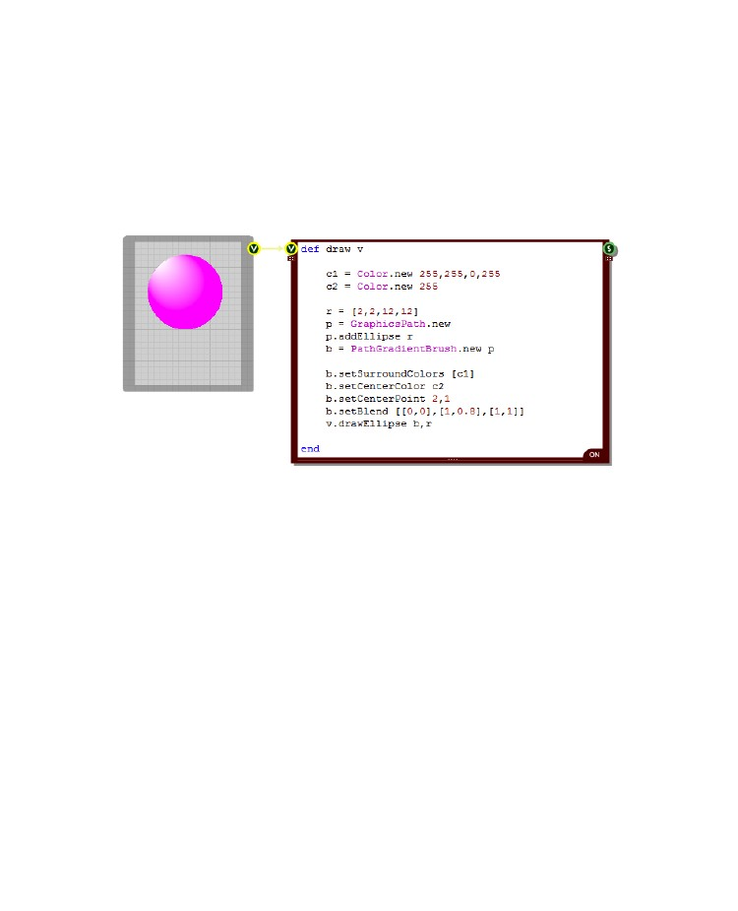
CHAPTER 8
Centre Point
By default the centre point is calculated for you based on the path. However, you can set the position
of the centre point yourself using the setCenterPoint method.
setCenterPoint x, y
All you need to do is pass the x and y coordinates of the point you want to have as the new centre.
The example below shows a displaced centre point being used to create a 3D effect by creating the
illusion of reflected light from a ball.
- 176 -

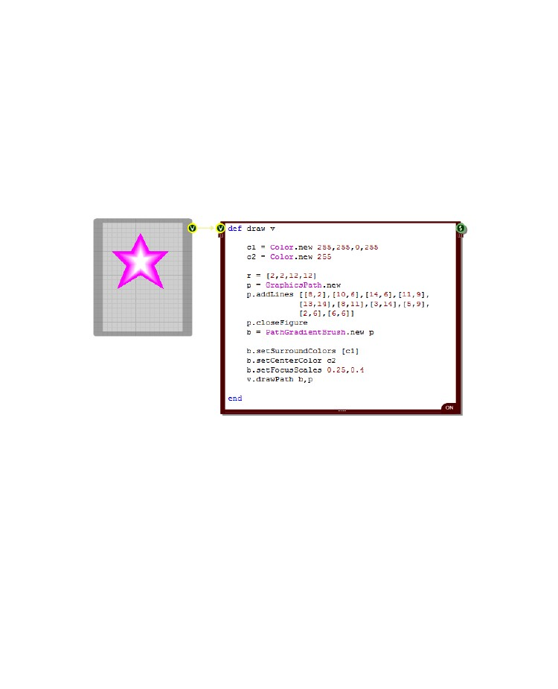
RUBY COMPONENT
Focus Scales
By default the centre colour is focused at the centre point. However, you can change the focus size
around this point by using the setFocusScales method.
setFocusScales scaleX, scaleY
The method takes two scale factors. These are applied to the path that defines the brush and the
resulting shape defines the area that is filled with the centre colour. Scale factors of 1.0 will make the
whole shape the focus colour so most of the time the scale factors you use will be less than 1.0.
Here's an example that shows how this works. Here we have increased the size of the focus point and
stretched it a bit more vertically than horizontally.
Transformations
You can rotate, translate or scale a PathGradientBrush after it has been created. To do this you use
the following methods:
rotateTransform angle
translateTransform x, y
scaleTransform sf-x, sf-y
resetTransform
The rotation method takes an angle in Degrees. The translate method takes x and y offsets. The scale
method takes x and y scale factors – these are floats with 1.0 meaning no change. The resetTransform
method does exactly what it says, it resets any applied transforms.
- 177 -

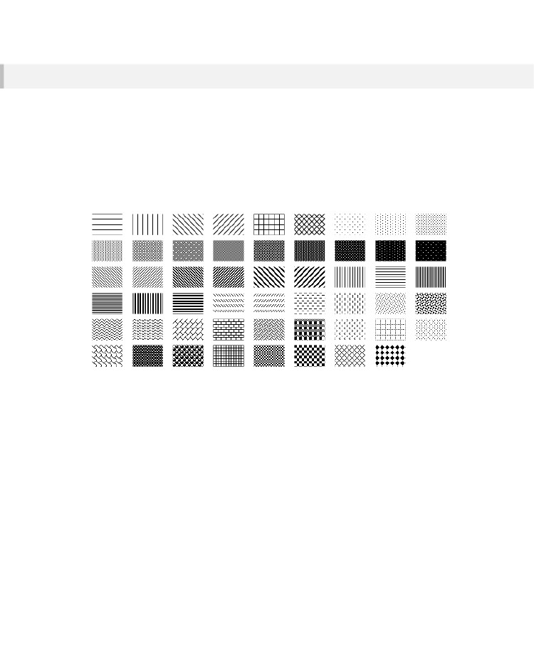
CHAPTER 8
Hatch Brushes
A HatchBrush is is used for filling an area with a hatched or stipple effect. It s defined by a hatch style,
a foreground colour and an optional background colour. You can create an instance as follows:
b = HatchBrush.new style, foregroundCol, backgroundCol
If you don't supply a background colour then the background will be left transparent and all you will get
is the hatching. For the style you have 53 different options. This can be specified as an integer (in the
range 0-52) or a text string.
The hatch styles are shown below (in increasing order left to right, top to bottom):
The hatch style strings are as follows:
"HORIZONTAL"
"VERTICAL"
"FORWARDDIAGONAL"
"BACKWARDDIAGONAL"
"CROSS"
"DIAGONALCROSS"
"05PERCENT"
"10PERCENT"
"20PERCENT"
"25PERCENT"
"30PERCENT"
"40PERCENT"
"50PERCENT"
"60PERCENT"
"70PERCENT"
"75PERCENT"
"80PERCENT"
"90PERCENT"
"LIGHTDOWNWARDDIAGONAL"
"LIGHTUPWARDDIAGONAL"
"DARKDOWNWARDDIAGONAL"
"DARKUPWARDDIAGONAL"
"WIDEDOWNWARDDIAGONAL"
"WIDEUPWARDDIAGONAL"
"LIGHTVERTICAL"
"LIGHTHORIZONTAL"
"NARROWVERTICAL"
"NARROWHORIZONTAL"
"DARKVERTICAL"
"DARKHORIZONTAL"
"DASHEDDOWNWARDDIAGONAL"
"DASHEDUPWARDDIAGONAL"
- 178 -

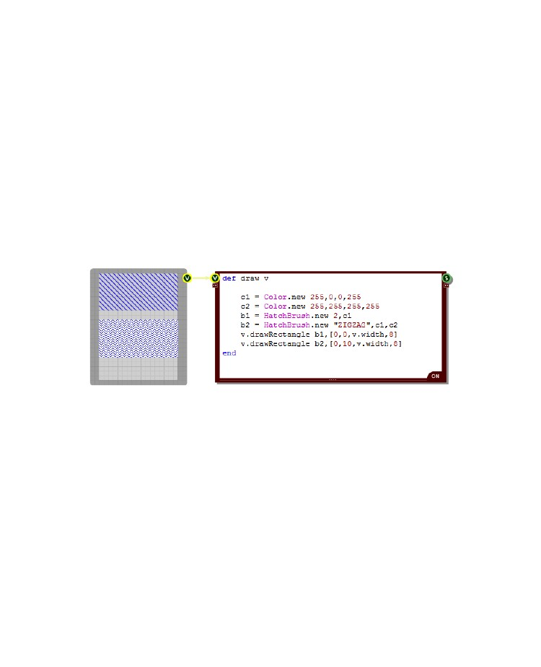
RUBY COMPONENT
"DASHEDHORIZONTAL"
"DASHEDVERTICAL"
"SMALLCONFETTI"
"LARGECONFETTI"
"ZIGZAG"
"WAVE"
"DIAGONALBRICK"
"HORIZONTALBRICK"
"WEAVE"
"PLAID"
"DIVOT"
"DOTTEDGRID"
"DOTTEDDIAMOND"
"SHINGLE"
"TRELLIS"
"SPHERE"
"SMALLGRID"
"SMALLCHECKERBOARD"
"LARGECHECKERBOARD"
"OUTLINEDDIAMOND"
"SOLIDDIAMOND"
The following example shows how to create and use a HatchBrush. The top rectangle uses a brush
created using just a foreground colour. You can see the background underneath as only the hatching is
applied. The bottom rectangle has been defined with a white background colour. We've also used the
two different ways of specifying the hatch style in each rectangle – by index or by name.
- 179 -

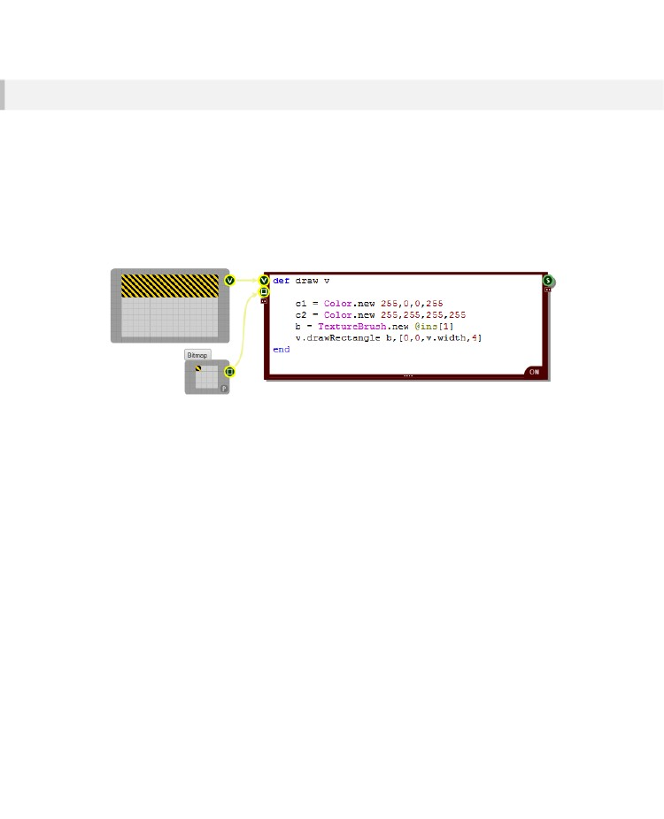
CHAPTER 8
Texture Brushes
A TextureBrush is defined by a bitmap. When you fill an area with a TextureBrush the bitmap is used
repeatedly to tile the area you want to fill.
You can create an instance as follows:
b = TextureBrush.new
bitmap
The bitmap input parameter needs to be a Bitmap object. You need to pass a Bitmap object into your
Ruby component so that you can use it in your TextureBrush.
The example below shows how a TextureBrush is created and used.
Wrapping
When filling an area TextureBrush tiles are placed next to each other. However, you could choose to
flip the tiles alternately as you pave vertically or horizontally to create a more fluid pattern. To do this
you need to use the setWrapMode method.
setWrapMode mode
Here are the options for the mode input value:
0 or “tile”
1 or “flipx”
2 or “flipy”
3 or “flipxy”
Normal tiling is performed – this is the default option
Tiling is performed with alternate tiles flipped in the x direction
Tiling is performed with alternate tiles flipped in the y direction
Tiling is performed with alternate tiles flipped in the x and y directions
- 180 -

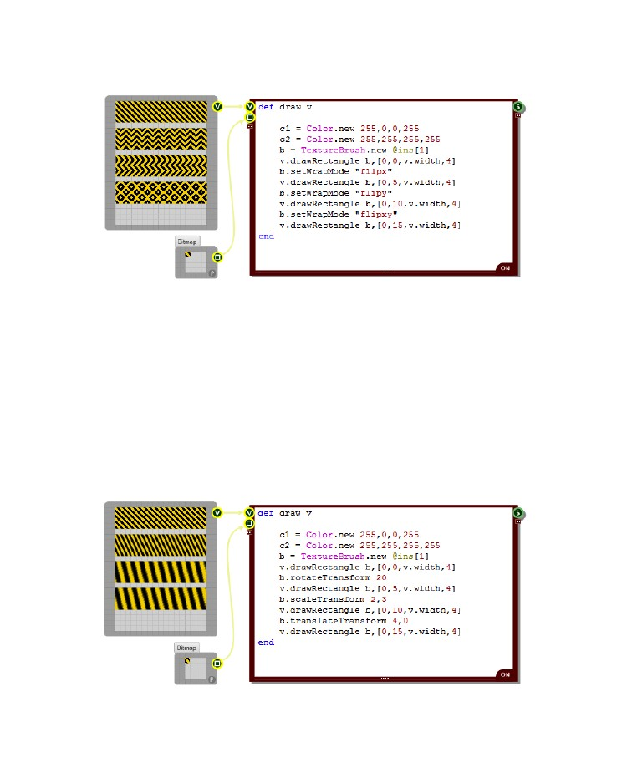
RUBY COMPONENT
The example below shows the four different wrap modes in action.
Transformations
You can rotate, translate or scale a TextureBrush after it has been created. To do this you use the
following methods:
rotateTransform angle
translateTransform x, y
scaleTransform sf-x, sf-y
resetTransform
The rotation method takes an angle in Degrees. The translate method takes x and y offsets. The scale
method takes x and y scale factors – these are floats with 1.0 meaning no change. The resetTransform
method does exactly what it says, it resets any applied transforms.
Here's an example showing how these all work:
- 181 -

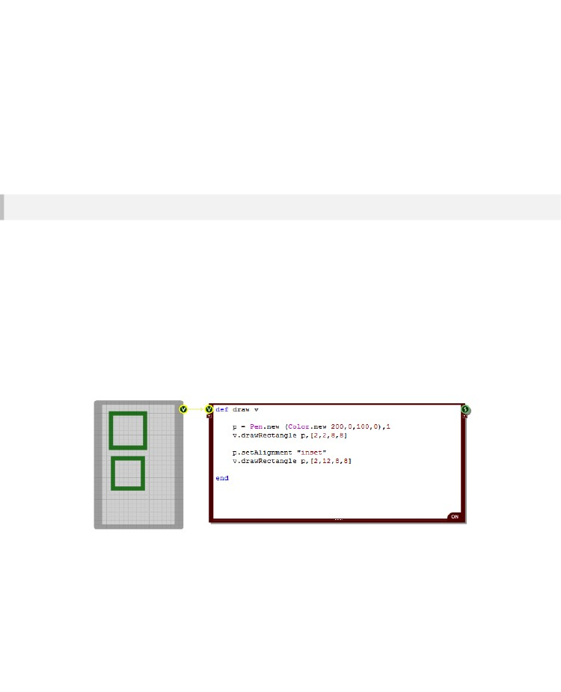
CHAPTER 8
Advanced Pens
The Drawing section we covered the very basics of Pens. In this section we'll look at Pens in more
detail and show you some of the more advanced things that you can do with them.
Pen Alignment
By default lines drawn with a pen are centred. This means that if you have a thicker pen then part of
the pen will fall on either side of the line. Sometimes this is not the behaviour you want so you can
change it using the setAlignment method for the Pen.
setAlignment alignmentType
There are just 2 options for the alignment type:
0 or “center”
1 or “inset”
The pen is centred on the line
The pen is inset so its outer edge always follows the line
The example below shows how the two types work in practice. The two rectangles are exactly the
same size. However, the top rectangle is drawn with the alignment centred. You can see how this
makes the rectangle appear larger.
- 182 -

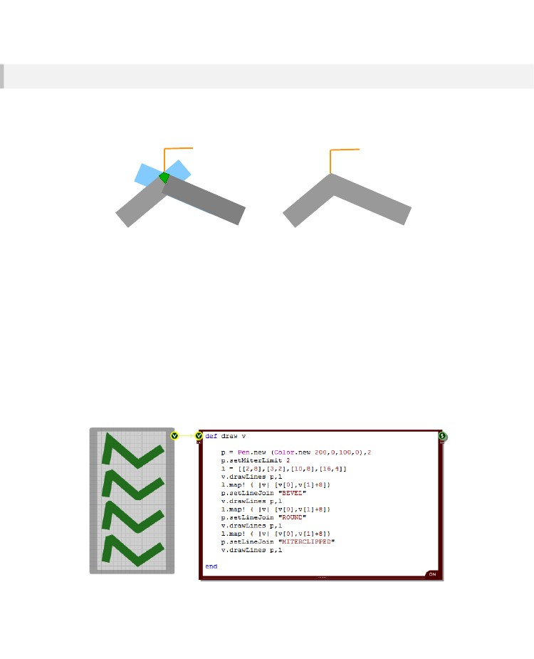
RUBY COMPONENT
Line Joins
When you draw any shape that contains straight lines the joints between the lines are mitred together
by default. A mitre joint is created between two lines by extending both lines artificially until they cross
each other and then cutting off the protruding edges.
Green area is kept to form joint
End result
In the diagram above the blue lines show the artificial extensions. The green area is kept to form the
joint and the blue protruding parts are removed. The end result is shown on the right.
You can change the way in which lines are joined using the setLineJoin method of the Pen object.
setLineJoin type
The method takes a single input. This can be either an index or a string:
0 or “mitre”
1 or “bevel”
2 or “round”
3 or “mitreclipped”
A standard mitre joint – this is the default option
The joint is flattened off instead of creating a point at the outer edge
A curved edge is used to join the lines
A mitre joint is used if under the mitre limit otherwise a bevel is used
The best way to understand these is to see them in action:
- 183 -

CHAPTER 8
The bottom line shows the “mitreclipped” option. Notice that the first joint is beveled but the others are
mitred. This is because for the first joint a mitre would extend beyond the mitre limit.
The mitre limit is the maximum allowed limit of mitre length to pen width. The mitre length is measured
as shown in the diagram below.
Mitre length
The default mitre limit for a pen is 10.0 but you can change this using the setMitreLimit method.
setMitreLimit limit
If the line join is set to the default “mitre” option then any mitre joins above the mitre limit will be clipped
at the mitre limit. However, if the line join is set to “mitreclipped” then any mitre joins above the mitre
limit will be converted to bevels.
- 184 -

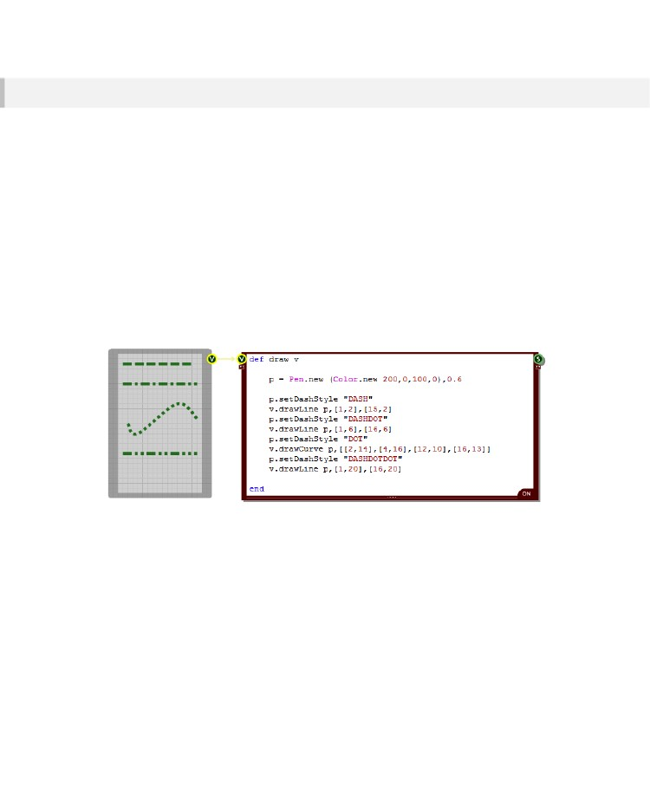
RUBY COMPONENT
Dashes
Pens can be set to draw broken rather than solid lines. Y can do this using the setDashStyle method
of the Pen object.
setDashStyle type
The method takes a single input. This can be either an index or a string:
0 or “none”
1 or “dash”
2 or “dot”
3 or “dashdot”
4 or “dashdotdot”
No dash is applied, instead you get the default solid line
A dashed line
A dotted line
A line comprised of alternating dashes and dots
A line comprised of alternating dashes and double dots
The example below shows a selection of these styles.
Dash Caps
You can set the way that ends of the dashes and dots are drawn by using the setDashCaps method.
setDashCaps type
There are only 3 options for the type:
0, 1 or “flat”
2 or “round”
2 or “triangle”
The ends are flat, dots are squares – this is the default option
The ends are rounded, dots are circles
The ends are pointed, dots are diamonds
- 185 -

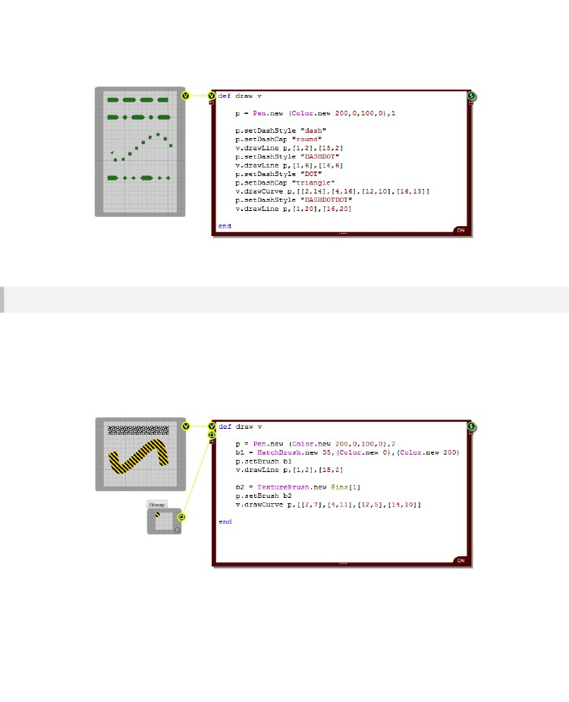
CHAPTER 8
Here's an example showing how the round and triangle options work:
Brushed Lines
We've seen how it's possible to fill a shape using a brush. Well you can also use a brush to fill a line
drawn with a pen. To do this use the setBrush method of the Pen object.
setBrush brush
The input is a brush object. You can use any kind of brush, gradient, hatched, texture, path or
solid.The example below shows two lines being drawn with hatch and texture brushes.
- 186 -

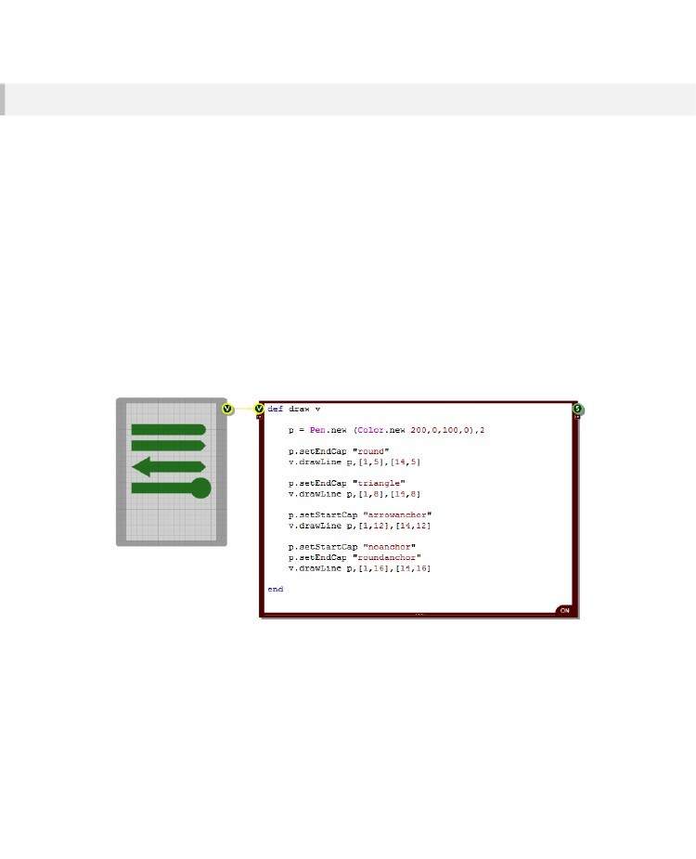
RUBY COMPONENT
Line Caps
Line caps define how the end points of a line are drawn. By default lines are squared off at the ends
but you may want a rounded or triangular end to your lines and line caps allow you to do this.
You can also have a larger shape at the start or end of a line. This is called an Anchor. The most
familiar line cap anchor is the arrow head but there are several more standard ones and you can also
make your own.
Line caps are properties of Pen objects. To set the line caps for a pen there are two Pen class
methods, one for setting the cap at the start of the line and one for setting the one at the end:
setStartCap type
setEndCap type
The type parameter can be any of the following strings:
“square”, “round”, “triangle”, “noanchor”, “squareanchor”, “roundanchor”,
“diamondanchor”, “arrowanchor”
Here is an example that shows how to use line caps:
- 187 -

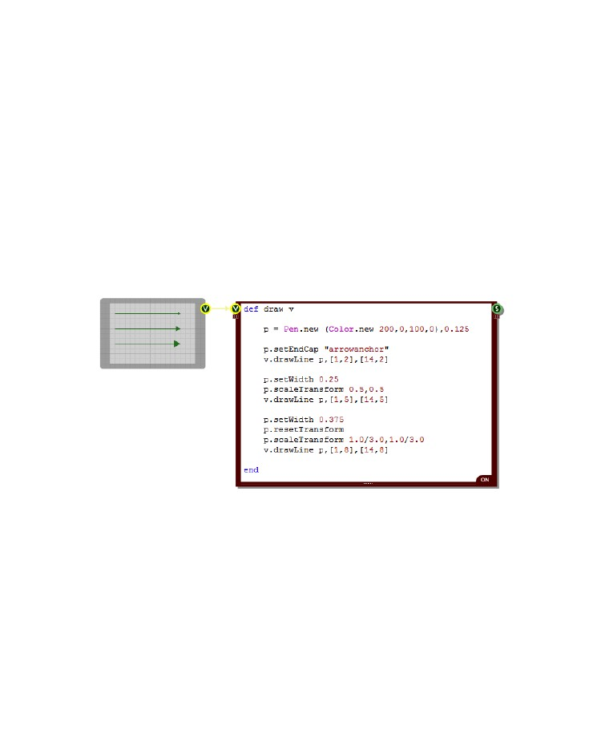
CHAPTER 8
Scaling
Line caps are scaled automatically in proportion to the line thickness. This scaling can make it difficult
to achieve the style you're looking for. For example, if you create a single pixel thickness line with an
arrow end cap the arrow will be just 2 pixels wide.
You can get round this by creating a thicker pen and then scaling it down using the scaleTransform
method. The end cap is inversely affected by the scaleTransform and so if you find a scale factor that
maintains the .
scaleTransform sf-x, sf-y
resetTransform
The scaleTransform method takes x and y scale factors – these are floats with 1.0 meaning no
change. There is also a resetTransform method which is useful if you're reusing the same pen and
resets any applied transforms.
The example below shows a single pixel width line with an arrow end cap. Below it are two identical
lines but with larger arrows using the technique we just described.
- 188 -

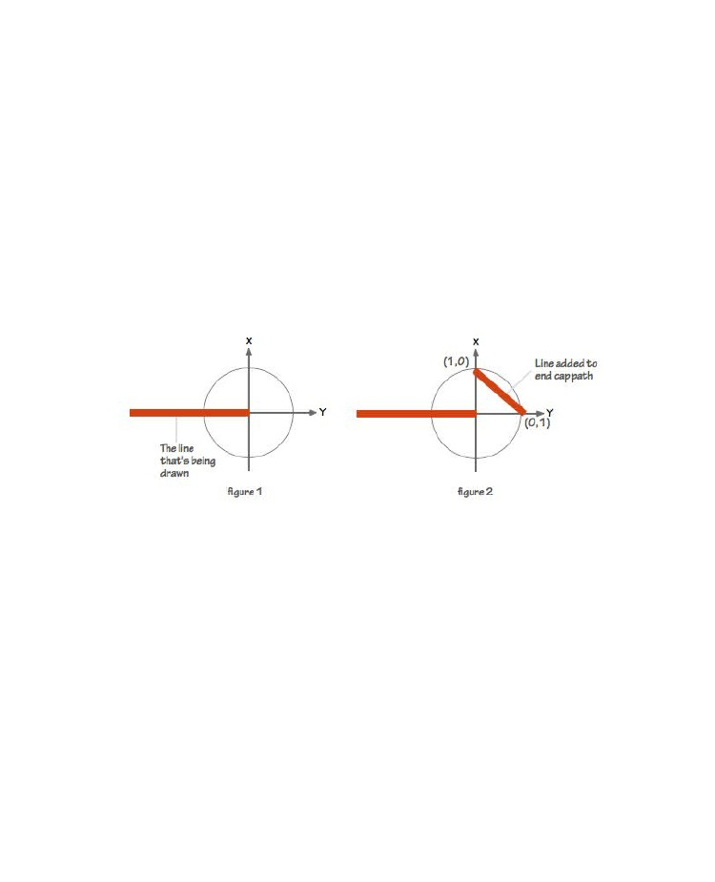
RUBY COMPONENT
Custom Line Caps
If you want to create your own custom line caps then you can do this using the CustomLinecap class.
You create an instance of this class the use it to set the start or end cap for the pen.
Before you can do any of this you will need to create a GraphicsPath object. This will define the
shape of the line cap.
You create a graphics path in the same way as usual. The units are still grid squares, however the
coordinate system is relative to the line. This is necessary because when the line changes direction
you want the end cap to change its orientation accordingly.
The diagram below shows how the coordinate system works. Figure 1 shows the axes relative to an
arbitrary line. Figure 2 shows a single line having been added to the graphics path for the custom end
cap. The line starts at (1,0) and ends at (0,1). If we added another line from (0,1) to (-1,0) and closed
the path then we'd have a path to make our own custom arrow head line cap.
So now we go back to the CustomLineCap class. We can create an instance of this class in one of two
ways. Either we have an end cap where the path shows as an outline or we have a path which is filled
(with the pen color). Here's how you handle both cases:
c = CustomLineCap.new nil,path,0
c = CustomLineCap.new path,nil,0
# line cap outline
# line cap filled
The third parameter is the offset of the cap from the line in grid squares. A positive offset will move the
cap away from the line and a negative one will pull it closer.
Now that you have a CustomLineCap object you can use the setCustomStartCap and
setCustomEndCap methods of the Pen class to assign the cap to the Pen. The example below shows
how this all works.
- 189 -

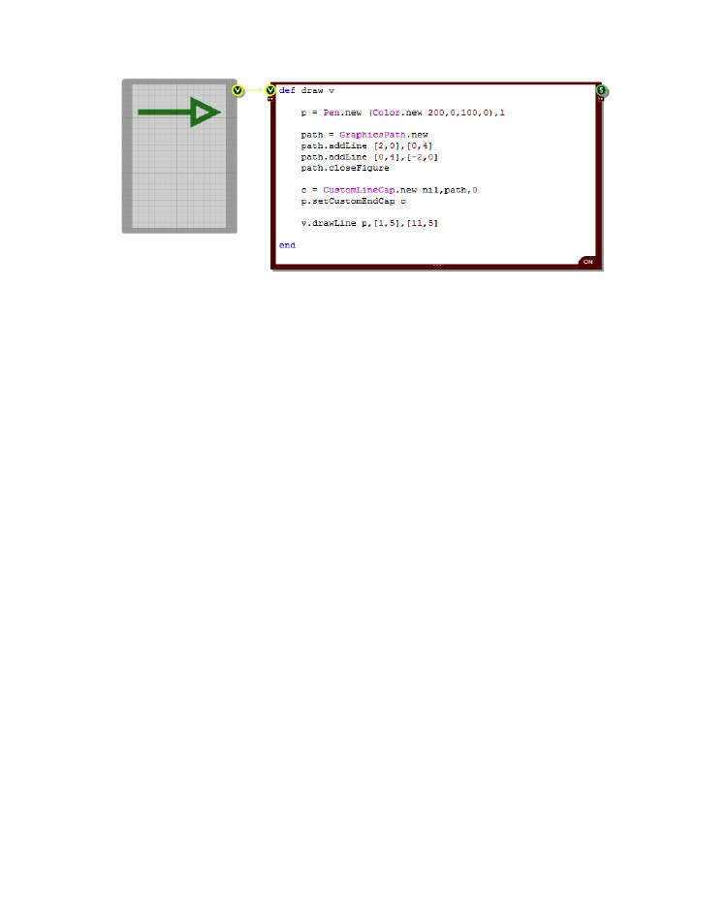
CHAPTER 8
Scaling
The custom line cap scales proportionally to the pen size. The default is for this to scale 1:1. You can
change this by using the setWidthScale method of the CustomLineCap class. Setting this to 2 for
example, would make the cap be double the size it would be normally at whatever pen width. The
width of the pen used to stroke the path would also be double the pen width.
Join and Caps for the Path
Going into even more detail, you can even set the end caps for the custom line cap itself. Use the
setStrokeCaps method of CustomLineCap. This takes two parameters, a cap for the start of the path
and a cap for the end of the path. These are strings and can be one of the following:
“square”, “round”, “triangle”
The join style can also be set by using the setStrokeJoin method. This takes a single string to define
the join style and can be one of:
“bevel”, “round”, “miterclipped”
The example below shows these methods being used. Note that the end cap and join styles only apply
to stroked paths. If you use a filled path for your custom end cap then these are ignored.
- 190 -

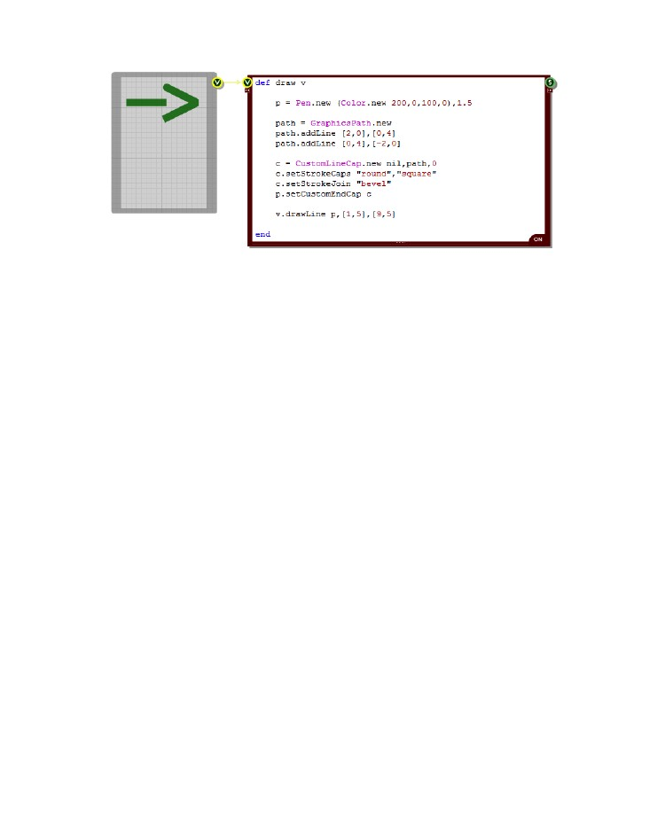
RUBY COMPONENT
- 191 -

CHAPTER 8
Interaction
En la sección anterior vimos cómo se puede dibujar a un panel frontal con un componente de Ruby. En esta sección vamos a hablar sobre cómo controlar eventos de ratón a partir de un panel frontal.
Usted necesitará una vista de entrada configurado exactamente de la misma forma que para el dibujo.
En cambio, si lo que desea es controlar la entrada de eventos de ratón se puede crear un conector de ratón en lugar de la Vista.

La forma en que maneja los eventos dentro del componente de Ruby es exactamente el mismo en ambos casos

Overview
Usted recordará de la sección anterior de que para la elaboración FlowStone buscó un método draw en el componente de Ruby. Los eventos del ratón se manejan de una manera muy similar.

Para cada tipo de evento FlowStone busca un método particular de su componente de Ruby.
Si lo encuentra a continuación, los detalles del evento que se pasan al método de modo que pueda responder.
Hay diez métodos de FlowStone para esto. Todos ellos toman el mismo conjunto de parámetros de entrada.
Hay un primer parámetro de opción que es la referencia conector de entrada (una cadena de número entero o etiqueta). Sólo es necesario esto si tiene múltiples Vistas conectados a su componente de Ruby.

En la gran mayoría de los casos esto no será así, y por lo que no tendrá que preocuparse por el parámetro de referencia del conector.
Los principales parámetros son las coordenadas x e y. Estos son los dos flotadores y están en unidades cuadradas de cuadrícula.
Por ejemplo, para definir el método para manejar los clics izquierdos del ratón:
def mouseLDown x,y
end
Si tuviera más de un Vista o el conector del ratón entonces usted puede agregar la referencia del conector para que pueda diferenciar entre la llegada eventos:
def mouseLDown i,x,y
end
Ahora nos ocuparemos de los 10 métodos en detalle.
- 192 -

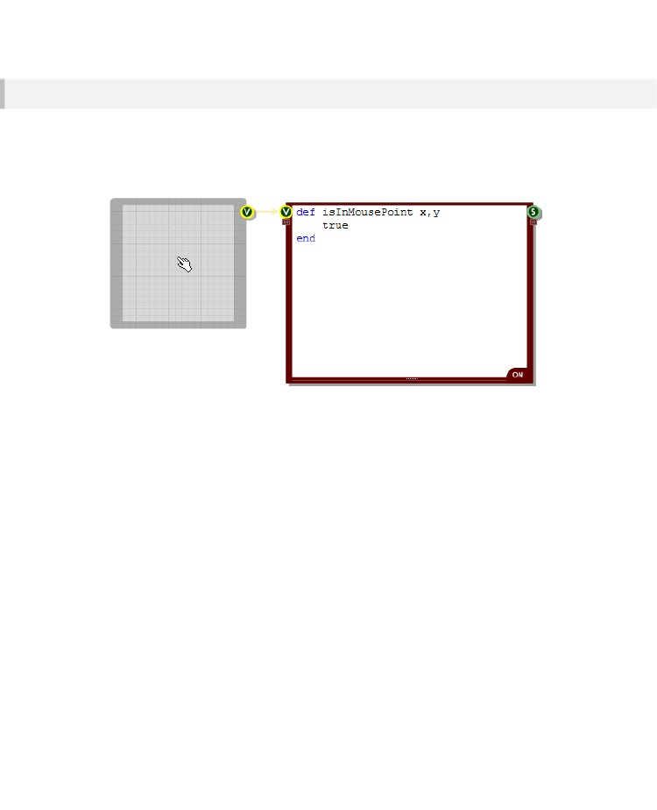
RUBY COMPONENT
Handling Mouse Events
El método más importante que hay que definir es isInMousePoint porque esto es lo que dice FlowStone que usted acepta eventos del ratón. Sin esto obtendrás ningún evento de ratón en absoluto.
El método debe devolver true o false para decirle FlowStone si controla los eventos del ratón o no (también puede volver 1 o 0)
El ejemplo anterior muestra cómo el cursor del ratón cambia a la 'mano' por defecto para indicar que la interacción es posible.
En este caso hemos elegido para manejar eventos de ratón, independientemente de que el puntero del ratón se encuentra en la Vista. Sin embargo, se puede utilizar la posición x e y para devolver un resultado diferente dependiendo de si el ratón está en un área o lugar en particular.
- 193 -

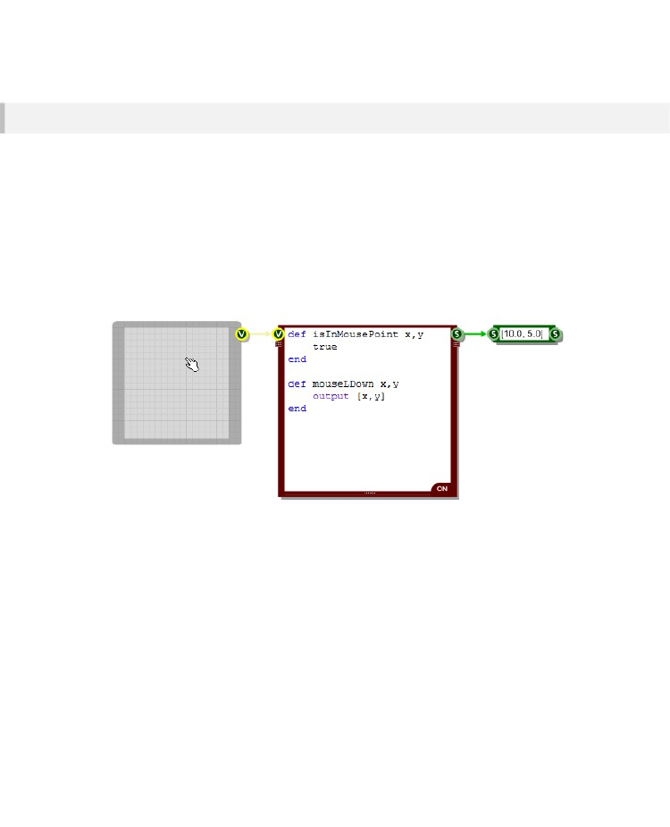
CHAPTER 8
Mouse Clicks
Una vez que haya definido su método isInMousePoint recibirá un evento cada vez que un clic de ratón se produce en la vista (que proporciona isInMousePoint devuelve true para el punto en particular).
Hay 6 métodos para responder a los clics del mouse estándar, 3 para el botón izquierdo del ratón y 3 para la derecha. Estos son los siguientes:
mouseLDown
mouseLUp
mouseLDouble
mouseRDown
mouseRUp
mouseRDouble
- Botón izquierdo del ratón cuando se hace clic
- Botón izquierdo del ratón cuando es soltado
-
-
-
-
Botón izquierdo del raton cuando se hace doble click
left mouse button cuando se hace click
left mouse button cuando es soltado
left mouse button cuando hace doble-click
Aquí definimos un método de clic de botón izquierdo del ratón. Lo hicimos de forma que produzca una matriz con las coordenadas del punto de clic. Se puede ver que el puntero del ratón se encuentra en 10 cuadrículas de ancho y 5 hacia abajo.
Todos los otros métodos clic del ratón funcionan de la misma forma.
- 194 -

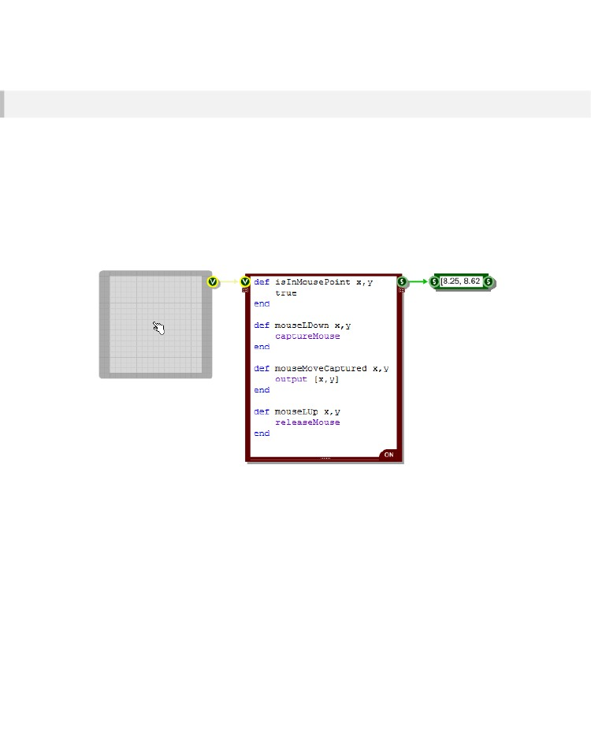
RUBY COMPONENT
Mouse Capture & Dragging
Si desea controlar las operaciones de arrastre, en los que el usuario hace clic, celebra luego se mueve el cursor, usted tendrá que capturar el ratón. Para ello se llama al método CaptureMouse. Esto debe hacerse en respuesta a un evento de ratón.
Ahora, siempre y cuando el botón del ratón sigue siendo bajista FlowStone buscará un método llamado mouseMoveCaptured en su componente de Ruby. Si existe será llamado cada vez que se mueve el ratón.
Cuando se suelta el botón del ratón obtendrá una llamada al método apropiado del ratón hacia arriba. A partir de este método tendrá que llamar al método ReleaseMouse.
Todo esto es mucho mejor ilustra en un ejemplo:
Aquí hemos ampliado el ejemplo anterior para enviar las coordenadas del puntero del ratón solamente mientras arrastra el ratón.
- 195 -

CHAPTER 8
Key Modifiers
A veces se quiere definir diferentes respuestas a los clics y arrastres en función de si un modificador de tecla en particular se ha aplicado.

Por lo general usted querrá comprobar si las teclas SHIFT, CTRL o ALT se presionan en el momento de o durante la interacción.
Para ello tenemos el método isKeyPressed:
isKeyPressed keyName
El método tiene una entrada, el keyName. Esto puede ser una cadena que representa la clave o un número entero que representa el código de tecla virtual.
Así que para comprobar la tecla 'q', utilice "q" o el código de tecla virtual de 81 como el nombre de la clave. Usted puede encontrar una lista de los códigos de tecla virtual aquí:
http://msdn.microsoft.com/en-us/library/aa243025(v=vs.60).aspx
El método devolverá true o ​​false dependiendo de si se presiona la tecla actualmente o no.
Special Keys
Para algunas teclas especiales, que se utilizan con frecuencia tenemos cadenas de métodos abreviados de configuración para ahorrarle tener que buscar los códigos de teclas virtuales:
Key
Shift
Control
Alt
Space
Return / Enter
Arrow Key Up
Arrow Key Down
Arrow Key Left
Arrow Key Right
Cadena de nombre clave para el uso (mayúsculas y minúsculas)
“Shift”
“Control” or “CTRL”
“Alt”
“Space”
“Return” or “Enter”
“Up” or “Arrow Up”
“Down” or “Arrow Down”
“Left” or “Arrow Left”
“Right” or “Arrow Right”
- 196 -

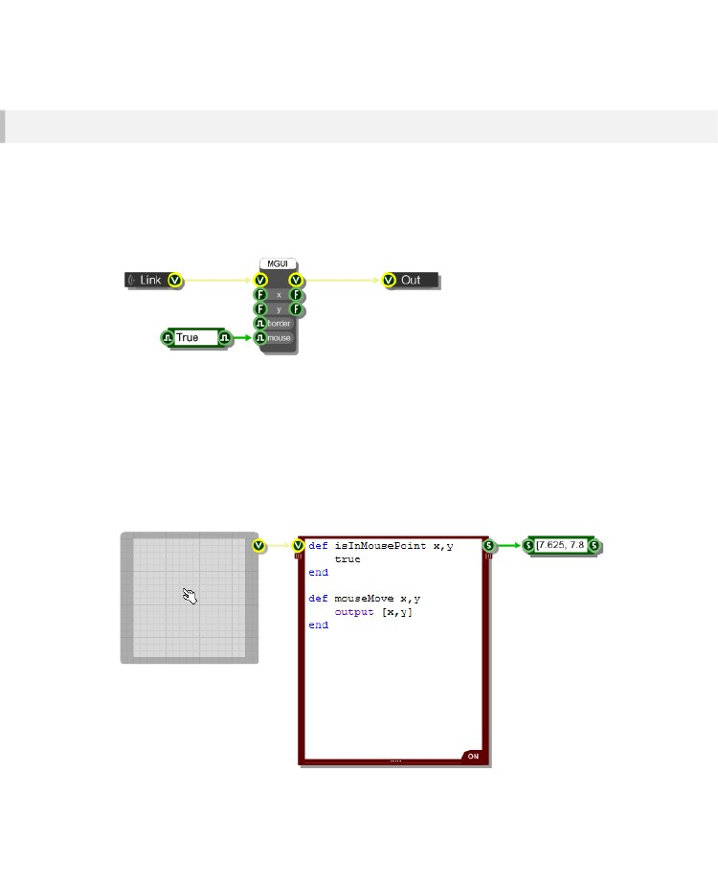
RUBY COMPONENT
Mouse Move
Si desea capturar los movimientos del ratón cuando no se pulsan los botones del ratón, entonces primero hay que habilitar esto en el componente MGUI que se está conectando. Por defecto los mensajes de movimiento del ratón suprimen con el fin de mejorar el rendimiento.
Para activar movimientos del ratón que usted necesita ir al componente MGUI, conecte un componente de Boole a su entrada Ratón y establecer en True (como se muestra a continuación).
El ejemplo anterior muestra lo que tenemos en el interior del módulo que hemos estado utilizando en los ejemplos que hemos mostrado hasta ahora.
Una vez que haya habilitado el ratón se mueve FlowStone buscará un método mouseMove en su componente de Ruby. Cada vez que se mueve el ratón en la vista del método mouseMove se llamará.
El siguiente ejemplo muestra las coordenadas que se envían a cabo cada vez que se mueve el ratón sobre la vista.
- 197 -

CHAPTER 8
Mouse Cursor
Hay otros cursores que se pueden utilizar distintos del predeterminado. Para establecer el cursor tiene que crear un método MouseCursor. FlowStone espera un valor devuelto de este método, que le diga que el cursor
you want to use. The return value can be an integer or a string:
0 or “default” (por Defecto)
1 or “ibeam” (Cursor)
2 or “pointer” (Puntero)
3 or “handpointer” (Mano Indicativa) o (Punto de Mano)
4 or “move” (Mover)
5 or “pointeradd” (Puntero Aumentador)
6 or “pointerdel” (Puntero Disminuidor)
7 or “smallpointer” (Puntero Pequeño o secundario)
8 or “resizeew” (Reaumento Horizontal)
9 or “resizens” (Reaumento vertical)
10 or “handopen” (palpar)
11 or “handclosed” (tomar)
12 or “crosshair” (Punto de Mira)
13 or “deny” (Negar)
- 198 -

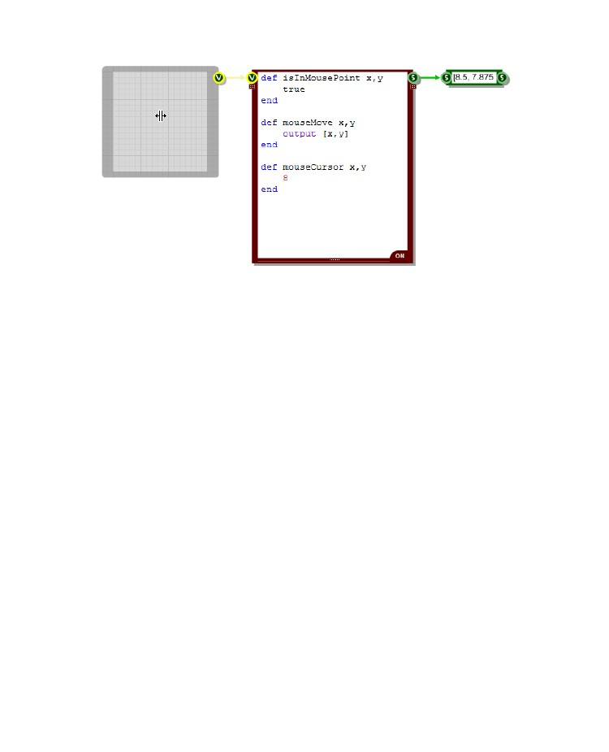
RUBY COMPONENT
- 199 -

CHAPTER 8
Controls and Dialogs
Hay un par de elementos de la interfaz de usuario que utilizamos con controles de Windows y cuadros de diálogo.

Tenemos primitivas para ellos, pero cuando se está programando una interfaz que use componentes de Ruby es mucho más fácil para poder acceder a ellos desde su código.
Esta sección describe estos elementos y cómo usarlos.
In Place Edit Controls
Los controles de edición son prácticamente indispensables para reunir numérica precisa o la introducción de texto. Se puede crear un lugar en el control de edición sobre la marcha cada vez que se necesita para obtener la información mediante el uso del método createEdit:
createEdit input, id, area, [startText [,font [,textColour
[,backColour [,multiline]]]]]
Las entradas al método son los siguientes:
input
id
area
startText
font
textColour
backColour
multiline
-
-
-
-
referencia al conector de entrada Ver (nombre o índice)
un identificador que se puede utilizar en la devolución de llamada para que usted sepa lo que está informando de edición
cuatro array elemento [x, y, w, h] para definir la posición y el tamaño
el texto que aparecerá en la edición para empezar con [OPCIONAL]
- El tipo de letra a utilizar (un objeto de fuente) [OPCIONAL]
- El color del texto [OPCIONAL]
- El color del rectángulo de fondo para el control de edición [OPCIONAL]
- si el control debe ser una edición de múltiples líneas (verdadero o falso) [OPCIONAL]
Una vez creado el control de edición se presentará un informe al componente de Ruby. Usted puede capturar la información reportada por la aplicación de uno o ambos de los siguientes métodos:
def editFinished id,text
end
def editChanged id,text
end
Las entradas a estos métodos son los mismos - el id del control de edición que informa (el que usted le ha proporcionado al crearla) y el texto que se encuentra actualmente en el control.
La única diferencia entre los dos es que el método editChanged se llama con cada golpe de teclado mientras que el método editFinished sólo se llama cuando el control de edición se cierra (cuando el usuario presiona el tabulador o clics).
- 200 -

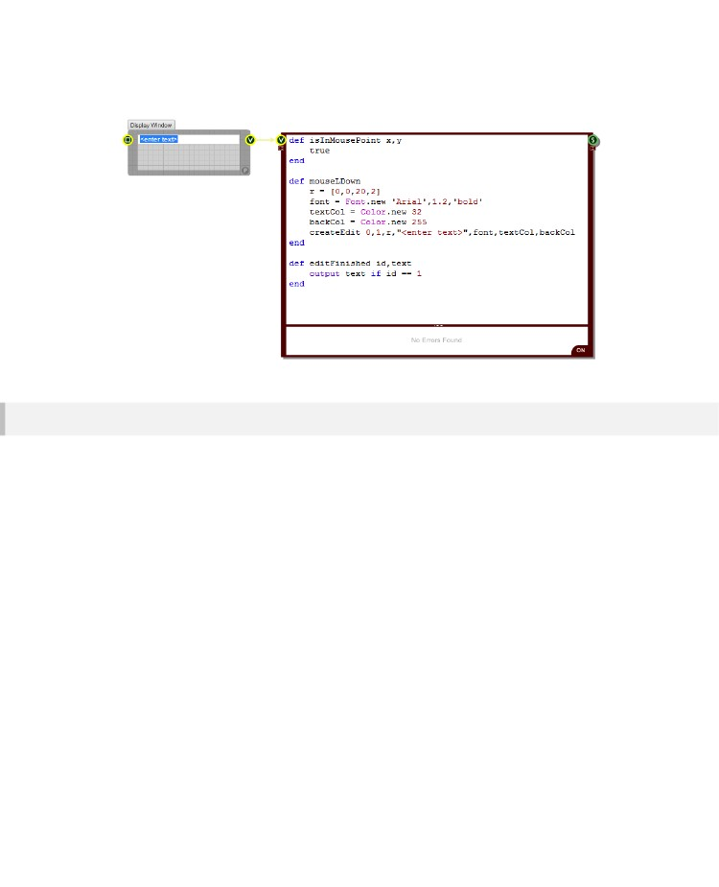
RUBY COMPONENT
He aquí un ejemplo de un control de edición en el lugar que se utiliza para capturar la entrada. En este ejemplo hemos hecho clic en la interfaz de usuario por lo que el método mouseLDown ya se ha llamado y ha creado el control de edición.
Drop Lists (Suelta Listas)
Para la selección de una lista discreta de opciones que tenemos para el control de lista desplegable. Puede crear una utilizando el método createDropList:
createDropList input, id, pos, items, [checked [,style [,disabled]]]
Las entradas al método son los siguientes:
input
id
pos
items
checked
style
disabled
- referencia al conector de entrada Ver (nombre o índice)
- un identificador que se puede utilizar en la devolución de llamada para que usted sepa qué lista está informando
- esquina superior izquierda de la lista desplegable
- comas de cadenas de nombres de elementos separados
- Índice del elemento que desea mostrar como prueba [OPCIONAL]
- "scroll", "autocol" o el número de artículos por la columna [OPCIONAL]
- el índice del elemento que desea mostrar como discapacitados [OPCIONAL]
Una vez creado el control de lista desplegable que informará al componente Rubí vez a la selección se ha hecho. Usted puede capturar la información reportada por la aplicación del siguiente método:
def dropListFinished id, index, name
end
La entrada id es el id de la lista desplegable que informa (el que se suministra cuando lo creó). El índice es el índice del elemento seleccionado y el nombre es el nombre del elemento que se muestra en la lista.
- 201 -

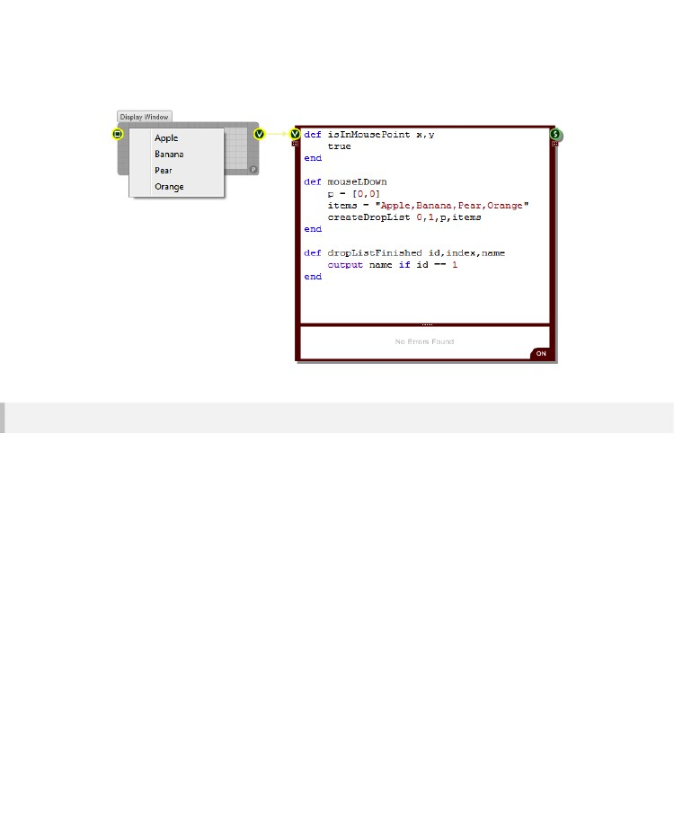
CHAPTER 8
He aquí un ejemplo de un control de lista desplegable en la acción. En este ejemplo hemos hecho clic en la interfaz de usuario por lo que el método mouseLDown ya se ha llamado y ha creado el control.
Message Boxes
Es útil ser capaz de dar avisos al realizar acciones irrecuperables o para solicitar un usuario para su confirmación. Aquí es donde los cuadros de mensajes vienen pulg Usted puede crear un cuadro de mensaje con el método messageBox:
messageBox id, text [,title [,type ]]
Las entradas al método son los siguientes:
id
text
title
type
- Un identificador que se puede utilizar en la devolución de llamada para que usted sepa cuál va a denunciar
- El texto a mostrar en el cuadro de mensaje
- El texto de la barra de título del cuadro de mensaje [OPCIONAL]
- define cómo se ve el cuadro de mensaje y se comporta [OPCIONAL]
El tipo es una combinación de cadenas en cualquier orden con ningún separador que te gusta. Las opciones son las siguientes:
arreglos de Botón: okcancel, retrycancel, yesnocancel, yesno, abortretryignore
Iconos: exclaimation, warning, information, asterisk, question, stop, error, hand
Botones por defecto: defbutton1, defbutton2, defbutton3, defbutton4
- 202 -

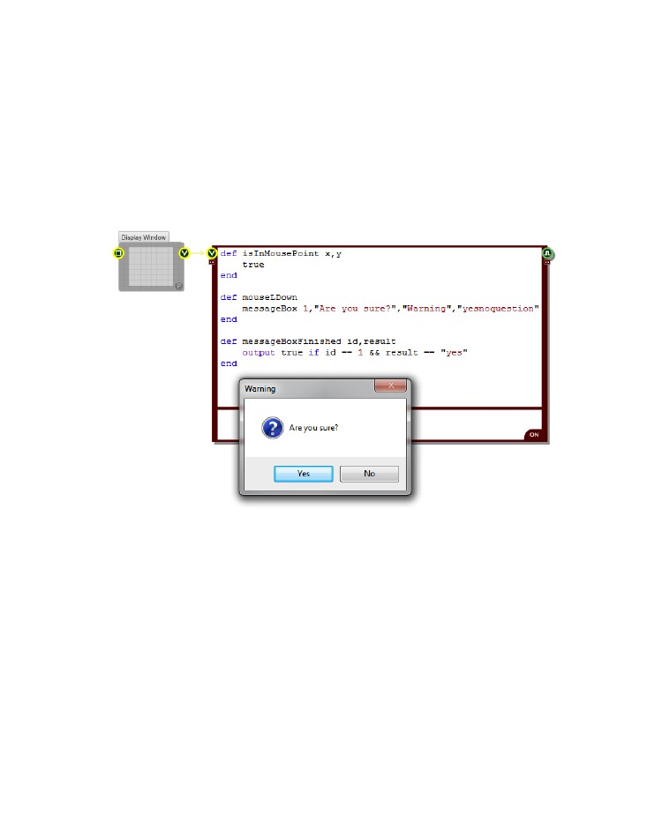
RUBY COMPONENT
Una vez que el cuadro de mensaje ha cerrado informará al componente de Ruby. Usted puede capturar la información reportada por la aplicación del siguiente método:
def messageBoxFinished id, result
end
La entrada id es el identificador del cuadro de mensaje que informa (el que se suministra cuando lo creó).
La entrada de resultado es el botón que se presionó ej "yes", "ok", "cancel", "retry" etc.
He aquí un ejemplo de un cuadro de mensaje en la acción. En este ejemplo hemos hecho clic en la interfaz de usuario por lo que el método mouseLDown ya se ha llamado y creamos el cuadro de mensaje..
- 203 -

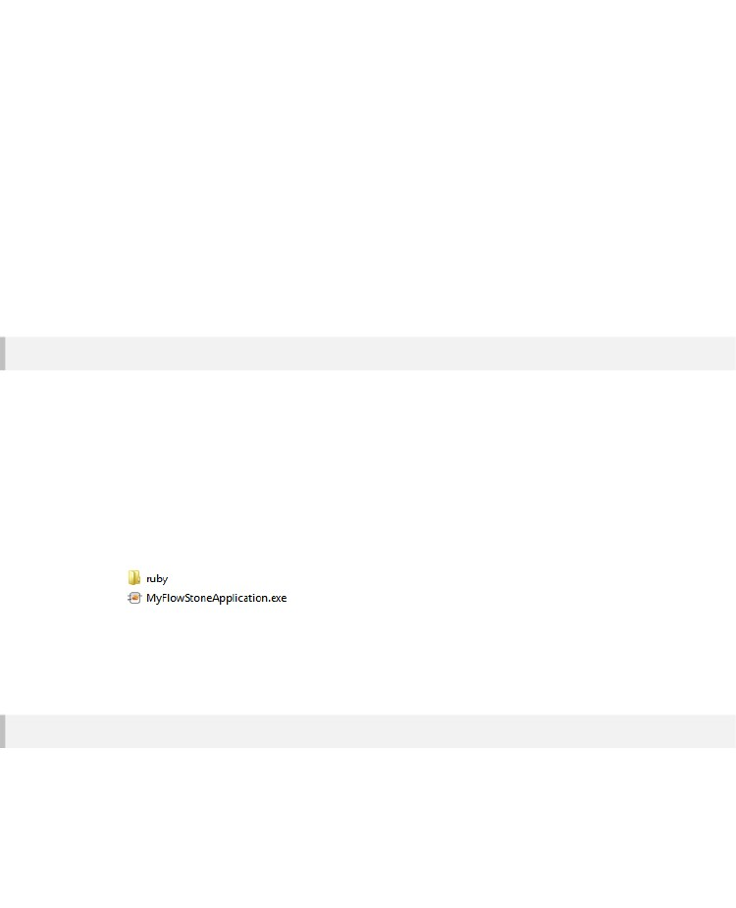
CHAPTER 8
External DLLs
You can call functions in external DLLs from inside your Ruby code. This is done by making use of the
Ruby Win32API extension.
All you do is create an instance of the Win32API class that has all the information about the function
call you want to make. You then execute the Win32API call method to execute the function. All very
straightforward.
Let's take a look in detail about how this is all achieved.
The Win32API Extension
The key to providing access to external DLLs is the Win32API extension. This is installed in your
FlowStone folder in Program Files under \ruby\libraries\win32.
The files are separate from the software but FlowStone knows where to look for them on your PC. If
you are only ever working on the same machine then you don't have to worry about any of this.
However, if you create an exported exe that uses the extension and want to pass this to someone else
then either they will need to have FlowStone installed on their system or you will have to distribute
the \ruby\libraries\win32 folder (including the ruby and libraries parent folders).
The ruby parent folder should then be inside the same folder and at the same level as your exported
exe as shown in the picture below:
The first thing you need to do is tell Ruby you want to use the Win32API extension. This is done by
calling the Kernel method require:
require "Win32API"
Creating a Function Object
Before you can call a function in an external DLL you need to create an instance of the Win32API
class. The resulting object must have all the information it needs about the target function before it can
be used to make the call.
- 204 -

RUBY COMPONENT
To create a Win32API object:
callObject = Win32API.new( library, functionName, inTypes, outType )
The input parameters (shown in italics above) are as follows:
library
This is the name of the dll that contains the function you want to call. You don't need to add the .dll file
extension so you can leave that off if you wish. If you don't specify a path then the software will look for
the dll in the following places:
•
•
•
•
•
the folder from which the application executed
the current folder
the Windows system folder (e.g. c:\windows\system or system32)
the Windows folder
the folders that are listed in the PATH environment variable
functionName
This is the name of the function you want to call. It must be exactly as it is written in the dll and is case
sensitive.
inTypes
This defines the number of inputs to the function and their types. Each parameter is represented by a
single character. You can use a Ruby array with each element as a character ( e.g. ['I','n','c'] ) or you
can use a string ( e.g. “inc” ).
The types you can use are as follows:
I or i
L or l
P or p
S or s
V or v
- integer
- long
- pointer (including char* buffers)
- string (const char* only)
- void
For constant strings use 'S'. For string buffers that might be modified by the function call use 'P'.
outType
This defines the output type. This is a single character and can be any of those shown above including
'v' (upper or lowercase) to represent a void return value.
As an example we're going to use the GetCursorPos function in user32.dll so our Win32API object
would be created as follows:
getCursorPos = Win32API.new("user32", "GetCursorPos", ['P'], 'V')
- 205 -

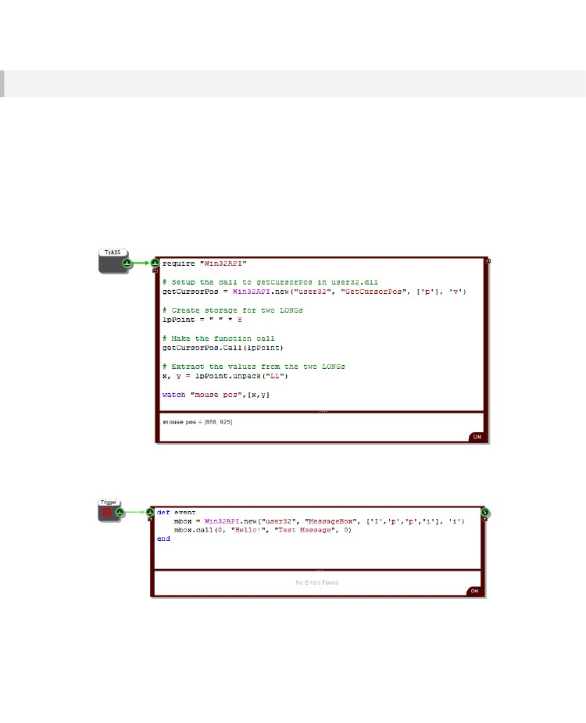
CHAPTER 8
Making the Call
Once you have your object you are ready to make your function call. To do this we use the Win32API
method call and pass it a set of parameters that match the ones we supplied when we created the
object.
If your function call modifies the input data passed to it then you need to allocate the memory for that
data before passing it to the function.
In the example we've chosen the GetCursorPos function takes an LPPOINT which is 8 bytes. So we
need to create a string with 8 characters to allocate this memory. We can then unpack this after the call
has been made to extract the x and y coordinates we're after.
Here's how everything looks when it's put together:
We added a Tick25 so that we can watch the coordinates change as we move the mouse.
Here's another example:
This will show a message box whenever the trigger button is pressed. The input parameters to the
MessageBox call are parent window, message, title, type. Notice that the message and title are passed
- 206 -

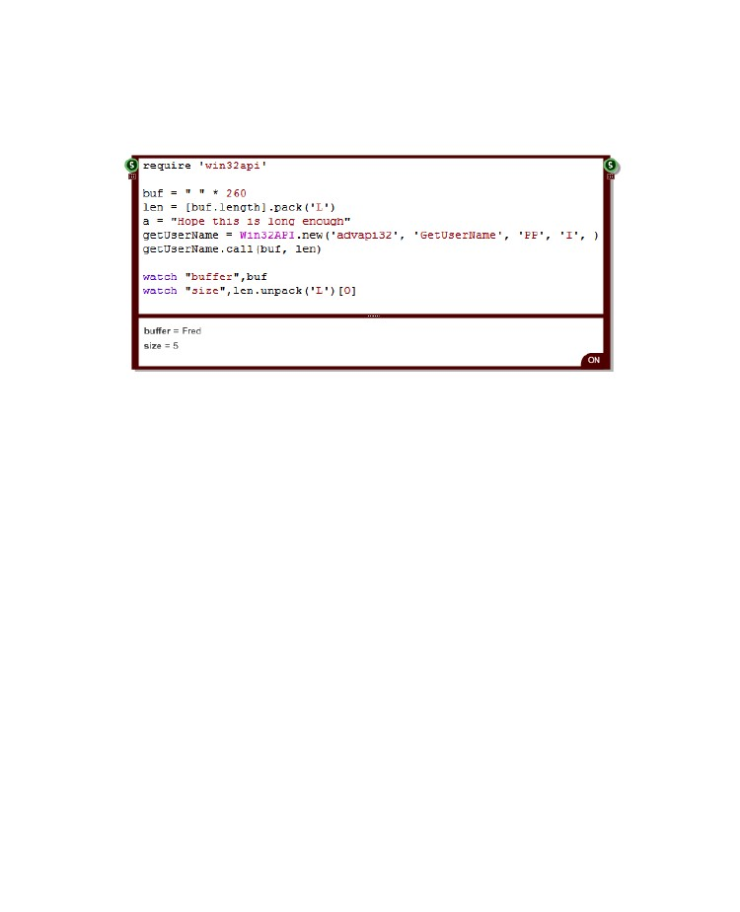
RUBY COMPONENT
as strings. You don't need to do any packing. We use 'p' in the input types because these strings are
char* values, not constants.
Here's one final example. This shows how to retrieve a string value from a function call.
We're using a call to GetUserName to return us the name of the current user. For this we have to
create a buffer for the function to put the name into and also pass a variable to send the buffer size
and receive the length of the string sent back.
To create a suitable buffer we just need a Ruby string of sufficient size. To set up the variable to send
the buffer size we have to create a 32bit unsigned int. This we do using the pack method of the Ruby
Array class. We put the number we want to initialise the int with in an array ([buf.length] ie. [260]). We
call pack on the array passing 'L' meaning 32bit unsigned int. See the Ruby documentation for more
on the Array Pack method.
You can see that the buffer returns the name of the user, “Fred” in this case.
The size of the returned string is placed in 'len'. This is a 32bit unsigned int remember so to convert it
to a Ruby Int we need to unpack it. The result of calling unpack is an array with the string size as the
first entry. We can see the size is 5, the four characters in 'Fred' and the string null terminator.
Distribution
If you plan to distribute any exported exes or plugins that use an external DLL you must ensure that
the DLL is distributed with it. You must also distribute the ruby\libraries\win32 folder that is located in
your FlowStone install folder. You need to have a folder called ruby in the same folder as your exported
file. Inside this folder should be a libraries folder and inside that you place the win32 folder and all its
contents. Without these your export will not function correctly.
- 207 -

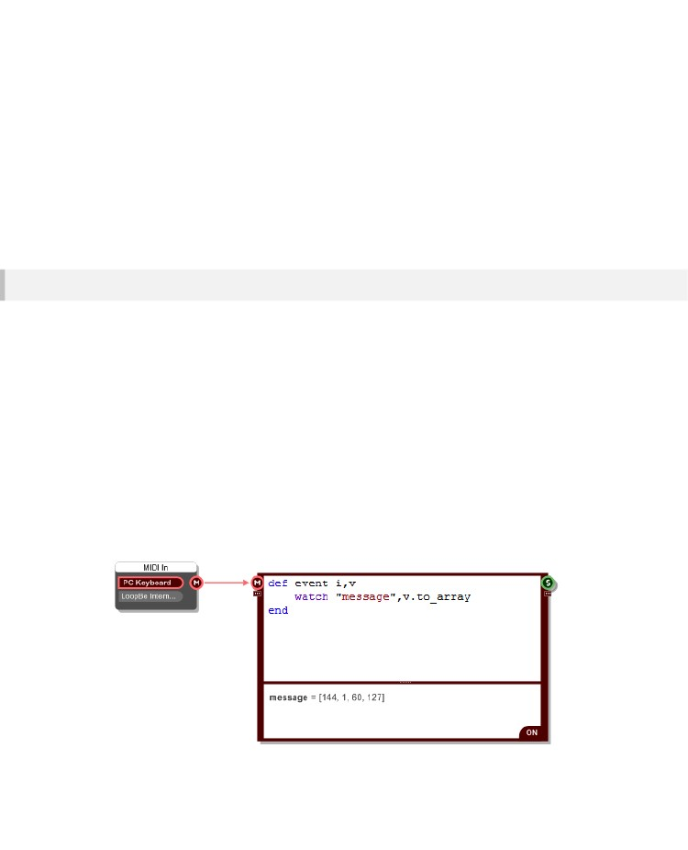
CHAPTER 8
MIDI
When you send MIDI data to a Ruby component it is represented by an instance of the MIDI class.
Using Ruby you are then free to process this MIDI object in any way you like. You can create new MIDI
objects and you can send objects out of the Ruby component to play a synth in your schematic or
somewhere else.
Reading MIDI Objects
The MIDI class is a very straightforward. A single instance of the class represents one individual MIDI
message. FlowStone handles MIDI channel messages and MIDI system exclusive messages.
MIDI Channel Messages
MIDI channel messages are defined by four properties:
Status
Channel
Data1
Data2
-
-
-
-
the type of message eg. note on, program change etc.
the MIDI channel on which the message was transmitted (1-16)
first piece of status dependent data associated with the message
second piece of status dependent data associated with the message
We won't go into the MIDI specification in any great detail here. If you're not familiar with it then there
are plenty of good resources online.
To look access these properties for a MIDI object, call the to_array method. This will give you a ruby
array with the above properties as the elements, listed in order.
- 208 -

RUBY COMPONENT
In the above example we're playing a middle C. You can see that the MIDI message shows 144 for the
status (ie. NOTE ON) and 1 for the MIDI channel. For MIDI note on and off messages Data1 gives you
the note number (60 = middle C) and Data2 gives you the velocity (127 is maximum velocity).
MIDI System Exclusive
MIDI system exclusive messages (or sysex for short) are single chunks of data expressed in
hexadecimal (Hex) form. A sysex hex string starts with F0 and is terminated by F7. The data in
between can represent mostly anything that a synth manufacturer may want to send or receive from
their MIDI device.
Again, we won't go into the details of sysex here, we'll just explain how you can manipulate it within a
Ruby component.
When a MIDI object containing sysex arrives at a Ruby component you can look at it using the
to_array method. This will give you a Ruby array containing two entries. The first is the sysex hex data
string and the second is the number of hex bytes in that string (as each byte is two characters this
number will of ocurse be half the length of the string).
The above example shows how to look at the data in a system exclusive message. You can see the
array with the hex data as the first entry.
- 209 -

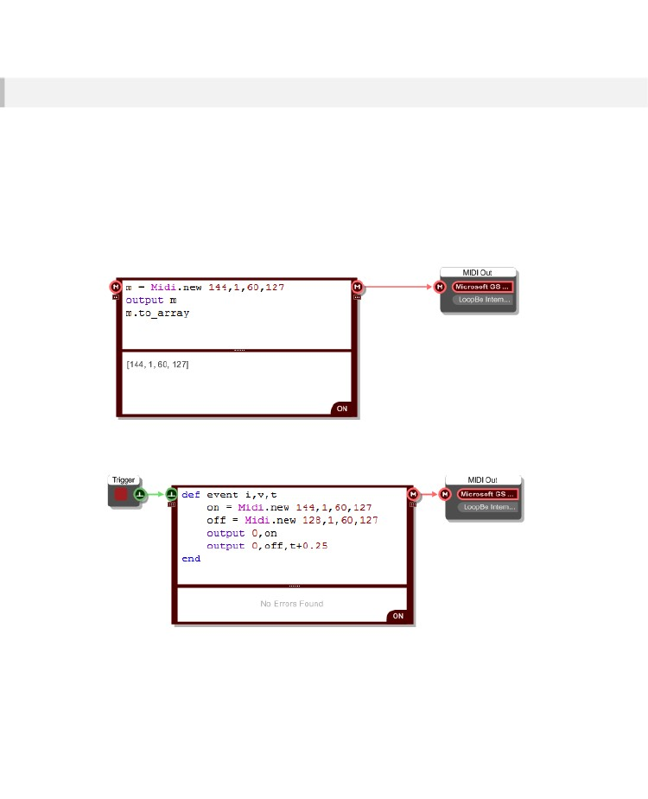
CHAPTER 8
Creating MIDI Objects
You can create your own MIDI messages using the MIDI class. This is done differently depending on
whether you want a MIDI channel or system exclusive message.
MIDI Channel Messages
To create a MIDI channel message you need to supply the four properties mentioned above as inputs
to the new method.
The example below shows how to create a NOTE ON message for middle C and send it out.
Ideally you'd want to create a note on together with a note off shortly after, so that you get a note of a
particular length. To do this you use the event scheduling capabilities of the Ruby component.
The example above will play a middle C at full velocity lasting a quarter of a second whenever you
press the trigger button. We need to make use of the optional time input to the event method here.
This gives us the current time and we schedule the 'off' MIDI event to be sent at time now + 0.25
seconds.
- 210 -

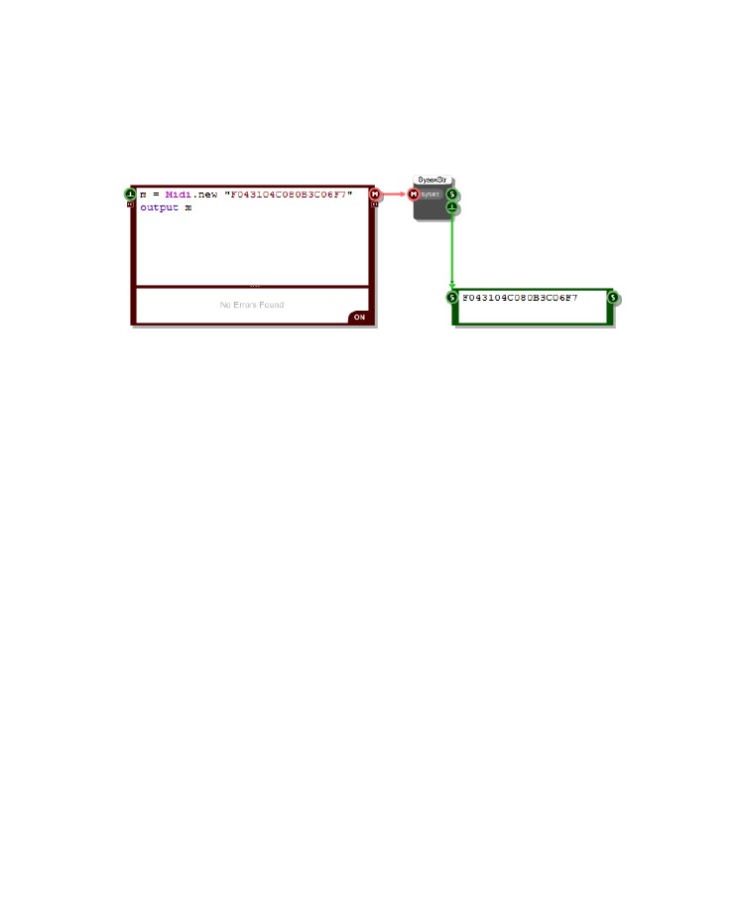
RUBY COMPONENT
MIDI System Exclusive
To create a MIDI sysex message you simply provide the sysex string to the new method.
The following example shows how you do this. You can see that we've sent the sysex message out
and the Sysex To String component has deciphered it.
- 211 -

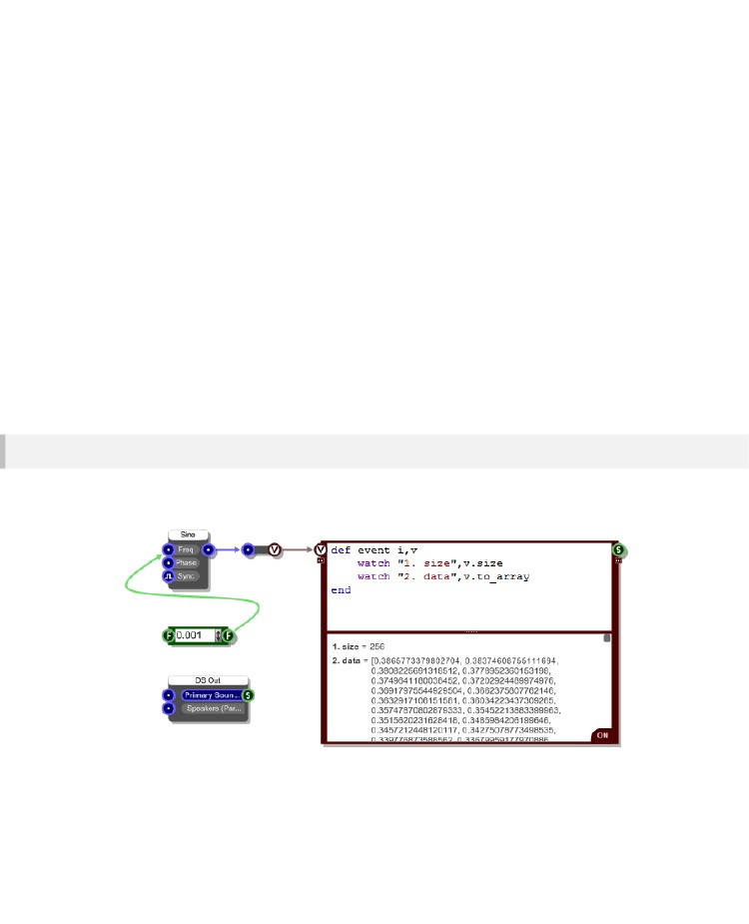
CHAPTER 8
Frames
FlowStone processes high data rate signals such as audio using Streams. These allow you to perform
one-sample-at-a-time processing at rates of 44.1Khz and beyond with minimal compromise in
performance.
Frames allow you to process this data via the Ruby component without losing a single sample.
Because of the high data rates involved you can't do this processing one sample at a time – the
processing overhead would be way too much. What we can do is give you access to the data in
batches of samples. We call these batches Frames.
Processing frames in Ruby can never compete with the speed of streams, so there is a performance
cost. However, if squeezing everything out of your cpu is not that critical then, together with Ruby,
Frames provide a very flexible way of analysing high data rate signals.
Mono to Frame
The Mono To Frame component takes Mono stream data and delivers it one frame at a time in precise
sync with the stream. The example below shows how you can use this.
The component produces instances of a Frame class. These are generated every time a frame of
samples is requested from ASIO or Direct Sound. The size of the frame depends on the ASIO or Direct
Sound setup you have.
- 212 -

RUBY COMPONENT
The Frame Class
The Frame class encapsulates a frame of samples. Frame objects can be easily manipulated inside a
Ruby component.
Reading Sample
There are two ways to access the individual samples. You can use the element reference operator ie.
square brackets to access a particular sample:
myFrame[i] – gives you the sample at index i in myFrame
If you need access to the whole frame of samples you can convert it to an array:
myFrame.to_array – gives you the samples in a Ruby array
There's a little bit of an overhead in converting to a Ruby array. However, if you plan on manipulating
all the samples then it's probably more efficient to convert to a Ruby array and do the processing on
the array than it is to access each sample individually.
Writing Samples
In the same way that you can read a single sample you can also write to a single sample:
myFrame[i] = 3.0 – assigns 3.0 to the sample at index i in myFrame
If you want to assign an array of Ruby Floats to a Frame then you'll need to create a new Frame
object. Here's how you do it:
f = Frame.new smpls – creates a new Frame from the array called smpls
- 213 -

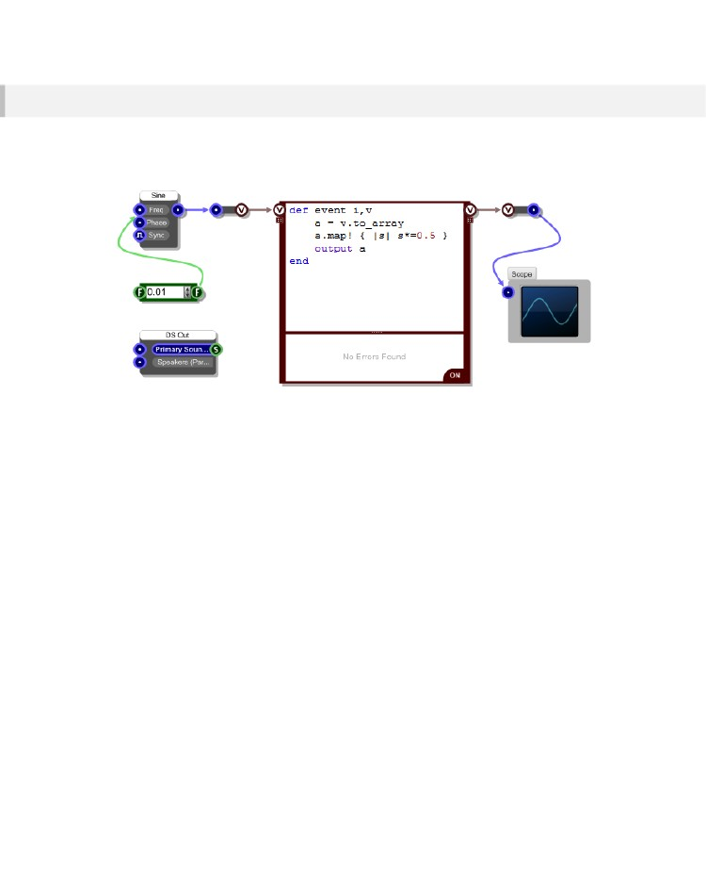
CHAPTER 8
Frame To Mono
The Frame To Mono component takes Frames and passes them back into the Mono stream. Using this
component in conjunction with the Mono To Frame component allows you to apply Ruby processing
within a Mono section.
In the example above we're taking a sine wave signal and halving the amplitude before passing it back
into the Mono stream. The Frame is converted to a Ruby array and then each element in the array is
multiplied by 0.5. The resulting array is passed out.
Note that we didn't pass out a new Frame object. This is because the Mono To Frame component can
take a Ruby array as input too.
We could easily have created a Frame object too by replacing the “output a” by
“output (Frame.new a)”.
- 214 -

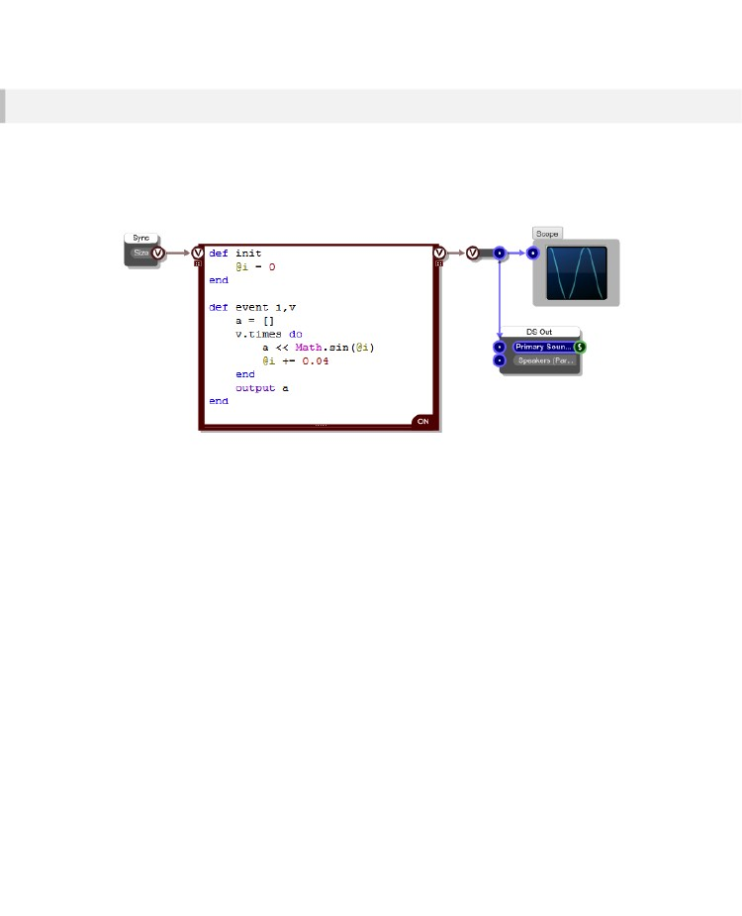
RUBY COMPONENT
Frame Sync
If you just want to generate a signal then you don't need the Mono To Ruby component, you just need
to generate Frames from your Ruby component and pass them to the Frame to Mono.
However, what you do need is a way to sync the Frame output with the Mono stream and also a way of
finding out the required frame size. This is where the Frame Sync component comes into play.
The example here shows a generated sine wave. The Frame Sync component sends the required
Frame size to the Ruby component at the time when a Frame needs to be generated. The Ruby
component then creates an array of samples, in this case based on a sine wave and sends this out
immediately.
- 215 -

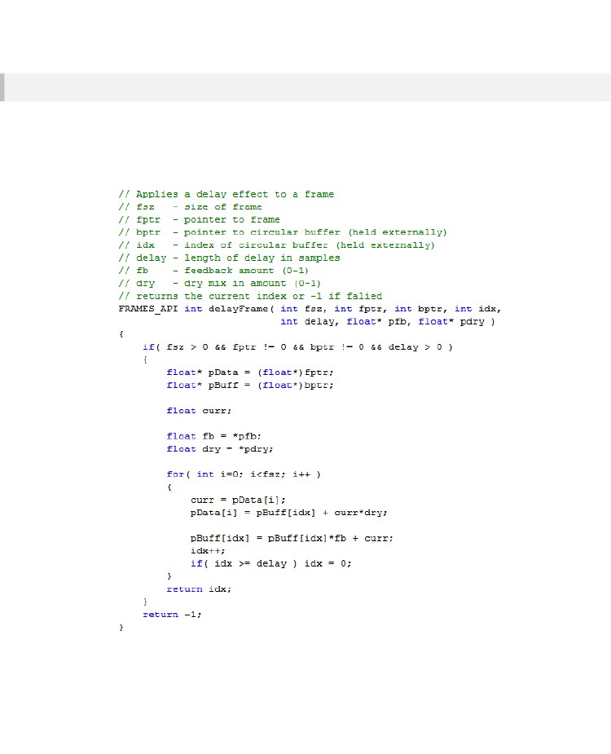
CHAPTER 8
Processing Frames in a DLL
You can process Frames in an external DLL. This is useful if you need maximum performance or if you
have existing algorithms written in another language that you want to make use of.
To show you how this is done we've created a function, written in C, for a simple delay effect and put
this in an external DLL. The code for this function is as follows:
- 216 -

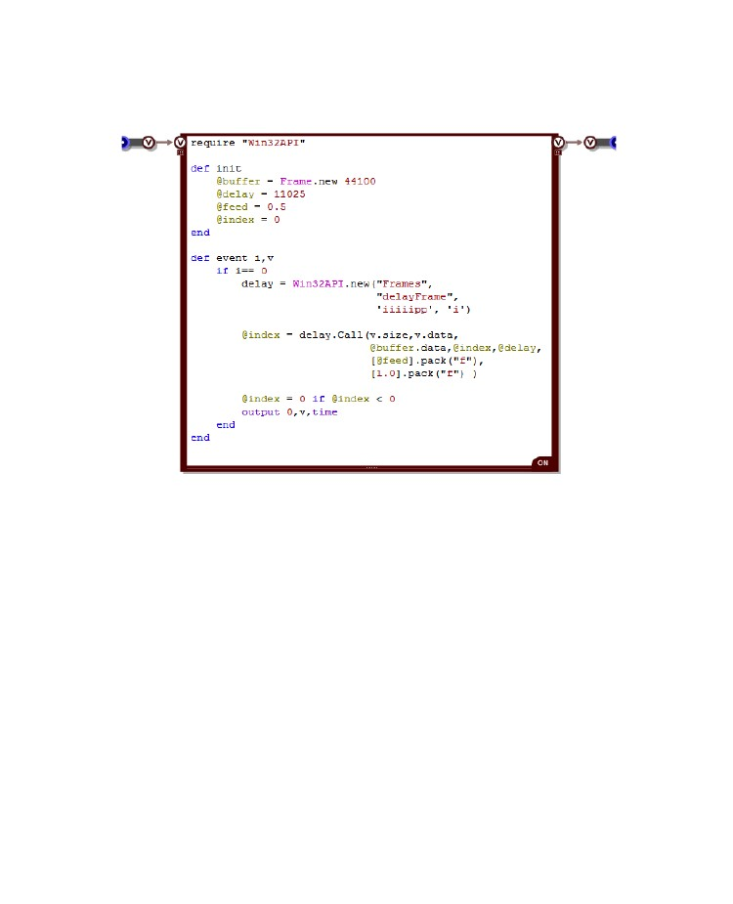
RUBY COMPONENT
To call this from FlowStone we need to use a Ruby component and the Win32API class. See the
earlier section on External DLLs for more information about using Win32API.
We use a circular buffer for the delay and this together with the current buffer index needs to be
managed on the FlowStone side. For the buffer we use a Frame object.
You can see from the C code of the external DLL that the function is called delayFrame and it takes 5
ints followed by two pointer inputs.
In the Call method we pass ints directly. So the size of the frame, the current index and the delay
amount are all passed without any need for conversion. The other two int values are pointers to the
Frame data for the current frame and the circular buffer. These are accessed via the data method of
the Frame class. This method gives you a Ruby int value which is the memory address of the raw
sample data. By doing this we don't need to convert between the underlying sample data and Ruby
which is much more efficient.
The remaining two inputs are Float values. Floats are not handles explicitly by Win32API so you need
to pack them into 32 bit floats.
That's all there is to it. The call is made and the external function updates the data in the current Frame
object and the circular buffer.
NOTE: if you want to create a standalone that uses a dll in this way then see the External DLLs section
for details on what you have to include in your distributiion.
- 217 -

CHAPTER 8
Ruby Limitations
Our main aim for Ruby in FlowStone was to provide a scripting mechanism that binds tightly into our
graphical programming environment and allows you to do things that were not possible before or were
very difficult previously using graphical programming techniques.
Ruby integration brings a massive number of benefits but this is Ruby within FlowStone and as such
there are some limitations when compared with using pure Ruby via text files and the command line.
The vast majority of people will be able to use Ruby in FlowStone without encountering any of these
limitations. However, for some advanced users of Ruby there are certain aspects of the
implementation in FlowStone that you should be aware of as they may restrict some of the things you
might want to do. This section covers those limitations.
Single Interpreter
The first thing to note is that there is a single interpreter for each instance of FlowStone. This means
that if you open two schematics within the same exe they will share the same interpreter – the same
Ruby airspace so to speak.
Individual Ruby components are always completely self contained so any instance variables you use
there relate only to the Ruby component in which they are declared. However, if you declare global
variables or classes in one schematic then they will be visible in the 'Ruby space' of the other
schematic.
Most of the time this will not be an issue. It's just worth knowing in case you happen to run into any
behaviours that may arise from this.
Standard Ruby Libraries
The standard installation of Ruby comes with a number of libraries. We don't currently supply all of
these with FlowStone. In fact we only supply one, win32 (used for connecting to external DLLs).
The main reason for this is that if you choose to export to a standalone exe or plugin, because the
libraries are external to Ruby you would need to distribute the library files alongside your export.
We hope to be able to provide an automatic way of dealing with this in the future so that you don't
need to think about dependencies on libraries – instead it would all be dealt with in the export process.
This would allow us to be able to offer the full set of standard libraries.
- 218 -

RUBY COMPONENT
Declaration Order
Because all Ruby components share the same interpreter you can declare globally available classes
and variables in one Ruby component and they will be available in all others. This is a very useful
feature. However, you need to make sure that when you re-load your schematic, the declarations
occur before they are needed. To do this the Ruby component that contains the declarations must be
interpreted before any Ruby components that use those declared items.
When FlowStone loads a schematic it starts with the top-level schematic and then loads each
component on that schematic in the order they were added. When it reaches a module it will load the
schematic for that module and the process continues in the same way.
The earlier a Ruby component appears in this ordering the earlier it will be interpreted. So let's say that
you have some class declarations in a Ruby component that are only used in a particular module. If
you ensure that the Ruby component is the first component in the schematic for the module then all
will be fine.
Unless you really plan ahead and add the Ruby component for your declarations first it's likely that
you'll find yourself in a situation where you need to change the order of components so that it's the first
one. You can do this by selecting all the other components, cutting them and pasting them back in.
Declaration Persistence
The Ruby interpreter is running constantly. Because of this any declared classes, global or instance
variables and constants will remain declared even if you delete the code for them. Currently the only
way to flush all the declarations is to save your schematic and restart FlowStone.
Gems
All seasoned Rubyists will know about Gems. These are packaged libraries of code that you can install
and use to extend Ruby beyond its standard capabilities.
If you have a Gem you want to use with FlowStone then if it is implemented in pure Ruby you should
have no problem using it. You will need to place the ruby files for the gem in a folder and then
reference that folder when you write your 'require' statement. You could also put it in the FlowStone
install folder under “ruby/libraries”.
If your Gem is written partly or wholly in C then it needs to be (or have been) compiled using Visual
Studio in order for it to work with FlowStone. If it has been compiled with mingw (as many Windows
gems are) it is unlikely to work.
- 219 -

CHAPTER 8
The same distribution issues apply to gems as for the standard libraries. If you decide to export your
creation and it uses a gem then you need to distribute the gem alongside it. You must also make sure
that the paths to the gem are all taken care of or it won't load.
Gems and VST Plugins
Currently VST plugins generated by FlowStone cannot make use of Ruby extensions or Gems.
- 220 -

RUBY COMPONENT
Ruby DLL
Ruby functionality is provided by an external DLL. This dll is called msvcr90-ruby191.dll. In order to
use this with FlowStone it has to be compiled using Microsoft Visual Studio 2008.
To comply with the Ruby licence agreement we provide details here of how to build it.
Changes
We have made no changes to the Ruby source that change the way that the Ruby interpreter
functions. However, we have added a small section of code into eval.c that we use to reference one of
our own objects.
The code is:
void* g_pInterpreter = 0;
void* ruby_interpreterPtr(void) { return g_pInterpreter; }
void ruby_setInterpreterPtr(void* ptr) { g_pInterpreter = ptr; }
This should be inserted into eval.c just after:
#include "eval_jump.c"
This change does not affect the way Ruby works or add to it in any way. It merely allows us to store an
object within the scope of the dll.
- 221 -

CHAPTER 8
Building the DLL
You must have a version of Microsoft Visual Studio 2008 installed before you can proceed.
1.
Download the ruby source code from here:
http://mirrors.ibiblio.org/ruby/1.9/ruby-1.9.3-p0.zip
2.
3.
4.
5.
6.
Unzip to a folder eg. C:\ruby-src
Open the Visual Studio/C++ Command prompt as Administrator
Run vcvars32.bat
Move into C:\ruby-src\ruby-1.9.3-p0
In the command prompt execute the following instructions:
win32\configure.bat
nmake
nmake test
nmake install
The msvcr90-ruby191.dll binary will be located in the C:\ruby-src\ruby-1.9.3-p0 folder.
- 222 -

DSP CODE COMPONENT
9 DSP Code
Component
THE
ULTIMATE LOW-LEVEL
DSP
TOOL
- 223 -

CHAPTER 9
DSP Coding
Para la mayoría de las tareas, el enfoque de la programación gráfica de FlowStone se adapte a sus necesidades muy bien. Sin embargo, cuando se trata de DSP de programación se requiere un enfoque más algorítmica. Para este propósito tener el componente de código.
Usando el componente de código que puede hacer cualquier tipo de procesamiento que te gusta.

El componente utiliza un muy pequeño conjunto de comandos que le permite traducir algoritmos DSP en un código muy simple. El código es luego compilado dinámicamente en binario que se ejecuta muy rápido para un máximo rendimiento.
The DSP Code Component
Encontrará el componente de código de DSP en el grupo Código de la caja de herramientas. El componente proporciona un área en la que puede escribir su código. Haga clic en el elemento para ir al modo de edición. Usted permanecerá en el modo de edición hasta que haga clic o pestaña de distancia.
Inputs and Outputs
Con el fin de vincular el código en un esquema que necesitará algunas entradas y salidas.
El componente de código es utilizado para el procesamiento de señales de audio por lo que sólo le permite crear Poly, Mono, Stream o corriente booleana entradas y salidas. Hay ocho comandos para añadir entradas y salidas:
polyin, polyout, monoin, monoout, streamboolin, streamboolout, streamin,
streamout
Usted necesita asegurarse de que usted da a cada entrada y salida de un nombre y que cada línea de código se termina con un punto y coma. Una vez que la sintaxis correcta se ha aplicado, la entrada o salida aparecerán automáticamente al hacer clic o pestaña de distancia.
Entradas / salidas booleanas Arroyo le permiten procesar o recibir datos de la máscara booleanos. Vea las secciones sobre las expresiones y declaraciones condicionales para más información sobre las máscaras.
- 224 -

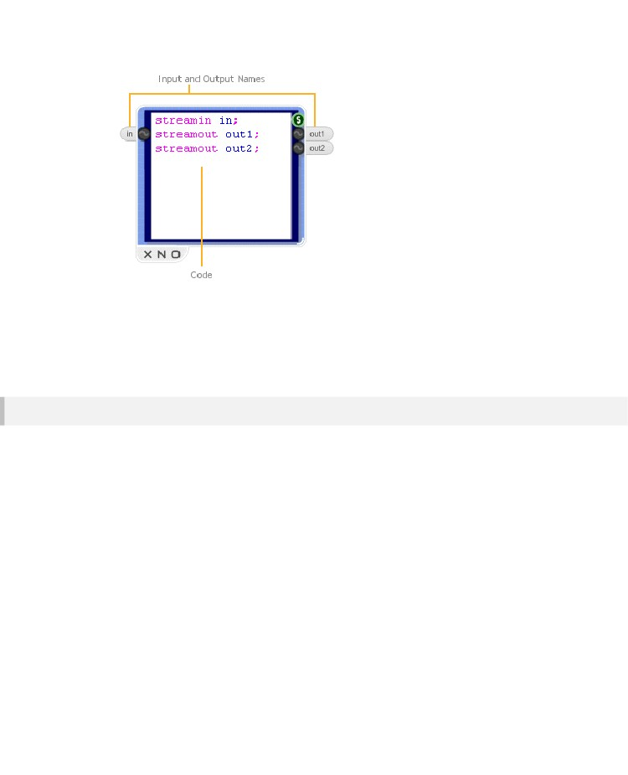
DSP CODE COMPONENT
Los nombres de entrada / salida se convierten en variables que se pueden utilizar en el código siguiente. Las variables tomarán cualesquiera valores vienen en o salir al vincular el componente a otras partes de un esquema.
Si nada está vinculado a una entrada, la variable asumirá un valor de cero.
Un último punto a destacar es que es una buena idea utilizar streamin y streamout lugar de las alternativas poli y mono como su código puede ser utilizado en las secciones tanto poli y mono.
Syntax Colouring
Los colores de edición de código para indicar la sintaxis correcta. Entrada / Salida de comandos,
operadores y soportes son “purple”, variables son “blue” y loa tipos de datos y funciones son “green”.
Si en algún momento el coloreado de sintaxis se detiene y todo el texto después de ese punto se vuelve negro, esto es una indicación de que hay un error en la sintaxis en ese punto.
- 225 -

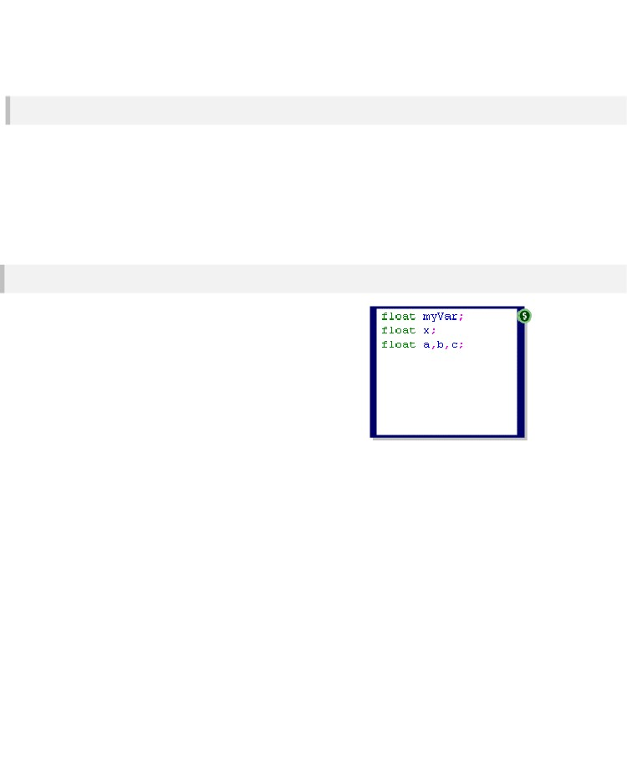
CHAPTER 9
Editor
Los soportes de editor de código copiar y pegar a través de las teclas de acceso directo estándar (CTRL + C, CTRL + V). A deshacer local también se implementa para que pueda deshacer y rehacer mecanografía, supresiones, pega, etc
la acción de deshacer locales se aplica a los cambios que realice en una sesión especial (Entre clic en el componente y hacer clic de distancia). Después de que todavía se puede deshacer a través del sistema de deshacer de la aplicación, pero esto sólo va a volver a través de las modificaciones realizadas entre ediciones.
Puede desplazarse con la rueda del ratón o las teclas del cursor. Puede página utilizando el PGUP y las teclas AV PÁG. CTRL + INICIO irá a la parte superior y CTRL + FIN irá a la parte inferior.
Local Variables
Además de los datos que extrae de su esquema a través de
entradas también se pueden crear variables locales. Estos son definida exactamente de la misma manera que las entradas y salidas.
No es sólo un tipo de la variable en el momento y que es
un flotador. Esto representa un número de punto flotante. Al igual que con las entradas y salidas que necesita para dar a la variable un nombre y terminar el mandato con un punto y coma.
Las variables pueden ser inicializados al mismo tiempo que se declaran. Usted puede escribir:
float x=3;
Y x se le asigna el valor 3. Variables que no se inicializa explícitamente se ponen a cero.
Puede declarar múltiples variables en una sola línea de código. por ejemplo:
float x,y,z;
Creará tres variables x, y, z.
- 226 -

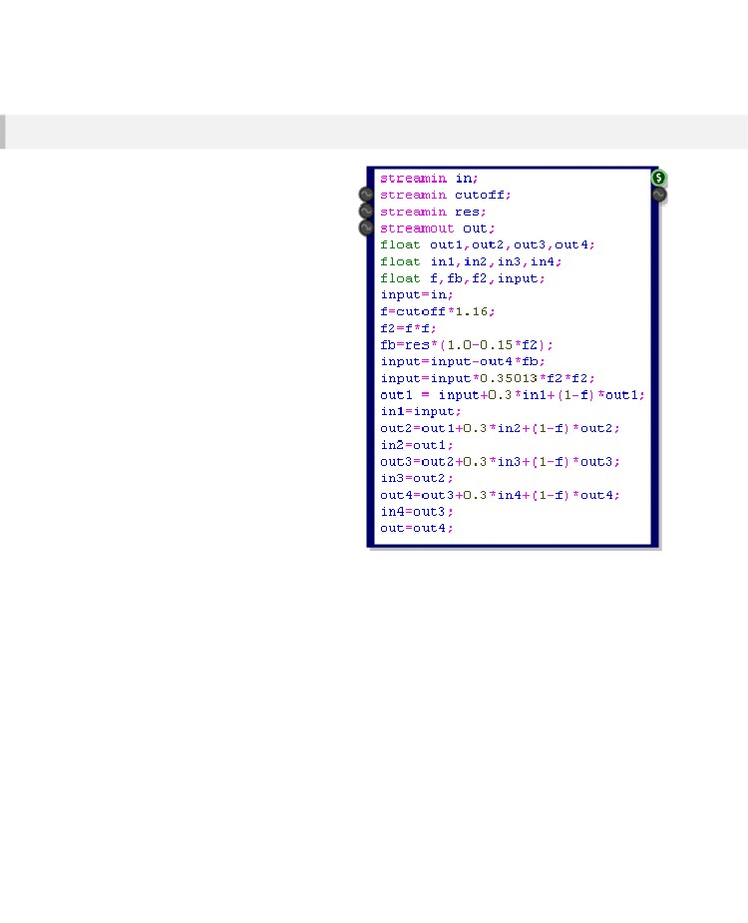
DSP CODE COMPONENT
Assignments
Después de haber configurado sus entradas, salidas y las variables locales a continuación, puede pasar a la implementación de su algoritmo DSP.
Para asignar un valor a una variable o enviarlo a una salida, utilice el operador de igualdad =. Puede asignar valores fijos o se puede utilizar una expresión regular para calcular el valor.
- 227 -

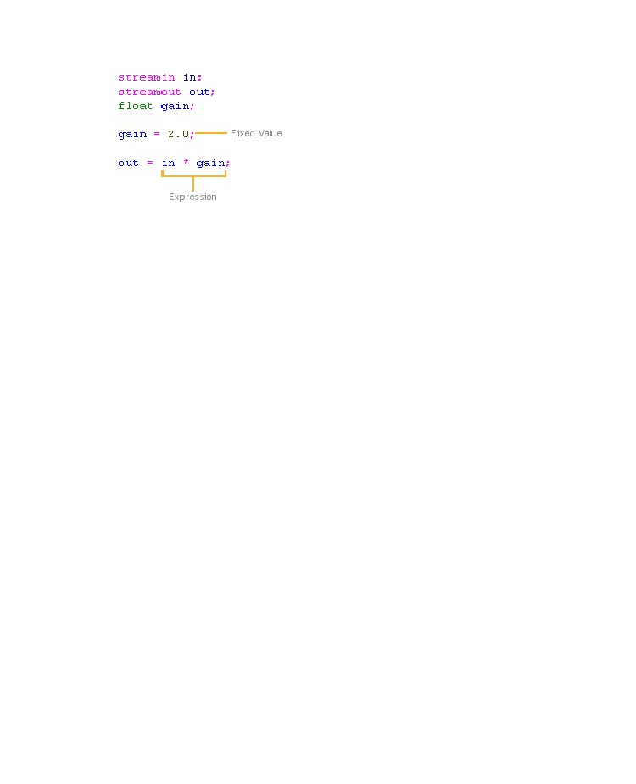
CHAPTER 9
El ejemplo de la derecha muestra cómo se pueden combinar todos los elementos expuestos hasta ahora para crear un filtro moog simple.

- 228 -

DSP CODE COMPONENT
Expressions
Las expresiones pueden utilizar una combinación de operaciones matemáticas y funciones integradas. A continuación se presenta un resumen completo de los operadores y funciones que se admiten en la actualidad.
sin1(a)
cos1(a)
tan1(a)
log10(a)
max(a,b)
min(a,b)
rndint(a)
*
+
-
/
%
>
>=
<
<=
&
Mathematical sine, cosine and tangent
The 1 indicates that the input value a is converted to a value in the range 0-1
and not 0 and 2π . So 0.5 would be equivalent to and 1.25 would be
equivalent to /2
Logarithm (base 10) of a
The numerically largest (max) or smallest (min) of a and b
Rounds a to the nearest integer value above or below (so 1.4 becomes 1 but
1.6 becomes 2)
Standard mathematical operations
Calcula el resto después de dividir el lado izquierdo por el lado derecho
Los operadores de comparación Estos generan una máscara basada en el resultado de la comparación
Operador AND. Utilice esta opción para aplicar una máscara
- 229 -

CHAPTER 9
One limitation of the code component is that you can only have 8 successive operations in an
expression. For example, the expression:
a = 0+1+2+3+4+5+6+7+9+10;
is not allowed because there are 9 addition operations in a row. You can easily get round this by
splitting the expression up into smaller sections using brackets ‘(‘ and ‘)’. For example:
a = (0+1+2+3+4)+(5+6+7+9+10);
Conditional Statements
Because FlowStone uses SSE to process four channels at a time, conditional statements can't be
implemented in the traditional way. However, you can achieve the effect of a conditional statement by
using a mask.
A mask can be applied to all four channels at the same time. Each channel is affected differently.
FlowStone includes conditional operators that generate exactly these kind of masks.
For example, the following FlowStone code:
x = x -
(x >= 1) & 1.0;
is equivalent to the following C/C++ code:
if( x >= 1 ) x = x – 1.0;
The >= operator creates a mask. The mask will effectively be true for each channel that meets the
condition and false for each one that doesn't. The bitwise & will return a value of 1.0 or 0.0 for each
SSE channel based on the mask.
Comments
You can leave comments in your code. These are just snippets of text that remind you of what a
particular part is doing. Comments take up no processing time. They can be put at the end of a line or
they can have a whole line to themselves
For example:
index = index + 1; //Increment index
//Increment index
index = index + 1;
- 230 -

DSP CODE COMPONENT
Advanced Features
Arrays
Usted puede declarar matrices en el componente de código. Estos actúan como amortiguadores que se puede utilizar para almacenar los valores del pasado, por ejemplo, o para utilizarlos como una tabla de búsqueda.
An array is declared as follows:
float buffer[100];
This defines an array called buffer which is 100 floats (4x100=400 bytes) in size.
Initialising
By default all the entries in the array are set to zero. You have two other options for initialising an array:
1. Set all entries to a particular value
float buffer[100] = 0.62;
2. Randomise the contents of the array
float buffer[100] = rand(-0.5,0.5);
Accessing
To access a particular entry in an array use the array specifiers (square brackets) ‘[‘ and ‘]’.
out = buffer[25] ;
buffer[6] = 3.14159;
Note that the array index is zero based so in the example above buffer[0] would be the first entry and
buffer[99] would be the last entry in the array.
You must make sure that you use indexes that are within range for the array, failure to do so will
produce unpredictable results and could even crash the software.
- 231 -

CHAPTER 9
Hop
There are some calculations that don’t need to be calculated for every sample, it’s sufficient to
recalculate for every 4 th sample say. For this purpose we have the hop command.
The syntax for the hop command is as follows:
hop(8)
{
< code in here is executed only for every 8th sample >
}
Hops must be powers of 2 and the maximum hop length is 4096 so values of
2,4,8,16,32,64,128,256,512,1024,2048 and 4096 are the only acceptable values.
Loop
Sometimes you need to execute the same code several times, changing one or two parameters on
each pass. You can do this in the code component using the loop command.
Here’s the syntax:
loop(10)
{
< code in here is executed 10 times in succession >
}
You could use a loop to initialise an array for example:
float index;
float buffer[10];
loop(10)
{
buffer[10] = sin1(index);
index = index+0.1;
}
Usted debe tener cuidado de no utilizar demasiados bucles o lazos con muchas iteraciones, ya que pueden provocar un aumento significativo en la CPU.
También para algunos bucles (como el ejemplo de inicialización array) sólo desea que se ejecutan una vez, aquí es donde las etapas se presentan en.
- 232 -

DSP CODE COMPONENT
Stages
The code is split into four parts called stages. These are numbered 0,1,2 and 3.
Stage(0)
Stage(0) runs only for the first sample and is intended for processing that you only want to happen at
the very start, usually to set up other parameters that you will then use on every sample.
For the example we’ve just been looking at we could put the array initialisation into Stage(0) and it will
run only once.
Defining the stage is very easy:
stage(0)
{
< code in here is executed only for the first sample >
}
Stage(2)
We'll jump to Stage(2) now because this is the default stage. Any code written outside of a Stage
definition is assumed to be Stage(2).
Stage(2) code is executed for every sample (including the first) and happens after Stage(0).
Stage(1) and Stage(3)
These two stages are only used for implementing delays. They are needed to make sure that data
flows correctly when one or more delays are chained together in a feedback loop.
The software executes the code in stage order so after Stage(0) Stage(1) goes next.
Stage(1) should be used to move data from internal variables (most likely a buffer) and the outputs.
This ensures that all delays have a consistent output value before doing any calculations.
Next the standard Stage(2) is executed. Any code that needs the outputs of any delays will have the
values they need now.
Finally Stage(3) is executed. This should be used to move data from the inputs to internal variables
(again most likely a buffer) and perform any calculations.
Note that each stage is executed for the whole of the schematic before proceeding to the next stage.
- 233 -

CHAPTER 9
An example of how to use Stage(1 ) and Stage(3) for a delay is shown below.
streamin in;
streamout out;
streamin delay;
float mem[44100];
float index;
stage(1)
{
out = mem[index];
}
stage(3)
{
mem[index] = in;
index = index + 1;
index = (index<delay)&index;
}
Note that because the transfer to outputs in Stage(1) occurs before the buffer update in Stage(3) this
will always produce a minimum of 1 sample delay. If you need a delay that will work correctly when the
input delay length is zero samples then you can implement this by modifying the above code as
follows:
stage(1)
{
out = mem[index]&(delay>0) + in&(delay==0);
}
.
- 234 -

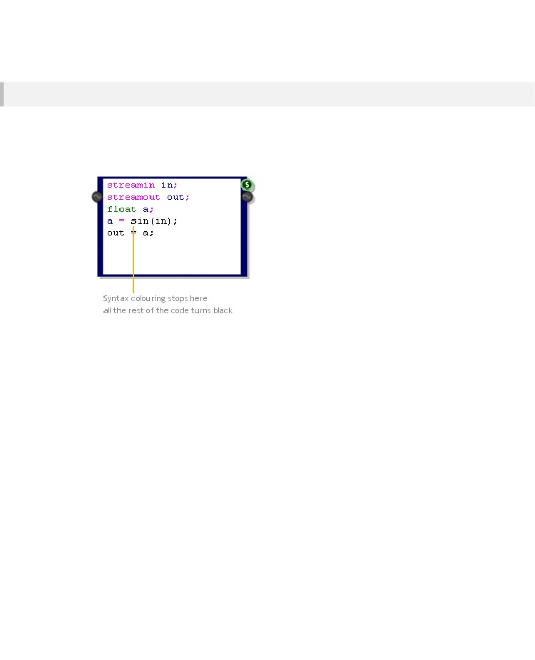
DSP CODE COMPONENT
Debugging
Using Syntax Colouring
We’ve already seen that the first indication you’ll have that your code is incorrect will be a discontinuity
in the syntax colouring. The following example shows this.
You can see that the colouring stops with the sin function. This indicates that there is something wrong
with the expression. Sure enough we forgot the ‘1’, the line should read:
a = sin1(in);
If we make this correction everything becomes coloured correctly.
Checking the Assembler
The code component converts the high-level language that it uses into x86 assembler prior to
compiling. You can look at this assembler code by connecting a Text component to the String output of
the code component.
If you understand assembler (and even if you don’t) it can be useful to examine this code to make sure
that nothing out of place is happening.
When there is a syntax error the assembler code will only be generated up to the point at which the
syntax broke down.
If the syntax is correct then the other possible problem could be the limitation on expressions
discussed earlier. This is much more difficult to spot in the code because the colouring will indicate
correct syntax. However, a quick look at the assembler code can identify this type of problem.
- 235 -

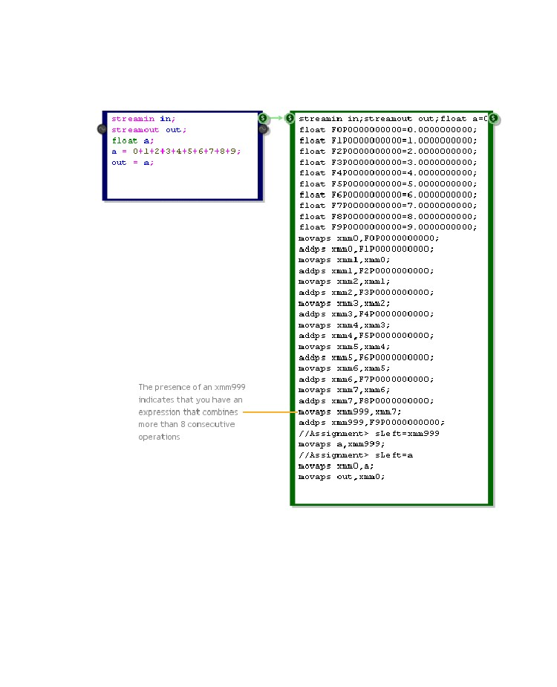
CHAPTER 9
The example below shows exactly this. The way to spot the problem is to look for xmm999 in the code.
If this happens then you know to look at your expressions to make sure that the 8 consecutive operator
limit has not been exceeded.
- 236 -

DLL COMPONENT
10 DLL Component
THE ULTIMATE IN FLEXIBILITY AND PERFORMANCE
- 237 -

CHAPTER 10
Introduction
The DLL component allows you to call your own custom code which you write in C/C++ and compile
into an external dynamic link library (DLL).
The DLL can be kept external to the software or you can choose to embed it directly inside a DLL
component so it's completely self contained. This allows you to create your own components which
you can easily share with others.
You can of course already make your own components from modules in FlowStone. However by using
compiled code in a separate DLL you have the advantage of huge flexibility and streamlined
performance. You can also keep any proprietary algorithms secret as, unlike a module which is build
from lower level components, the compiled code is not readable within a schematic.
For the rest of this chapter we assume that you have an understanding of how to program in C/C++
and how to build DLLs using a compiler such as Visual Studio.
- 238 -

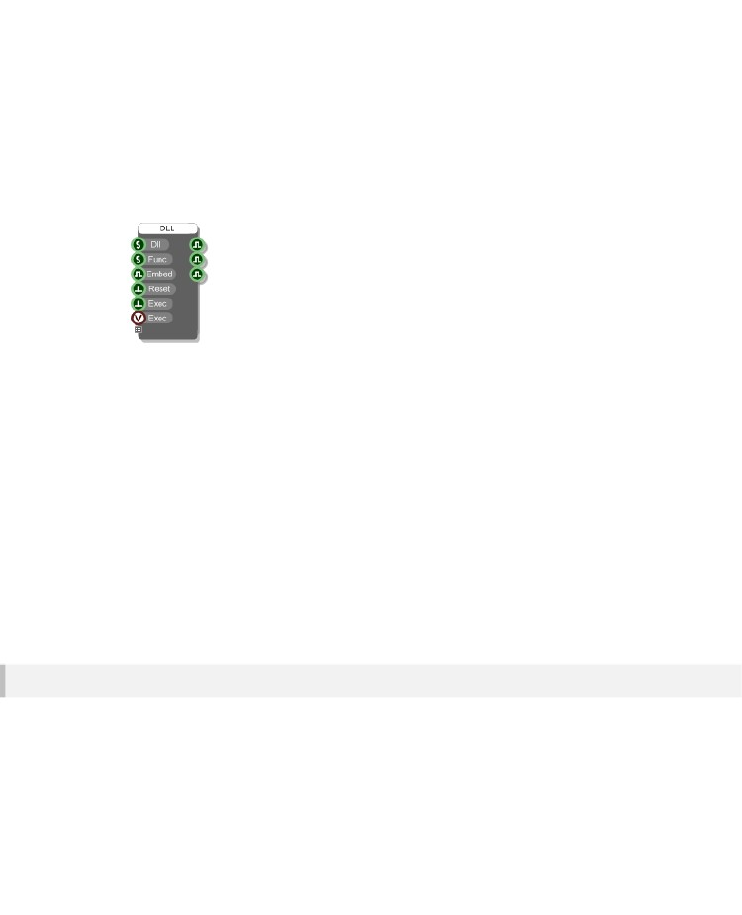
DLL COMPONENT
The Component
The DLL component has 6 inputs and 3 outputs initially.
The Dll and Func inputs are for the path to the dll and the name of the function you want to call. The
Embed input determines whether the dll is left external to the software or whether it is to be embedded
into the component.
The 3 boolean outputs will indicate whether the inputs that lie opposite them have succeeded. So the
first output will be true if the dll was found, the second will be true if the function was found within the
dll and the third will be true if the dll can be successfully embedded into the component (some dlls
can't be embedded because they depend on other dlls – more on that later).
The Reset input disconnects the software from the dll. This is useful if you want to make changes to
your dll and then retry them in your schematic without having to close it. Note that all DLL components
that use the dll will be disconnected because otherwise the dll would remain locked and you wouldn't
be able to rebuild it.
Finally the Exec inputs allow you to call the function in the dll. Two inputs are provided depending on
whether you want to execute the call based on a green data trigger or a Ruby event.
Defining Inputs and Outputs
In most cases you'll want to be able to send data to and receive data from the dll. You define this data
by dragging the gripper control on the component itself. This is located below the very last input
(similar to the Ruby component).
Dragging the gripper control down will create more inputs and outputs.
You'll notice that connectors are added in pairs – one input and one corresponding output.
- 239 -

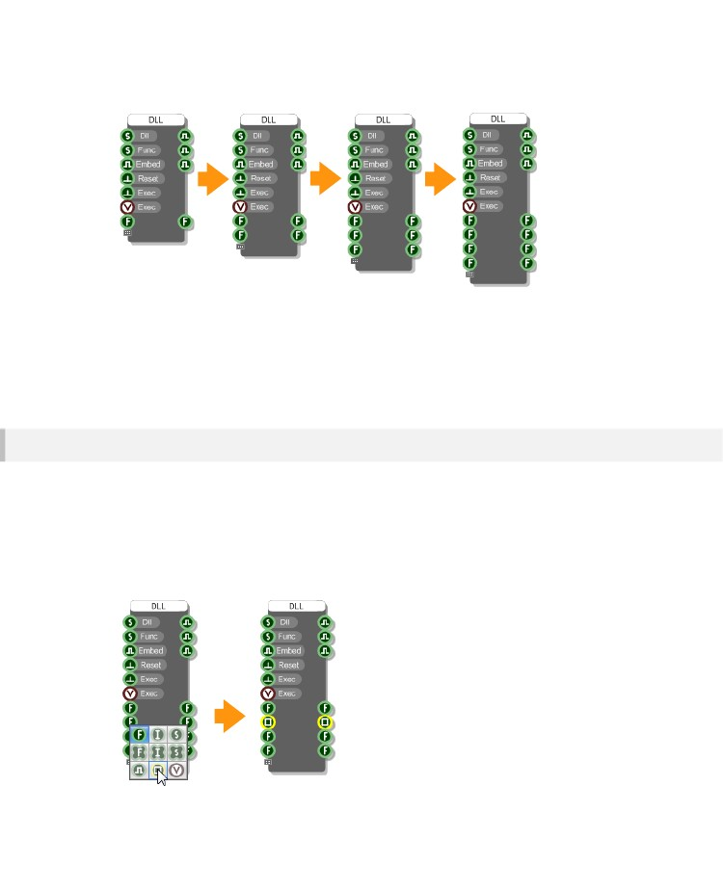
CHAPTER 10
We add the connectors in pairs in order to keep things simple and also because for Ruby Frame types
you must have a matching input and output.
You still have all the flexibility you need. If you need an input but not an output, just ignore the
corresponding output and vice-versa.
Connector Types
The DLL component supports 9 FlowStone data types: Float, Int, String, Float Array, Int Array, String
Array, Boolean, Bitmap and Ruby Frame. With this subset you can do just about anything you need to.
When you create new inputs and outputs as described above, the type of connector added will be the
same as for the previous one (or a Float if you haven't added any yet).
To change the connector type, right-click on the input then choose the new type from the pop up menu.
When you change the input type the corresponding output will change accordingly.
- 240 -

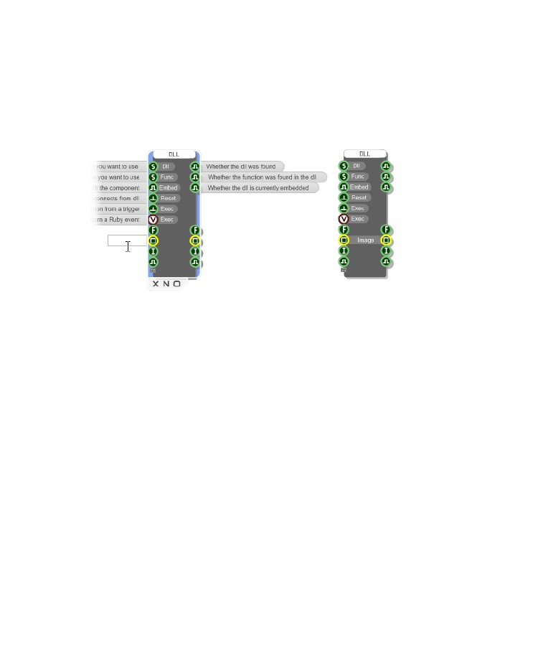
DLL COMPONENT
Connector Labels
In order to make it easier to remember what each connector is for you can add labels. To do this first
select the component then hold CTRL and hover over where the input labels would go. You'll see the
outline of an edit box appear.
Click in the box, type a label then hit return. The label will appear on the component. You can change
the label in exactly the same way.
Use the TAB key to move between labels and edit several at a time.
- 241 -

CHAPTER 10
The DLL
Now that we've looked at the component let's turn our attentions to the dll. As you've seen, the DLL
component calls a particular function in your dll. This function must have a very specific declaration
which goes as follows:
extern "C" __declspec(dllexport) void myFunction( int nParams, int* pIn, int* pOut )
nParams tells you how many parameters are being passed. This is equal to the number of inputs you
created on the DLL component.
pIn is an array which contains the input values that have been passed to the component. The contents
of each entry depend on the connector type.
pOut is an array which you use to pass values back to the component. Each entry maps onto an
output on the component. You manage the contents of this array but the array itself is created for you
by FlowStone.
The pOut array is filled with zeros to start with (each entry is set to zero). The only exception to this is if
the type is Ruby Frame in which case the output entry points to the same value as the input entry.
We'll talk about data types next and have a look at how you access the information passed to you from
the DLL component. We'll also look at how you pass data back to the DLL component using the pOut
array.
Data Types
The pIn and pOut arrays are declared as int* but each entry is not necessarily an int. The value
changes depending on the data type and to get at this data you may need to do some C casting. More
on that in a moment.
First we'll look at the various FlowStone types and how they are represented in C when they arrive at
your dll. We've seen in the last section that the DLL component allows you to use 9 different data
types. These are represented in C as shown in the table below.
- 242 -

DLL COMPONENT
FlowStone Type
Int
Float
Boolean
String
Float Array
C Representation
int
float
The first byte of the entry is a bool
char* an array of chars which is zero terminated
float[n+1] where n is the number of array entries and the first 4
bytes is an int giving you the number of entries
Int Array
int[n+1] where n is the number of array entries and the first 4 bytes is
an int giving you the number of entries
String Array
char*[n+1] where n is the number of array entries and the first 4
bytes is an int giving you the number of entries
Bitmap
unsigned char[n+12] where n = width x height x channels. The first
4 bytes give you the width, the next 4 bytes give you the height and the
next 4 bytes give you the number of channels (all as ints).
Frame
float[n+1] where n is the number of array entries and the first 4
bytes is an int giving you the number of entries. This is the same as for a
Float Array
Let's take a look at each type in more detail.
Ints
Say we have a DLL component where input 'x' has been defined as an Int connector. The pIn array is
already defined as an array of ints so to get at this value in C all we only need do the following:
int value = pIn[x];
If we then wanted to set the corresponding output value we'd do this:
pOut[x] = value;
- 243 -

CHAPTER 10
Floats
For the Float type we need to cast to a C float like this:
float value = *((float*)&pIn[x]);
Note that we can't just cast the value of pIn[x] to a float as this would convert from an int to a float. The
4 bytes that make up the int value need to be addressed as if they were 4 bytes making up a float.
Hence we need to cast the address of the value to a float pointer and then dereference that.
To set the corresponding output we need to do the same cast for the pOut array:
*((float*)&pOut[x]) = value;
Booleans
Boolean types become a C bool type. A bool in C is a single byte. We therefore cast as follows:
bool value = *((bool*)&pIn[x]);
To set the corresponding output we need to do the same cast for the pOut array:
*((bool*)&pOut[x]) = value;
Strings
From the table you'll see that FlowStone Strings are represented as a zero terminated array of chars.
In this case we need to cast as follows:
char* value = *((char**)&pIn[x]);
Up to now we've dealt with data whose value is contained within the 4 bytes that defined the array
element. However, for strings the value is a pointer to other data i.e. an array of chars.
So when it comes to sending a string to the output array we need to create our own array of chars. The
memory management we leave up to you.
This time, to set the corresponding output we need to do more than assign a value. Something like the
following would be typical for strings:
- 244 -

DLL COMPONENT
// Delete previous string and reset pOut entry
if( pOut[x] )
{
delete *((char**)&pOut[x]);
pOut[x] = 0;
}
// Create new string (assume we have declared 'length' – add 1 for null terminator)
char* s = new char[length+1];
// {initialise the string here}
// Don't forget to null terminate
s[length] = 0;
// Assign to correct entry in the output array
*((char**)&pOut[x]) = s;
If you're using the same length string each time then you could create it once and save having to
delete and make a new one each time. If you're working with strings of a maximum length then you
could also stick with one string and move the null terminator each time. It's up to you.
Float Arrays
These are represented as a C array of floats but with an extra entry at the start which provides 4 bytes
to store the number of array elements. So we have two casts to make, one for the array size and one
for the array itself:
int size = *((int*)pIn[x]);
float* array = (float*)pIn[x]+1;
You can see that we interpret the first entry as an int giving us the array length. The array itself then
begins at the second entry, hence the '+1'.
To set the output value we need to create a new array. This is a similar process as for Strings. Once
again the management of memory is up to you. Here's one way of doing it:
// Delete previous array and reset pOut entry
if( pOut[x] )
{
delete *((float**)&pOut[x]);
pOut[x] = 0;
}
// Create new array (assume we have declared 'length' – add 1 for size at front)
float* array = new float[length+1];
// Set the size
*((int*)array) = length;
- 245 -

CHAPTER 10
// {initialise the array here}
// Assign to correct entry in the output array
*((float**)&pOut[x]) = array;
This will create a new array each time the function is called. Again, you could create a single array if
you're working with fixed sizes or adjust the array only if you need more storage space.
Int Arrays
Int arrays are handled in an identical way to Float arrays. The only difference is the base type, a C int
in this case. Again, there's an extra entry at the start which provides 4 bytes to store the number of
array elements. So we have two casts to make, one for the array size and one for the array itself:
int size = *((int*)pIn[x]);
int* array = (int*)pIn[x]+1;
You can see that we interpret the first entry as an int giving us the array length. The array itself then
begins at the second entry, hence the '+1'.
To set the output value we need to create a new array. The management of memory is up to you.
Here's one way of doing it:
// Delete previous array and reset pOut entry
if( pOut[x] )
{
delete *((int**)&pOut[x]);
pOut[x] = 0;
}
// Create new array (assume we have declared 'length' – add 1 for size at front)
int* array = new int[length+1];
// Set the size
*((int*)array) = length;
// {initialise the array here}
// Assign to correct entry in the output array
*((int**)&pOut[x]) = array;
This will create a new array each time the function is called. You could create a single array if you're
working with fixed sizes or adjust the array only if you need more storage space.
- 246 -

DLL COMPONENT
String Arrays
String arrays are probably the most complicated of all the data types to work with. You not only have to
manage the array but you also have to manage each String in the array.
A string array is represented by a C array of char*. As with the other arrays, there is an additional
element at the front which is used to store the size of the array.
Accessing the array is similar to Float and Int arrays in that there are two casts to make, one for the
array size and one for the array itself:
int size = *((int*)pIn[x]);
char** array = (char**)pIn[x]+1;
You can see that we interpret the first entry as an int giving us the array length. The array itself then
begins at the second entry, hence the '+1'.
To set the output value we need to create a new array and each string that goes in it. Here is one way
of doing this:
// Delete previous array (and contents) and reset pOut entry
if( pOut[x] )
{
int size = *((int*)pOut[x]);
char** array = (char**)pOut[x]+1;
for( int i=0; i<size; i++ )
{
if( array[i] )
delete array[i];
}
delete (char**)pOut[x];
pOut[x] = 0;
}
// Create new array (assume we have declared 'length' – add 1 for size at front)
char** array = new char*[length+1];
// Set the size
*((int*)array) = length;
// Create the strings in the array
for( int i=1; i<length+1; i++ )
{
// Create new string (assume we have declared 'stringlen')
char* s = new char[stringlen+1];
// {initialise the string here}
// Don't forget to null terminate
s[stringlen] = 0;
// Add to the sting array
array[i] = s;
}
- 247 -

CHAPTER 10
// Assign to correct entry in the output array
*((char***)&pOut[x]) = array;
Bitmaps
Bitmap data is also provided as an array, this time of BYTEs (unsigned chars). The array begins with
12 bytes of data descriptor information. This is used to supply 3 int parameters: bitmap width, bitmap
height and number of channels (bytes per pixel).
You can access these values as follows:
int width = *((int*)pIn[x]);
int height = *((int*)pIn[x]+1);
int channels = *((int*)pIn[x]+2);
The number of bytes of pixel data we will have is then the product of these values:
int bytes = width * height * channels;
You can get at the array of pixel data like this:
unsigned char* pData = (unsigned char*)pIn[x]+12;
The data will give us the value for each channel (0-255) for each pixel in the bitmap. The pixel data
runs from top-left across to the right before starting the next line.
EXAMPLE
Let's say we have 3 channels (Red, Green and Blue) and a bitmap that is 10 pixels wide and 4 pixels
high. We will have 10 x 4 x 3 = 120 bytes of pixel data. pData[0] will give you the red component of the
top-left pixel. pData[29] will give you the green component for the rightmost pixel in the top row.
pData[90] will give you the bottom-left pixel red component and pData[119] will give you the blue
component of the very last (bottom-right) pixel.
- 248 -

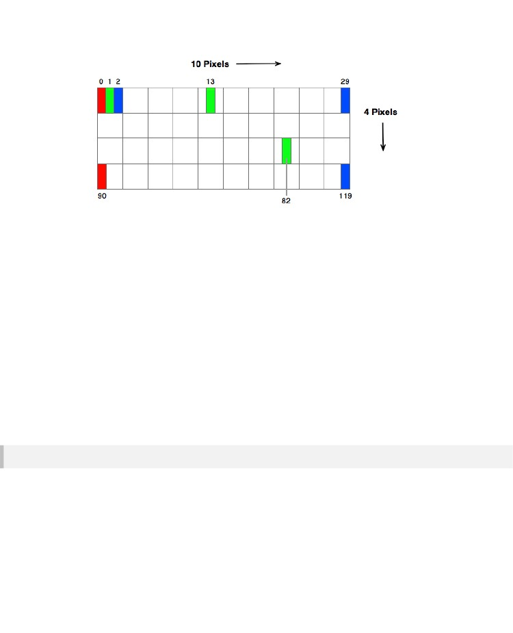
DLL COMPONENT
To set the output value we need to create a new byte array. Again, this is very similar to the arrays and
strings. Once again the management of memory is up to you:
// Create a new byte array (assuming we have already defined bytes)
unsigned char* pNewBytes = new unsigned char[bytes+4*3];
*((unsigned char**)(&pOut[x])) = pNewBytes;
// Set the data descriptors (assume width, height and channels have been defined)
*((int*)pNewBytes) = width
*((int*)pNewBytes+1) = height
*((int*)pNewBytes+2) = channels
// Get pointer to pixel data
unsigned char* pPixelData = pNewBytes+12;
{you then need to initialise your byte data}
This only shows you how to create the data. You may have to provide additional code to manage when
the bitmap data is deleted. For example, you may want to create a new array and then keep reusing it
(as opposed to deleting and recreating it every time). You may then want to delete and recreate it only
when the bitmap changes size. All this is down to you to decide.
Frames
By handling Ruby Frame objects (generated by the Mono To Frame component) you can process
audio at sampling rate.
Like Float arrays, Frames are represented as a C array of floats. They have the same extra entry at
the start providing 4 bytes to store the number of array elements followed by the float array itself. To
separate these we do the following:
int size = *((int*)pIn[x]);
- 249 -

CHAPTER 10
float* array = (float*)pIn[x]+1;
Unlike Float Arrays, Frames use the same array for both the input and the output. This means that you
don't have to create a new array to pass to the output array – it has already been done for you. The
main reason for this is that the output array must be the same size as the input one. However, there is
also a benefit in terms of efficiency too.
So all you need to do is process the input array and update it. Just be careful not to assign a value to
an array element until you've finished using it or you've stored its value otherwise you may end up
using the new value instead of the one that came originally.
Helpers
The casting can be a bit cumbersome so we came up with some simple macros that make accessing
and setting the input and output arrays a bit easier and more readable.
Also, for most of the types you should always check that pIn[x] or pOut[x] are zero before attempting to
extract values using the above casts so the macros incorporate this check too which reduces crashing.
The macros are shown below:
#define GETFLOAT(p) *((float*)&p)
#define GETBOOL(p) *((bool*)&p)
#define GETINT(p) p
#define GETSTRING(p) *((char**)&p)
#define GETFLOATARRAY(p) p ? ((float*)p+1) : 0
#define GETINTARRAY(p) p ? ((int*)p+1) : 0
#define GETSTRINGARRAY(p) p ? ((char**)p+1) : 0
#define GETARRAYSIZE(p) p ? *((int*)p) : 0
#define GETFRAME(p) p ? ((float*)p+1) : 0
#define GETFRAMESIZE(p) p ? *((int*)p) : 0
#define GETBITMAPWIDTH(p) p ? *((int*)p) : 0
#define GETBITMAPHEIGHT(p) p ? *((int*)p+1) : 0
#define GETBITMAPCHANNELS(p) p ? *((int*)p+2) : 0
#define GETBITMAPDATA(p) p ? ((BYTE*)p+12) : 0
#define GETBITMAPBYTES(p) p ? *((int*)p) * *((int*)p+1) * *((int*)p+2) : 0
#define NEWINTARRAY(p,n) if(n>0) { *((int**)&p)=new int[n+1]; ((int*)p)[0]=n; }
#define NEWFLOATARRAY(p,n) if(n>0) { *((float**)&p)=new float[n+1]; ((int*)p)[0]=n; }
#define NEWSTRINGARRAY(p,n) if(n>0) { *((char***)&p)=new char*[n+1]; ((int*)p)[0]=n; }
#define DELETESTRING(p) if(p) { delete *((char**)&p); p=0; }
#define DELETEINTARRAY(p) if(p) { delete *((int**)&p); p=0; }
#define DELETEFLOATARRAY(p) if(p) { delete *((float**)&p); p=0; }
- 250 -

DLL COMPONENT
#define DELETESTRINGARRAY(p) if(p) { for( int j=0; j<*((int*)p); j++ ) { if( ((char**)p+1)[j] ) delete
((char**)p+1)[j]; } delete *((char***)&p); p=0; }
To illustrate how these macros can help the code below shows how the code for resetting the output
value for an Int Array, would reduce down to just two lines:
// Delete previous array and reset pOut entry
DELETEINTARRAY(pOut[x])
// Create new array (assume we have declared 'length' – add 1 for size at front)
NEWINTARRAY(pOut[x],length)
If you want to use the macros, simply copy and paste them in at the top of your dll source file.
Example 1 – Float Add
This is a really simple example which simply adds two floats together and outputs the result. Whilst it is
basic it shows you how all the things we've talked about come together.
extern "C" __declspec(dllexport) void addFloats( int nParams, int* pIn, int* pOut )
{
if( pIn && pOut && nParams >= 2 )
{
float f0 = GETFLOAT(pIn[0]);
float f1 = GETFLOAT(pIn[1]);
GETFLOAT(pOut[0]) = f0+f1;
}
}
- 251 -

CHAPTER 10
Example 2 – String Uppercase
This example takes a string and makes it uppercase. There's a bit more to it in that you need to
manage the memory for the output string that holds the result.
extern "C" __declspec(dllexport) void makeUppercase( int nParams, int* pIn, int* pOut )
{
if( pIn && pOut && nParams >= 1 )
{
char* strIn = GETSTRING(pIn[0]);
DELETESTRING(pOut[0]);
if( strIn )
{
int i=0;
int len = strlen(strIn);
char* strOut = new char[len+1];
while( strIn[i] )
{
char c = strIn[i];
strOut[i] = toupper(c);
i++;
}
strOut[len]=0;
GETSTRING(pOut[0]) = strOut;
}
}
}
- 252 -

DLL COMPONENT
Example 3 – Audio Delay
This little delay effect will give you and idea of how to do audio processing in your dll. The effect
expects 6 inputs, the frame, number of samples delay, feedback amount, mix level, a counter to
maintain the position in the circular buffer and the circular buffer itself.
We could have created the buffer and counter as global variables in the dll but we've chosen to supply
them from the schematic so that the dll could be used by more than one DLL component at a time.
extern "C" __declspec(dllexport) void makeUppercase( int nParams, int* pIn, int* pOut )
{
if( pIn && pOut && nParams >= 6 )
{
if( pIn[0] )
{
float* pData = GETFRAME(pIn[0]);
int n = GETFRAMESIZE(pIn[0]);
int delay = GETINT(pIn[1]);
float feed = GETFLOAT(pIn[2]);
float mix = GETFLOAT(pIn[3]);
int ctr = GETINT(pOut[4]);
float* pBuffer = GETFRAME(pIn[5]);
int buffSize = GETFRAMESIZE(pIn[5]);
if( pBuffer && buffSize >= delay && pData )
{
float curr;
for( int i=0; i<n; i++ )
{
curr = pData[i];
pData[i] = (mix)*pBuffer[ctr] + curr;
pBuffer[ctr] = pBuffer[ctr]*feed + curr;
ctr++;
if( ctr >= delay ) ctr = 0;
}
GETINT(pOut,4) = ctr;
}
}
}
}
- 253 -

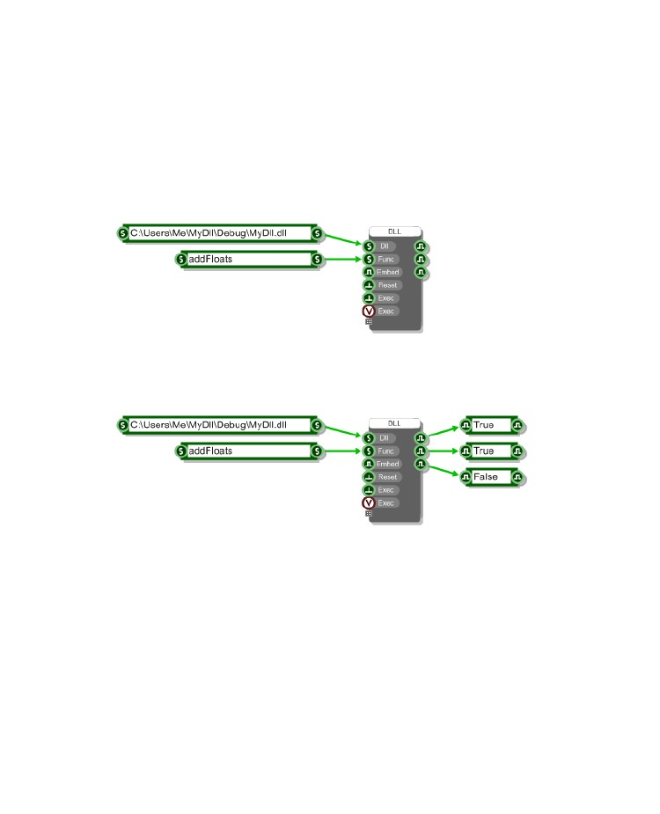
CHAPTER 10
Connecting
Once you have built your dll it's time to connect to it from FlowStone. Drag in a DLL component and
connect Strings to specify the dll path and function name.
Connect Boolean components to the first three outputs so you can check that the component is
communicating with your dll. The first two should read 'true' if the dll and function have been found. If
they read 'false' then check carefully the path and function and make sure they match your dll.
Next add the inputs and outputs that your dll will need and wire them up as you require. For the
addFloats we need two Float inputs and outputs.
- 254 -

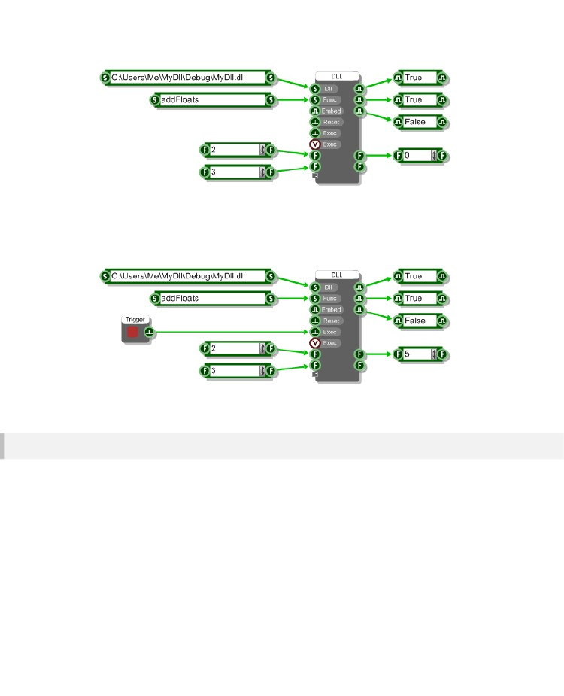
DLL COMPONENT
Finally you need to have something attached to one of the two Exec inputs. Unless you are processing
Ruby Frames you will need to use the green trigger Exec input (the first of the two). You can connect a
trigger button to this for now but if you make it into a module then you may need to wire it up so that
changes to the module inputs will trigger the Exec.
That's it! Click the trigger button and your dll will process the inputs and send any result out.
A note about Outputs
As we saw in the previous section the array of output data is populated in your dll code. Anything you
put there will be accessible from the outputs on the DLL component. However, how and indeed
whether the outputs send out this data depends on which Exec input you use to invoke the call to your
dll function.
Exec 1 - green Trigger connector
If you use the first Exec input then all outputs that are not a Ruby Value connectors will be sent a
trigger and hence anything you have connected to these outputs will be updated after the dll function
has been executed.
- 255 -

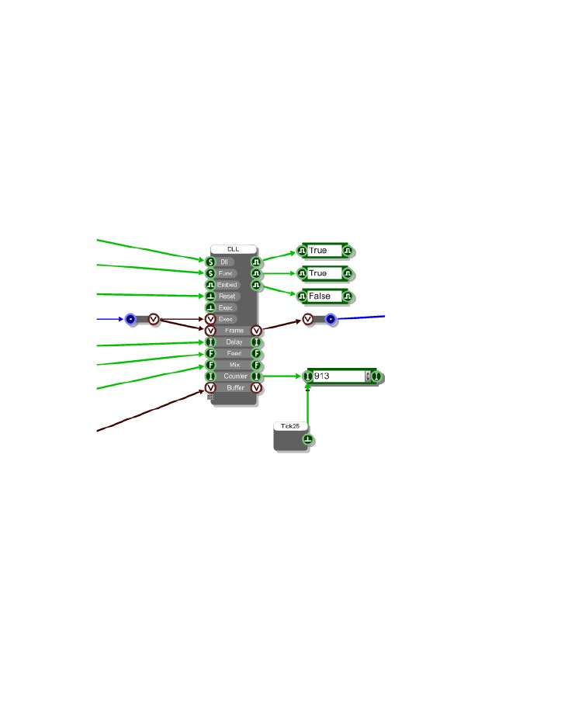
CHAPTER 10
Exec 2 – Ruby Value connector
If you use the second Exec input then all outputs that are also Ruby Value connectors will be sent a
Ruby event after the dll function has been executed.
All other connectors will have their values updated but no triggers will be sent. This is because the
Ruby Value input is usually used for audio which is running at sampling rate. Triggering green
connectors at this frequency would be way too cpu intensive.
If you do need to be able to read a green triggered data output under these circumstances then the
best way to do this is to connect a trigger from a Ticker (or something similar) to the same input that
the output from your DLL component is connected to.
This is much better illustrated in a picture:
- 256 -

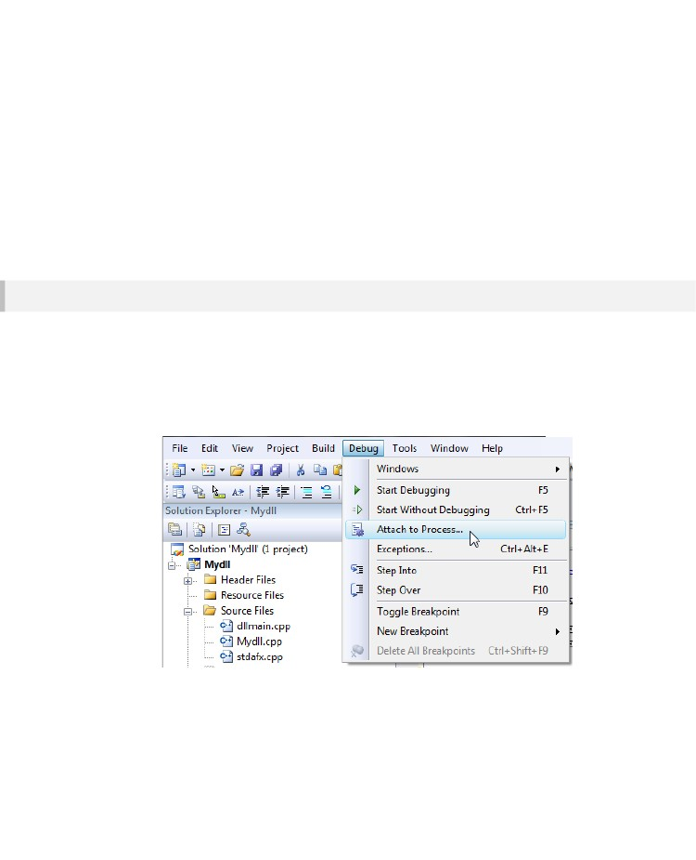
DLL COMPONENT
Debugging
Working at such a low level, it's inevitable that you will run into bugs at some point. Thankfully most
compilers will allow you to attach to the FlowStone process so you can step into your code and see
where any crashes are occurring. The next section describes how to do this in Visual Studio.
Debugging using Visual Studio
To debug your dll using Visual Studio:
1.
2.
First run FlowStone and open the schematic which you are using to connect to your dll.
Open your dll project in Visual Studio (make sure you've built it in debug or with debugging
information).
From the Debug menu choose 'Attach To Process'
3.
- 257 -

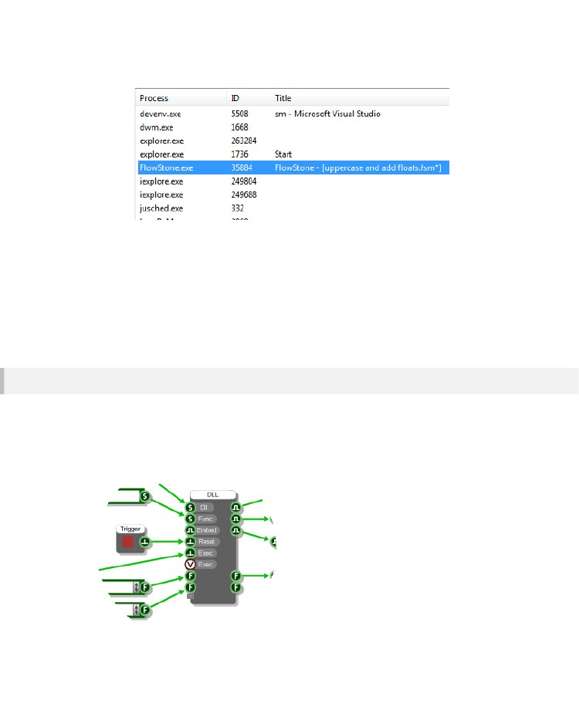
CHAPTER 10
4.
From the process list select FlowStone and click 'Attach'
Visual Studio will now attach to FlowStone. You can set break points in your dll code then trigger the
Exec input on the dll component inside FlowStone and Visual Studio will stop execution at the break
point you have specified. You can now step through your code, trap crashes and browse variables in
the usual way.
In our experience with making the example projects all the crashes we had were due to bugs in the dlls
we were creating. So please, before reporting a suspected bug in FlowStone do check over your dll
code as it is more than likely that this is where the problem will lie.
Code – Test – Debug Cycle
If you spot a bug or need to change your dll then you can do this without exiting FlowStone or your
schematic. However, if you've already connected and run your dll function you will probably find that
when you rebuild your dll you get an error saying that the dll file could not be opened for writing.
This is because the dll gets file locked by the software when it loads it into memory. To release it simply
trigger the Reset input on the DLL Component.
- 258 -

DLL COMPONENT
If the dll is used by other DLL Components in your schematic then it will be released from those too.
However, it won't release if you have other schematics open that have locked it or if other DLL
components in the same schematic are continuously triggering the Exec input.
Once the dll has been released you can rebuild it and then re-trigger the Exec input to see the results
of your changes.
In this way you can rapidly run through the code – test – debug cycle.
- 259 -

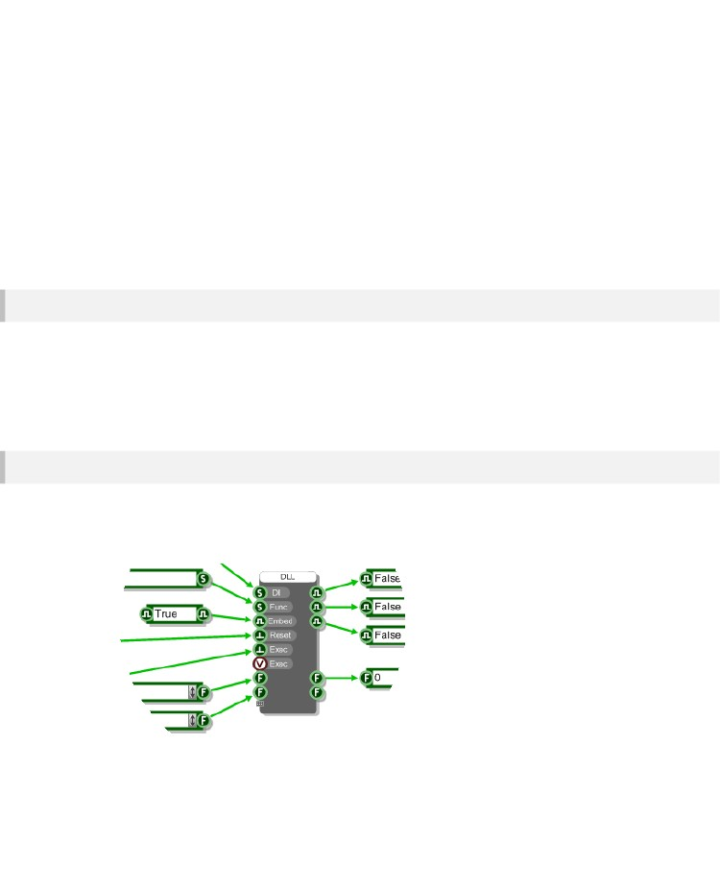
CHAPTER 10
Sharing
The main advantage of the DLL Component is that it allows you to create your own components
without compromising on performance safe in the knowledge that any trade secrets are kept hidden
from the world. All you need to do is wrap your DLL Component in a module.
There are then two ways you can share your new modules with others.
Share the DLL Separately
Simply share the dll and your schematic with the module in it. Any recipient may need to modify the
path to the dll inside the schematic to match where they end up putting it. If they don't do this then the
module will not work.
If you want to share the source code as well then this is the method of distribution you want to go for.
It's also the route you'll have to take if your dll uses any other external libraries.
Embed the Dll
If you're not distributing the source code and want to send the module as a kind of black box then you
can embed the dll inside the DLL component.
This is really easy. Go to your DLL component and set the Embed input to True:
- 260 -

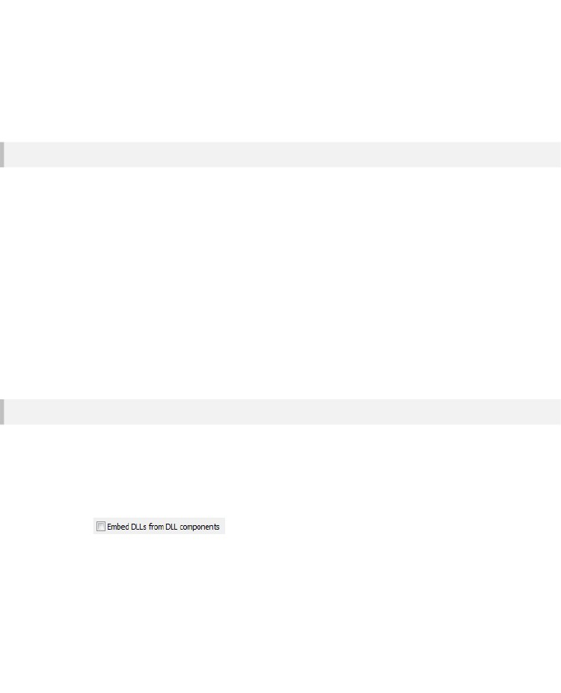
DLL COMPONENT
That's it – your dll is now embedded in the DLL Component. You can copy and paste it and the dll will
be retained. If you want to you can delete the Dll path input value as it's not needed. You might do this
if you wanted to hide where the dll was originally located but it's completely up to you.
To share this simply send the module in a schematic.
Pros and Cons of Embedding
On most occasions embedding the dll will be the go to option However, there are some disadvantages
of embedding that are worth noting. We've listed the pros and cons below.
PROS
Easy to distribute – there is no separate dll file and no need to worry about file paths.
Independent Globals – you can create global variables to store persistent data that won't be shared.
CONS
Larger files – because the dll is stored in the schematic the file size will be larger.
No Debug – once embedded you can't debug the dll code (not usually an issue when sharing though).
No shared Globals – you can't create global data to share amongst calls from different dl components.
No external Libraries – you can't use external libraries as these dlls can't be embedded
Exporting
When you export to EXE or VST you can choose whether to automatically embed any dlls which are
currently external to the schematic. So that's dlls for which you haven't set the Embed input to true.
This is handy if you want to keep the dlls external until the point of exporting and saves you having to
go through your whole schematic to embed each dll.
Look for the check box below on the VST or EXE export dialog box.
If any dlls are found which can't be embedded the software will tell you about them.
- 261 -

CHAPTER 11
11 Options
CUSTOMISING
THE
APPLICATION
- 262 -

OPTIONS
The Options Dialog
There are a number of application and schematic level options/features that you can change in order
to make the software work the way you want it to. You can get at these by going to the Options menu
and selecting one of the seven categories under which the various parameters are organised.
- 263 -

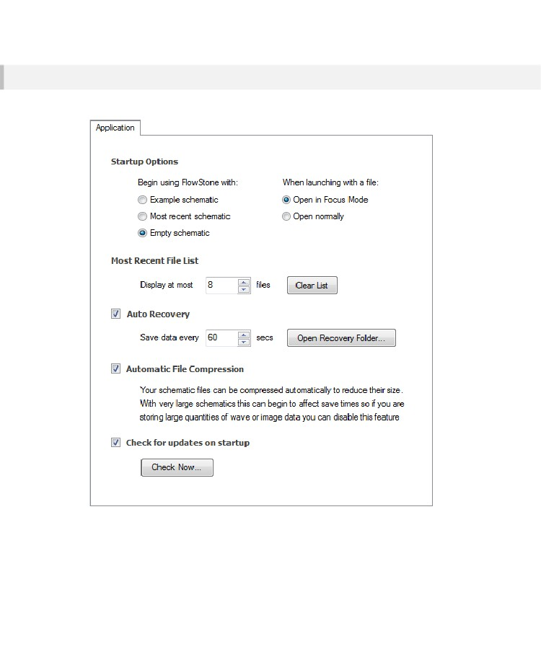
CHAPTER 11
Application
These options apply to features and settings that apply at application level.
Startup Options
By default the software will load up the example file that ships with the software. This is fine when you
first start looking at the software but once you begin making your own creations this behaviour
becomes undesirable.
- 264 -

OPTIONS
Thankfully you can switch this off. You can choose between the software launching with a blank
schematic (the fastest way to load up) or the schematic that you were working on last time you closed
down.
If you double-click on a file in Explorer it will usually open in FlowStone for editing. However, you can
choose to have double-clicked files open in Focus Mode and run the schematic as if it were an Exe.
Most Recent File List
The most recently used schematics are shown at the bottom of the File menu for rapid access. The
default size of this list is 4 items but you can choose to have up to 16 schematics displayed. You can
also choose to clear the recently used file list by clicking the Clear List button.
Auto Recovery
Auto Recovery is a handy little feature that saves a copy of your schematic periodically so that if your
session should suddenly be closed down due to a crash or loss of power you won’t lose your work.
Instead, when you next launch FlowStone the file(s) you were editing will be recovered based on the
state when they were last saved.
You can switch auto recovery on and off at any time. By default the save period is every 5 seconds.
For larger schematics you may want to choose a longer save interval to allow for the increased save
time.
Recovery files are saved to the App Data folder on your system. If you need to access this folder you
can do so by clicking the Open Recovery Folder button.
Automatic File Compression
Schematic files are automatically compressed to keep file sizes down. With very big files that contain
large amounts of image or sample data you may find that your save times begin to increase. In these
cases you can reduce the save time by switching file compression off.
Check For Updates On Startup
FlowStone is updated regularly so the software can check whether you have the latest version and
notify you that there is an update waiting. If you prefer not to do this you can switch the behaviour off.
You can also manually check for updates by clicking the Check Now button.
Please be assured that your privacy is maintained at all times. No data is transmitted during the update
check and only the latest version information is download to your PC from our server.
- 265 -

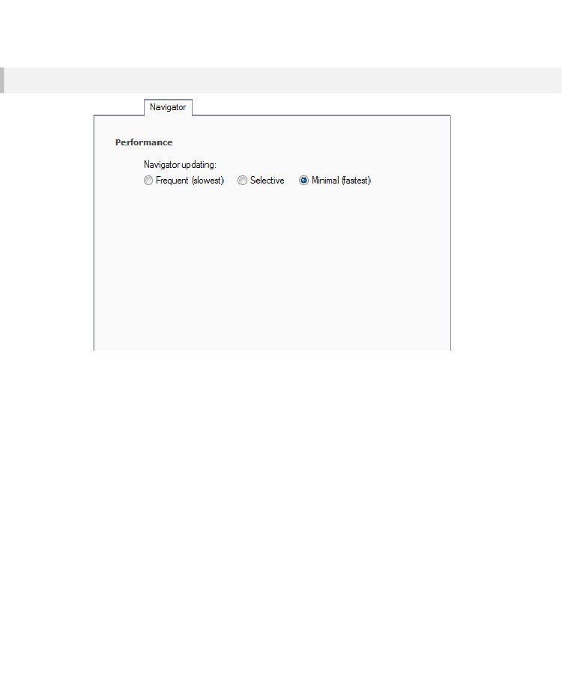
CHAPTER 11
Navigator
Performance
When you change a front panel item like a knob or a slider this often results in values changing in
other parts of your schematic. Any modules that are shown in the navigator will be updated to reflect
these changes. On some PCs this can be very slow.
You can therefore choose how often the Navigator updates. The default is for minimal updates and
often this is all you need. If you want to see the results of your interactions reflected in just the current
module in the navigator then choose Selective. To make the Navigator update on every change select
Frequent.
- 266 -

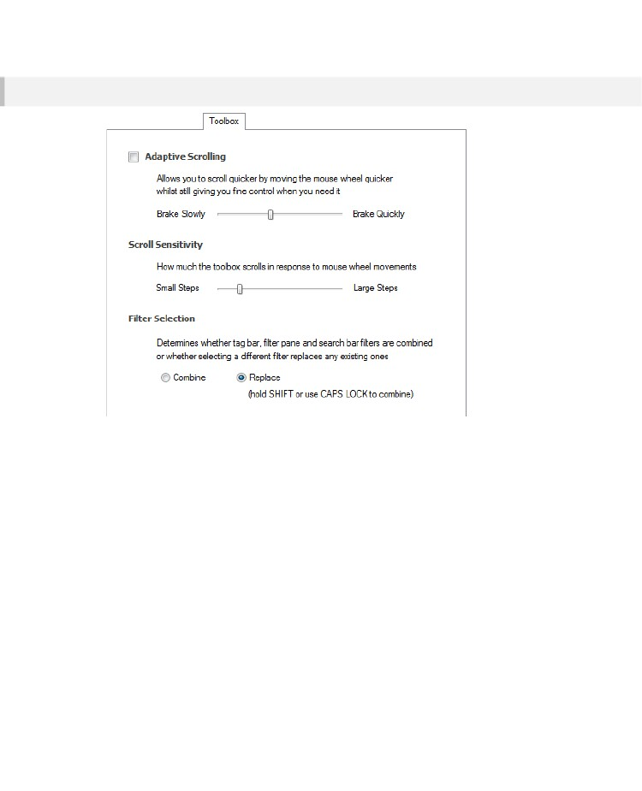
OPTIONS
Toolbox
Adaptive Scrolling
Enabling this option makes the toolbox scrolling amount adapt to the speed at which you move your
mouse wheel. Move the wheel slowly and you'll get small movements. Move it quickly and the toolbox
scrolls rapidly, building momentum as it goes.
When you stop scrolling the toolbox will slowly brake to a halt. You can control how quickly or slowly
the toolbox braking is applied.
Scroll Sensitivity
This determines how far the toolbox scrolls in response to each mouse wheel movement.
Filter Selection
There are numerous ways of filtering the toolbox to zero in on what you're looking for. You can use
tags or the search bar and there several types of filter on the filter pane.
This option allows you to choose what happens to the currently applied filter when you click on a
different one.
- 267 -

CHAPTER 11
If you choose to Combine filters then the existing one(s) will be retained when you click on another
one. For example, if you have the Audio tag selected and then click on the Float type filter only
components with the Audio tag that also match the Float type will be shown. If you then type some
search text this will only search the components that are currently shown.
If you choose to Replace filters then then the existing filter will be cleared when you click on another
one. Taking the same example as above, if you have the Audio tag selected and then click on the Float
type filter then all components matching the Float type will be shown (not just the ones with an Audio
tag). If you then type some search text all components matching that search text will be shown.
When the Replace option is selected you can (at any time) hold SHIFT to temporarily combine filters.
For search text you can use CAPS LOCK to save you having to hold SHIFT as you type.
Schematic
Mouse Behaviour
When drag selecting you can choose whether components will become part of the selection once they
are fully enclosed in the drag rectangle or when they touch some part of the area covered by the drag
rectangle.
You can decide whether a right-click brings up the standard context menu or if moves you up to the
parent when inside a module.
Zoom Level
The default zoom level is defined as a number of pixels. This represents the size of a single grid
square so a higher number will result in a default zoom that appears magnified. If you click Use
Current you’ll get the zoom level for the current module.
Auto Linking
You can decide how close components have to be before the software will suggest an automatic link.
You can also choose whether links are then created after a short time or if the software waits for you to
right-click to accept a suggested link.
Links On Top
Check this box if you want links to appear on top of components in your schematic (applies to the
schematic as a whole).
- 268 -

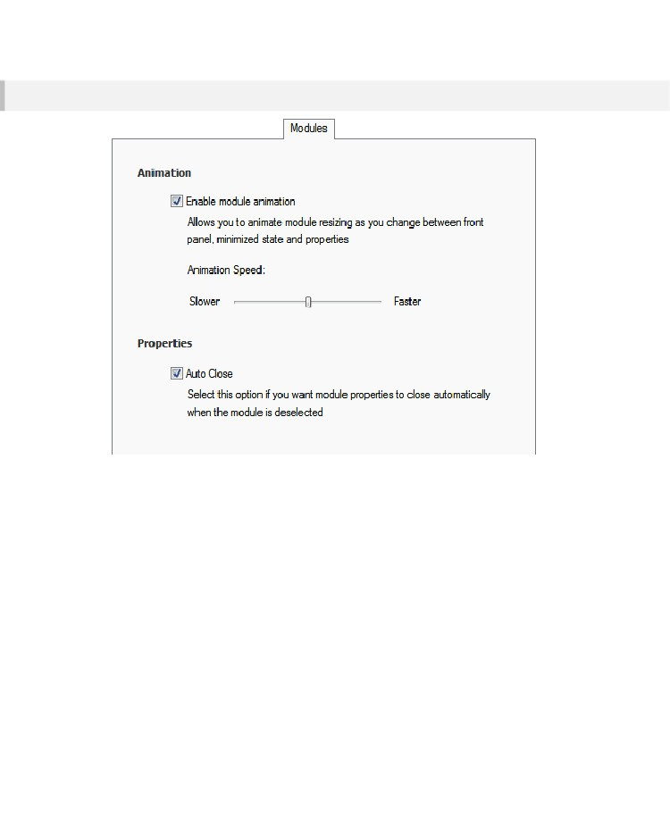
OPTIONS
Modules
Animation
You can choose whether to enable or disable module animation for when you minimize or maximize a
module or open/close the properties panel.
Properties
By default a module’s properties panel will close as soon as you click away (provided it isn’t pinned
open). You can switch this off so that the properties remain open until you close them.
- 269 -

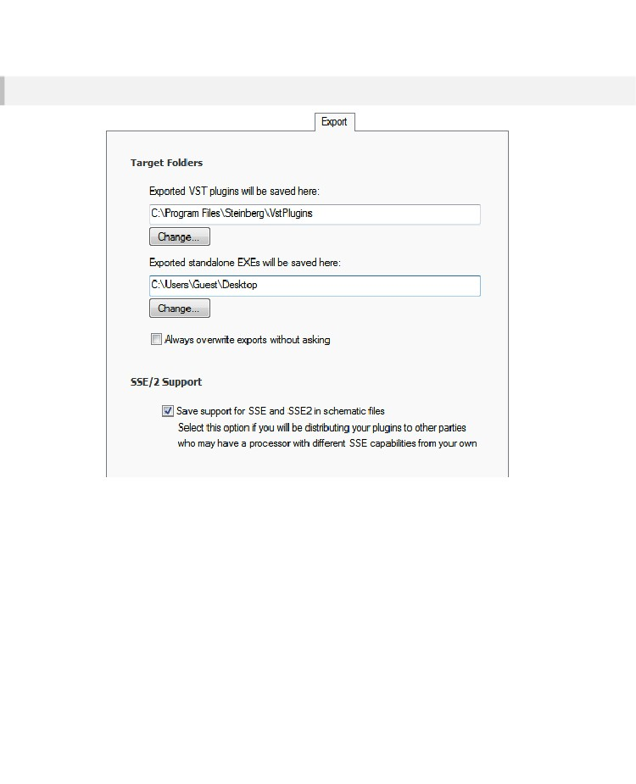
CHAPTER 11
Export
Target Folders
When you export standalone exes they are saved to a particular folder. You can set this here.
SSE/2 Support
The PC on which you generate your exports may support SSE2 or it may just support SSE. When you
export the software saves code that is optimised for the SSE capabilities of your own PC. If you then
give the export to someone whose PC has different SSE capabilities from you the software needs to
make adjustments on loading so that the export will work.
These adjustments can slow down the loading process. To avoid this you can choose to include
support for all SSE setups at export time. This way there is no reduction in loading speed when
exports are used on PCs with different SSE capabilities.
- 270 -

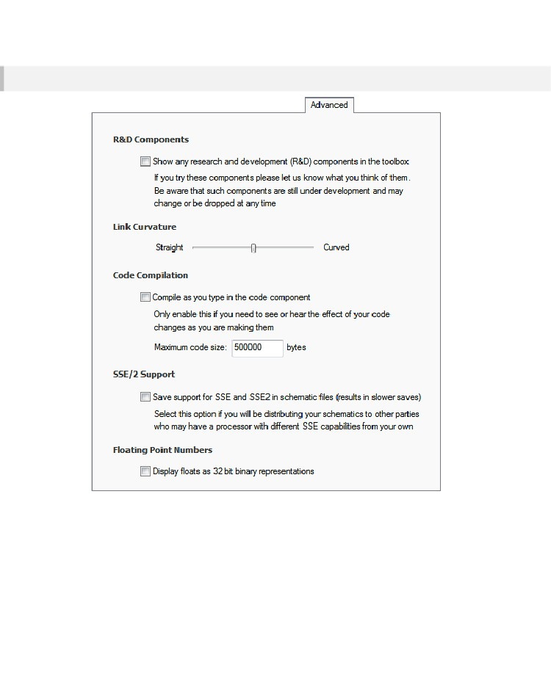
OPTIONS
Advanced
R&D Components
We will periodically offer some components on a trial basis to gather feedback or for testing. You can
decide whether to show these components by checking the box.
- 271 -

CHAPTER 11
Link Curvature
When you bend links they take a curved form. You can decide how curved you want them to be from
highly curved to perfectly straight lines. Note that this affects the way that links look in any schematic
you open.
Code Compilation
In order to increase performance code compilation is switched off while you are typing in a code
component. However, sometimes you want to be able to see the effects of your code as you type.
SSE/2 Support
The PC on which you create your schematics may support SSE2 or it may just support SSE. When
you save a schematic the software saves code that is optimised for the SSE capabilities of your own
PC. If you then give the schematic to someone whose PC has different SSE capabilities from you the
software needs to make adjustments on loading so that the schematic will work.
These adjustments can slow down the loading process. To avoid this you can choose to include
support for all SSE setups at save time. This way there is no reduction in loading speed when
schematics are used on PCs with different SSE capabilities.
You only need to enable this option for schematics if you intend to distribute them. One side affect of
enabling this option is that your save times are increased.
Floating Point Numbers
In computing floating point numbers cannot represent every possible number using 32bits. The system
therefore has to approximate some numbers.
For example, 0.01 is represented as 9.9999998 x 10
-3
These small inaccuracies can sometimes lead to unexpected results in calculations because
FlowStone will display 0.01 as 0.01 when in fact the number being used is of course the floating point
approximation.
These situations are quite rare but if you are doing precise calculations where these inaccuracies may
be significant in your results then you can choose to display the underlying representations instead so
that all your calculations are completely transparent.
- 272 -

